Project 13: An Analysis of Phosphate Concentration in Various Brands of Cola

Authors: Annabel Miller, Gillian Stitt, Stephanie Kusguen, Owen Sullivan

Our/My signature indicates that this document represents our/my own work. Excluding shared data, the information, thoughts, and ideas are our/my own, except as indicated in the references.

Contributors include: Annabel Miller, Gillian Stitt, Stephanie Kusguen, Owen Sullivan, Oscar Hernandez Manuel, Kobe Mathis, Blaise Mengue, Harmon Brock Graham

Dates conducted: September 7, 2021; September 14, 2021; September 21, 2021; September 28, 2021

Introductory note:
A series of equipment malfunctions and failures resulted in unreasonable data for Group C (Annabel Miller, Gillian Stitt, Stephanie Kusguen, Owen Sullivan) throughout much of the initial processes of Project 13, including: the analysis of food coloring in water, the analysis of potassium permanganate (KMnO₄), the analysis of the phosphate ion^{[2]} (PO₄³⁻), and the analysis of colas (Coca-Cola, Dr. Pepper, Sam’s Club Cola, Dr. Thunder). As a result, CHEM 1011 Section 246’s TA (Alex Mayfield) recommended merging the data sets of Group C and Group D (Oscar Hernandez Manuel, Kobe Mathis, Blaise Mengue, Harmon Brock Graham); thus, the analyses of the phosphate ion^{[2]} (PO₄³⁻) and colas were conducted as one experiment for both groups. The limitations of each experiment are detailed alongside the data; the original data sets for Group C have been noted as well as the final shared data set.

Project introduction:
The question was posed of what concentrations of a phosphate ion^{[2]} (PO₄³⁻) are present in a number of leading cola brands; since many major cola brands incorporate the phosphate ion^{[2]} into the formulae of the sodas, there should be a measurable concentration.

For the experiment, it was determined that three different brands (samples) of cola should be analyzed using a spectrophotometer. Because of the aforementioned merging of data sets between Group C and Group D, four colas were analyzed; this is due to the fact that each group’s original plan for experimentation included two of the same cola samples (Coca-Cola and Dr. Pepper). The four brands used for the final experiment were Coca-Cola, Dr. Pepper, Sam’s Club Cola, and Dr. Thunder.

Background experiments were conducted using both mixtures of water and food coloring and a sample of potassium permanganate (KMnO₄) to serve as examples for how to use the spectrophotometer^{[1]}. Data for these experiments is listed below.

Background materials:
- Spectrophotometer (SPECTRONICTM 200 Spectrophotometer)^{[1]}
- Various sized beakers
- Various sized flasks
- Various volume pipettes
- Red and blue food coloring
- Potassium permanganate solution (KMnO₄)
- Water
- Cuvettes

Background experiments (methods and data):
Prior to conducting the experiment with food coloring, a 5mL sample of water was poured into a cuvette and used to zero-out the spectrophotometer^{[1]}.

The first sample of food coloring and water used contained rich blue food coloring. A mixture of 5mL of water mixed with 1 drop of food coloring was agreed upon and measured into a cuvette. The cuvette was then placed into the spectrophotometer^{[1]} for analysis. Tests were conducted with wavelengths ranging from 350nm to 650nm. A table of the recorded absorbances follows:

Table 1
Wavelength (nm) | Absorbance | Wavelength (nm) | Absorbance
350 | 0.27 | 510 | 0.26
360 | 0.32 | 520 | 0.34
370 | 0.41 | 530 | 0.45
380 | 0.58 | 540 | 0.62
390 | 0.79 | 550 | 0.85
400 | 0.96 | 560 | 1.21
410 | 1.24 | 570 | 1.77
420 | 0.96 | 580 | 2.50
430 | 0.47 | 590 | 2.50
440 | 0.22 | 600 | 2.50
450 | 0.15 | 610 | 2.50
460 | 0.13 | 620 | 2.50
470 | 0.14 | 630 | 2.50
480 | 0.15 | 640 | 2.50
490 | 0.18 | 650 | 2.50
500 | 0.21

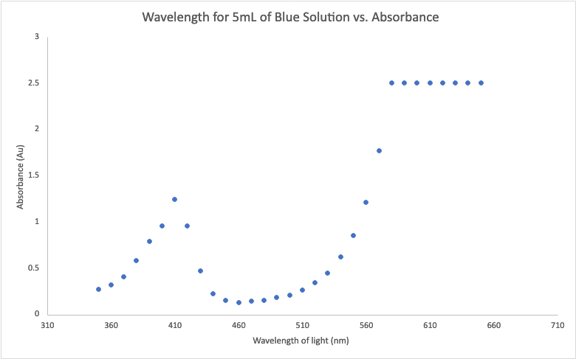
Graph 1

As for why the absorbances from wavelengths of 580nm to 650nm all maxed out at 2.50 on the spectrophotometer^{[1]}, the TA (Alex Mayfield) advised that the blue food coloring was so rich that the equipment could not detect higher wavelengths in the solution.

A similar experiment was conducted with a mixture of water and red food coloring. Again, 5mL of water and a drop of red food coloring were measured into a cuvette and placed in the spectrophotometer for analysis. Absorbances:

Table 2
Wavelength (nm) | Absorbance | Wavelength (nm) | Absorbance
350 | 0.38 | 510 | 2.20
360 | 0.40 | 520 | 2.20
370 | 0.44 | 530 | 2.13
380 | 0.49 | 540 | 1.72
390 | 0.54 | 550 | 1.15
400 | 0.58 | 560 | 0.68
410 | 0.60 | 570 | 0.37
420 | 0.61 | 580 | 0.19
430 | 0.62 | 590 | 0.09
440 | 0.65 | 600 | 0.04
450 | 0.75 | 610 | 0.03
460 | 0.97 | 620 | 0.02
470 | 1.24 | 630 | 0.02
480 | 1.56 | 640 | 0.01
490 | 1.95 | 650 | 0.01
500 | 2.20

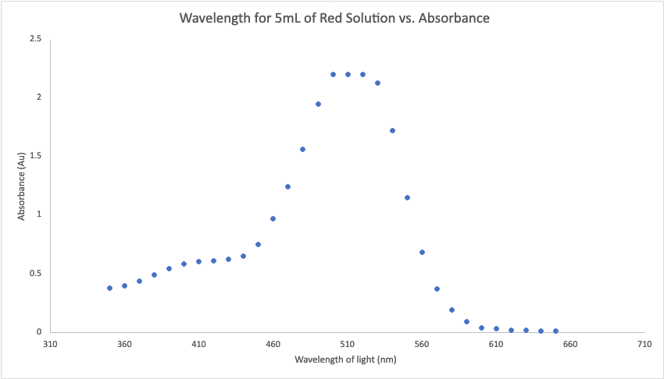
Graph 2

Although the data for red food coloring was less flawed than the data found for blue food coloring, there were still several values in the 500-520nm and 590-650nm ranges. It was agreed that the results may represent the opposite outcome to the test with blue food coloring, meaning the red food coloring may not have been rich enough.

A third experiment was conducted with a 5mL mixture of water mixed and one drop each of red and blue food colorings. The TA (Alex Mayfield), believing that a diluted mixture would produce more reasonable results, poured some of the mixture out and replaced the remainder with water. Because neither the group or the TA measured exactly how much of the solution was replaced with water, the data may be inaccurate. Absorbances:

Table 3
Wavelength (nm) | Absorbance | Wavelength (nm) | Absorbance
350 | 0.17 | 510 | 0.52
360 | 0.19 | 520 | 0.55
370 | 0.23 | 530 | 0.57
380 | 0.27 | 540 | 0.50
390 | 0.31 | 550 | 0.40
400 | 0.33 | 560 | 0.37
410 | 0.37 | 570 | 0.42
420 | 0.31 | 580 | 0.54
430 | 0.21 | 590 | 0.65
440 | 0.17 | 600 | 0.80
450 | 0.18 | 610 | 1.04
460 | 0.22 | 620 | 1.43
470 | 0.28 | 630 | 1.83
480 | 0.35 | 640 | 1.77
490 | 0.43 | 650 | 1.16
500 | 0.49

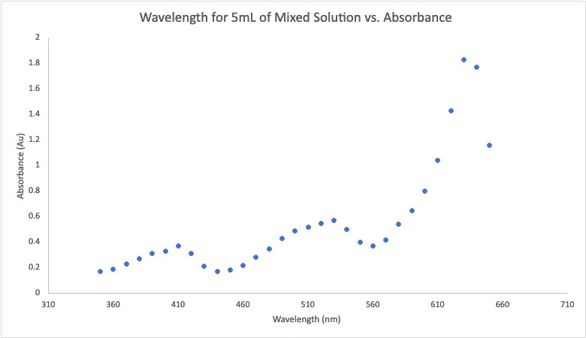
Graph 3

Group C believed that the results in the 600-650nm range can once again be attributed to a mixture too rich for the spectrophotometer^{[1]} to detect those wavelengths, despite the dilution of the sample prior to analysis.

One final experiment was conducted in a similar fashion using a 5mL mixture of 12.5% potassium permanganate (KMnO₄) and 87.5% water. Absorbances:

Table 4
Wavelength (nm) | Absorbance | Wavelength (nm) | Absorbance
350 | 0.25 | 510 | 0.43
360 | 0.21 | 520 | 0.47
370 | 0.16 | 530 | 0.58
380 | 0.09 | 540 | 0.50
390 | 0.04 | 550 | 0.55
400 | 0.00 | 560 | 0.39
410 | 0.05 | 570 | 0.32
420 | 0.04 | 580 | 0.24
430 | 0.04 | 590 | 0.11
440 | 0.05 | 600 | 0.07
450 | 0.04 | 610 | 0.06
460 | 0.02 | 620 | 0.06
470 | 0.03 | 630 | 0.06
480 | 0.04 | 640 | 0.06
490 | 0.07 | 650 | 0.05
500 | 0.04

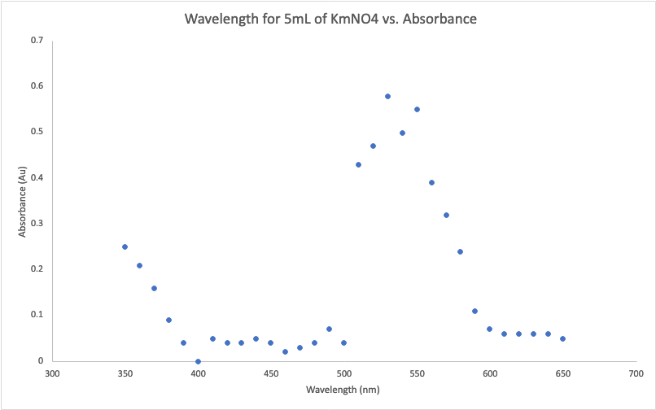
Graph 4

Once again, unexpected results are attributed to the mixture being too rich.

A lambda max of 530nm was found for the purposes of a later experiment, but was eventually disregarded in favor of more usual data from Group D.

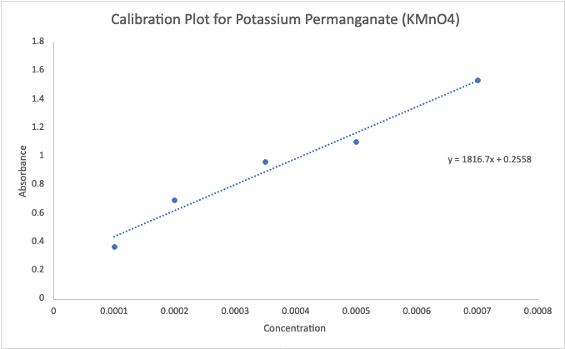
Graph 5

Despite the unexpected results of each experiment, Group C effectively learned how to analyze samples using the spectrophotometer^{[1]}.

Primary experiment materials:
- Spectrophotometer (SPECTRONICTM 200 Spectrophotometer)^{[1]}
- Various sized beakers
- Various sized flasks
- Various volume pipettes
- Phosphate ion^{[2]} (PO₄³⁻)
- AVM solution
- Colas (Coca-Cola, Dr. Pepper, Sam’s Club Cola, Dr. Thunder)
- Water
- Cuvettes
- Hot plate

Primary experiment (methods and data):
Using the background knowledge from the above experiments, Groups C and D conducted tests first on the phosphate ion^{[2]} solution (PO₄³⁻) using the spectrophotometer^{[1]}.

First, a blank solution of a mixture of AVM and water was prepared; this mixture was used to zero the spectrophotometer^{[1]}. Then, Group D used the equation provided by the TA (Alex Mayfield) to calculate the concentrations of the phosphate ion^{[2]} mixed with water:

C₁V₁ = C₂V₂
(0.101)(v₁) = (0.001)(50mL) → v₁ = 0.495mL

A total of five calculated mixtures were produced using this equation to measure a calibration curve for the phosphate ion^{[2]}:

- (0.001m)(v₁) = (0.0001m)(10mL) → v₁ = 1mL
- (0.0001m)(v₁) = (0.0008m)(10mL) → v₁ = 8mL
- (0.0008m)(v₁) = (0.0005m)(10mL) → v₁ = 6.25mL
- (0.0005m)(v₁) = (0.0002m)(10mL) → v₁ = 4mL
- (0.001m)(v₁) = (0.0003m)(10mL) → v₁ = 3mL

Each sample of cola was heated on a hot plate to remove gas bubbles. Then, each sample was mixed to create a solution of 1mL cola + 49mL water. A second mixture of 2 parts cola + water to 1 part AVM was created; 5mL of AVM was mixed with 10mL of each soda + water solution, in this case.

The calibration curve was calculated by Group D and a member of Group C (Gillian Stitt).

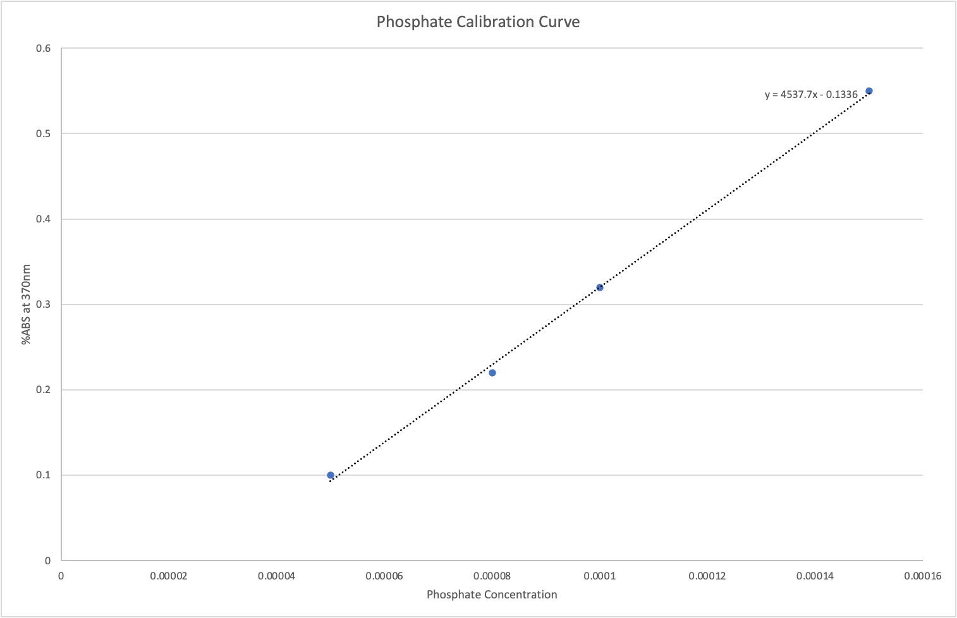
Graph 6

The equation came out to be:

$y=4537.7x-0.1336$

The absorbances of each cola at a lambda max of 355nm (taken from Group D’s potassium permanganate experiment) were measured and are as follows:

Table 5
Coca-Cola | 1.17
Dr. Pepper | 1.07
Sam’s Club Cola | 0.97
Dr. Thunder | 1.33

A limitation of this data is that the AVM/water blank solution used for zeroing the spectrophotometer^{[1]} did not result in an exact zero on the equipment. The reason for this is unknown, so the TA (Alex Mayfield) permitted both groups to continue the experiment noting the equipment malfunction.

Using these absorbances and the calibration curve equation, and an equation for the concentration of the phosphate ion^{[2]} in undiluted soda (concentration from calibration curve * [(total volume of cola + water solution) / (total volume of cola)]), the molarity of each soda was produced.

Table 6
Coca-Cola | 0.01435
Dr. Pepper | 0.01325
Dr. Thunder | 0.0167

This data does not include the molarity of Sam’s Club Cola, as it did not get calculated during this time of experimentation.

Conclusions:
Based on the calculated molarities, the concentration of the phosphate ion^{[2]} (PO₄³⁻) in each cola must be very low. The inaccuracies of this experiment, exacerbated by equipment failure, resulted in calculations that may not be nearly representative of the actual molar concentration of the phosphate ion^{[2]} (PO₄³⁻) in each cola.

Although the molar concentration of the phosphate ion^{[2]} (PO₄³⁻) in Sam’s Club Cola was not calculated, it can be inferred that, based on the other concentrations, it, too, would be very low.

If this experiment were to be repeated, it would make sense to do so with brand new equipment that we could be most certain is not malfunctioning in any way. For the food coloring experiment, in particular, it would be ideal to use food coloring solutions that are consistently rich for each color. It may even be necessary to measure the solutions using a higher volume of water.
Works Cited

^{[1]}
“SPECTRONICTM 200 Spectrophotometer.” Thermo Fisher Scientific. N.p., n.d. Web. 4 Oct. 2021.

^{[2]}
Wikipedia contributors. “Phosphate.” Wikipedia, The Free Encyclopedia. N.p., 18 Sept. 2021. Web. 4 Oct. 2021.

