Calcium Supplement Project
By: Owen Sullivan, Gillian Stitt, Annabel Miller, and Stephanie Kusguen

Background info:
Calcium is the most abundant mineral in the body. It is found in many different foods, and it is also present in some medicines. Calcium makes up a large portion of bones and teeth, and it keeps our tissue strong and flexible.

The majority of calcium in your body is stored in your bones and teeth, and it helps give them their hardness and structure.

Calcium supplements are usually taken to help treat and prevent osteoporosis. Osteoporosis is a disease that weakens the bones and causes them to become more fragile and fracture easily. This is why so many Americans take calcium supplements, but people complained about them being too chalky, so our team set out to design a liquid calcium supplement. The goal was to create a nontoxic clear liquid supplement with a pH between 4 and 10 with a known concentration.

Calcium salts solubility table:

Slot | Anion Candidate | Precipitate?* | Soluble?** | Toxic (When Reacted with CaCO₃)?*** | Valid?
A1 | Na₃PO₄ (aq) | No | Yes | Yes | No
A2 | NaCl (aq) | No | Yes | Yes | No
A3 | Na₂SO₄ (aq) | No | Yes | No | Yes
A4 | Na₂C₂O₄ (aq) | Yes | No | N/A | No
B1 | NaNO₃ (aq) | No | Yes | Yes | No
B2 | NaCH₃COO (aq) | No | Yes | No | Yes
B3 | Na₂CO₃ (aq) | Yes | No | N/A | No

* Valid anion candidates for the creation of a calcium supplement should not form a white solid precipitate when reacted with CaCO₃ (aq).
** Valid anion candidates for the creation of a calcium supplement should be soluble in water.
*** Valid anion candidates for the creation of a calcium supplement should not be toxic when ingested (after reacting with CaCO₃ (aq)). Rows marked “N/A” were not soluble in water, and thus were not valid candidates, so the toxicity of these were not considered.

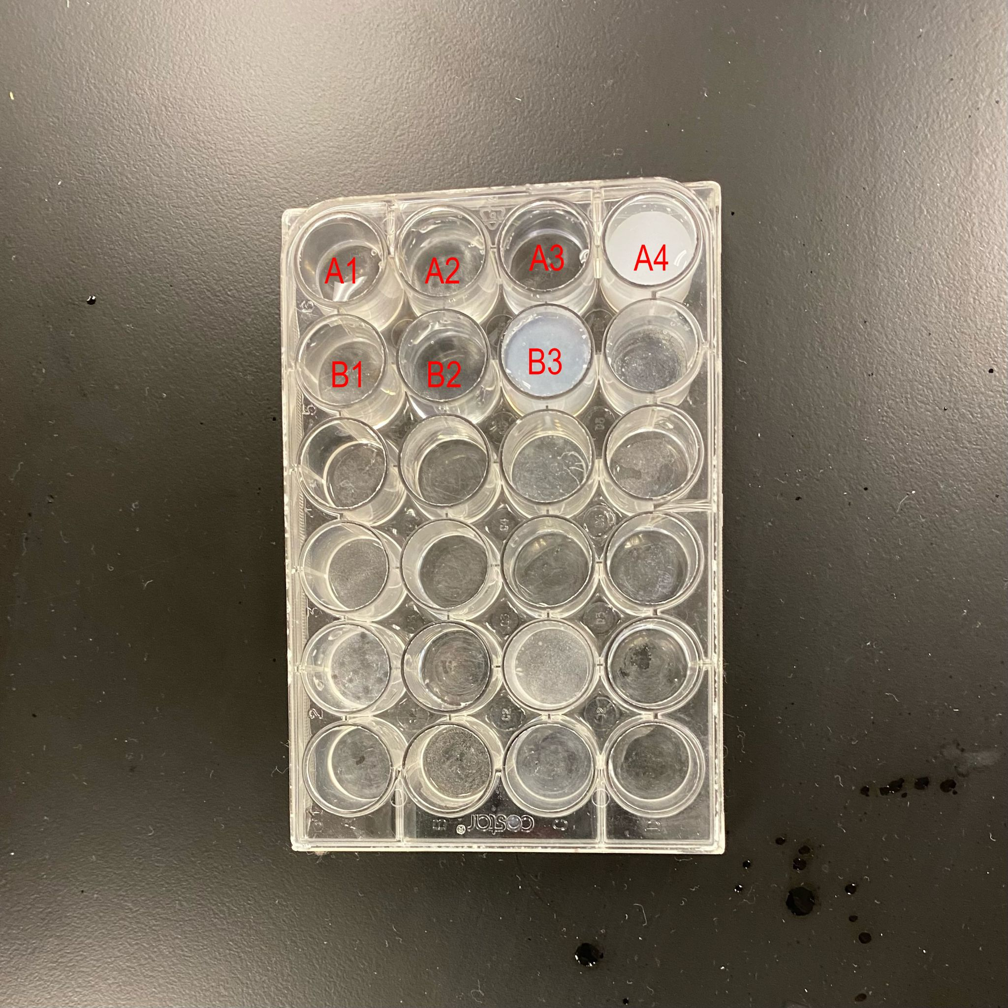

Total ionic balanced chemical equations:
CaCO₃ + 2NaCH₃COO -> Ca(CH₃COO)₂ + Na₂CO₃
(Soluble)

CaCO₃ + Na₂CO₃ -> CaCO₃ + Na₂CO₃
(Insoluble)

pH measurement:
We estimated the pH of the final calcium supplement solution to be somewhere between 4.5 and 6.0 based on the pink color of the pH paper after mixing in HCl and NaOH.

Calculation & volume per day:
- We started with 0.5 grams of calcium carbonate and used titration to find the volume of hydrochloric acid needed to dissolve all of the calcium carbonate.
- We went back and forth adding different measurements of HCl and NaOH making the solution too acidic and too basic.
- We found that 35.0mL of HCl and 61.0mL of NaOH dissolved the CaCO₃ and ended up with 96.0mL of solution.
- We were then able to calculate:

0.5g CaCO₃
--------------------- X 0.4g Ca²⁺ = 0.0021 X 1000 = 2.0833g/L
96.0mL solution

1
---------------- = 0.48L of CaCO₃ to drink daily
2.0833g/L

Preparation of calcium supplement:
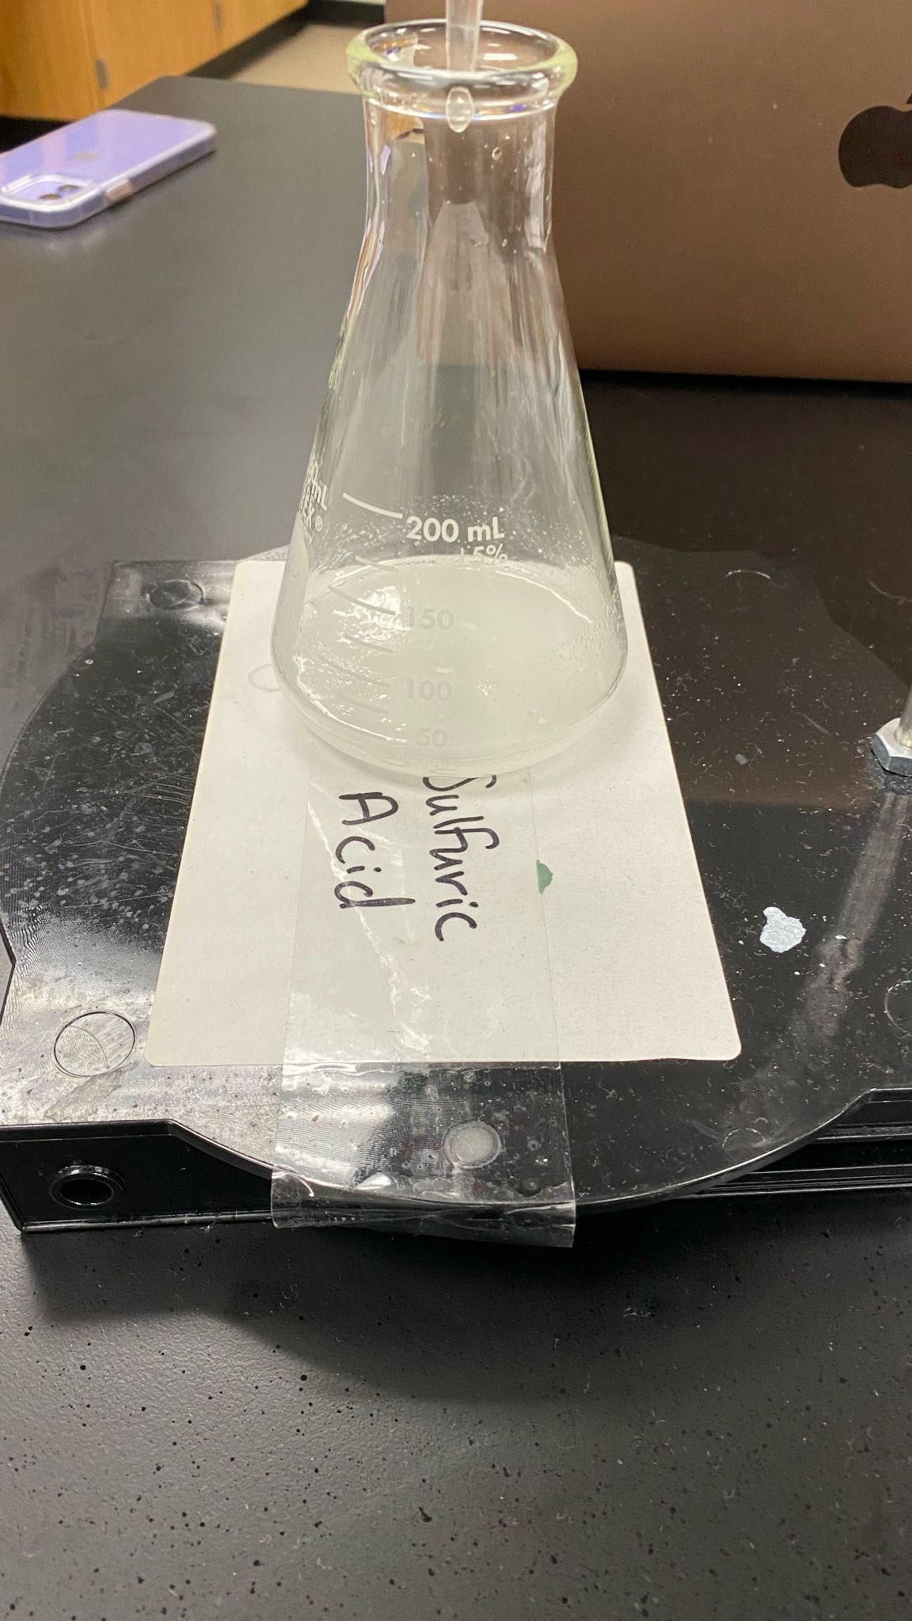

(Precipitate)

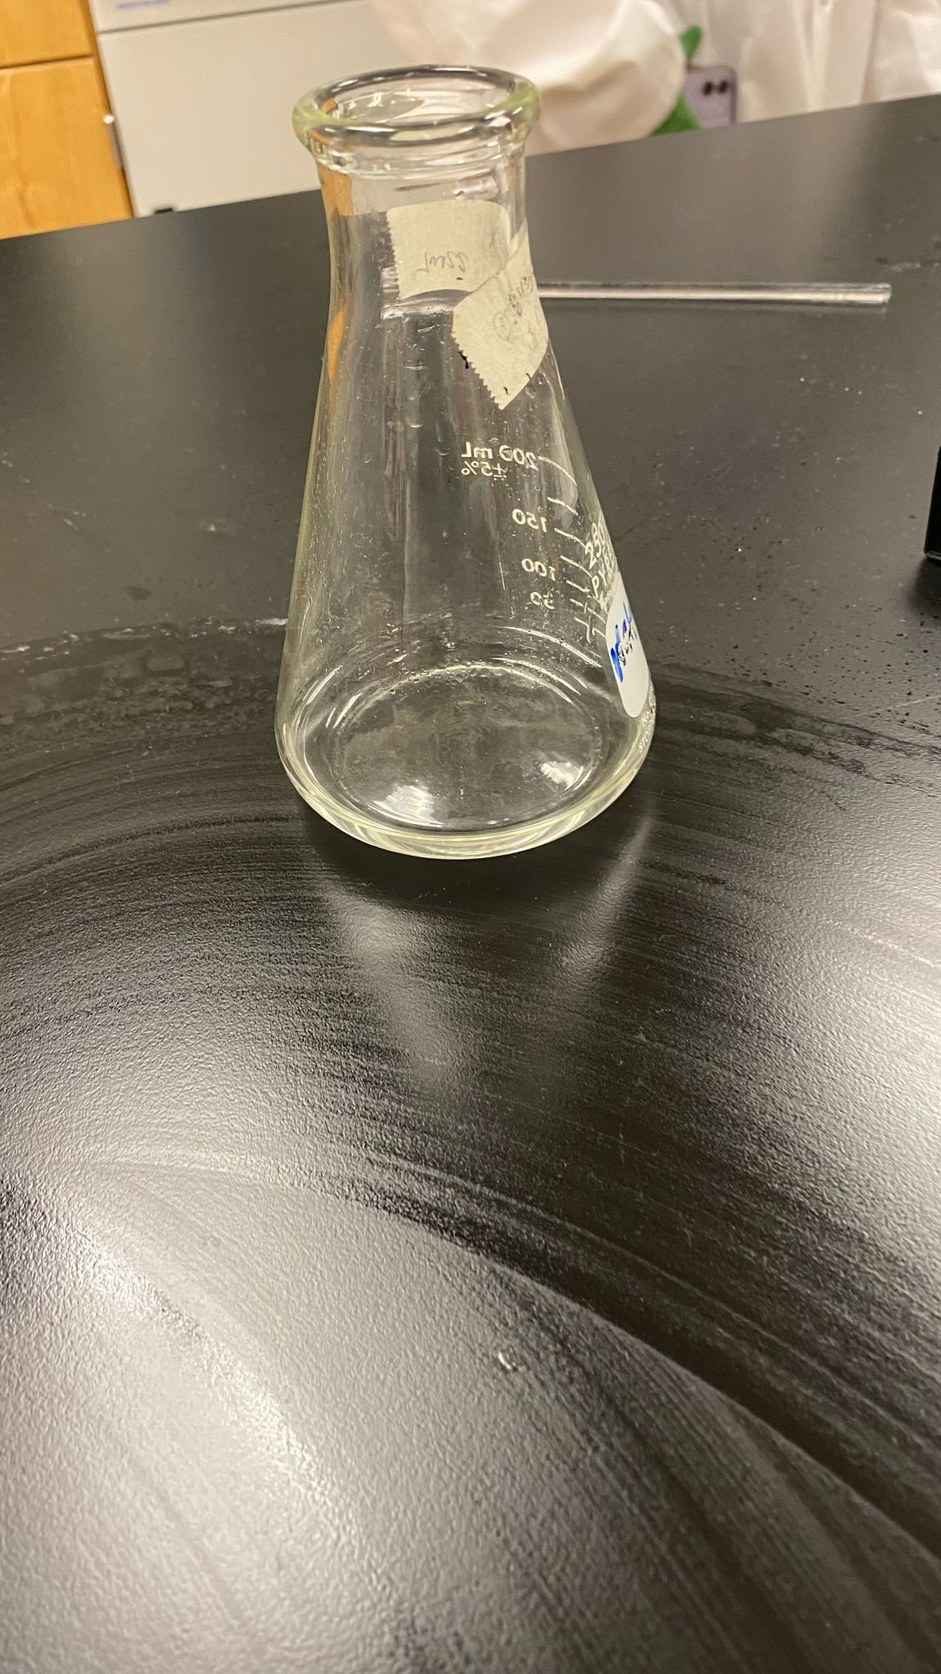

(Titrated)

