JMP Instructions

TABLE OF CONTENTS
Graphical Displays
Qualitative Graphs
Frequency Table | 1
Relative Frequency Table | 4
Pie Chart | 5
Bar Chart | 6
Comparative Bar Chart | 7
Quantitative Graphs
Histogram | 8
Dot Plot | 9
Comparative Dot Plot | 10
Stem and Leaf | 12
Box Plot | 13
Scatterplot | 14
Linear Regression | 15
Confidence Intervals and Hypothesis Testing
Confidence Interval for Mean | 16
Confidence Interval for Proportion | 20
Hypothesis Test for Mean | 21
Hypothesis Test for Proportion | 25
Other
Changing the Type of Data | 27
Printing | 28

Graphical Displays
For JMP
Using Cereal Data for Examples
Graphing Qualitative Data
FREQUENCY TABLE
JMP

There are two ways to do this. One is just finding the frequency table while the other shows the frequency table, the relative frequency, and a histogram of the data.

Only the frequency table:
- Open Dataset - Help -> Sample Data Library -> Cereal.jmp
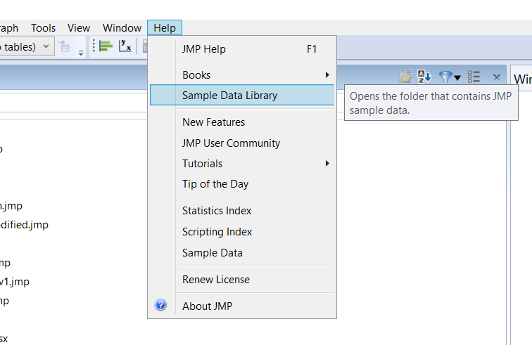
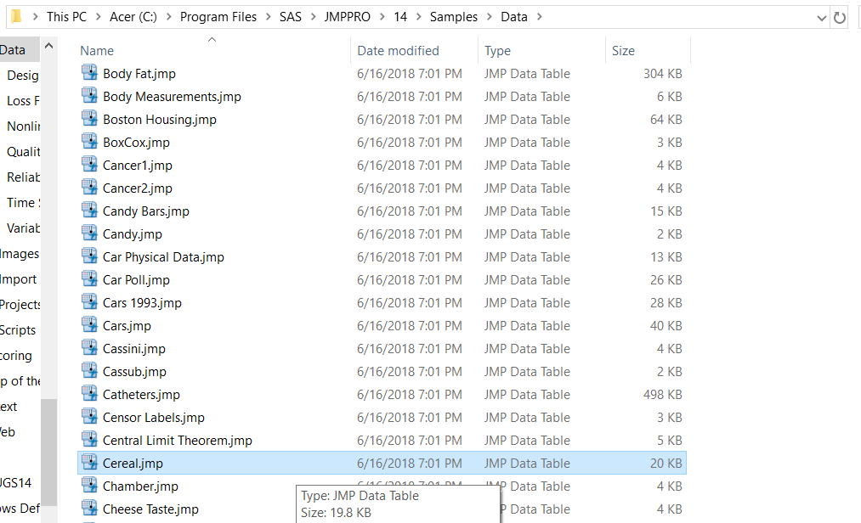
- Analyze -> Tabulate -> Drag the Column Name of interest to the top
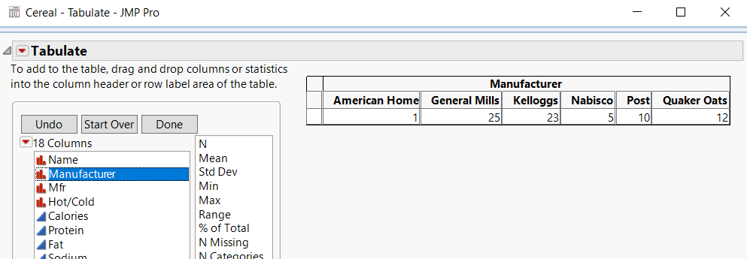

Frequency table, relative frequency table, and histogram:
- Look at the toolbar on the top and find Analyze. Click on it.
- Click on Distribution, the first option.
- Highlight the column of interest -> Click Y, Columns -> Click OK. Instead, you can drag the column to the first empty box and click OK
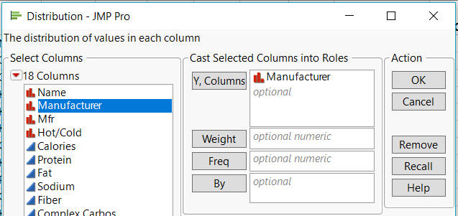
- Click on the red arrow nest to “Distributions” and select “Stack” to switch the histogram to be horizontal.
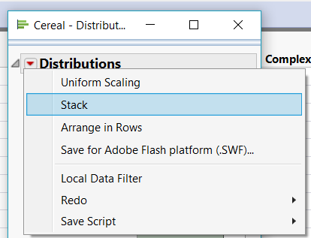
- “Y, Columns” is the most important because it is required. Whatever column(s) are in that block are going to have a distribution/histogram for each column(s). The only other optional block that is often used is “By” which will create histograms for the column(s) in “Y, Columns” based on the criteria in “By”.
  - For instance, if you wanted to analyze the cereal Manufacturers by the type of cereal (hot or cold), you would get the following:
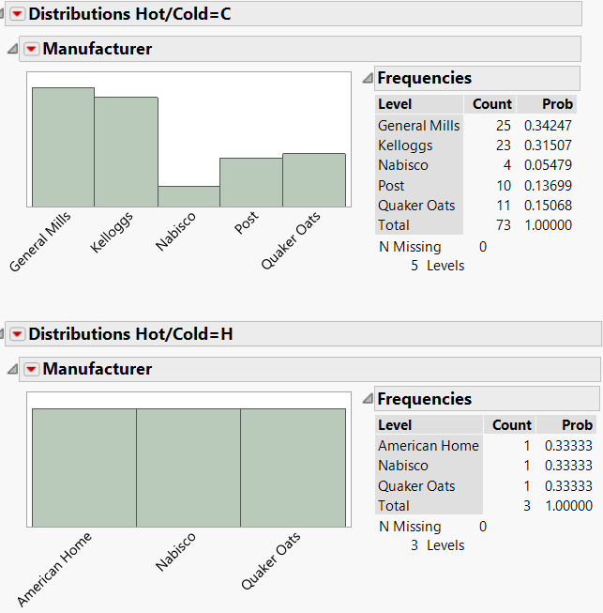

RELATIVE FREQUENCY TABLE
JMP
- Create Frequency Table for data (see direction above)
- If you created the frequency table from “Analyze”, the relative frequency table is listed as Prob (as in probability). If you created the frequency table using “Tabulate”, drag % of Total to the empty white cell in the first column.
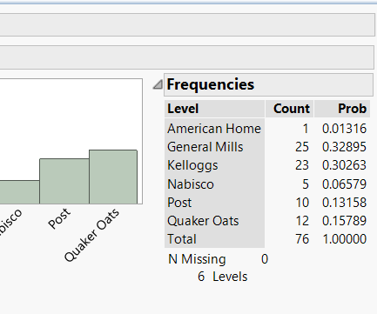

PIE CHART
JMP
- Click on Graph in the toolbar on top.
- Click on Graph Builder, the first option.
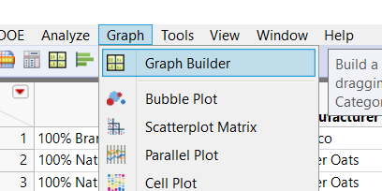
- Click Pie Chart picture.
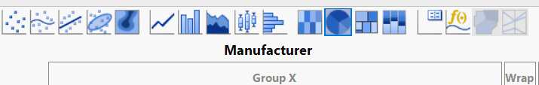

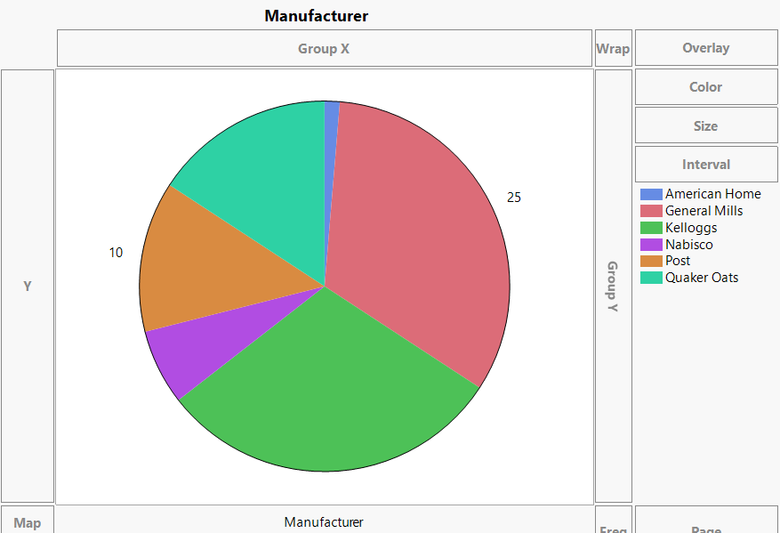
- Drag the variable of interest into white zone in the middle.

BAR CHART

JMP
- Go back to the Graph Builder (as shown in Pie Chart).
- Click on the 7th icon (the one that says “Bars” when hovered over).
- Drag the variable of interest into the large white space.
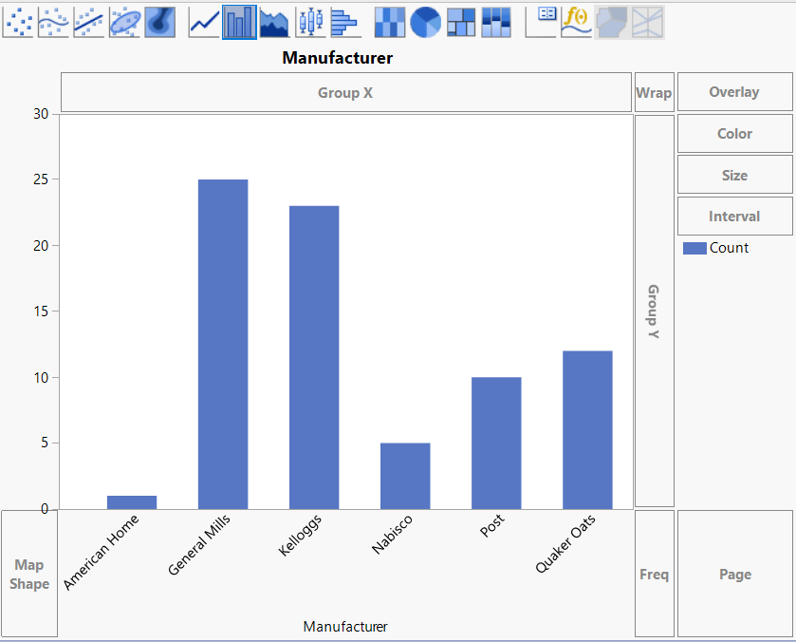

COMPARATIVE BAR CHART /SIDE-BY-SIDE BAR CHART
JMP
- Create a bar chart using the Manufacturer column
- In the top-left of the bar chart, there is a small box with “Overlay.” Drag “Hot/Cold” onto “Overlay.”
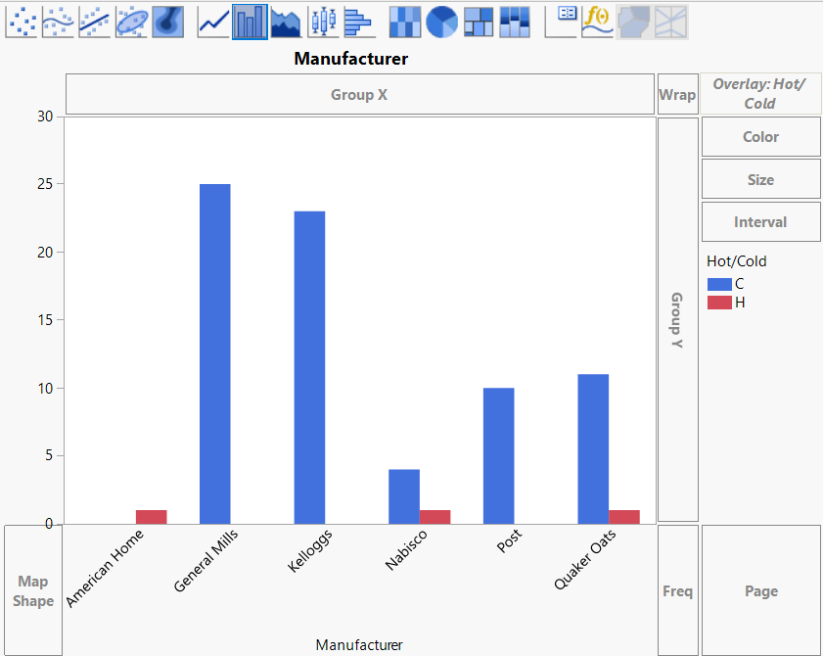
- If you want a count, you can hover above each column and it will tell you the height of each bar as “N: “
- You can also get a count of each bar by going to Analyze -> Tabulate. Drag “Manufacturer” to the top. Then drag “Hot/Cold” to the small empty box in the bottom-left.
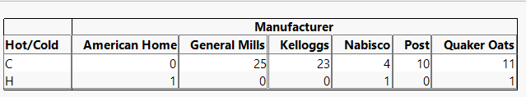

QUANTITATIVE VARIABLES

HISTOGRAM

JMP
- Make a histogram through “Analyze” using the quantitative variable of interest, such as “Sodium.”
- “Stack” the histogram.
To change the bin width, click on the red triangle beside the name of your variable. Go to Histogram Options -> Set Bin Width. Note that the histograms in JMP include the left endpoints in a bin but not the right endpoint.
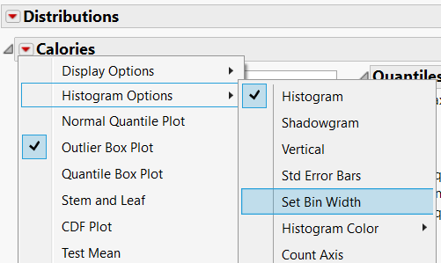
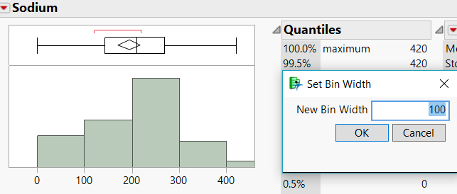
- Changing the values of the horizontal axis is tricky. When you move the cursor to that axis, it will change to a vertical hand. Move the cursor closer to the ends and it will change to a horizontal hand. Clicking and holding will allow you to change the range on the horizontal axis.
- There is no way to make JMP create a frequency or relative frequency table because the bin widths can be changed. Instead, you can make JMP display the number of items in above each bin and use that to create a frequency/relative frequency table by hand.
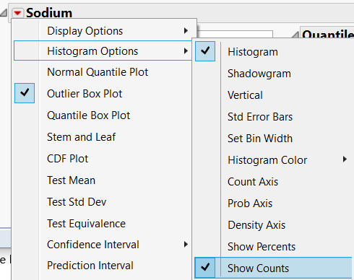

DOT PLOT

JMP
- Graph -> Graph Builder
- Drag Sodium under the white space to the area marked “X”.
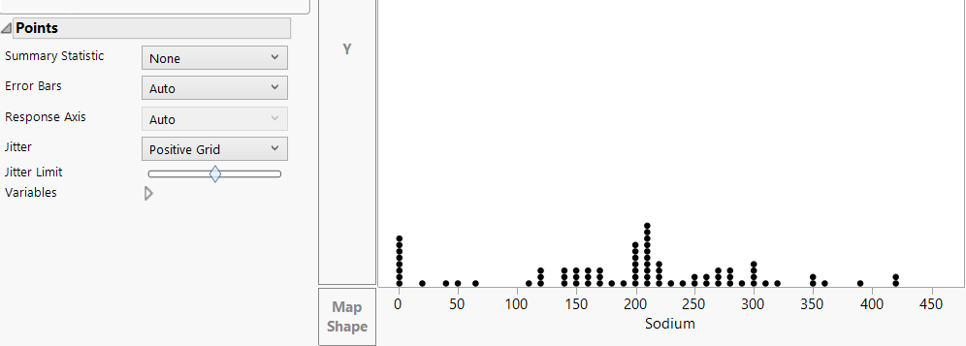
- Go to “Jitter” (located under Points) and change it to Positive Grid

- If the symbols are bothering you or impeding your counts, go back to original data set. Right click the area above the row numbers, and select “Clear Row State”. When you go back to the dot plot, everything is now a black dot.
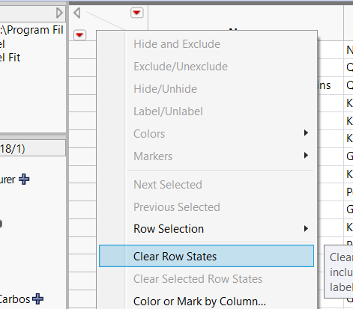

COMPARATIVE DOT PLOT

JMP

- Create a dot plot as described above.
- There are several ways to create a comparative dot plot using a second variable.
  - One way is to drag the second variable to “Group X”. Doing this will create many different individual dot plots.
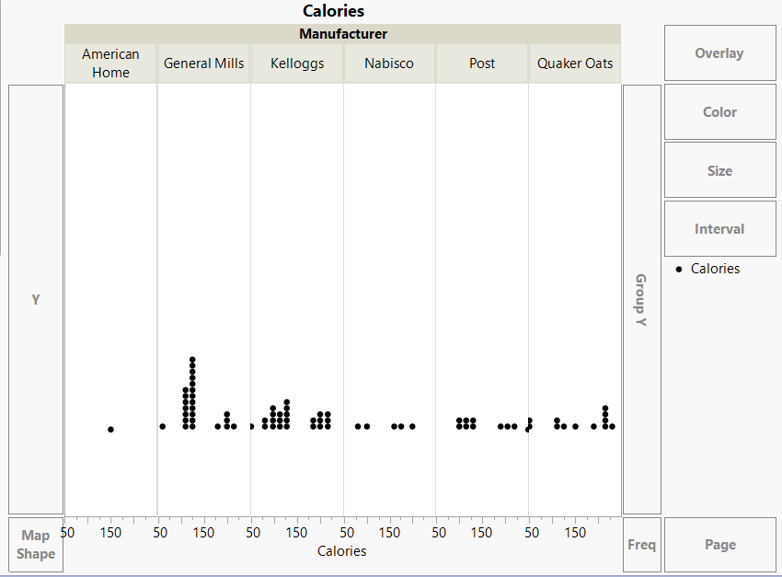
  - Another way is to drag the variable to “Group Y”. Doing this will create different dot plots but they are all over a single horizontal indicator. 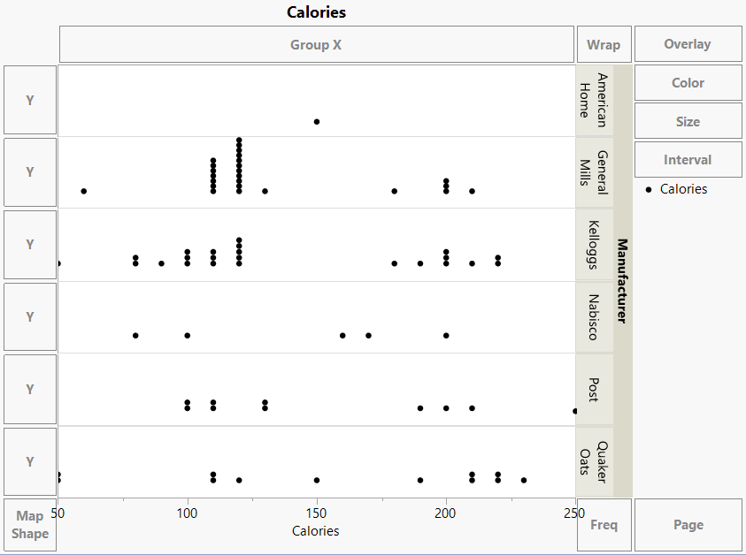
  - A third way is to drag the variable to “Overlay” in the top right corner. Doing this will add colors to the plot depending on the variable you used. Examples of each are below. 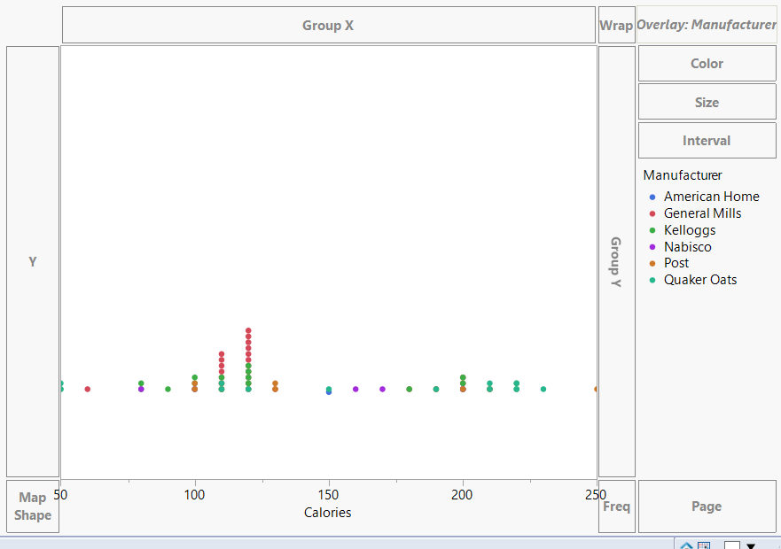

STEM AND LEAF

JMP

- Make a histogram.
- Click on the red arrow beside the variables name.
- The sixth option should be “Stem and Leaf.” Click on it.
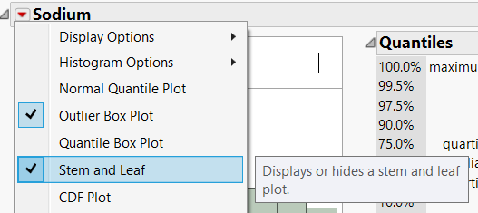
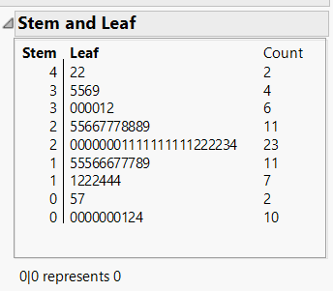

BOX PLOTS

JMP

- Make a histogram.
- By doing this, JMP automatically makes a box plot indicating any outliers.
- To remove the histogram, click on the red arrow next to your column name. Go down to “Histogram Options” and select “Histogram”. This will remove the histogram and keep the box plot.

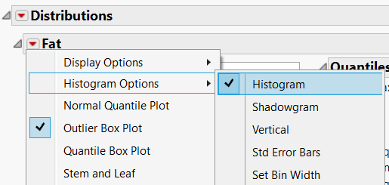

SCATTERPLOT

JMP

- Graph -> Graph Builder.
- Drag one quantitative variable to “X” and another quantitative variable to “Y”. Ideally, the response variable should be on “Y” and the independent variable should be on “X.” As an example, drag “Sugars” to X and “Calories” to Y.
- JMP automatically creates the best curve to describe these two variables. To remove this, look above the graph where the different plots are. The first two are highlighted. Click on the second icon to remove the curve.
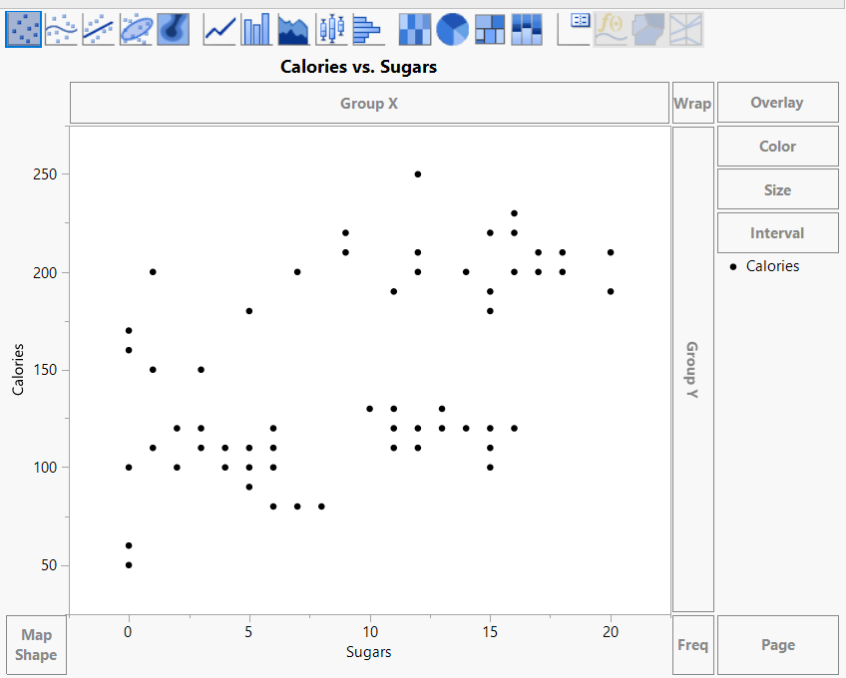

LINEAR REGRESSION

JMP
- Analyze -> Fit Y by X.
- Drag one quantitative variable to “X” and another quantitative variable to “Y”. Ideally, the response variable should be “Y” and the independent variable should be “X”. As an example, drag “Tot Carbo” to X and “Calories” to Y.
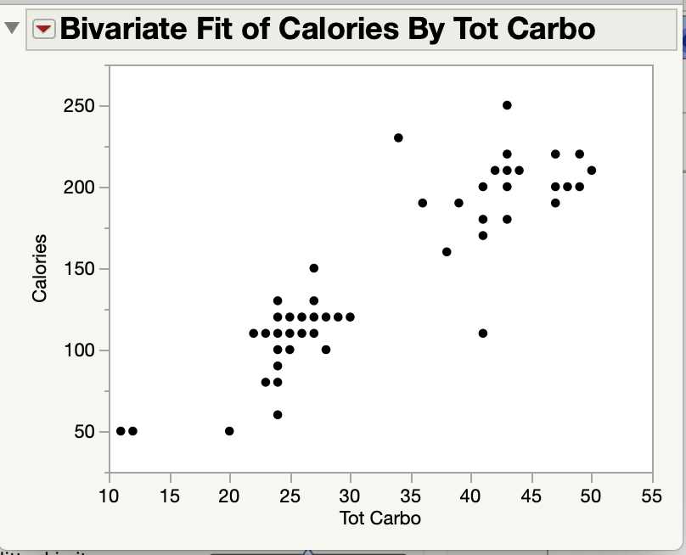
- JMP creates a scatterplot

- Click the red triangle next to “Bivariate Fit …. “
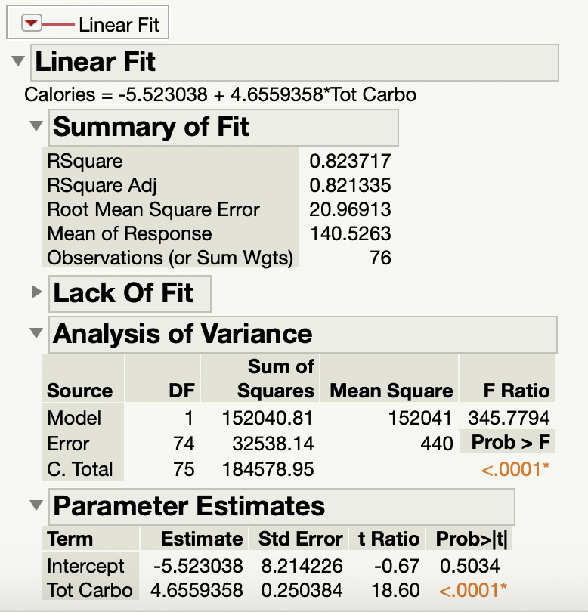
- Choose Fit Line. JMP will perform Linear Regression, add the best fit line to the scatterplot and provide output.

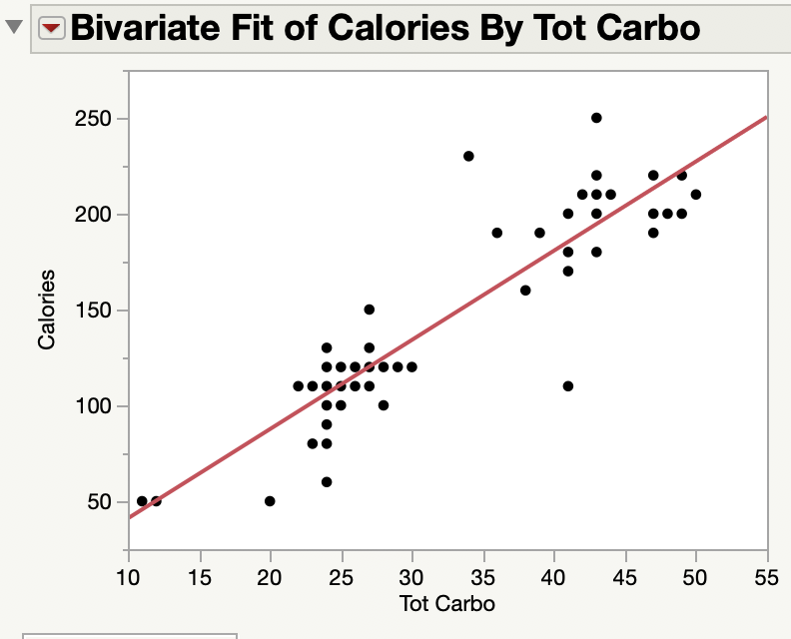
Confidence Intervals and Hypothesis Testing
For JMP
Using Big Class data for Examples

CONFIDENCE INTERVALS - Mean

JMP

There are two ways to compute confidence intervals for a mean.
If you have sample data in a column in JMP:
Example: The JMP sample data file “Big Class.jmp” contains data from randomly selected martial arts students between the ages of 12 and 17. Construct and interpret a 90% confidence interval for the average height of martial arts students between the ages of 12 and 17.

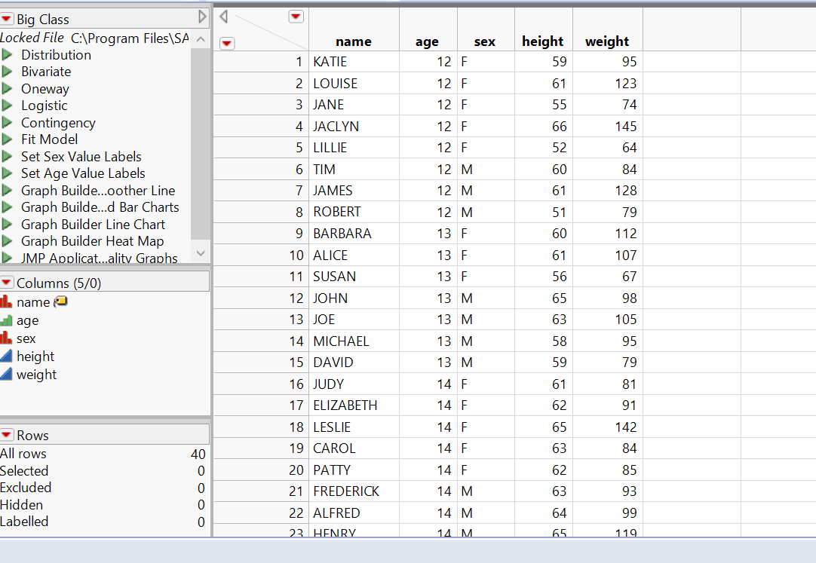
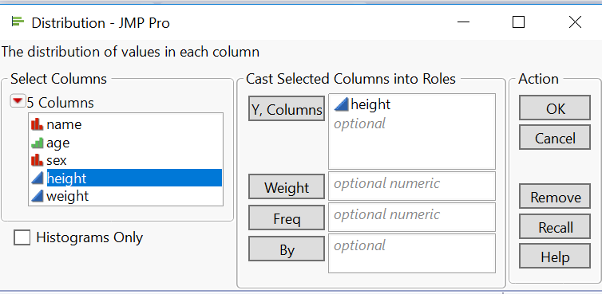
- Select Analyze -> Distribution and put the desired variable into Columns, in this case the “height” variable and click OK.

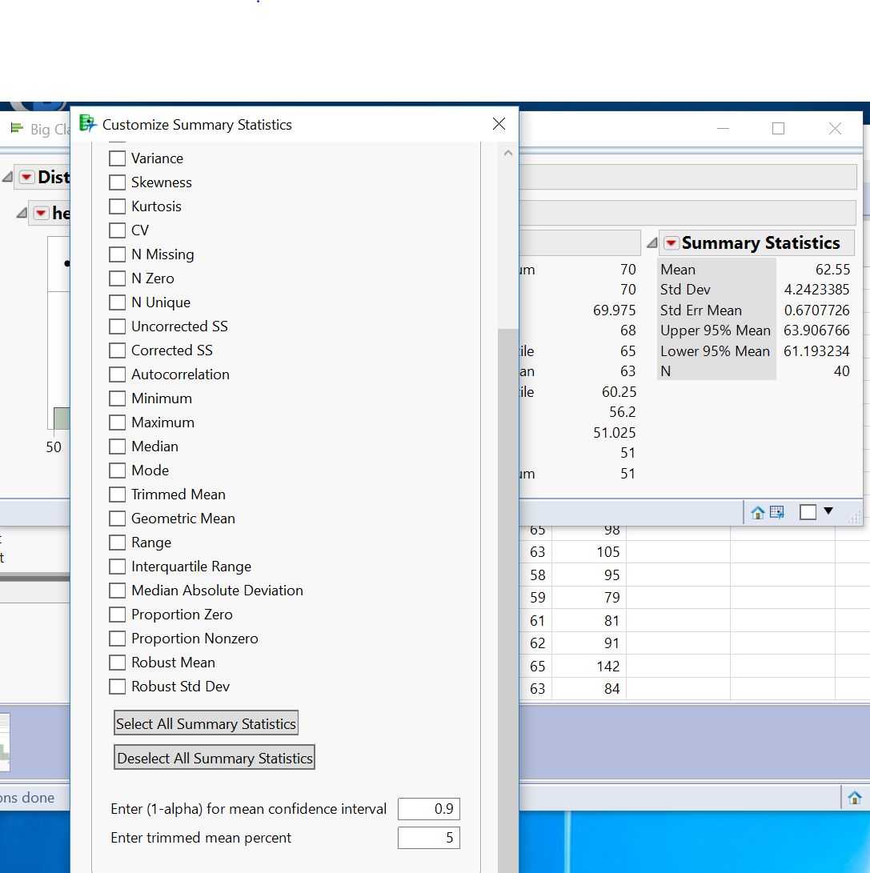
- JMP automatically gives you a 95% confidence interval in the Summary Statistics information. To change the confidence level to 90%, click the red triangle next to Summary Statistics, and choose Customize Summary Statistics and change the confidence level in the input box “Enter (1-alpha) for mean confidence interval.” to 0.90. Click OK.

The Summary Statistics will now contain the upper and lower bounds for a 90% confidence interval for the mean.
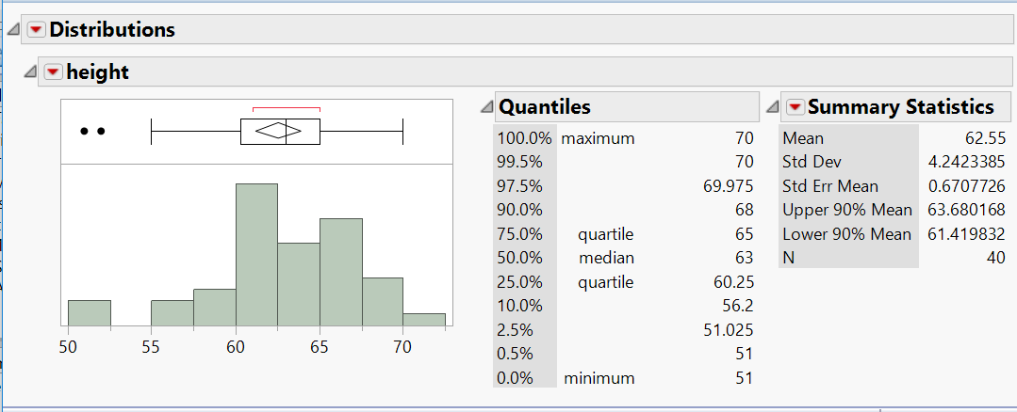
We are 90% confident that the average height of all martial arts students between ages 12 and 17 is between 61.42 and 63.68 inches.

If you have summary statistics:
Using the summary statistics from sample of heights of martial arts students between the ages of 12 and 17:
- Help-> Sample Data->Calculators -> Confidence Interval for One Mean.
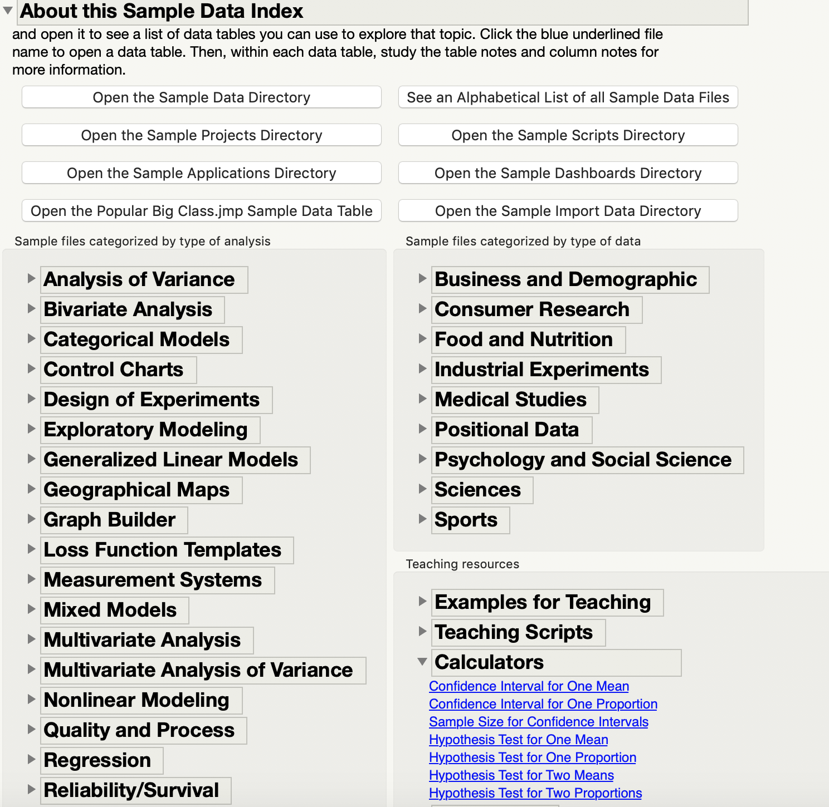

- Choose the interval for your type of data and select Summary Statistics as the input method
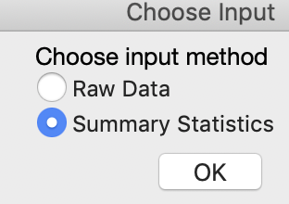

- For a confidence interval for a mean select t-interval and enter the sample average, standard deviation and sample size and confidence level.
JMP calculates the critical value which it calls “t multiplier”, the standard error of the mean, and the lower and upper bounds of the desired confidence interval.
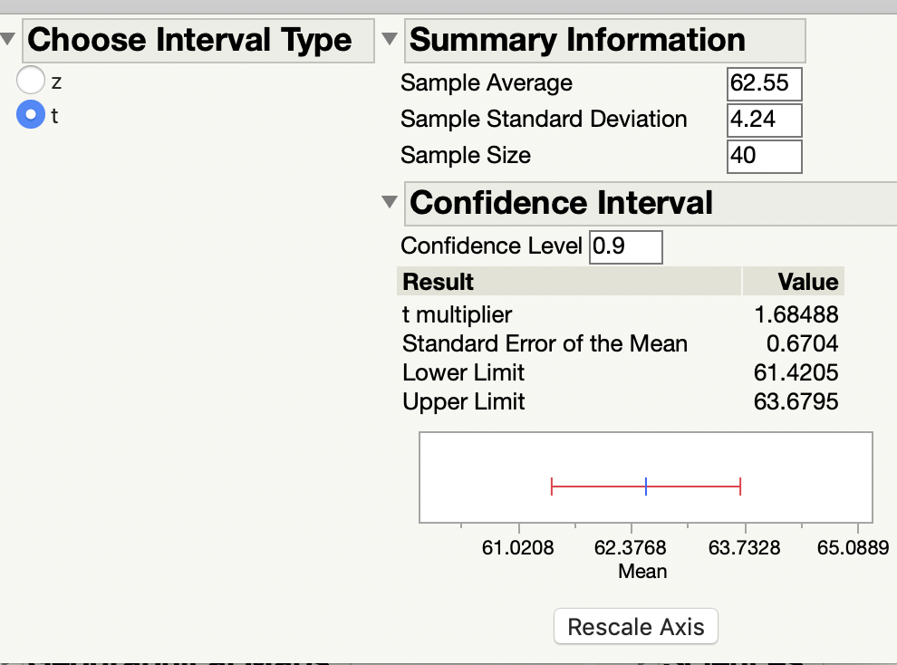

We are 90% confident that the average height of all martial arts students between ages 12 and 17 is between 61.42 and 63.68 inches.

Note: When using summary statistics, the values of the lower and upper limits may be slightly different due to rounding.

CONFIDENCE INTERVALS - Proportion

JMP

These instructions produce normal approximation confidence intervals which are taught in STAT 3090. Other confidence intervals for proportions produced by JMP use an alternative method and should not be used in this course. You will need the sample size, the number of successes, and the confidence level. If your data is not already summarized, you should first select Analyze -> Distribution and enter the column containing your data into “Y,Columns” in order to obtain the sample size and number of successes.
Example: A university dean is interested in determining the proportion of students who receive some sort of financial aid. Rather than examine the records for all students, the dean randomly selects 200 students and finds that 118 of them are receiving financial aid. Use a 95% confidence interval to estimate the true proportion of students on financial aid.
- Help-> Sample Data->Calculators -> Confidence Interval for One Proportion and select Summary Statistics as your input method similar to the instructions for a confidence interval for a mean with summary statistics.

- For a confidence interval for a proportion select Normal Approximation and enter the number of successes, the sample size and the confidence level.
JMP calculates the sample proportion which it calls “Estimated Proportion”, the Standard Error of the proportion and the lower and upper bounds of the desired confidence interval.
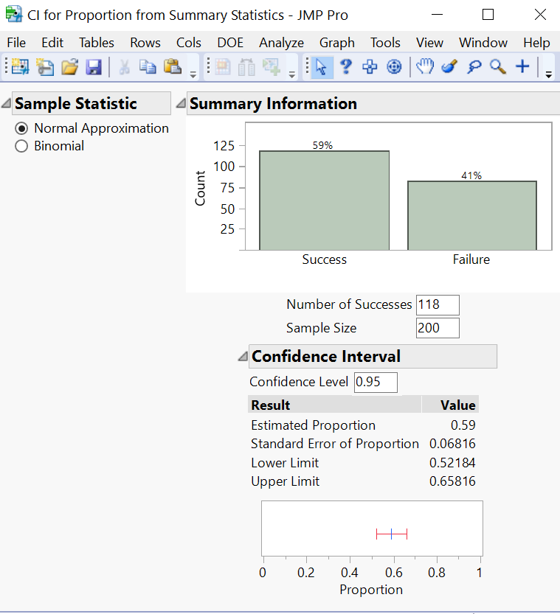
We are 95% confident that the true proportion of students at this university who use some sort of financial aid is between 52.18% and 65.82%.

Hypothesis Testing - Mean

JMP

If you have sample data in a column in JMP:
Example: The JMP sample data file “Big Class.jmp” contains data from randomly selected martial arts students between the ages of 12 and 17. In the past, the average height of martial arts students in this age group was 60 inches. Perform a hypothesis test for a mean to determine if the average height of martial arts students has changed? Assume all the conditions for a hypothesis test of a mean have been met. Use a significance level of 1%.
$$H_{0}: μ=60 inches$$
$$H_{a}: μ≠60 inches$$

- Select Analyze -> Distribution and enter the column height into “Y,Columns”.
- Click the red triangle next to the variable name (in this case height) and choose “Test Mean”
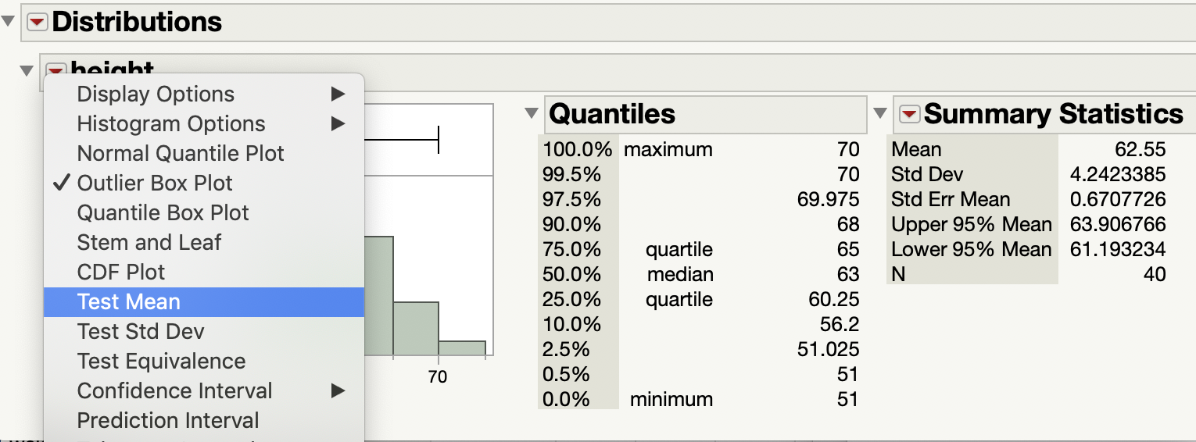

- Enter the Hypothesized Mean from the statement of the hypotheses which is 60 in this case. DO NOT enter the sample mean. To perform a t-test DO NOT enter the sample standard deviation. Click OK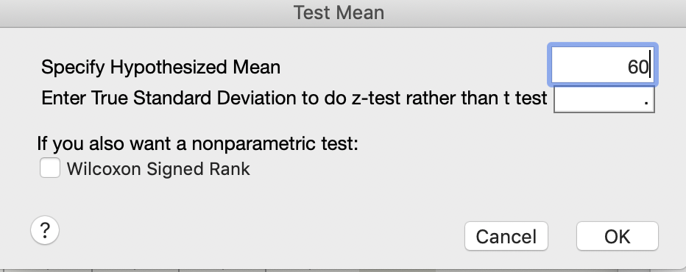

- JMP provides the test statistic and the p-values for a two tail, a right tail and a left tail test. You must select the correct information for your hypothesis test from the output. This example is asking for a two tail test so you need to use the information given for Prob >|t| which is 0.0005.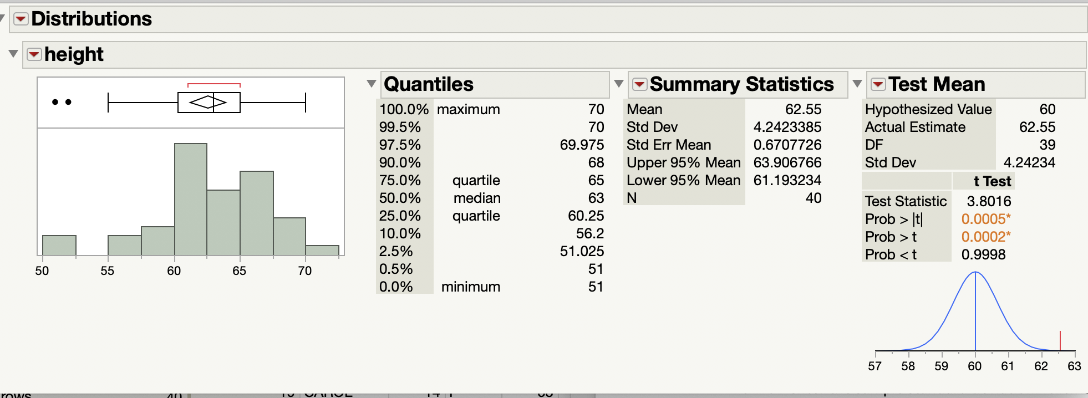
Since the p-value of 0.0005 is less than α=0.01, we reject the null hypothesis. There is sufficient evidence to suggest that the average height of all martial arts students in the age range of 12-17 years is different than 60 inches.
OR
Since the test statistic of 3.8016 does not lie in the rejection region, we reject the null hypothesis. There is sufficient evidence to suggest that the average height of all martial arts students in the age range of 12-17 years is different than 60 inches.

If you have summary statistics.
Example: In the past, the average height of martial arts students in this age group was 60 inches. A random sample of 40 martial arts students has a mean height of 62.55 inches with a standard deviation of 4.24 inches. At the 1% significance level, is there evidence to suggest that the average height of martial arts students has changed? Assume all the conditions for a hypothesis test of a mean have been met.
$$H_{0}: μ=60 inches$$
$$H_{a}: μ≠60 inches$$

- Select Help -> Sample Data -> Calculators -> Hypothesis Test for One Mean similar to the instructions for confidence intervals with summary statistics.

- Choose Summary Statistics as the input method and click OK.

- Select t-test. Select the correct alternative Hypothesis. In this example we are doing a two-tailed test. Input the Hypothesized Mean from your statement of the hypotheses, the Sample Average, the Sample Standard Deviation, the Sample Size and the Significance Level (alpha). Check the Reveal Decision box if you would like JMP to give you the answer.
JMP reports the Standard Error of the Mean, the test statistic (t-score), the t Critical Value and the p-value (Observed Significance).
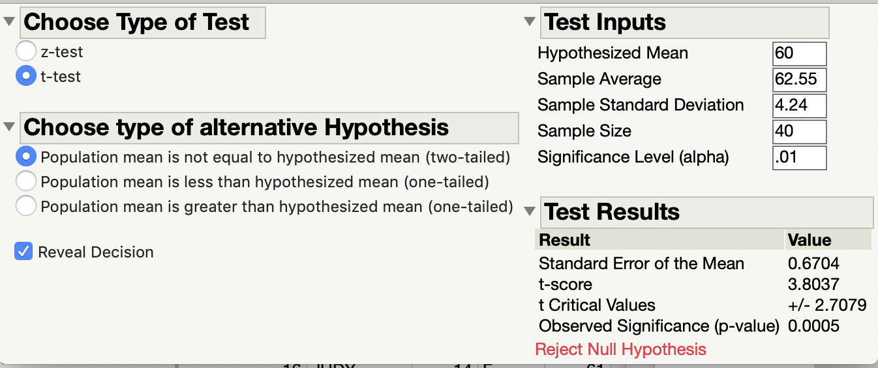

Since the p-value of 0.0005 is less than α=0.01, we reject the null hypothesis. There is sufficient evidence to suggest that the average height of all martial arts students in the age range of 12-17 years is different than 60 inches.
OR
Since the test statistic (t-score) of 3.8037 does not lie in the rejection region, we reject the null hypothesis. There is sufficient evidence to suggest that the average height of all martial arts students in the age range of 12-17 years is different than 60 inches. Notice that you are given the t-Critical values of -2.7079 and 2.7079 in the table labeled Test Results.
Note: Since we have used summary statistics, the test statistic is slightly different due to rounding of the summary statistics.

Hypothesis Testing - Proportion

JMP

These instructions produce the test statistic for a hypothesis test of a proportion which are taught in STAT 3090. You will need the sample size, the number of successes, and the significance level. If your data is not already summarized, you should first select Analyze -> Distribution and enter the column containing your data into “Y,Columns” in order to obtain the sample size and number of successes.
Example: The JMP sample data file “Big Class.jmp” contains data from randomly selected martial arts students between the ages of 12 and 17. Perform a hypothesis test to determine if the majority of students in this age group are males. Rather than examine the records for all students, we randomly select 40 martial arts students and finds that 22 of them are male. Assume the conditions for a hypothesis test of a proportion have been met. Use a significance level of 0.05.
Let p=the true proportion of martial arts students in the age group 12 – 17 years who are male.
$$H_{o}:p=0.5$$
$$H_{a}:p>0.5$$

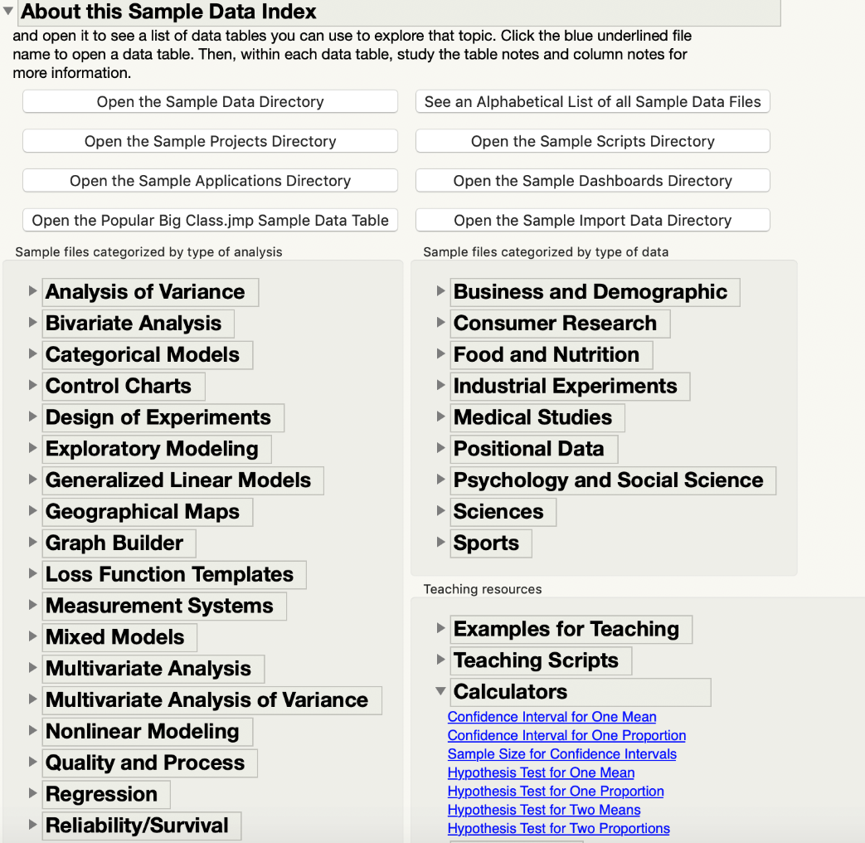
- Select Help -> Sample Data -> Calculators -> Hypothesis Test for One Proportion

- Choose Summary Statistics as the input method and click OK.

- Select the correct Alternative Hypothesis. In this case we are doing a one-tailed greater than test. If you would like JMP to provide the decision check the Reveal Decision box. Enter the Hypothesized Proportion from the statement of the hypotheses, the Number of Successes, the Sample Size and the Significance Level (alpha).
JMP provides the sample proportion (Estimated Proportion), the Standard Error of Proportion, the z Critical Value(s), the Test Statistic and the p-value (Observed Significance)
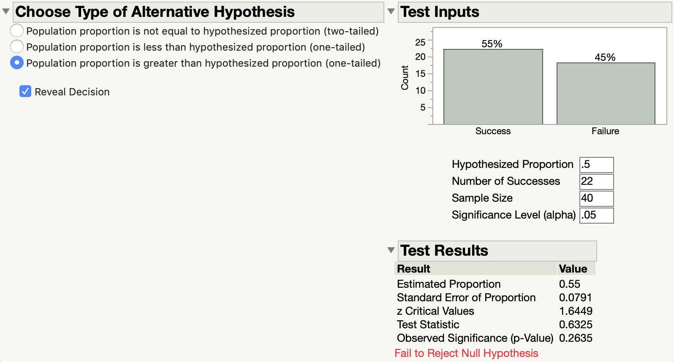

Since the p-value of 0.2635 is greater than α=0.5, we fail to reject the null hypothesis. There is insufficient evidence to suggest that the true proportion of male martial arts students between the ages of 12 and 17 is greater than 50%.
OR
Since the test statistic of 0.6325 does not lie in the rejection region, we fail to reject the null hypothesis. There is insufficient evidence to suggest that the true proportion of male martial arts students between the ages of 12 and 17 is greater than 50%. Notice that JMP gives you the z Critical Value of 1.6449 in the table Test Results.

Other Information
About JMP

CHANGING THE TYPE OF THE DATA

JMP

When you create new column, the first item you type in will determine what type of data JMP thinks the column is.
- If you start typing in a number, it will assume everything in that column is Numeric and the default is Continuous. This is represented by the blue triangle by the column’s name.
- Another data type with numbers is Nominal which is represented by red bars.
- Another data type associated with numbers is an Ordinal data type. This is represented by the green, increasing bars.
- If you start typing in a letter/word, it will assume everything is a Character (in other words a string of letters). This is represented by the red bars as well.
If you want to change the type of data in a column to something else or see what type of data is in a column, right-click on the column’s name and select Column Info. Doing this allows you to change the data and modeling type to fit with whatever you desire.
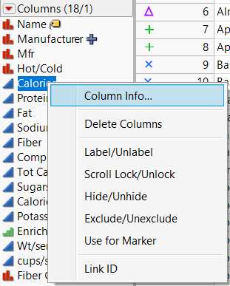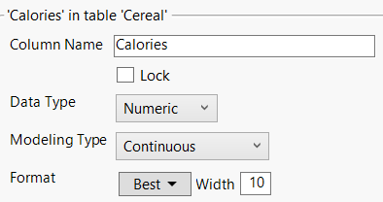

PRINTING

JMP

Printing is tricky. Whenever you create a graph or histogram, JMP is designed to give as much space as possible for the user to manipulate the information on screen. Because of this, JMP hides the usual toolbar that contains “File”, “Edit”, etc. directly underneath the title bar.
- To access the toolbar and the ability to print, move your mouse underneath the title bar. You should see that area be outlined in blue. If you leave your mouse there or click, it will reveal the typical toolbar. From here, you can save or print your graph/histogram/statistical information.

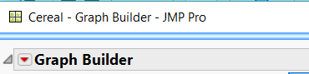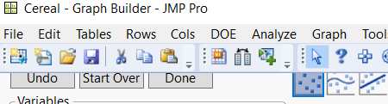

- If you want to copy a graph, right-click on the graph itself. Go down to “Edit” and select “Copy Graph”.
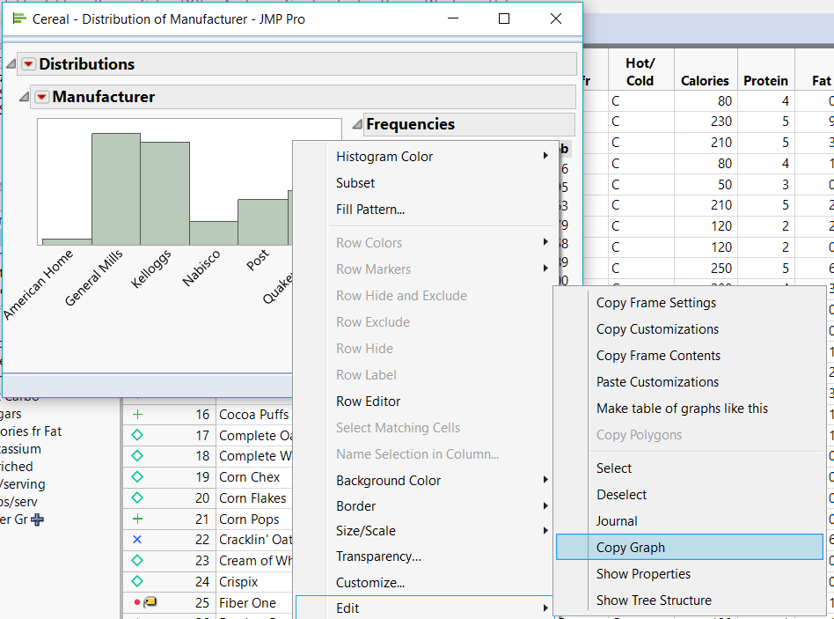
Doing so will copy only the graph with any labels on the x or y-axis.

