Name: Owen Sullivan

Objectives: Upon successful completion of this activity, you will be able to…
- Describe a distribution of values
- Find the 5-number summary of a data set and draw a box plot by hand
- Use JMP to draw multiple box plots on the same axis
- Compare two distributions

Delectable Delights is a large consumer food manufacturer selling its products in retail stores nationwide. You have landed your first job after graduation from Clemson in their advertising division. Since you took statistics as a part of your coursework, you are often called upon to perform data analysis for the advertising division, as well as other divisions of the company.

Directions: Answer the following questions using complete sentences as though you were presenting your analysis to the employees of Delectable Delights. Please provide any appropriate output and/or screenshots from JMP. Instructions for creating several types of graphs or tables and statistics can be found on Canvas in the file JMP Instructions.docx. Paste your answers and any output into this document.

Many manufacturing processes produce data that is approximately normally distributed (mound or bell shaped, symmetric and unimodal). The machine that fills the Cheerios boxes is set to have a mean box weight of 21 oz and a standard deviation of 0.4 oz. The JMP file Cheerio Box Weights contains the weights of 100 randomly selected boxes each of cereal that Delectable Delights prepared for 2 shipments.

- Observe the column of Shipment 1. Note that the data in Shipment 1 are already ordered increasingly. Find the 5-number summary of this Shipment 1 data set by hand. Include all decimal places. (10 pts)

Min: 20.02 oz
Q1: 20.66 oz
Median: 20.88 oz
Q3: 21.155 oz
Max: 21.88 oz

- Calculate IQR, lower fence, and upper fence by hand using the 5-number summary in Question 1. Determine whether there are any outliers. (10 pts)

IQR: (21.155 – 20.66) = 0.495 oz
Lower fence: 20.66 – 1.5(0.495) = 19.9175 oz
Upper fence: 21.155 + 1.5(0.495) = 21.8975 oz
There are no outliers.

- Draw a box plot by hand for this data set using what you obtained from Question 1 and Question 2. (10 pts)
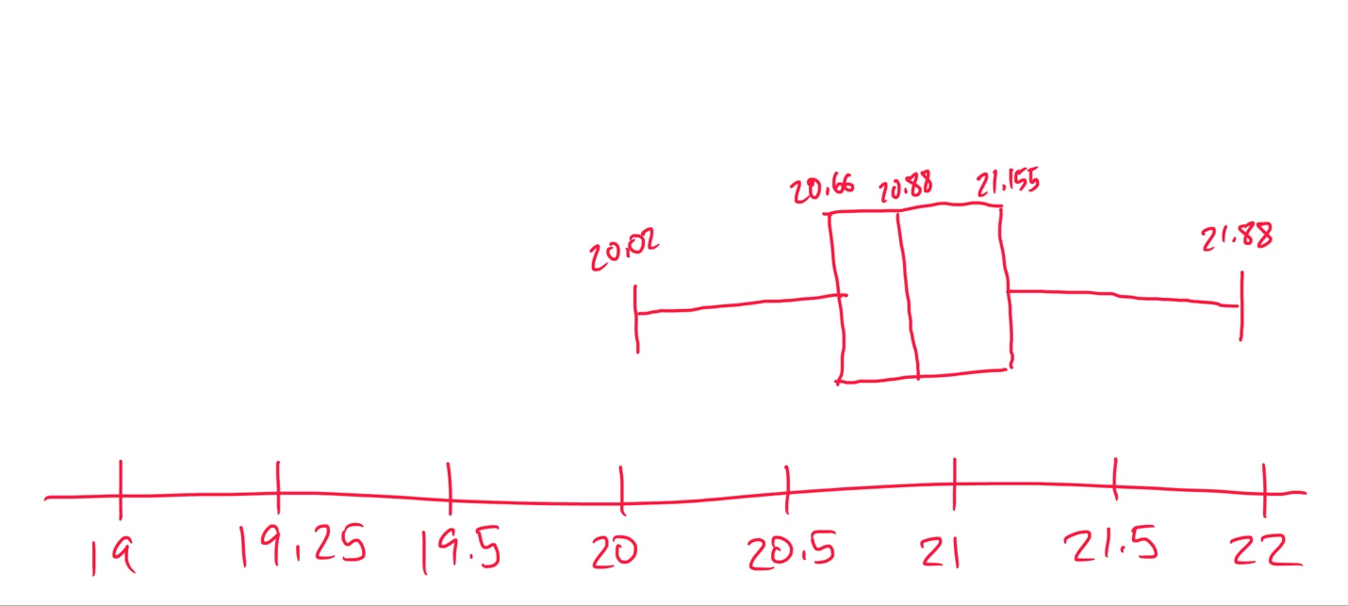
- Interpret the IQR you obtained from Question 2 based on the context. (5 pts)

The range of the middle 50% of the weights is 0.495 oz. In other words, 50% of the 100 boxes in the sample weigh within 0.495 oz of each other.

- Now let’s use JMP to analyze the data. Use JMP to draw a histogram along with quantiles table and summary statistics for the sample from shipment 1.

Step 1, create a histogram: Go to Analyze >> Distribution. Put the column for Weight (oz) Shipment 1 into Y, Columns and select OK. Change the orientation of the output to a horizontal format. To do this, select the triangle to the left of the word Distributions in your output and choose Stack.

Step 2, modify axis/labels:
For y-axis, click the red triangle to the left of the column heading (in this case it is Weight (oz) Shipment 1). Select Histogram Options >> Count Axis or Prob Axis. This will place either the frequency or relative frequency axis on the histogram depends on what you want to plot. Once more click the red triangle and select Display Options >> Axes on Left to change the location of y-axis. Change the label of the y-axis to Frequency instead of Count, or Relative Frequency instead of Probability by single clicking on the default label.
For x-axis, right click on the values on x-axis and select Add Axis Label, then enter the name “Weight (oz) Shipment 1”.

(Optional) Step 3, aesthetics: If you would like to change the color of the bars, right click in the white space around the bars and select Histogram Color. Note, we cannot separate bars in histogram for quantitative data as what we did in bar chart for qualitative data, since x-axis is a continuous axis now.

Step 4, copy/paste your result: Copy and paste all histogram, quantiles, and summary statistics here. You can use screenshot. (10 pts)

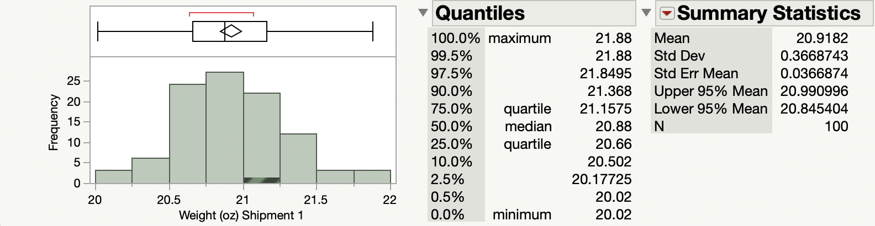

- Observe the 5-number summary given by JMP. You can find it in the quantiles table. Which one given by JMP is different from our calculation? What’s its value given by JMP?

JMP call them quantiles rather than percentiles, and it has a slightly different way of calculating them than we used in class and may give different answers. Keep it in mind: on a test question, if you are asked to calculate the percentiles, you need to strictly follow the way in our lecture guide (eg., Question 1) to calculate them by hand; if you are given JMP output, then you can use the output to answer the questions. (5 pts)

The 3rd quartile is different from my calculation; JMP reports a Q3 of 21.1575 oz instead of my calculation of 21.155 oz.

- Describe the distribution of the weights from the sample of 100 boxes of cereal. Remember to discuss the shape, center, and spread, and unusual values (if there are any). Be careful with the usage of resistant or non-resistant measures based on the shape of distribution. Include units where appropriate. (10 pts)
Shape: The distribution of weights from the sample of 100 boxes of cereal appears symmetric, close to normal (bell-shaped), and unimodal.
Center: The mean weight from the sample of 100 boxes of cereal is 20.9182 oz.
Spread: The weights of the 100 boxes are very similar, with a range of 1.86 oz, a variance of 0.13459675 oz, and a standard deviation of 0.3668743 oz.
Unusual values: There are no outliers in the weights of the 100 boxes of cereal.
- Suppose we believe the distribution is approximately symmetric. Use the empirical rule to fill in the following blanks: (10 pts)

- 68% of these 100 boxes in Shipment 1 will have weights between 20.551 to 21.285.

- 95% of these 100 boxes in Shipment 1 will have weights between 20.184 to 21.652.

- 81.5% of these 100 boxes in Shipment 1 will have weights between 20.551 to 21.652.

- Do you believe that the machine that filled the boxes in this sample from shipment 1 was working correctly? Why? (Hint: compare the statistics you got with the parameters in the first page. (5 pts)
I believe the machine that filled the boxes is working correctly because the sample mean of 20.9182 oz is very close to the expected mean of 21 oz, the standard deviation of the sampled boxes of 0.3668743 is close enough to the expected mean of 0.4 oz, and all the 100 sampled boxes weigh within three standard deviations of the expected mean.
- Harold is an employee who works in the shipping department. As he was preparing shipment 2, he felt that the boxes of cereal seemed lighter than usual. You are asked to compare a random sample of 100 boxes of cereal from shipment 2 to the sample from shipment 1.
Step 1: Go to Graph >> Graph Builder. Choose Box Plot at top of graph builder.
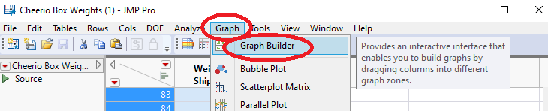

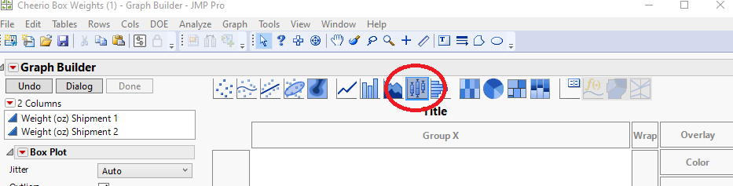

Step 2: Highlight both samples, then drag them to the x-axis. (How to highlight both samples: select one sample, then hold the shift key to select the second.)

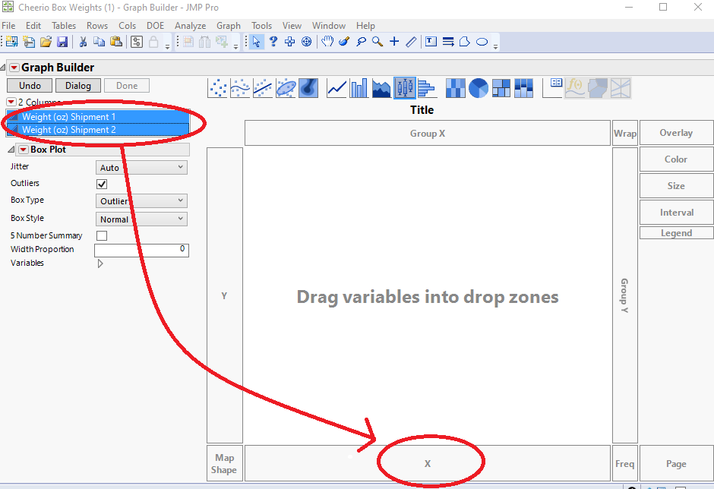

Step 3: On the left select the box for the 5 number summary.
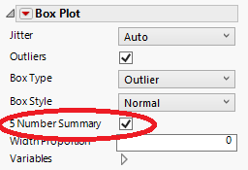

Step 4: Right click on the white space on graph and select Edit >> Copy Graph, then paste it here. (10 pts)

- Write a few sentences to compare the shape, centers, spread for the two box plots using the output provided by JMP. Do you think that the machine that filled the boxes for the second shipment may be malfunctioning? (10 pts)

Shape: The distribution for the first shipment appears symmetric, but the distribution for the second shipment appears skewed right.

Centers: The boxes in the first shipment generally weigh more with a median of 20.88 oz, compared to the boxes in the second shipment with a median of 20.19 oz.

Spread: The weights of the boxes in the first shipment are more consistent with an IQR of 0.495 oz, compared to the weights of the boxes in the second shipment with an IQR of ~0.52 oz.

I believe the machine that filled the boxes for the second shipment may be malfunctioning because the weights of the boxes are inconsistent with the boxes in the first shipment (which is close to the expected values from the filling machine).

- Consider the data in Shipment 2. Is it appropriate to apply the empirical rule or Chebyshev’s theorem to estimate the proportion of data within a certain range in Shipment 2? Choose one method and explain the reason. (5 pts)

It is appropriate to apply Chebyshev’s theorem because the distribution of the weights of the boxes in the second shipment is skewed right (not symmetric).

