Owen Sullivan
CPSC 3600 Assignment 3

1.
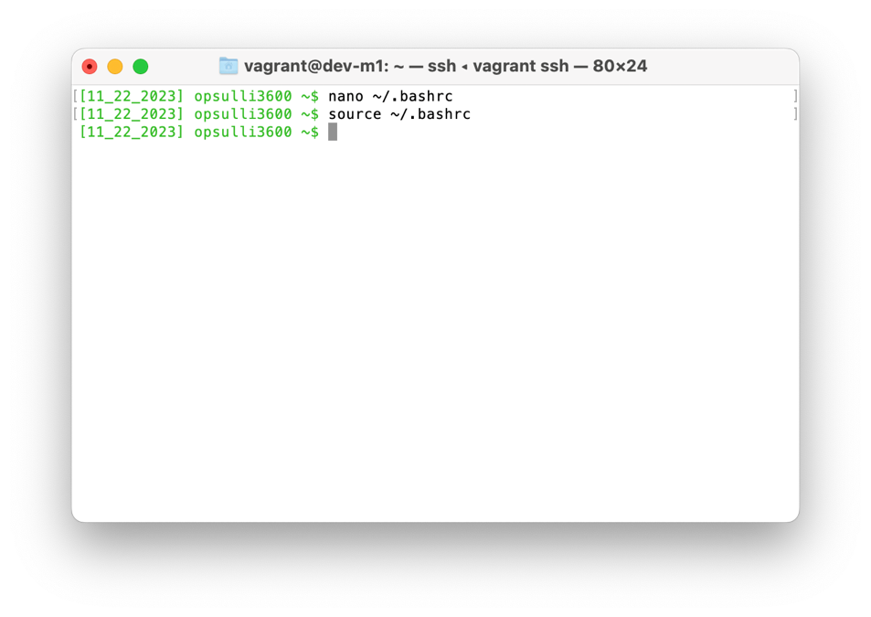
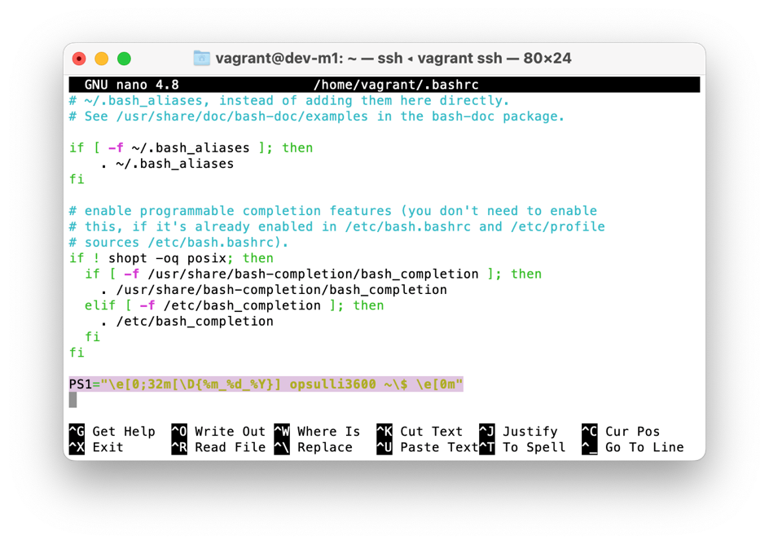
(I simply added the PS1 variable and overrode the text and color all in one line)

2. The tcpdump tool is a packet sniffing tool used to analyze and filter network packets being sent to the network adapters present on a machine or virtual environment, kind of like Wireshark.
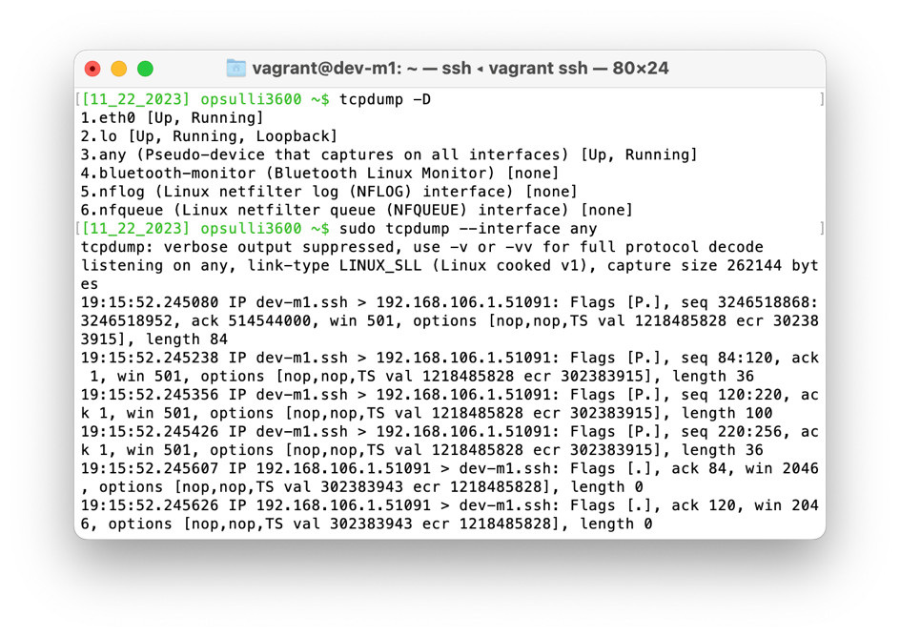
I first had to use the -D option to find out which interfaces I could inspect traffic on, then I used it on the “any” interface which catches all packets for all adapters
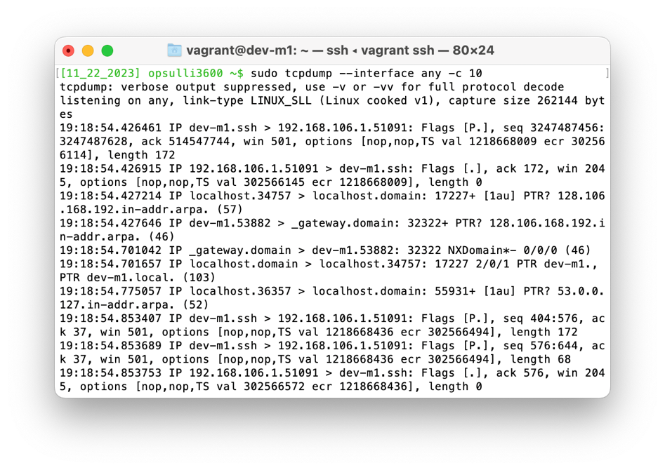
I then limited the number of packets to capture to 10 by using the -c option, since it otherwise goes until it receives the Ctrl-C interrupt signal
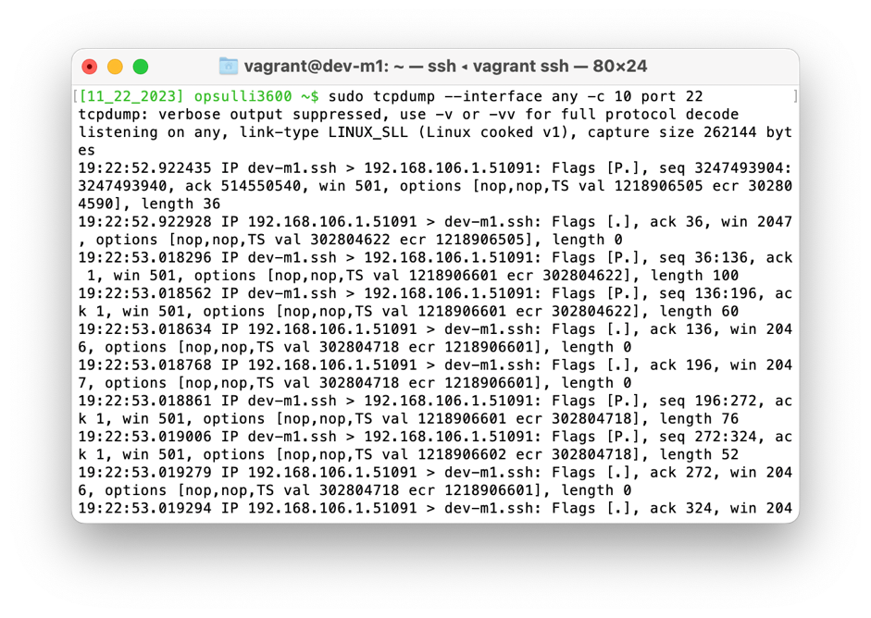
The last thing I did with tcpdump was limit captures to port 22 (which is SSH) because I am using a virtual machine that integrates with SSH. That means tcpdump will capture all of the packets being sent between my host OS and the guest OS to keep the SSH session alive

3. netcat is a port scanner/listener that allows you to interact directly with hosts on a network using TCP/UDP to send/receive packets. It can be used for a variety of functions, including opening chat sessions between network hosts and creating reverse shell sessions for attacks.
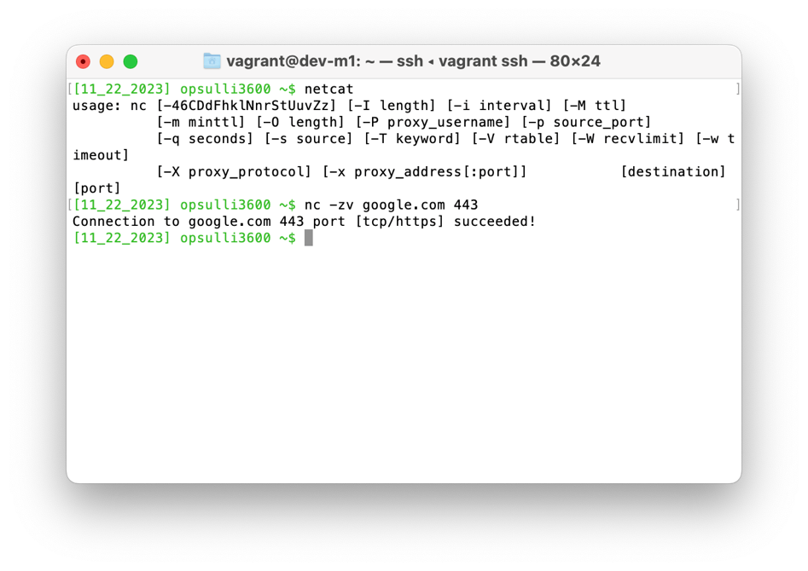
First, I used it to connect to google.com at port 443 (which is the port for HTTPS). All this does is make a connection, not do anything specific with it. The -z option makes sure that the connection does not persist.
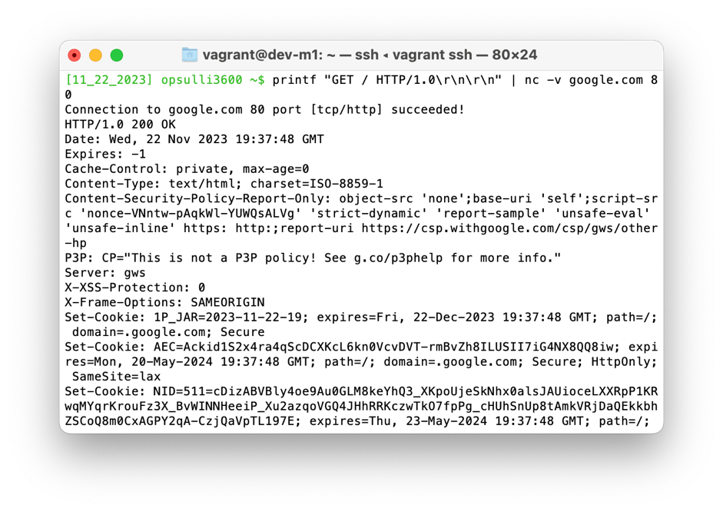
Next, I used it to echo a simple GET request to google.com at port 80 (HTTP), which returns the full HTML content of the webpage.
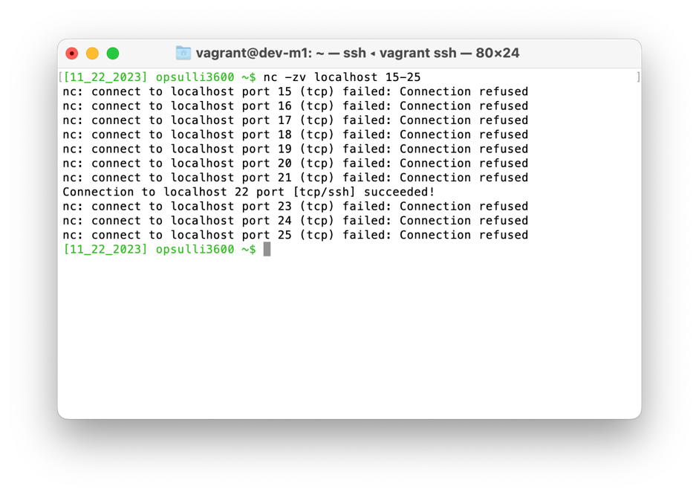
Finally, I used it to list all the open ports on my VM (localhost) in the range 15-25 (just to keep the output visible in the screenshot). This shows that port 22 (SSH) is the only open port between 15 and 25, which is expected in the case of my VM.

4. The nslookup tool allows you to get information about a domain based on its DNS records, such as the IP address it resolves to.
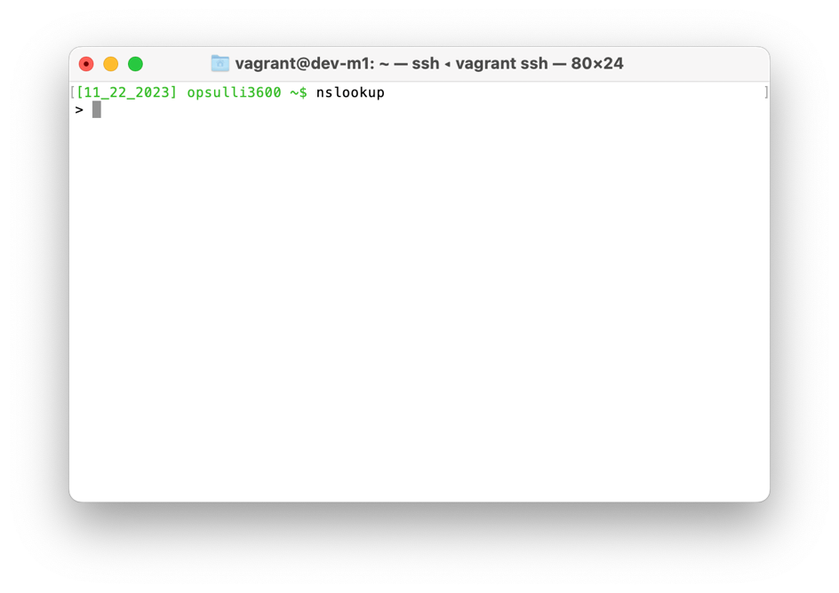
I first issued the simple “nslookup” command to enter the tool’s interactive mode, which is the default when no options are supplied. This allows you to issue multiple queries without leaving the scope of the nslookup tool
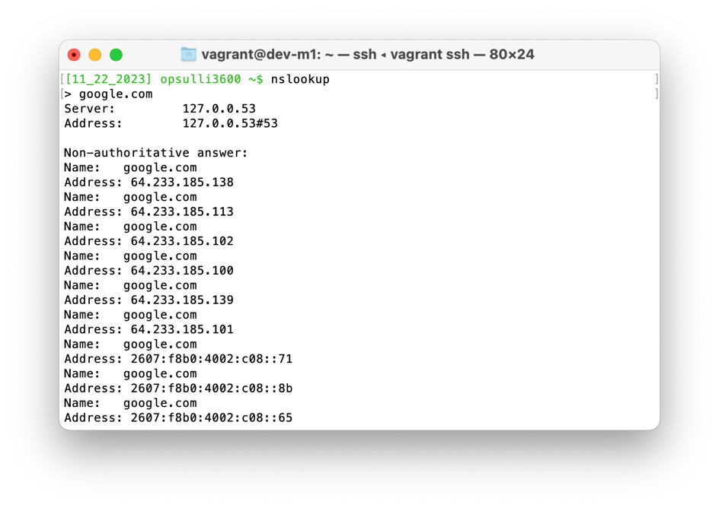
Next, I issued a simple query for google.com that returns the DNS records associated with the domain name. The results show that there are multiple A (IPv4) and AAAA (IPv6) DNS records for google.com, probably for load balancing purposes.
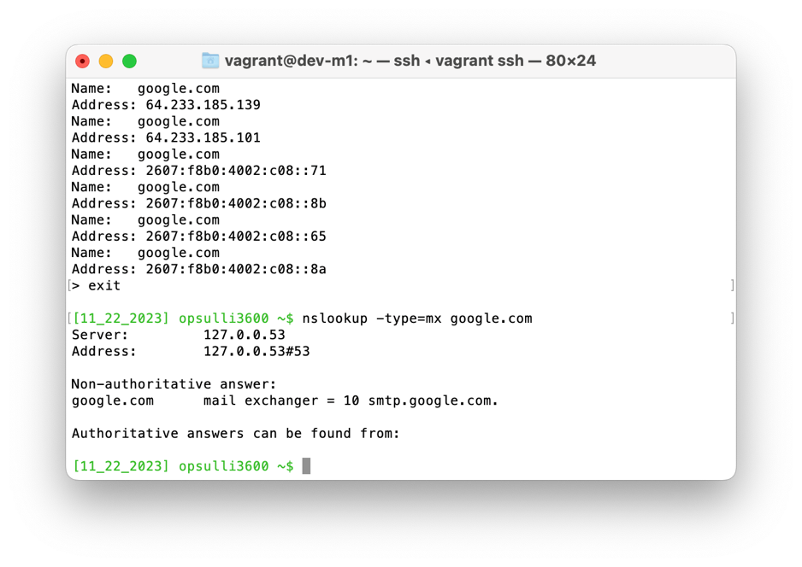
Finally, I exited interactive mode using “exit” and used the nslookup command with the -type option to find the MX (email delivery) records for google.com.

5. nmap is a tool similar to netcat that acts as a port scanner, and is widely used for penetration testing. It is advanced enough to be able to detect certain information about applications that are transmitting and receiving data over ports on a specific host on a network, including the application version.
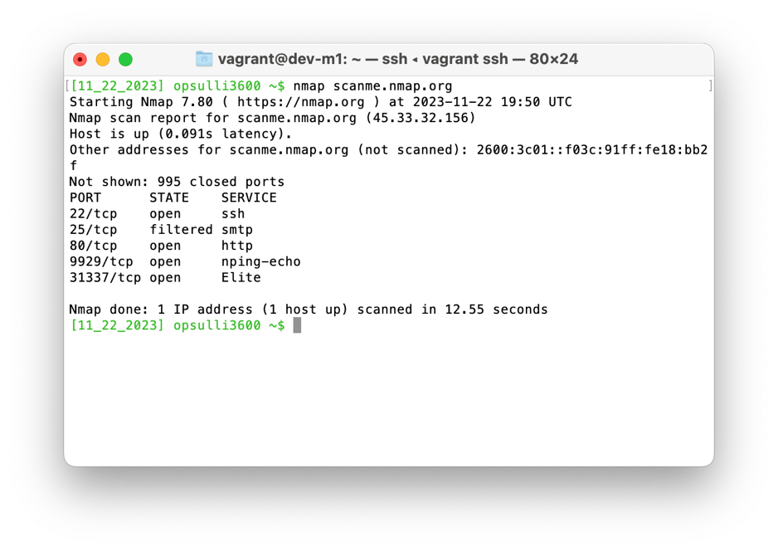
First, I used it to scan ports on scanme.nmap.org, which is a domain address provided by the developers of nmap to demonstrate how port scanning works. Using a domain with nmap without any options automatically defaults to scanning 1000 common application ports. The above results show that only 5 ports are open out of 1000 scanned.
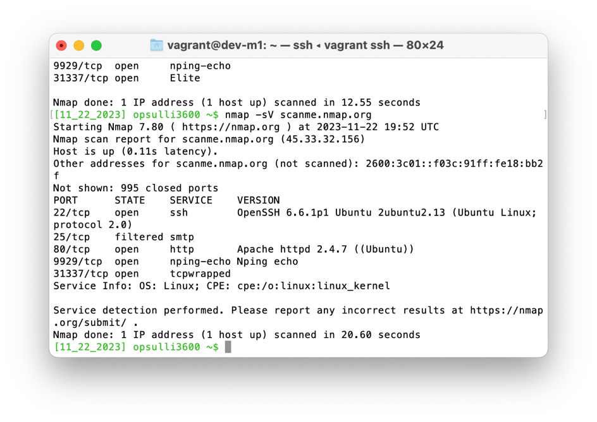
Then, I performed the same scan with the -sV options to perform an application version scan for open ports. Nmap was not able to find versions for every application, but it found the versions for SSH and Apache.
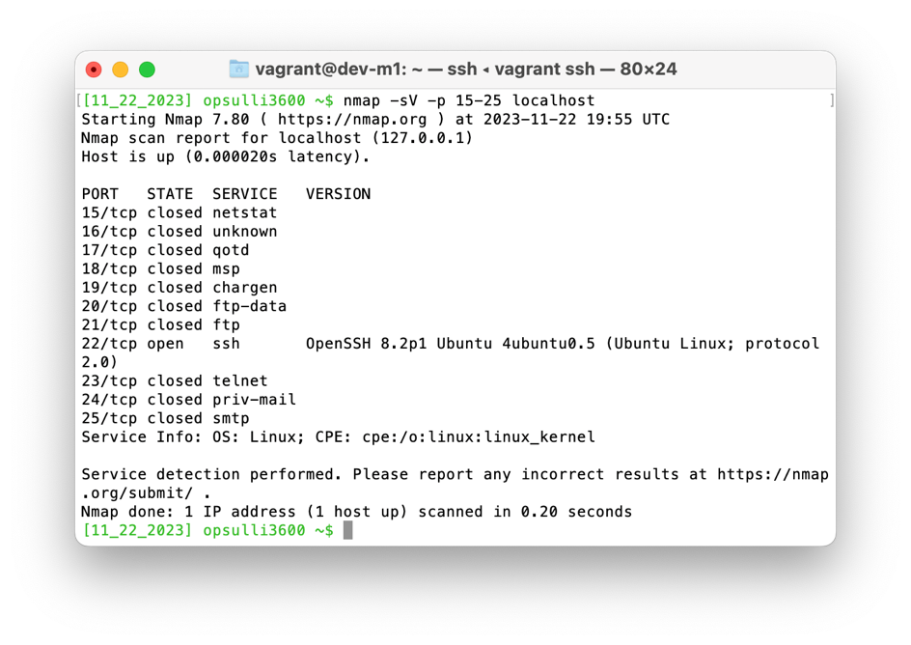
Finally, I performed the same port scan that I performed using netcat across ports 15-25 on my VM. This shows more information than netcat did, including which application is expected to use a given port. It also shows that my VM is running Linux (on the “Service Info: OS:” line).

6. Wireshark is a packet sniffer/protocol analyzer that includes extensive logging features for inspecting the fine details of packets sent across a network. It is also well-known for having a complete GUI, which most other tools do not. However, because my VM does not have a desktop environment, I used tshark (Wireshark’s own CLI tool).
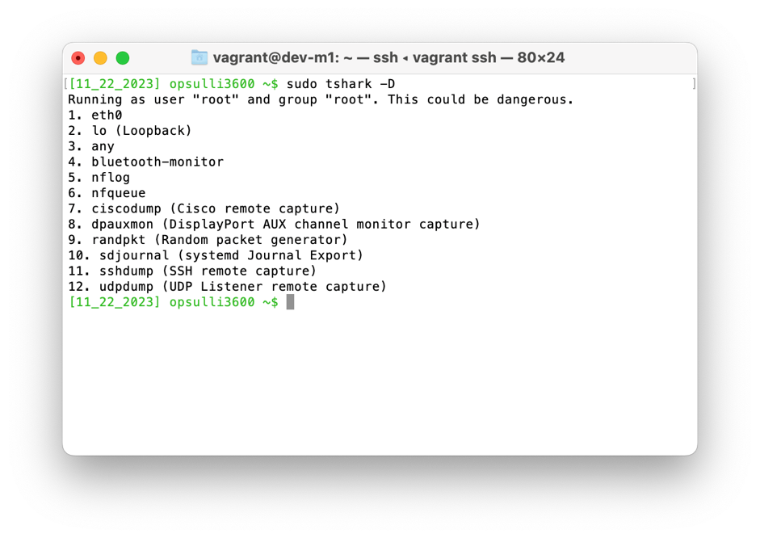
I first used the -D option to list the network adapters that Wireshark can listen on. It also includes the “any” option as a wildcard, like tcpdump, but it has other options that tcpdump does not have such as the “sshdump” option which allows for packet capture on a remote host.
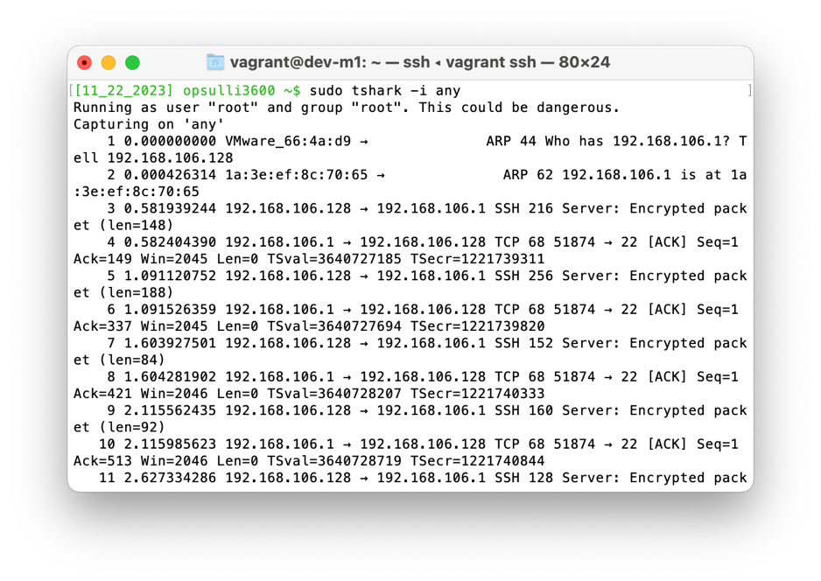
Like with tcpdump, I chose to capture packets on the “any” wildcard network adapter. The output shows a list of captured packets, again mostly SSH-related packets due to my connection to my VM’s shell.
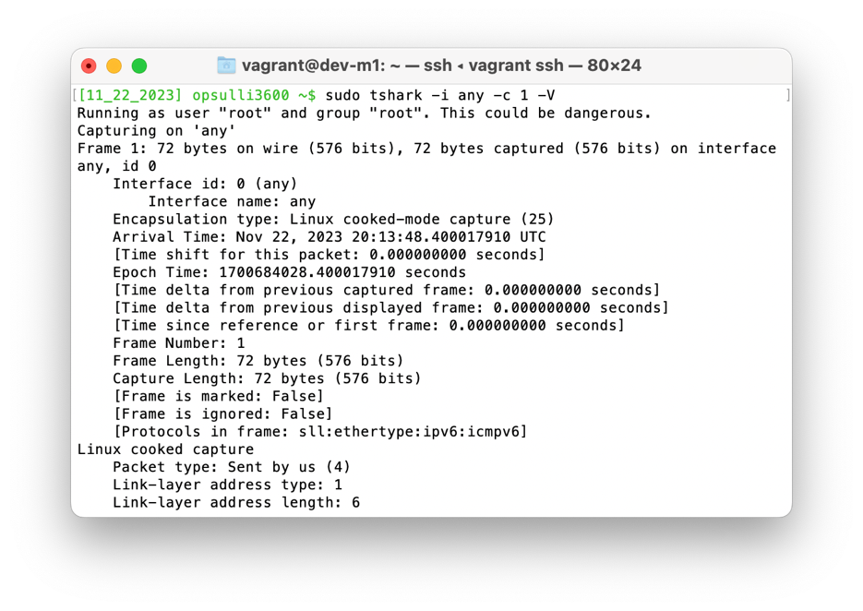
Finally, I used the -c option to limit the packet collection to a single packet, and the -V option to expand the details of the packet. This shows all sorts of data about the packet, including the frame number, the length of the frame, the protocol (IPv6 in my case), and most of the information I recognize from the IPv6 frame header.

