Levi Leard
Owen Sullivan
09/19/2023

Class Activity I

- Research how to use ping utility to ping IPv4 addresses. Using your virtual machine and ping utility, find two websites that are using IPv4 addressing scheme and ping them (domain names google.com, amazon.com and clemson.edu cannot be used in this activity). Include a screenshot for each one to illustrate that you have found these sites. (2 points). Screenshots show ping command run from Vagrant virtual machine, which is accessed through macOS Terminal.
ping apple.com results (IPv4: 17.253.144.10):
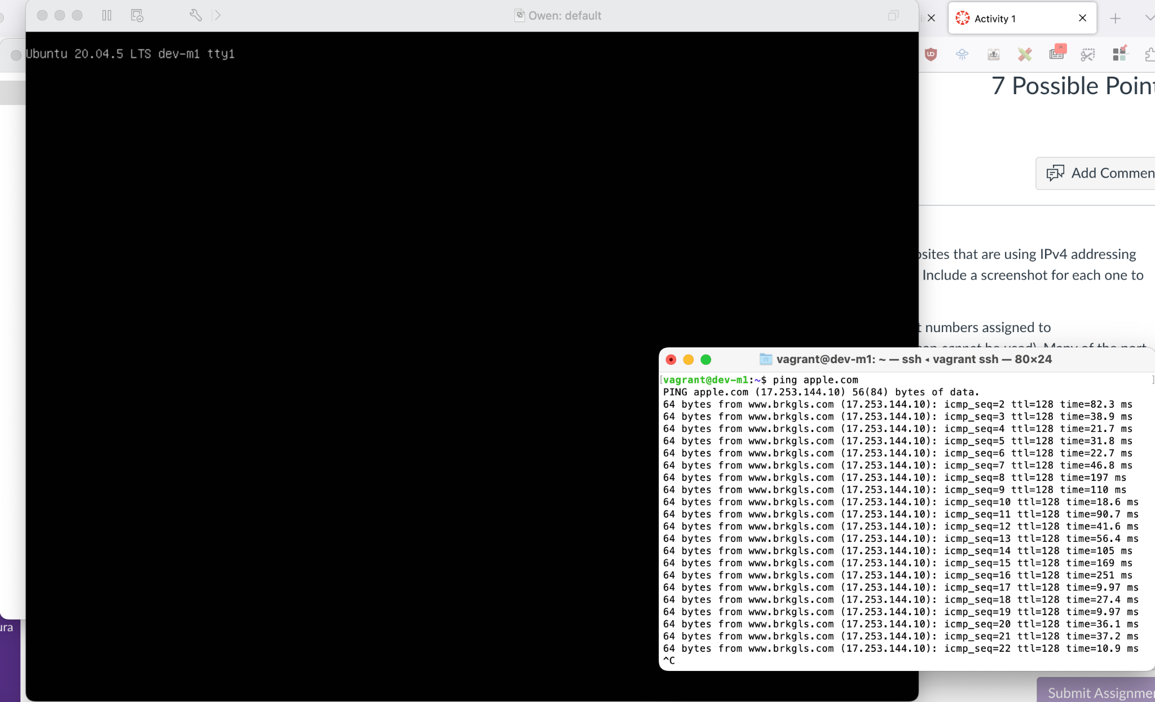
ping sulliops.co results (IPv4: 104.21.14.119):
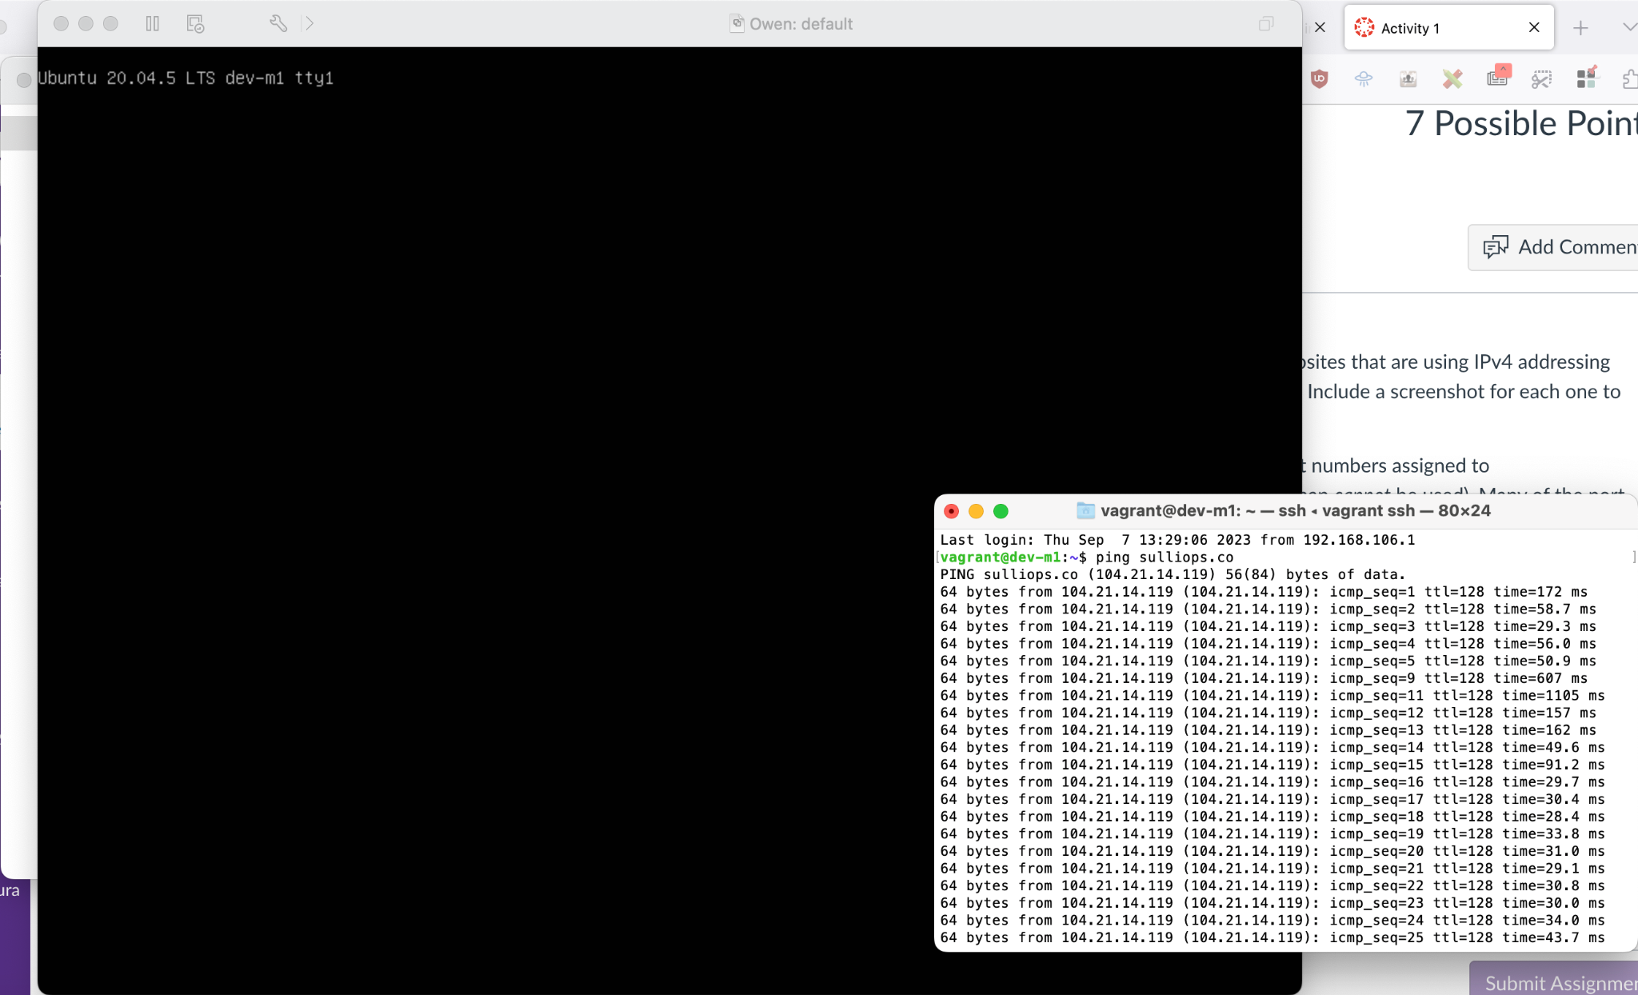
- Investigate iana.org website and find the listing of port numbers that are assigned to various services. List 2 port numbers assigned to services/applications that you are familiar with. List these services and their port numbers (http, smtp, pop3 and imap cannot be used). Many of the port numbers have human assignees. Find out who Jon Postel is and why he is assigned a number of ports. (2 points).
Per the IANA website’s port listing page, the following ports are assigned to common application protocols:
1. FTP - 21
2. SSH - 22
Jon Postel was the founder of the IANA, and had a number of the most common application protocol ports (including FTP, SSH, telnet, time, and etc.) assigned to him as he was the one to propose them.
- Investigate https://rfc-editor.org website. What is an RFC? Find RFC that describes UDP protocol. What information does it provide? Include a screenshot that shows the first page of the RFC as a proof that you have found it. (2 points).
An RFC is a “Request For Comments.” RFCs began as informal technical documents; however, they are technical and organizational documents that contain information about the internet and the specifications and policy documents. There are five streams: IETF, IRTF, IAB, Independent Submissions, and Editorial. An RFC that describes UDP protocol is below, and it describes how the UDP protocol allows applications to send messages to other applications in a transaction-oriented fashion where delivery and duplicate protection are not guaranteed.
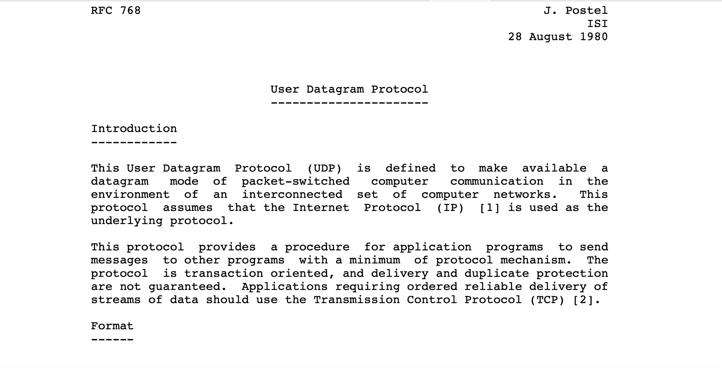
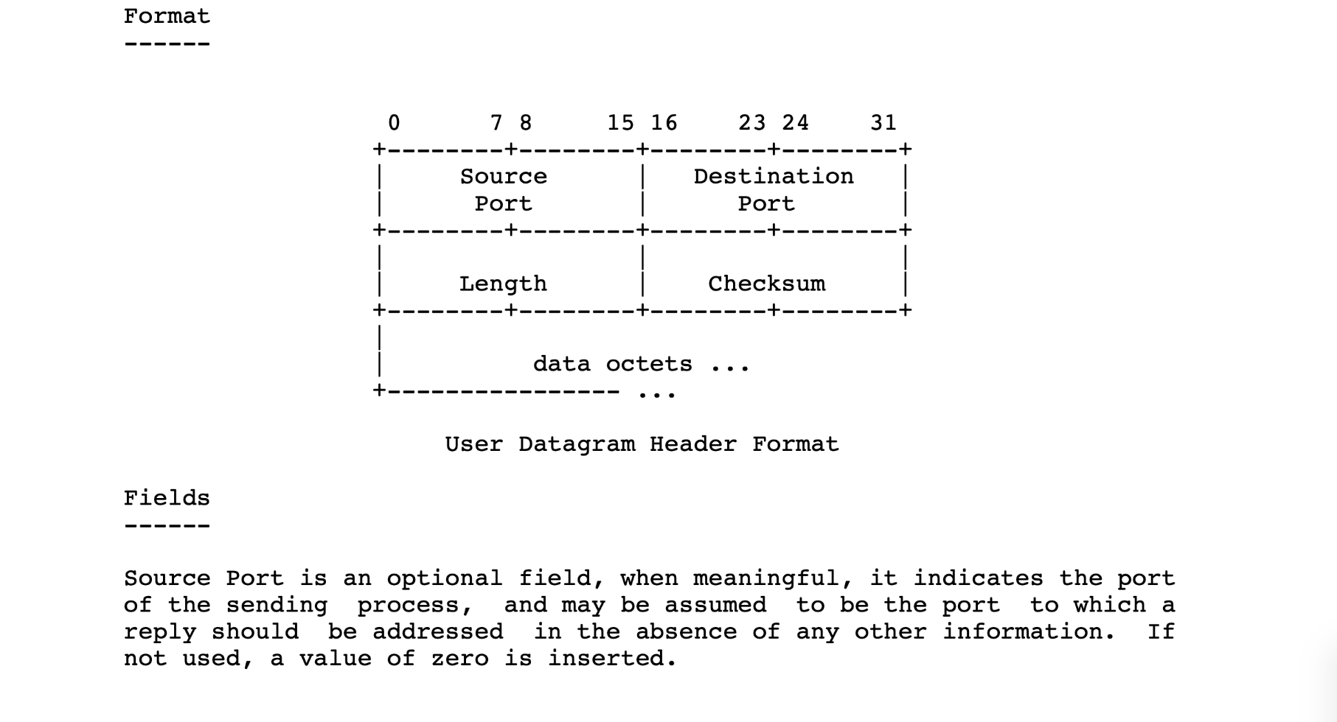
- What happened to IPv5 protocol? (1 point)
IPv5 protocol never became of public use due to its 32-bit limitations. IPv5 used IPv4’s 32-bit addressing, and since the internet quickly exhausted IPv4’s number of unique addresses, the development of IPv6 allowed a ubiquity of IP addresses which eliminated the development of IPv5. Therefore, IPv5 never amounted to anything due to it suffering the same 32-bit limitations of IPv4, so IPv6 became the next protocol to transition to.

