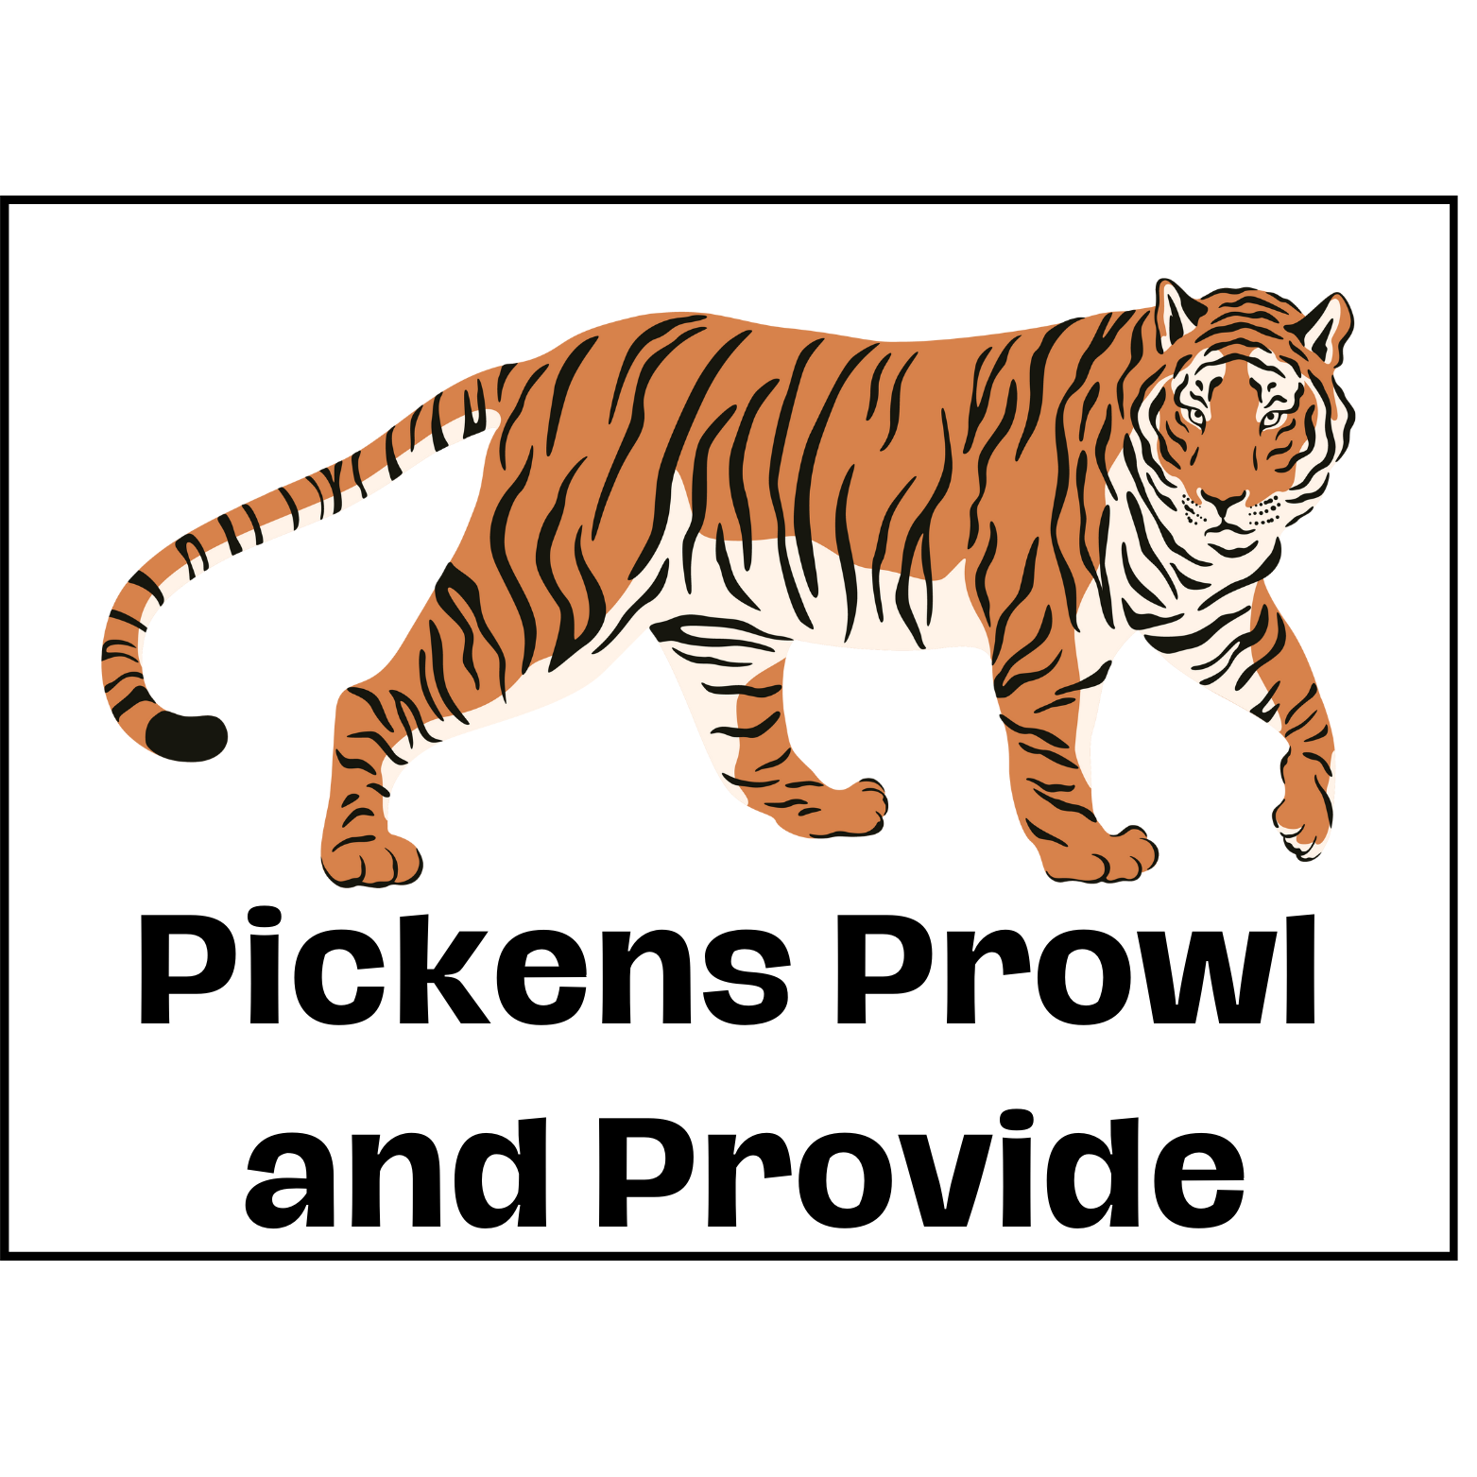
Press Release
Contact: Pickens Prowl and Provide
Telephone: (555) 317-4279
Email: pickensprowlandprovide@charity.com
Website: www.pickensprowlandprovide.org

FOR IMMEDIATE RELEASE
December 7th, 2023

PICKENS PROWL AND PROVIDE TO HOST AN EVENT TO COLLECT DONATIONS TO BOOST QUALITY OF LIFE FOR LOW INCOME FAMILIES

The organization hopes to raise money as well as non-essential household and personal items to donate to the families in Pickens county who are in need.

Pickens County, South Carolina, December 7th, 2023- Pickens Prowl and Provide, an organization that provides items to low income families, will be hosting a “Clemson Clean-Out.” They hope to collect lightly-used goods, including clothing, bedding, small appliances, and other personal and household items. The event will take place during move-out week at the end of the Spring semester in 2024.

This event will be widely advertised to the Clemson community in hopes to reach students who are out moving out of dorms and apartments. Every year many students throw out old items that they do not want/need anymore. This organized event will be a great way to prevent these items from going to waste.

The Clemson-Cleanout will consist of many volunteers working stations at every major living complex (Epoch, Signature, Cottages, Grandmarc, Earl, etc). These stations will be drop off locations for items that people are donating. Each station will provide food for volunteers as well as people who are donating items.. A silent auction will also be held on this day to raise money for families in need. The silent auction will consist of Clemson football west end zone box tickets, a tour of Death Valley Stadium, signed merch from Dabo Swinney, artwork from local artists, as well as many donated items from local businesses in the Clemson area.

This is what the president of Clemson University, Jim Clements, has to say about the Clemson Clean-Out event:

“I take great pride in the Clemson Community, and it always brings me great joy to see Clemson students trying to make a positive impact in the lives of others. The Clemson Clean-Out event is a great idea and I know that it will change the lives of so many people. This event not only showcases the generosity of countless people but also reflects a deep understanding of the challenges faced by some members of our community.”

This is what a mom of 5 children who has received donations from the Pickens Prowl and Provide has to say about the organization:

“I am very grateful for this organization and everything that they stand for. My family and I are very appreciative of everything that we have received because it has made a great difference in our lives. It is truly heartening to know that there are organizations dedicated to making a positive impact in our community and helping out families like mine.”

For more information about this event you can check out the website www.pickensprowlandprovide.org or contact pickensprowlandprovide@charity.com for any questions.

About Pickens Prowl and Provide
Pickens Prowl and Provide is a charity based in Pickens County. They aim to improve the lives of low-income families by providing clothes and non-essential items. They do this year round by collecting donations and at their main facilitation.

###

