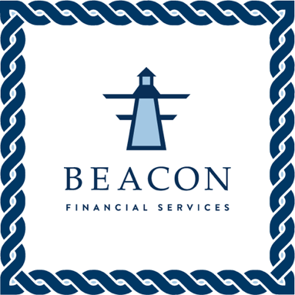
Contact: Owen Sullivan
Telephone: (843) 906-9712
Email: owen@mybeaconfinancial.com
Website: https://mybeaconfinancial.com

FOR IMMEDIATE RELEASE
OCTOBER 22, 2023

BEACON FINANCIAL SERVICES, LLC ADDRESSES ALLEGATIONS OF IMPROPER TAX PREPARATION TECHNIQUES
Some Clients Reported IRS Penalties and Accounting Discrepancies for the 2022 Fiscal Year

Charleston, SC, October 22, 2023 — Four small business clients, each of whom relied on tax preparation services provided by Beacon Financial Services, LLC, have reported accounting inconsistencies that may have resulted in incorrect tax reporting for the 2022 fiscal year. These clients received notification from the Internal Revenue Service concerning tax returns prepared by Beacon Financial Services, and subsequently observed improper calculations for taxable income.

The affected clients purchased a variety of financial services for their businesses, including, but not limited to: Outsourced CFO roles, Tax Preparation and Reporting services, and Financial Health services for the 2023 fiscal year. However, the services purchased by each client are not related to the underlying issue; each client reported discrepancies between their expected taxable income and the taxable income reported by tax preparers at Beacon Financial Services. A client provided the following statement concerning the effects of the reported discrepancy:

“I thought my business’ tax returns were complete until I received a certified letter from the IRS that the tax returns prepared by Beacon Financial Services were rejected due to incorrect taxable income calculations throughout the return. This was a shock, especially because the deadline for submitting tax returns had just recently passed, and I thought everything was taken care for the 2022 year; I was later informed that a tax penalty would be assessed for a late re-submission, and my business could be liable for reporting incorrect financial information. I was lucky to avoid the latter penalty, but this experience shook my confidence in the financial reporting for my business as I have been a Beacon Financial customer for the past three years.”

~ CEO of affected client

The founders of Beacon Financial Services, LLC were saddened to learn of the penalties assessed by the Internal Revenue Service after this unfortunate series of misreporting. While the founders deeply regret the inconveniences and difficulties caused by these events, they maintain that Beacon Financial Services employs only the best accountants and tax preparation experts available in the Charleston area; additionally, Beacon Financial Services have employed third-party financial investigators to determine the source of the incorrect reporting. CEO Sherman Free provided the following statement concerning the company’s response to the issues reported by affected clients:

more

“I express my deepest and most sincere apologies to the clients affected by the unfortunate errors made by our tax reporting experts. We sought out to make tax reporting easier for small businesses in Charleston and its surrounding areas, and it’s clear that we’ve accomplished the opposite with respect to these clients. Rest assured that we are treating this situation with the utmost seriousness, and we are actively in discussion with the four affected clients to remedy the situation by way of waived fees for corrected tax reporting and discounts for other services; we are also partnering with external investigators to learn how we can prevent these issues from occurring in the future. Ultimately, we hope to retain these clients and provide a better guarantee for our services going forward.”

~ Sherman Free, CEO, Beacon Financial Services, LLC

Other existing and prospective clients can rest assured that all future tax preparation processes performed by Beacon Financial Services, LLC will face increased scrutiny for accuracy prior to review or submission as outlined in a new addendum to yearly contracts. This addendum will be applied retroactively to all active contracts, and all clients will receive advance notice from Beacon Financial Services before contract modifications are formalized.

About Beacon Financial Services, LLC
Beacon Financial Services offers corporate financing and accounting services and acts as an outsourced CFO to businesses. Their staff is dedicated to helping small to mid-sized businesses succeed. With over 15 years of experience in accounting and corporate finance, CEO Sherman Free is well equipped to help business owners feel confident and supported.

# # #

If you are a client of Beacon Financial Services, LLC, and you notice discrepancies in your financial or tax reporting provided by Beacon Financial Services, please call (843) 906-9712 or visit https://mybeaconfinancial.com/#contact to discuss with a representative.

