First-year Profit Potential Simulation Analysis of Chemotherapy Exposure Limiter Devices

Report compiled by:
Owen Sullivan
HomeWorks Financial Services, LLC
123 Main St, Seneca, SC 29678
Tel: +1 (843) 555-1234 | Email: opsulli@clemson.edu
for:
MedicTronix

- Abstract
To understand the profit potential of a new medical device which limits healthcare workers’ exposure to chemotherapy treatments during preparation, administration, and disposal of hazardous medications, MedicTronix needed to understand the effects of parameters related to the manufacturing and sale of their device before and after the effects of inflation.
This report details how randomized simulations were used to perform analysis on parameters which influence the profit potential of the MedicTronix device. The primary variables which affected the outcomes of these simulations were the device’s selling price (per unit), the first-year administrative and advertising costs, the direct labor cost (per unit), the parts cost (per unit), and the first-year demand for the device.
HomeWorks Financial Services, LLC, will use this report’s findings to describe the potential impacts of these variables on the profit potential of MedicTronix’s new device, before and after the costs associated with production and sale of the device are affected by inflation, as well as to make suggestions about how these variables could be best optimized to maximize profit.
- Objective
HomeWorks Financial Services, LLC, performed randomized, hypothetical simulations which predicted the profit levels of MedicTronix’s new device to determine how changes to the selling price of the device, the administrative costs associated with producing the device, the labor cost per unit of the device, the parts cost per unit of the device, or the consumer demand for the device could affect the potential profit generated by sales of the device.
HomeWorks Financial Services, LLC, developed a simulation model to perform what-if analysis on these parameters. To ensure that any changes to these input parameters would not result in simulation outcomes based on unlikely or incorrect data, HomeWorks Financial, LLC, used bounded randomization to determine values for simulation input parameters for which static values were not previously provided by MedicTronix; in other words, the values for some input parameters were determined at random between upper and lower bounds, which, when used with simulations that are performed again with each change to a parameter, result in dynamic simulation outcomes.
What-if analysis would provide the broadest analysis of how changes to input parameters could affect (meaning increase or decrease) the overall profit potential of MedicTronix’s new device.
- Data Discussion
Prior to determining the effects of inflation on the development and sale of their new medical device, MedicTronix provided exact, high-certainty estimates for the following input parameters: the device’s selling price (per unit), which is the dollar amount which the company will sell a single device for, and the first-year administrative and advertising cost, which is the overall dollar amount which the company will invest in the design, marketing, and distribution of all of the devices sold in the first year combined.
Concerning the device’s selling price before inflation: MedicTronix is reasonably confident that the device will sell for $2,495 per unit.
Concerning the administrative and advertising costs before inflation: MedicTronix is reasonably confident that $5,000,000 will be spent on non-manufacturing production-related costs for all the devices produced and sold within the first year of sales.
MedicTronix also provided base estimates and bounded ranges for the direct labor costs and parts costs per unit of their new device, which must be subtracted from a single device’s sale price, as well as for the first-year consumer demand for the device, which affects the number of devices that could be sold.
Concerning direct labor costs before inflation: MedicTronix believed that the direct labor cost per unit of the device would average at $1,400 but could range between $1,200 and $1,600. MedicTronix further stipulated that the direct labor cost per unit may only take on values between these upper and lower bounds in increments of $100, and that the likelihoods of a given cost within that range fit a discrete probability distribution.
Direct Labor Cost (in $, per unit) | Probability
$1,200 | 0.1 or 10%
$1,300 | 0.21 or 21%
$1,400 | 0.38 or 38%
$1,500 | 0.21 or 21%
$1,600 | 0.1 or 10%

Concerning parts costs before inflation: MedicTronix believed that the parts cost per unit of the device would average at $350 but could range between $250 and $500. Because these upper and lower bounds were provided, but probabilities for exact values within the range were not stipulated by MedicTronix, the parts costs were fit to a uniform distribution where any value between the bounds is exactly as likely as another.
Concerning consumer demand before inflation: MedicTronix believed that first-year demand for the device would average at 25,000 units, with a standard deviation (a measure of how dispersed the values could be) of 10% of that figure, or 2,500 units, but could range from 0 to 50,000 units. The figure for the average demand was derived from a simple average of the upper and lower bounds of demand.
After determining that sales of their device could be impacted by inflation, MedicTronix provided updated figures for each of the parameters:
Concerning the device’s selling price after inflation: MedicTronix increased the selling price per unit to $2,795, an increase of $300 over the previous selling price per unit of $2,495.
Concerning the administrative and advertising costs after inflation: MedicTronix observed increased costs of $5,500,000, an increase of $500,000 over the previous costs sum of $5,000,000.
Concerning direct labor costs after inflation: MedicTronix determined that all possible values for the direct labor cost increased by a flat sum of $100. As such, the direct labor cost per unit would average at $1,500 but could range between $1,300 and $1,700 in the same increments of $100. The likelihoods of a given cost within that range still fit a discrete probability distribution and remain unchanged.
Direct Labor Cost (in $, per unit) | Probability
$1,300 | 0.1 or 10%
$1,400 | 0.21 or 21%
$1,500 | 0.38 or 38%
$1,600 | 0.21 or 21%
$1,700 | 0.1 or 10%

Concerning parts costs after inflation: MedicTronix determined that both the upper and lower bounds for the cost of parts increased by 10%. As such, the parts cost per unit would average at $412.5 but could range between $275, up from $250, and $550, up from $500. The parts costs could still be fit to a uniform distribution such that any value between the bounds is exactly as likely as another, the same as prior to inflation.
Concerning consumer demand after inflation: MedicTronix determined that first-year demand for the device would average at 27,000 units, with a standard deviation of 5% of that figure, or 1,350 units. MedicTronix did not provide an updated range for demand, so it was assumed that demand could still range from 0 to 50,000 units.
The input data provided by MedicTronix was based on evaluation of the key parameters in determining first-year profit of their new medical device, as well as market research and financial analysis previously conducted by MedicTronix.
- Methodology
HomeWorks Financial Services, LLC, chose to simulate values for each of the input parameters at random, using the most likely values for each input parameter as determined by MedicTronix before and after consideration of inflation as base cases, because the real-world sales performance of MedicTronix’s device could not yet be measured. To provide analysis of the device’s potential to generate profit without existing sales metrics, those metrics would need to be evaluated across a wide range of potential input and output values in order to consider as many likelihoods as possible.
To perform randomized simulations, HomeWorks Financial Services, LLC, created a simulation model using the input parameters and ranges described in III. Data Discussion in the following ways to create a base case: the selling price per unit of the device was inputted as a static value; the first-year administrative and advertising cost was inputted as a static value; the direct labor cost per unit was determined as a function of the randomized probability that a given value within the discrete probability distribution for direct labor cost would be selected, represented in Microsoft Excel as the function “VLOOKUP(RAND(), [Probability interval range], [Cost range], [Approximation representation]” where “RAND()” generates a random number between 0 and 1 (exclusive of the upper bound of 1); the parts cost per unit was determined as a randomized value between the upper and lower bounds for parts cost, represented in Microsoft Excel as the function “[Lower bound] + ([Upper bound] – [Lower bound]) * RAND()” where “RAND()” generates a random number between 0 and 1 (exclusive of the upper bound of 1); the demand was determined as a function of the randomized inverse of the normal cumulative distribution for the mean and standard deviation of demand, represented in Microsoft Excel as the function “NORM.INV(RAND(), [mean], [standard deviation]” where “RAND()” generates a random number between 0 and 1 (exclusive of the upper bound of 1).
For these base cases, total profit was calculated by subtracting the variable, per-unit costs from the device’s per-unit selling price, multiplying that figure by the number of devices demanded, and finally subtracting the static administrative and advertising costs. In Microsoft Excel, profit was represented as the function “([Selling price per unit] – [Direct labor cost per unit] – [Parts cost per unit]) * [Demand]) – [Administrative and advertising costs]”.
After the base cases for simulation were created, both before and after the effects of inflation were considered in the values of input parameters, HomeWorks Financial Services, LLC, used Microsoft Excel’s “Data Table” functionality to perform what-if analysis in the form of simulations. To produce a wide range of simulated values without the simulations resulting in unusually high usage of computer memory, a finite resource which computer simulations rely heavily on to perform calculations, HomeWorks Financial Services, LLC, performed 1,000 simulations using the appropriate base case as the values for the first simulation. Each of the remaining 999 simulations exhibited the following patterns:
Concerning the direct labor cost per unit: the value for each simulation run was determined in an identical manner to the base case.
Concerning the parts cost per unit: the value for each simulation run was determined in an identical manner to the base case.
Concerning the demand: the value for each simulation run was determined in an identical manner to the base case.
Concerning profit: the value for each simulation run was determined using the same function for the calculation of profit used in the base case, with values for the direct labor cost per unit, the parts cost per unit, and the demand substituted with those respective values previously determined for that simulation run.
As such, the values for each simulation run were completely independent of any preceding simulation run performed.
Then, the following summary statistics were calculated for profit based on all of the simulation runs performed: the mean simulated profit, the standard deviation of simulated profits, the minimum simulated profit, the maximum simulated profit, and the probability that a value for profit was less than $0.
Concerning the mean simulated profit: this statistic was calculated by averaging all of the simulated values for profit produced by 1,000 simulation runs, represented in Microsoft Excel as the function “AVERAGE([Range of simulated profits])”.
Concerning the standard deviation of simulated profits: this statistic was calculated using the Microsoft Excel function “STDEV.S([Range of simulated profits])”.
Concerning the minimum simulated profit: this statistic was calculated as the lowest value in all of the simulated profit values, represented in Microsoft Excel as the function “MIN([Range of simulated profits])”.
Concerning the maximum simulated profit: this statistic was calculated as the highest value in all of the simulated profit values, represented in Microsoft Excel as the function “MAX([Range of simulated profits])”.
Concerning the probability that a value for profit was less than $0: this statistic was calculated as a function of the percentage of simulated profit values which were less than $0, represented in Microsoft Excel as the function “COUNTIF([Range of simulated profits], “<0”)/COUNT([Range of simulated profits])” where the “COUNTIF” function measures the number of simulated profit values that were less than $0 and the “COUNT” function measures the total number of simulated profit values.
Finally, a histogram of the values for simulated profit was created using Microsoft Excel’s Data Analysis functionality, using bins, or increments in a range of potential values which match data inclusively to a range in a histogram, which represented estimates for the lowest simulated profit through the highest simulated profit in increments of $1,000,000. This allows the simulated profit data to be categorized in a human-readable way, as the data is grouped according to which bin most closely fits each given value.
Each of the steps outlined above for simulation and what-if analysis were performed using pre-inflation and post-inflation figures for input parameters, which are explained in greater detail in III. Data Discussion.
- Results
Because of the randomized nature of the simulated values observed for each of the input parameters and profit, with profit being the value MedicTronix is most interested in evaluating the potential performance of, it is not possible to frame simulated results in any definite manner. Instead, excerpts of simulated results for pre-inflation and post-inflation values are provided as follows:
For pre-inflation analysis, an excerpt of simulated results which are representative of simulated values is provided and should be considered only for the purposes of explaining simulation outcomes:
Simulation Trial (#) | Direct Labor Cost (in $, per unit) | Parts Cost (in $, per unit) | Demand (in # of people) | Profit (in $)
1 | $1,400 | $284.79 | 30,054 | $19,349,958
2 | $1,200 | $410.64 | 21,423 | $13,945,996
3 | $1,300 | $482.64 | 24,171 | $12,218,591
4 | $1,600 | $275.23 | 27,601 | $12,106,508
5 | $1,400 | $421.37 | 16,990 | $6,444,830
6 | $1,400 | $478.59 | 24,214 | $9,925,478

The following summary statistics generated using 1,000 simulation runs based on pre-inflation input values are provided and can be considered representative of actual results from simulations performed by HomeWorks Financial Services, LLC:
Mean Profit (in $) | $13,134,795
Standard Deviation of Profit (in $) | $3,734,279
Minimum Profit (in $) | $3,722,734
Maximum Profit (in $) | $24,335,990
P(Profit < $0) | 0.000 or 0%

For post-inflation analysis, an excerpt of simulated results which are representative of simulated values is provided and should be considered only for the purposes of explaining simulation outcomes:
Simulation Trial (#) | Direct Labor Cost (in $, per unit) | Parts Cost (in $, per unit) | Demand (in # of people) | Profit (in $)
1 | $1,500 | $292.23 | 26,266 | $20,838,945
2 | $1,600 | $389.50 | 28,243 | $17,250,012
3 | $1,500 | $358.84 | 29,100 | $21,743,575
4 | $1,600 | $473.60 | 25,160 | $12,650,111
5 | $1,400 | $454.52 | 28,418 | $21,226,612
6 | $1,600 | $439.94 | 24,775 | $13,206,375

The following summary statistics generated using 1,000 simulation runs based on post-inflation input values are provided and can be considered representative of actual results from simulations performed by HomeWorks Financial Services, LLC:
Mean Profit (in $) | $18,429,921
Standard Deviation of Profit (in $) | $3,982,409
Minimum Profit (in $) | $7,736,266
Maximum Profit (in $) | $31,276,928
P(Profit < $0) | 0.000 or 0%

Note the following information about excerpts of both pre-inflation and post-inflation simulation results listed above: the above representations of simulated results include the appropriate base case for input parameters, highlighted in grey, as reference points; in the above summary statistics, the description “P(Profit < $0)” can be read as the probability that simulated profit is less than $0.
As evident in above excerpts, each of the input parameters (direct labor cost per unit, parts cost per unit, and demand), as well as profit, take on values according to the criteria for determination outlined in IV. Methodology. Histograms generated using the results of simulation runs using both pre-inflation and post-inflation input values are as follows:
For pre-inflation data: 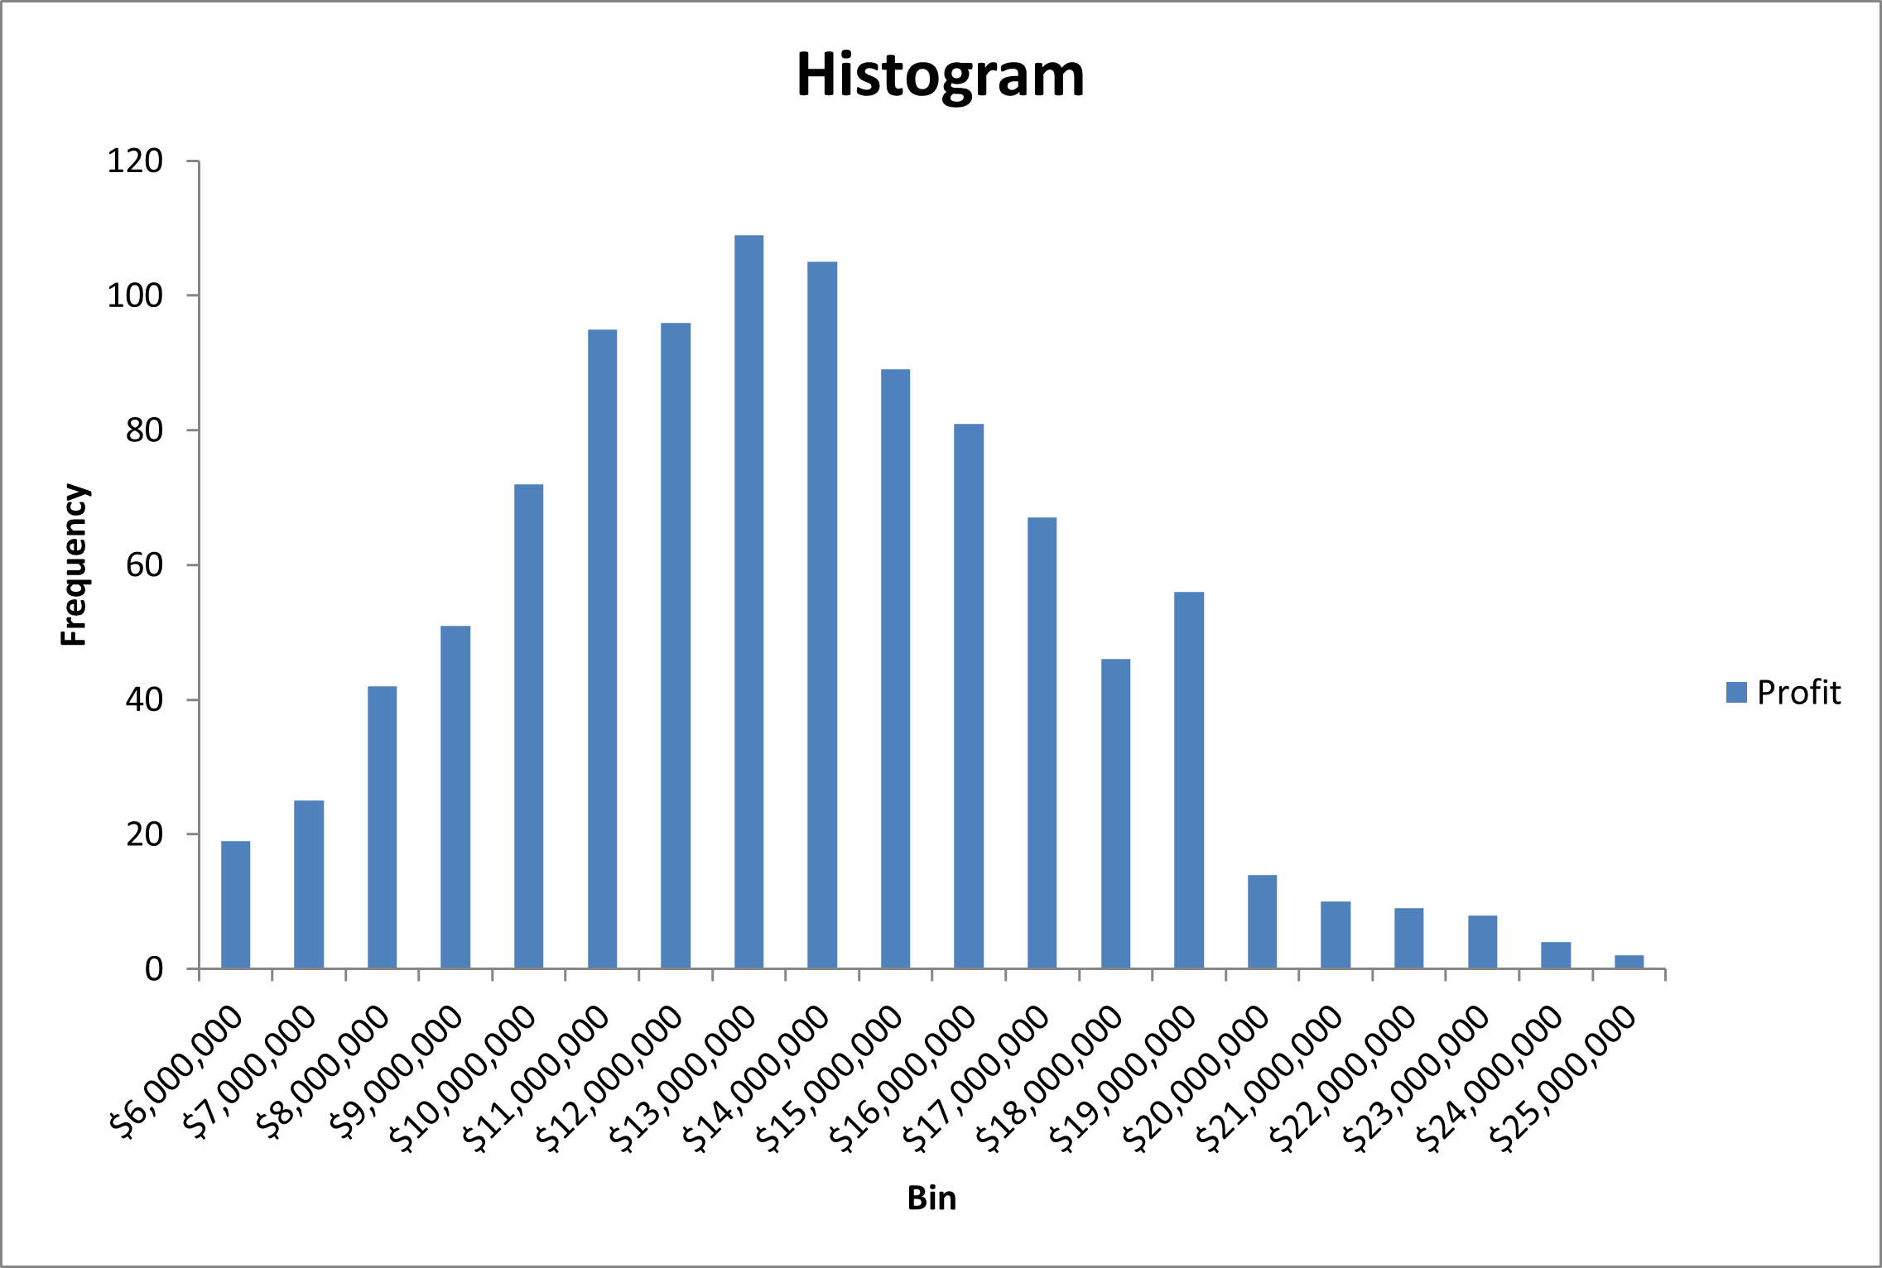
For post-inflation data: 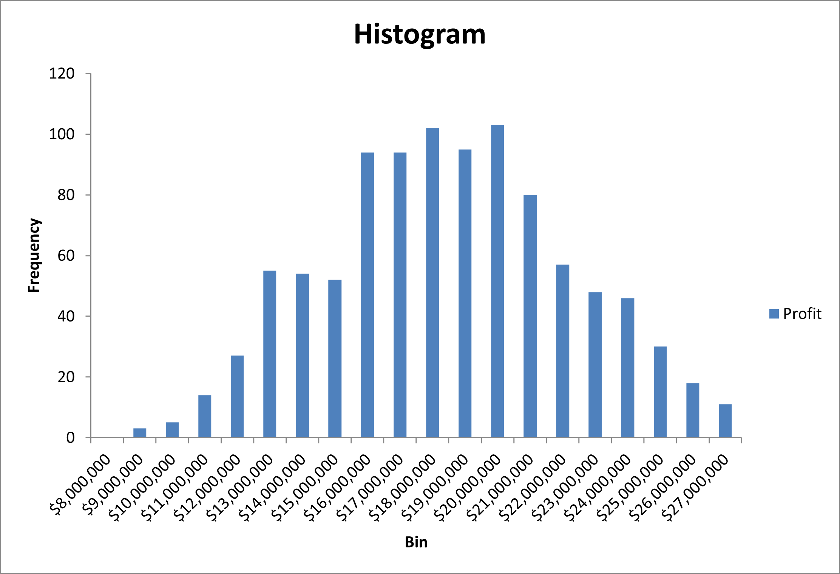
The above histograms demonstrate that simulation results can generally be approximated to fit a normal distribution, where outcomes resulting in profit which closely matches the base case for a given simulation are most likely, and thus more frequently observed, and all other outcomes for profit are less likely the farther they are (greater than or less than) from base case profit, and thus less frequently observed. The relevant figures for standard deviation found in the summary statistics above explain the variability in observed values for profit generated.
Observed simulation results also indicate that profit is likely to increase, on average, if the direct labor cost per unit, the parts cost per unit, and the demand are adjusted to post-inflation values as provided by MedicTronix in III. Data Discussion. Additionally, the simulations performed indicate that the likelihood of profit from sales of MedicTronix’s medical device being less than $0 is universally low, if not zero.
- Suggestions
Because the simulations performed by HomeWorks Financial Services, LLC, for MedicTronix will not necessarily be representative of real-world sales performance of and profit generation by MedicTronix’s new medical device, it is not realistic to provide any exact figures for suggested input parameter values. Instead, only generally applicable suggestions will be made. All suggestions made based on the outcomes of this report should be taken with caution and duly considered before being used to influence business decisions.
In order for MedicTronix to maximize the total profit associated with the development, manufacture, and sale of the new device, they should do the following: attempt to minimize the direct labor cost per unit of the device, in part by sourcing labor unaffected by inflation, as lower values for this parameter directly influence higher profit levels; attempt to minimize the parts cost per unit of the device, in part by sourcing parts unaffected by inflation, as lower values for this parameter directly influence higher profit levels; attempt to maximize consumer demand for the device, in part by matching demand to post-inflation levels as closely as possible, as higher values for this parameter directly influence higher profit levels.
However, for MedicTronix to generate more consistent profit levels regardless of the exact direct labor costs per unit or the exact parts cost per unit, they should do the following: decrease variability in the direct labor costs per unit, and instead attempt to use labor which can be consistently sourced at a single price point; decrease variability in the parts costs per unit, and instead attempt to use parts which can be consistently sourced at a single price point. It is unrealistic to make any suggestions that involve making consumer demand consistent.
In both scenarios, profit can be increased by increasing the selling price per unit of the device and lowering the administrative and advertising costs for the device, if either are possible.
- Final Summary
The simulations performed and the what-if analysis conducted by HomeWorks Financial Services, LLC, pertaining to how changes to the selling price of a medical device, the administrative and advertising costs associated with the device, the direct labor cost per unit of the device, the parts cost per unit of the device, and the consumer demand for the device on the profit potential of the device indicate that profit is directly related to the performance of each input parameter.
The profit can be increased as administrative and advertising costs, direct labor costs per unit, and parts costs per unit are decreased, as well as when the selling price per unit and the demand are increased.
It is the recommendation of HomeWorks Financial Services, LLC, that MedicTronix attempt to influence profit potential as outlined in detail in VI. Suggestions and according to the outcomes observed in V. Results.

