- The names and URLs of apt repositories are listed in “/etc/apt/sources.list” and there may also be separate listing files in the “/etc/apt/sources.list.d” directory (not common). Repositories can be added in one of two ways, either by using the “apt-add-repository” command (which is enabled by installing the “software-properties-common” package) or by using “echo” to write a full repository listing like “deb http://us.ports.ubuntu.com/ubuntu-ports/ jammy universe” to “/etc/apt/sources.list”.
- I downloaded the “.deb” file for Google Chrome and extracted it, revealing the “debian-binary”, “control.tar.xz”, and “data.tar.xz” files: 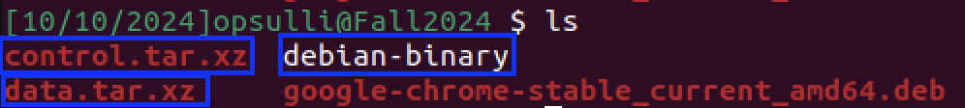
  - Inside the “control.tar.xz” archive are scripts and package metadata files: 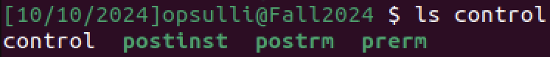
  - Inside the “data.tar.xz” archive are all of the installable files for the package, including some scripts (like a cron job) that are added to the system to make the software run properly: 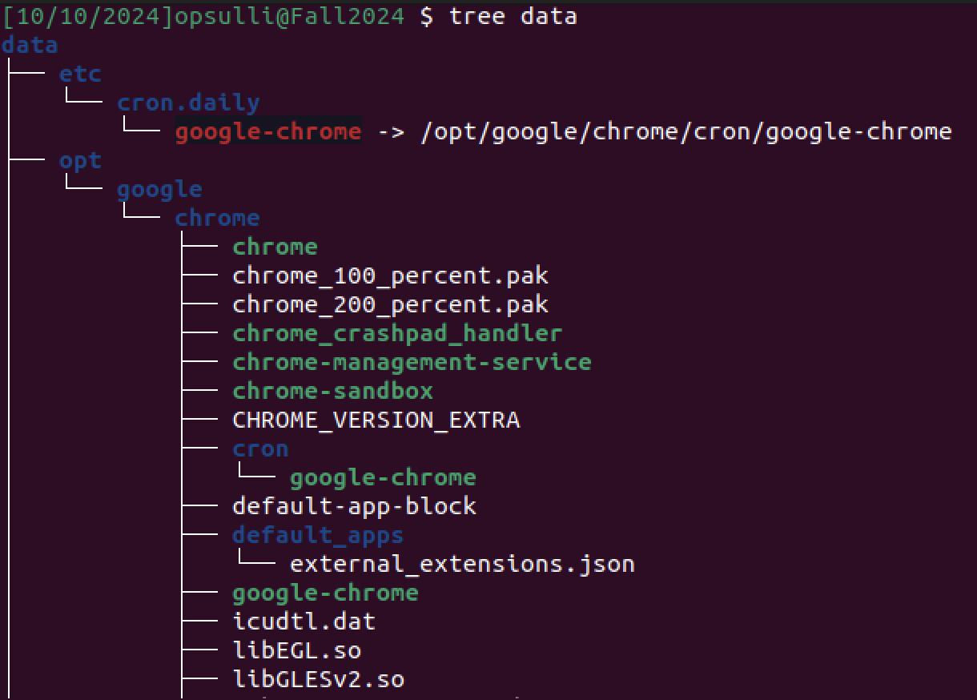
  - The “debian-binary” file just lists the package version:
- Creating users “bob” and “jon”:
  - Using “useradd” to add the “bob” user results in no command output. The “bob” user is added, but no new home directory is created. The “bob” user is simply added to the end of “/etc/passwd”: 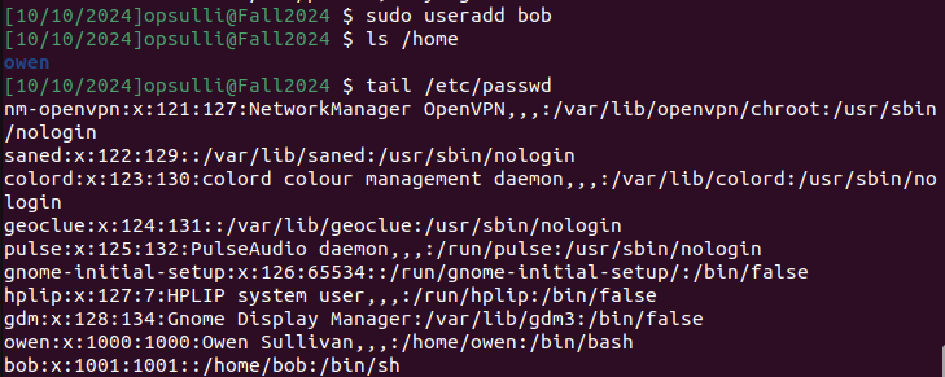
  - Using “adduser” to add the “jon” user prompts for a password for that user, as well as identifying information. A directory for the user is created in “/home”, in addition to the user being added to “/etc/passwd”: 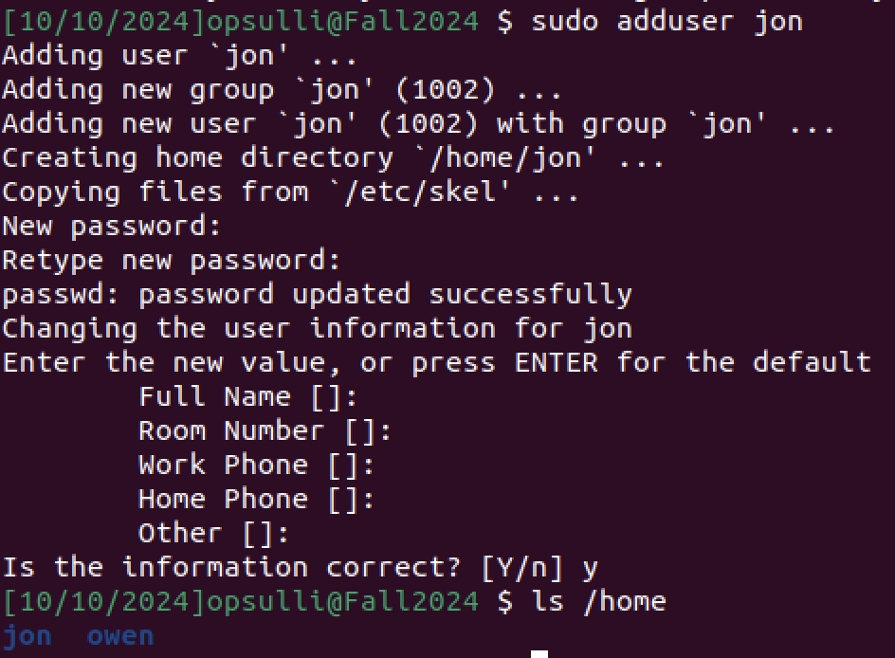
  - One way to lock a user out of their account is to use the “usermod -L” command. This adds an exclamation mark to the user’s entry in “/etc/shadow”, which causes the user’s password not to match the entry when it is hashed for authentication: 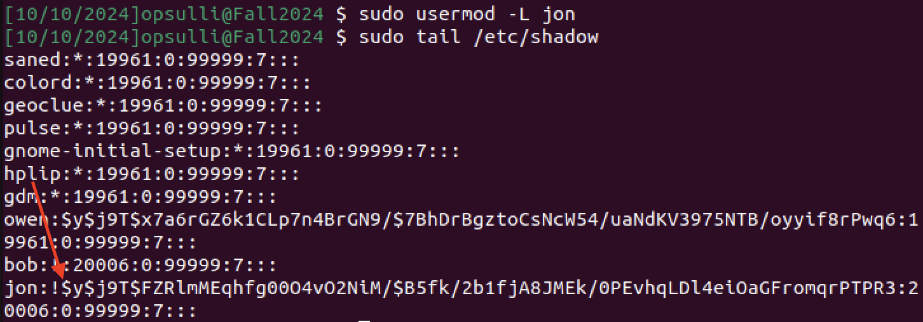
  - Another way to lock a user’s account is to simply edit “/etc/shadow” and add a character to the beginning of the user’s password hash, just like “usermod -L” does but instead done manually using a text editor: 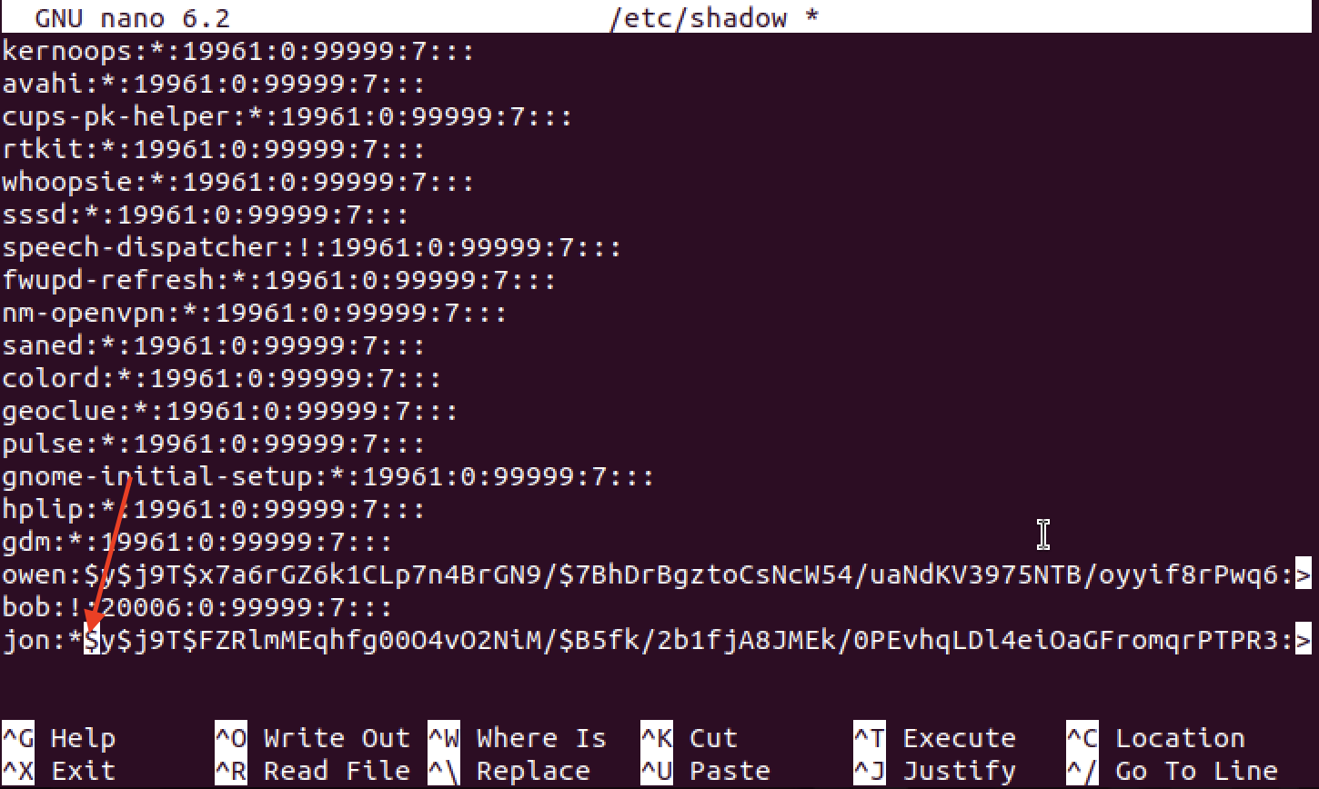
- Skeleton files that are copied to a new user’s home directory when using the “adduser” command live in “/etc/skel”. The skeleton files are all hidden files (beginning with a ‘.’) and they are default bash environment configuration files: 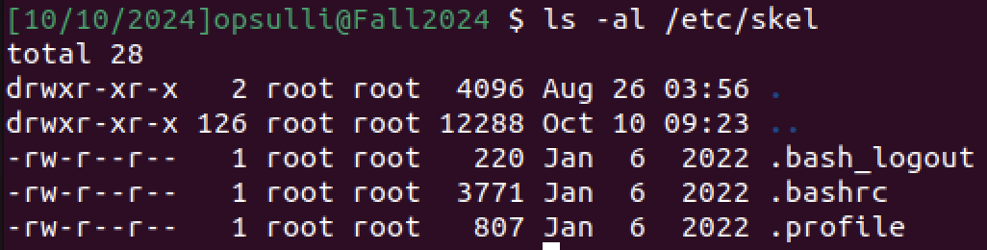
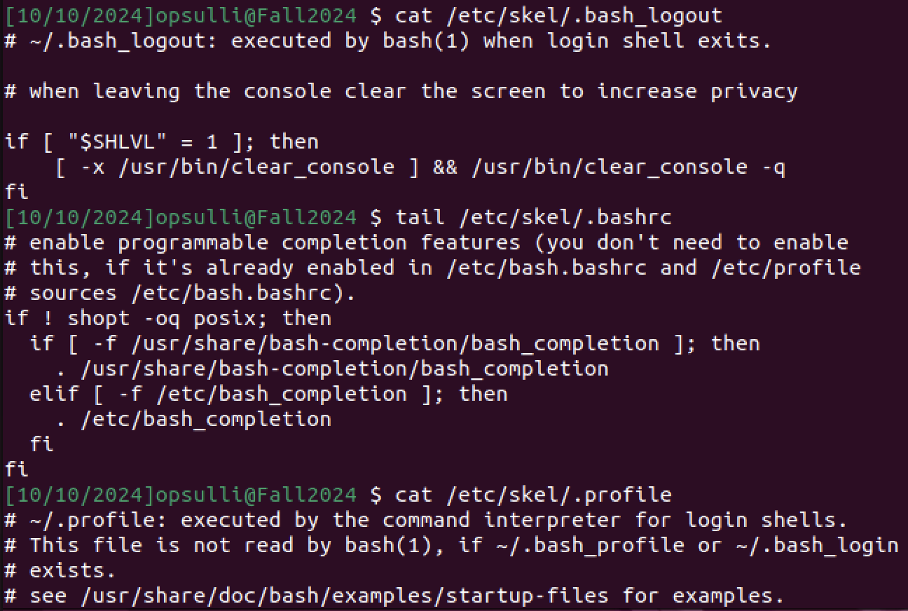
- Environment variables are variables that can be used by programs across a Linux system to reference common information. They often serve as configuration options relevant to the currently running shell (usually bash). They follow the syntax “[variable_name]=[value]” and can be printed with “printenv”: 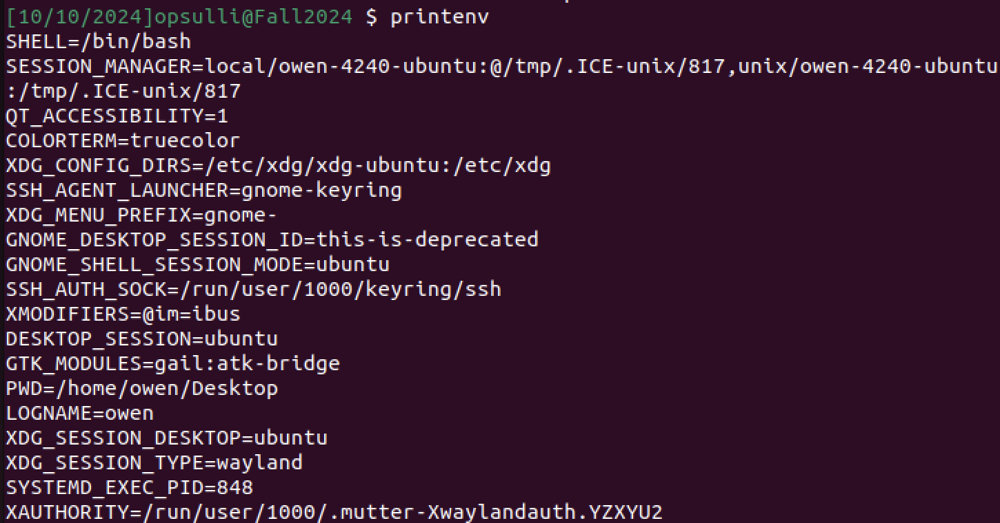
Or, they can be individually printed using “echo”: 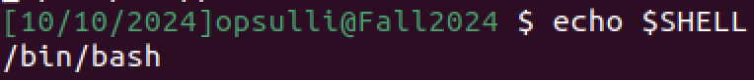
They can be set or updated using the “export” command or simply by using the name of the variable: 