- The file listing after running “ls -il” shows the two files I created in my ~/Desktop folder, “file1.txt” and “file2.txt”. The listing shows both files with their inode numbers on the left (790549 for “file1.txt” and 790630 for “file2.txt”), their permissions, how many links exist for the inode, the user and group that own the file, the file size in bytes, the timestamp of when the file was created, and the file name. 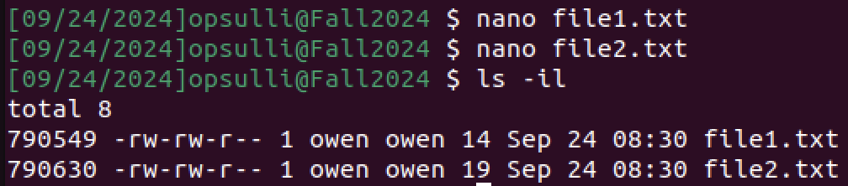
- After creating “my_softlink” and running “ls -il” again, three files are now shown. The inode number of “my_softlink” is different from that of “file1.txt” which it links to, because it is a soft link and it is effectively a completely new file that points to the original. Also, “my_softlink” has a different file size than “file1.txt” because it is a completely new type of file.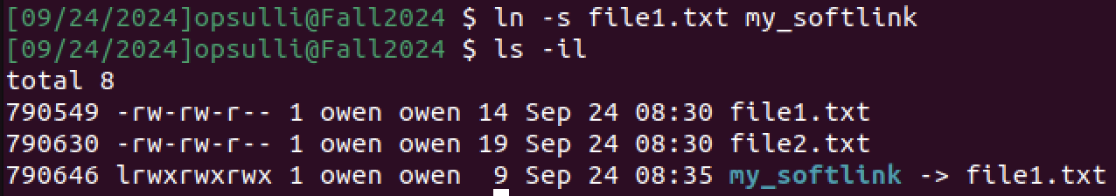
  - If “file1.txt” is deleted, “my_softlink” will no longer link correctly because the soft link can no longer resolve to the original file.
- After creating “my_hardlink” and running “ls -il” again, there are only three files shown still because “file1.txt” was previously deleted. The file listing shows “my_softlink” in red because it is a broken link, and it shows “my_hardlink” like a normal file except with the same inode as “file2.txt” which it links to. Also, “my_hardlink” has the same file size as “file2.txt” because it effectively is the same file.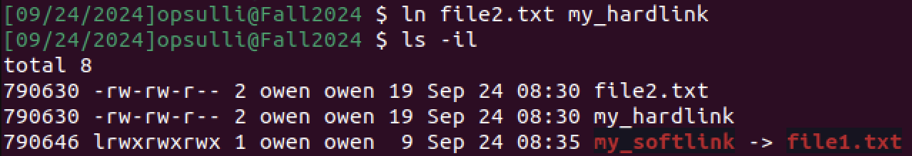
  - If “file2.txt” is deleted, “my_hardlink” will still link correctly because the hard link points to the same inode as the original file and assumes the responsibility of acting as the only file entry for that inode.
- Hard links are useful in the following cases:
  - When you need to have the same file organized in multiple directories on the same filesystem without consuming more disk space. For example: a large video file that needs to be referenced in multiple video editor project folders.
  - When you want to have incremental backups of data, hard links can be used in a new snapshot to point to an existing file in a previous snapshot if it has not changed since the previous snapshot was taken.
  - When you are concerned with the speed of accessing files, you can use hard links instead of soft links to achieve this. With a hard link, the kernel only has to access one inode to reach the correct file versus two inodes when loading a file pointed to by a soft link.
- Soft links are useful in the following cases:
  - When you need to have files from one filesystem partition accessible on another partition, soft links can be used to point to files on the first partition from the second. This is useful because hard links cannot be made across partitions.
  - When you need to create links to directories, you must use soft links.
  - When you need to quickly change what file a link points to, you can use soft links instead of hard links because soft links persist as individual files that can be reassigned as needed.
- “/bin” and “/sbin” are soft links to “/usr/bin” and “/usr/sbin”, respectively, to reduce the amount of redundancy in the filesystem. Previously, all four directories were separate (none of them were links), with the idea being that “/bin” and “/sbin” under the root directory would be for essential programs and “/usr/bin” and “/usr/sbin” would be for non-essential programs. It’s easier to keep them all together, so the directories under root were made soft links. Similarly, “stdin”, “stdout”, and “stderr” are soft links under “/dev” so that processes can write to and read from them without having to keep track of where in “/proc” their file descriptors (0, 1, and 2, respectively) are located.

