- umask value in my VM: 0002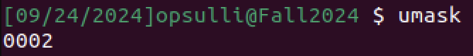
- After creating an empty file and an empty directory, running “ls -l” confirms that the default permissions are set for each (666 for the file and 777 for the directory). These are represented textually in the form “-[user][group][everyone]”, where each set of three values for ‘r’ (read), ‘w’ (write), and ‘e’ (execute) are represented in binary like 110 for read/write permissions. 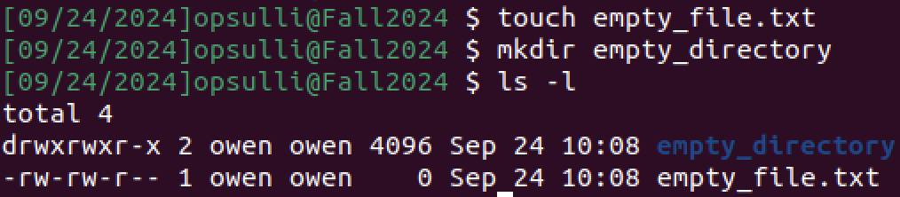
The permissions 666 are used by default for files so that everyone on the system can read and write, but not execute. The permissions 777 are used by default for directories so that everyone on the system can read, write, and execute. The umask is then subtracted from a file or directory’s permissions so that individual users and processes can specific their own access permissions to a file without having to constantly change the actual file or directory’s permissions.
- After changing my umask to “077” and creating a new file and a new directory (“new_file.txt” and “empty_directory”), the permissions look like this: 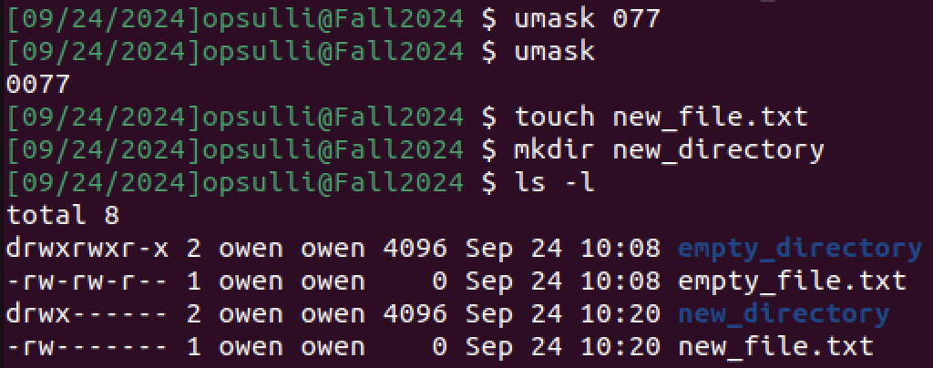
The new umask means that only the file owner (my user account) can read, write, and execute (for the directory only) whereas the old umask allowed more permissions.
- umask changes do not persist after a reboot (observe “reboot.txt” and “reboot” directory): 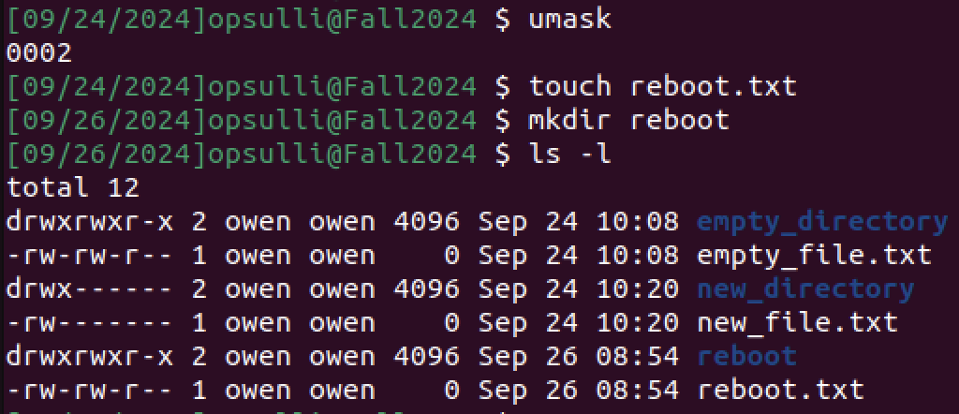
- On Ubuntu 22.04, the default value for umask is stored in “/etc/login.defs”.
- I created two files, “change_perms.txt” and “change_perms2.txt”, to demonstrate using chmod in two forms: 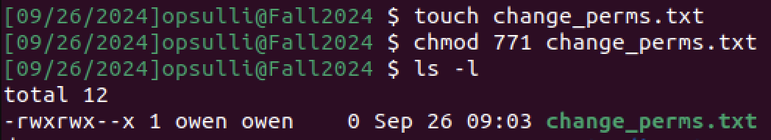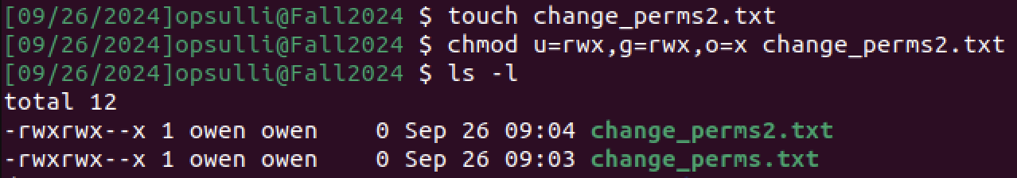
- In modern Linux, a sticky bit is used to restrict who can delete files within a directory. When the sticky bit is set, only the user who owns the directory or the root user can delete the files in that directory. Setting the sticky bit adds a ‘t’ to the end of the permissions mnemonic: 