- Changing terminal prompt text to match the pattern “[date]username@Fall2024” required adding a line to the bottom of my ~/.bashrc file, then using the “source” command to update my terminal environment. 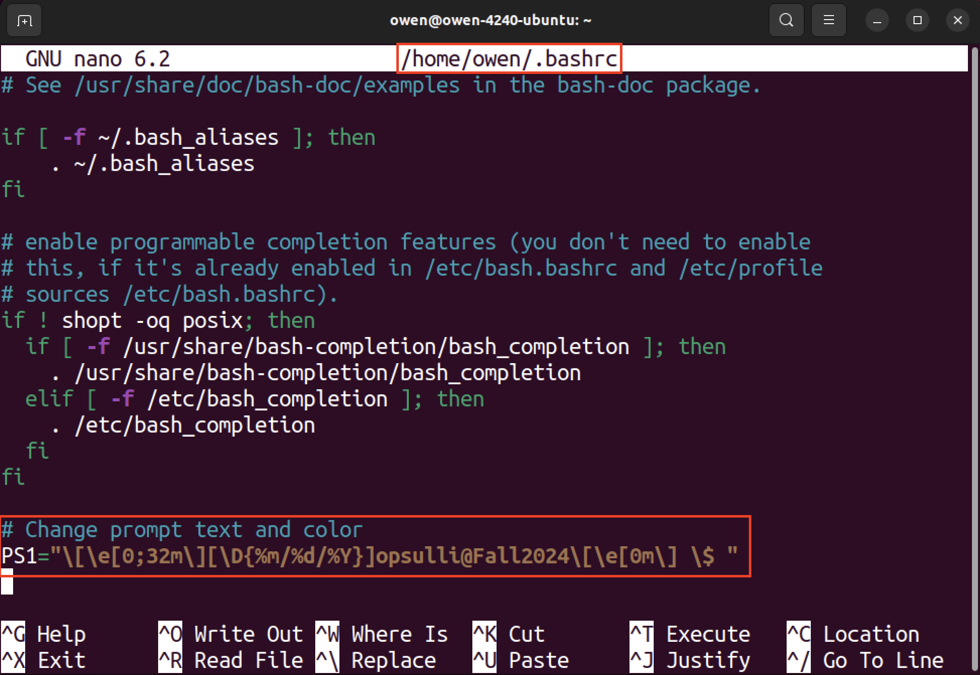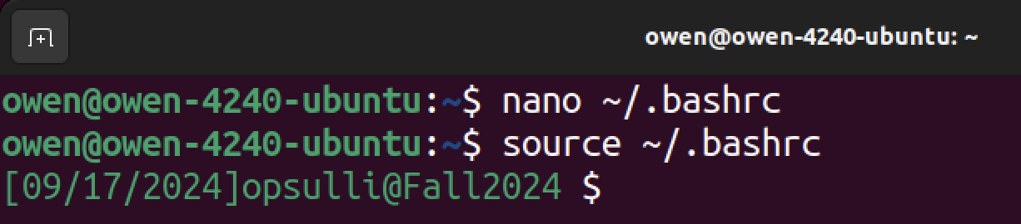
- setuid and setgid are permissions bits in the standard Linux permissions set that, when set on a file/directory, allow users to interact with that file/directory using different permissions than normally would be used according to the user.
  - The setuid bit works by allowing users to run an executable/binary with the owner’s permissions (such as root permissions when running “passwd”).
  - The setgid bit allows an executable/binary to be run with its group permissions set. Additionally, the setgid bit allows files within a directory to inherit the group permissions of that directory, which is useful for shared directories.
  - Two examples of programs that use these bits are:
    - The “sudo” command, which is an executable/binary using setuid to allow execution as root. The root user owns the binary, and users can execute it using root permissions to perform actions with administrator permissions.
    - The “crontab” command, which is used to update scheduled tasks on the system, uses the setgid bit so that changes to cron jobs can be registered with the cron daemon.
- Recovery mode on an Ubuntu system can be entered using the GRUB2 boot menu.
  - Once booted to the GRUB2 menu, I navigated to recovery mode through the “Advanced options for Ubuntu” sub-menu followed by “Ubuntu… (recovery mode)”. 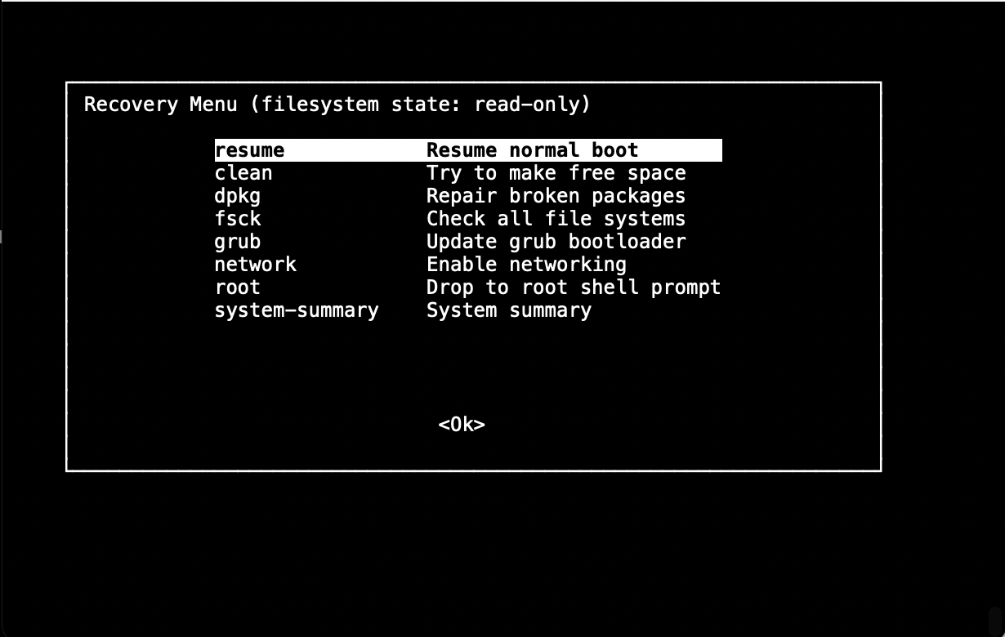
  - Three cases when you might need to enter recovery mode are:
    - If you have forgotten the root user’s password, you can use recovery mode to drop into a root shell prompt and mount the file system as read/write. Then, you can change the root user’s password.
    - If you suspect your file system is corrupted or damaged, you can use recovery mode to run a file system health check using “fsck”.
    - If there is a program on the system that is preventing the system from booting properly, recovery mode can be used to remove or modify that program and make the system bootable again.
- About “.profile”, “.bashrc”, and “.bash_profile”:
  - These files start with a dot (‘.’) to make them hidden files in the file system by default. Since Linux does not require that files have an extension, a dot at the beginning can be used to indicate a hidden file. These hidden files can be shown with “ls -a”.
  - My Ubuntu distro has “.profile” and “.bashrc” in my user’s home directory, but not “.bash_profile”. 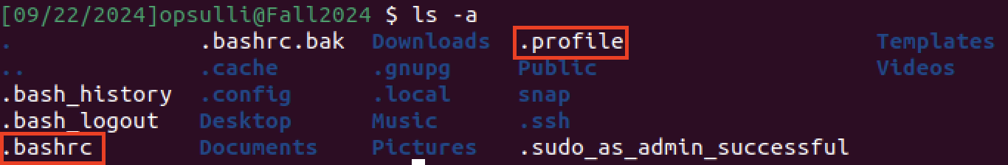
  - These files are used to determine a user’s preferences for using “bash”, which is the default terminal emulator program on most Linux systems (there are also others like “zsh” that use similar files like “.zshrc” on some distros). The files contain environmental variables and aliases that are read by bash under certain circumstances.
  - By default, “.bashrc” is read by bash when a new interactive non-login shell is created (such as using the terminal application in the desktop environment), whereas “.profile” is used for non-interactive login shells. “.bash_profile” is typically used for TTY shells, however it has not been used by default in Ubuntu for a few years.
- Aliases:
  - “cur” alias: 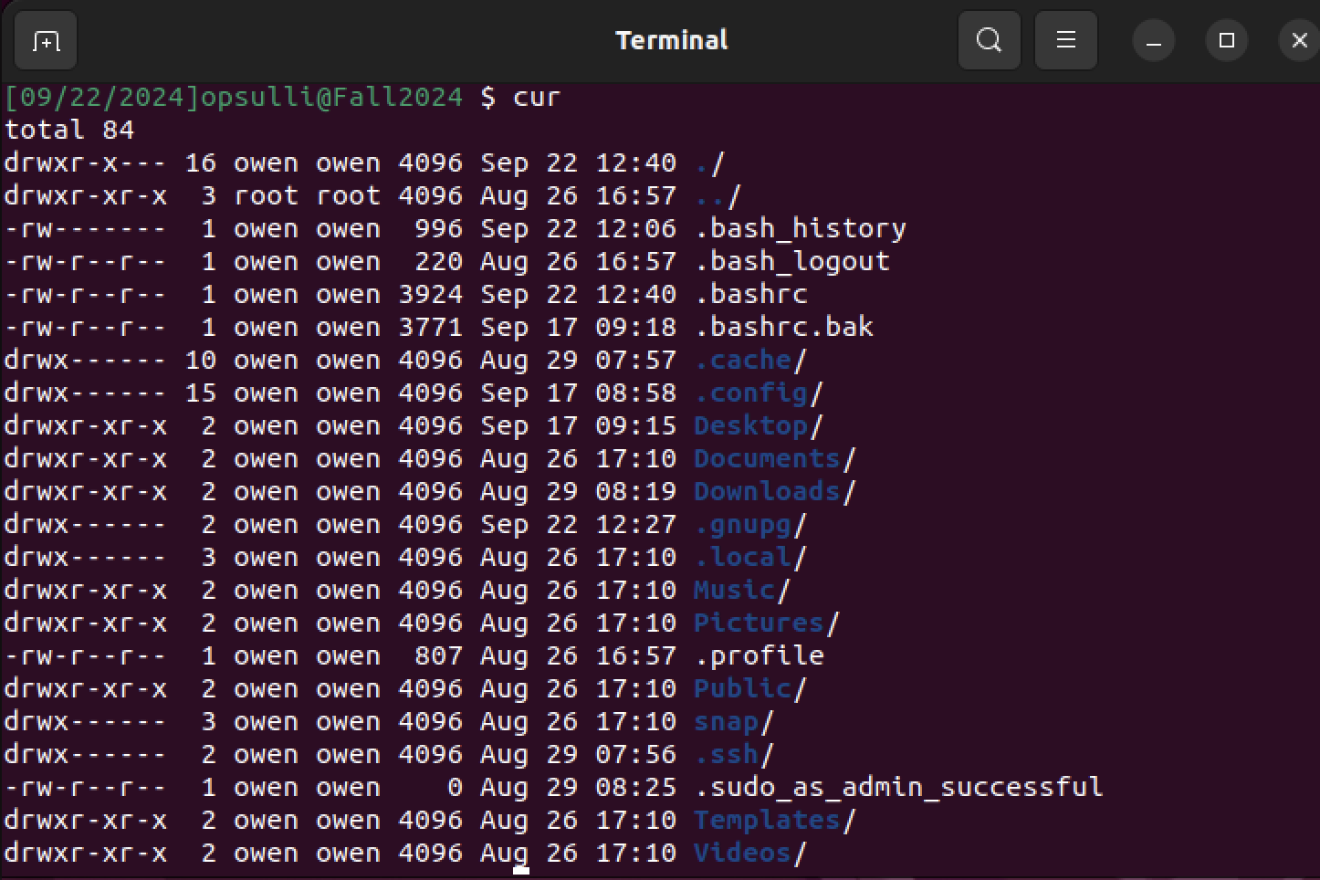
  - “h” alias: 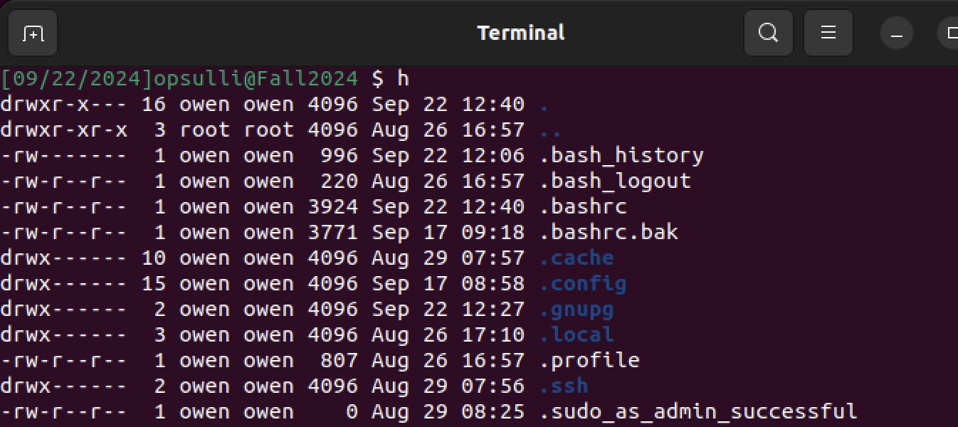
  - To add these aliases, I changed my “.bashrc” file and added two “alias” directives to the end of the file. Then, I used “source” to update my environment again. Alternatively, I could have used “.bash_aliases”, which is recognized by “.bashrc” already, but since my system did not already have that file I decided to just use “.bashrc”. 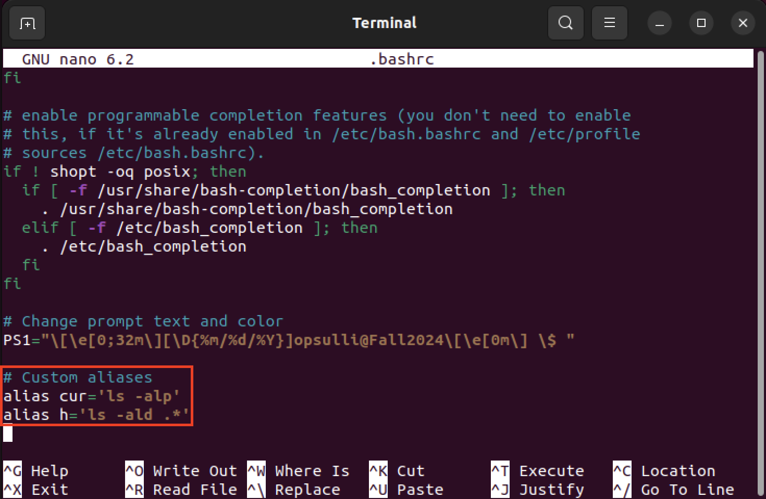
- To force the GRUB2 menu to appear on my VM, I had to edit the “/etc/default/grub” file and change the “GRUB_TIMEOUT” and “GRUB_TIMEOUT_STYLE” options. Then, I had to run “sudo update-grub” and reboot. 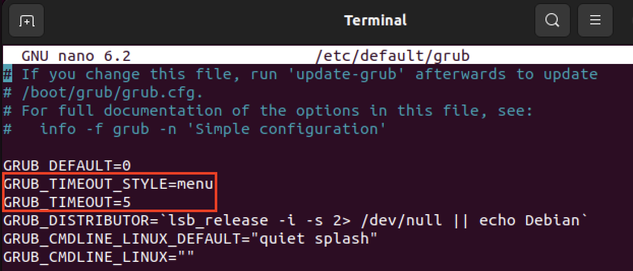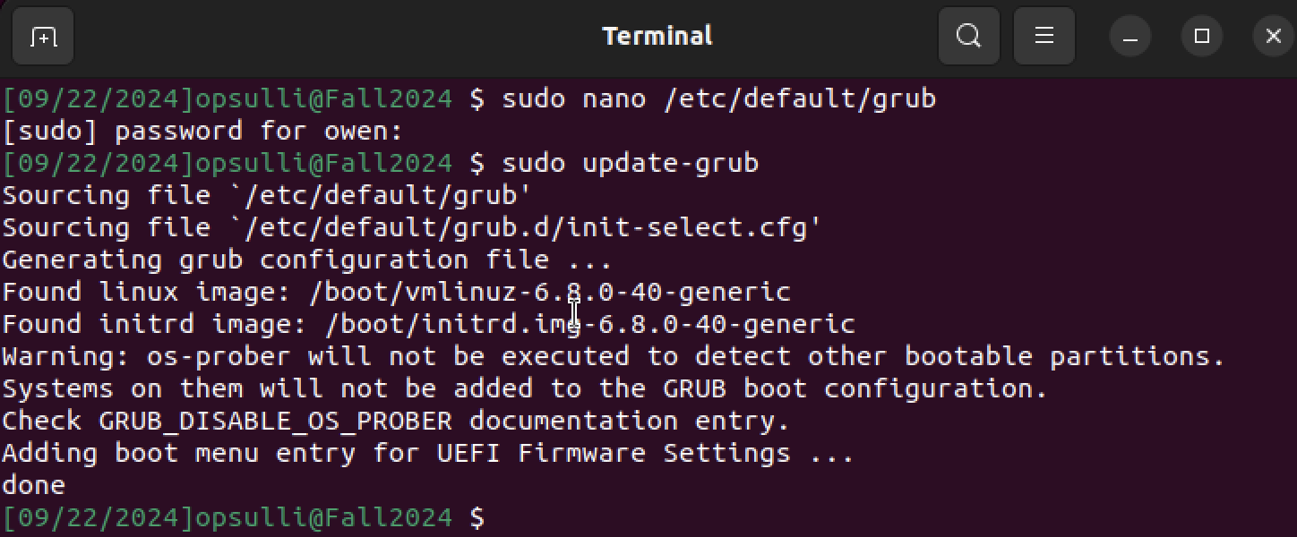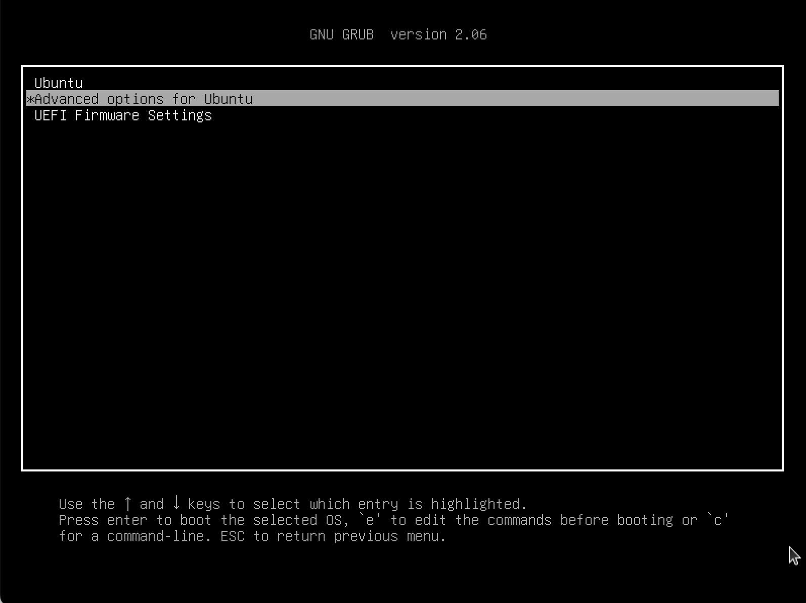
- To set a background image for the GRUB2 boot menu, I had to copy my image of a tiger to the “/boot/grub” directory and update the “GRUB_BACKGROUND” setting in the GRUB config file. Then, I ran “sudo update-grub” again. 