- The /run directory on a Linux system serves as a temporary “tmpfs” filesystem that mounts in RAM during the system’s boot process, and it stores runtime data and files for services starting during initial boot. The files in /run are cleared after each reboot, and those files include PID files for running services, named pipes, socket files, lock files, temporary mount points, and etc.
- Hard links to directories:
  - Newly created, empty directories have a reference count of 2 because each directory automatically contains a ‘.’ directory which is self-referencing. That means that navigating to the ‘.” directory within a new directory will not change to another directory. Because it’s a hard link, this increases the reference count.
  - Directories need the ‘.’ and ‘..’ directories so that programs can more easily access files from the current working directory that the program is running under. For example: if a program needs to access “file.txt” in the same directory as the program was run from, it can use the relative path “./file.txt” instead of having to determine the absolute path to that file. And if the program needs to easily access a file that’s in the directory above the program directory, it can use the relative path “../file.txt” instead of having to split parts of the current path.
- /dev directory:
  - Loop devices are pseudo devices that allow the system to interact with a normal file as though it was a block device (such as a hard drive). A use case for a loop device would be mounting and accessing a digital image file (like a .iso file). There are a lot of loop devices so that many different images or containers can be mounted at the same time. To mount a .iso file, for example, a loop device can be used like this:
  - TTY devices, short for teletypewriter devices, are virtual serial interfaces that can be used for serial connections to programs, physical devices (like microcontrollers), remote shell connections, virtual terminals, and etc. There are a lot of TTY devices because of the variety of different connections that may be made to a system, such as multiple SSH connections at one time or a combination of USB serial devices.
  - PTS/PTY devices, or pseudoterminals, are a type of TTY device used specifically for simulating physical terminals. They are frequently used by terminal emulators and SSH connections, and they’re especially useful for remote connections that require graphical capabilities. PTS/PTY devices work by creating a pair of devices: a master device, which is written to by the program/service leveraging the PTS/PTY, and the slave device, which is used for input/output on the user side.
  - vcs, vcsu, and vcsa devices are virtual console screen devices that allow access to virtual terminal content in different formats. vcs devices provide ASCII text output, vcsu devices provide Unicode text output, and vcsa devices provide the content on screen and metadata about the virtual terminal (like colors and screen size). There are a lot of these devices because many programs need low-level access to retrieve console output, and they are frequently used in automation to monitor the status of other running processes (especially graphical processes).
  - Virtual devices are software-based devices that are used to emulate physical hardware, such as network devices. A virtual device might be used to establish a VPN connection, where the virtual network device simulates network interactions like a hardware network card would. Pseudo devices are abstractions that provide methods for working with processes (including kernel services) and the operating system as though these were hardware devices. They primary facilitate communication and the exchange of information between processes.
  - Pseudo devices:
    - The /dev/null pseudo device acts like a “black hole” by discarding all input (from stdin) and producing no output. It can be written to like any other file:
    - The /dev/zero pseudo device produces a constant byte stream of all 0s and can be used to fill/overwrite memory or files. It can be read from like any other file, in this case to overwrite a file: 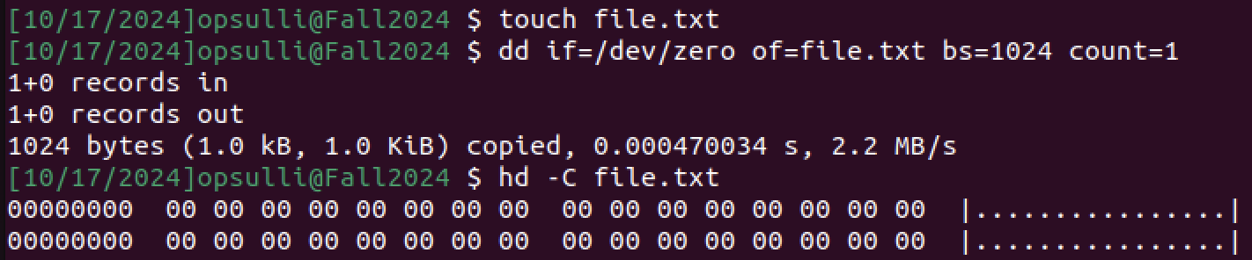
    - The /dev/urandom pseudo device can be used to generate random numbers. The device represents a secure, pseudorandom number generator. Specifically, /dev/urandom generates random data using a hashing algorithm to supplement a lack of random data in the entropy pool, and it doesn’t block reads once the entropy pool has run out. It can be read from like any other file, in this case to overwrite a file: 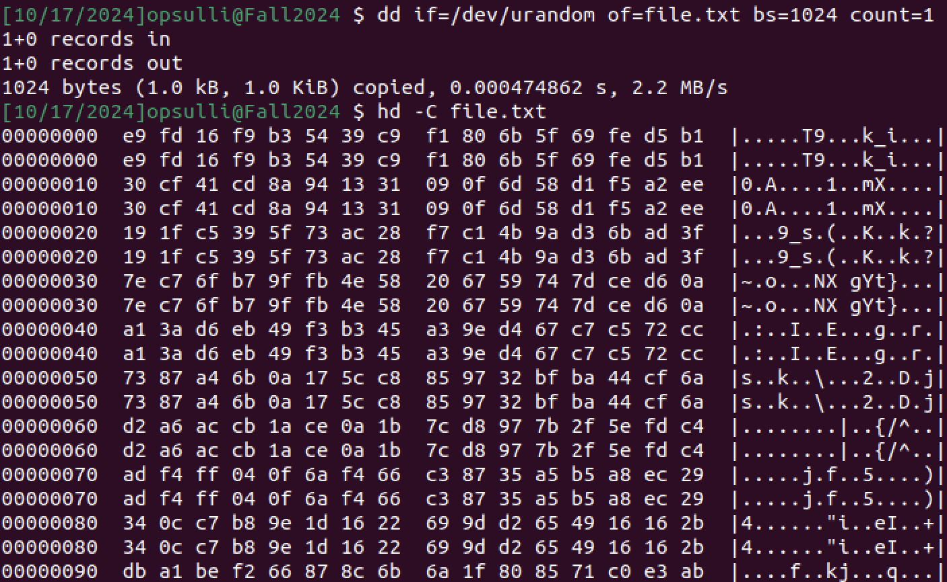
- journald.conf
  - The four storage options in journald.conf are:
    - “volatile”, which means that journal log data will only be stored in memory
    - “persistent”, which means that journal log data will be stored on a disk
    - “auto”, which defaults to “persistent” when the /var/log/journal directory exists in the filesystem or “volatile” otherwise
    - “none”, which turns off all log storage and drops all log data received (but still forwards to other targets, like the console)
  - 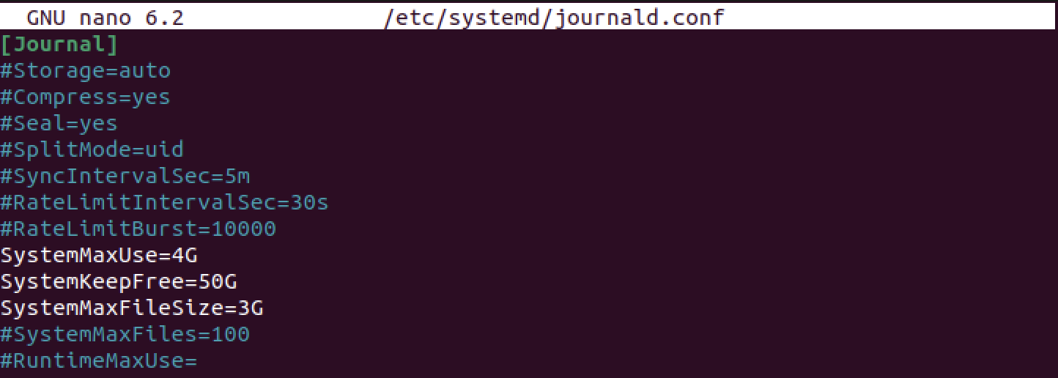
- The logrotate command can be used to manage, compress, and remove journald log files in order to prevent them from taking up too much storage space. There is typically a cron job that runs logrotate once per day to automatically rotate logs. Configuration information is stored in /etc/logrotate.conf, and there are some program-specific configuration files in the /etc/logrotate.d directory: 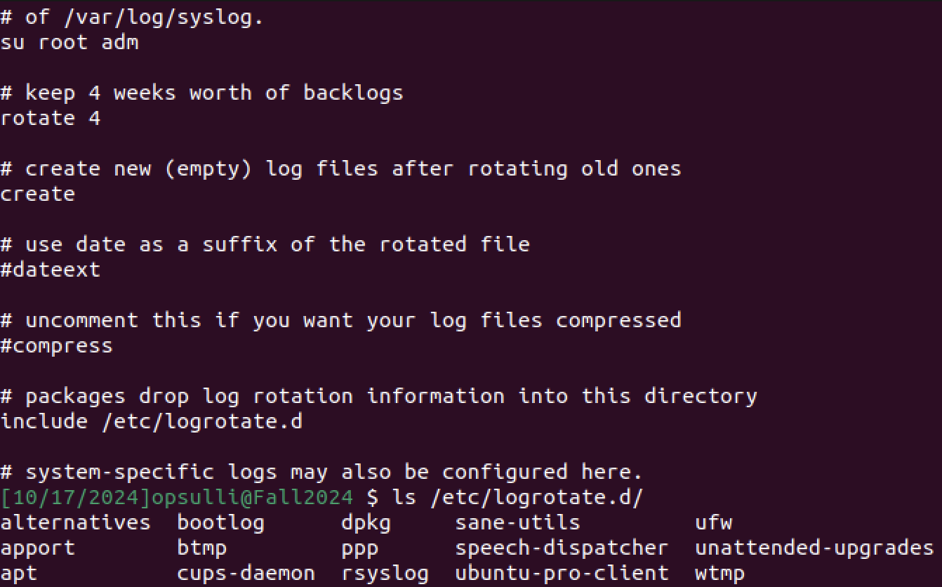
You can use a few command-line options with logrotate, such as the “-d” flag to perform a dry run (outputting steps but not actually performing them) or the “-f” flag to force log rotation (in cases where logs would not be rotated according to retention criteria): 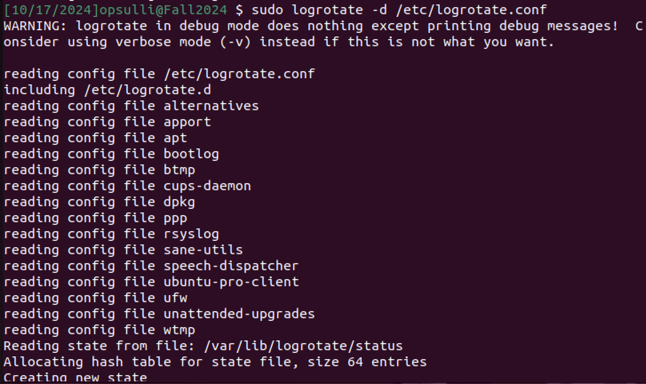
There are various directives used within a logrotate configuration file (such as those found in /etc/logrotate.d) that determine retention policies: 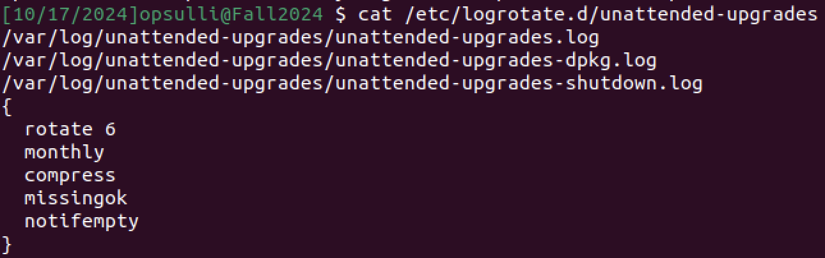
- Pipes and sockets:
  - Pipes (also called named pipes or FIFOs) are a type of file used for communication between processes on the system. They allow data to be transmitted in byte streams, either one-way or two-way, and they are responsible for most of the data flow between programs. Pipes can be created anonymously using the ‘|’ operator in a shell, which allows passing the output from one command as the input to another (commonly used for grep), or as named pipes using the mkfifo command or mknod system call, which allows two or more processes to interact with the pipe. Named pipes for communication between system services and daemons can commonly be found in /run: 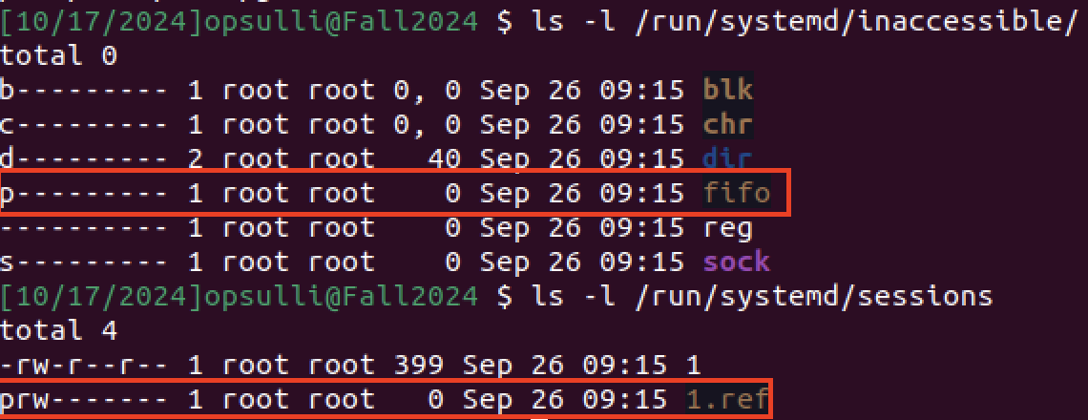
  - Sockets are another type of file used for communication between processes, either on same system or between systems on a network. Sockets are most commonly used for network communication, however they are also used to facilitate communication between a container and the host system. There are a couple of sockets associated with the snapd daemon in /run: 