- The partitioning scheme used on modern flavors of Linux (particularly those that support UEFI systems) is the GUID Partition Table, or GPT, scheme.
  - By default, the GPT scheme allows for 128 partitions. That maximum can be increased by modifying the partition table structure manually, however this is uncommon and not recommended for the typical system.
  - Although the GPT scheme does implement support for partition designations found in the Master Boot Record (MBR) scheme that was used prior to GPT, namely “primary”, “extended”, and “logical”, it does not use those designations and instead allows for all partitions to be used without special configurations.
    - Primary partitions support operating system installations and can be booted from under MBR.
    - Extended partitions support collections of logical partitions as a “single” partition under MBR, and they’re used to work around MBR’s limitations of 4 primary partitions. An extended partition functions similarly to a primary partition.
    - Logical partitions are partitions within an extended partition that are typically used to store data. In most cases, they cannot be used to boot an operating system installation.
- The paper “Security through Obscurity” by Jay Beale explains how obscurity, the practice of hiding some details about a system’s deployment and use, cannot be relied on as a primary means of security and instead should be used as a way of delaying attacks and reducing attack surfaces.
  - Beale uses the example of a company’s vulnerable internal web server running IIS 4.1:
    - Attackers can use a variety of tools (like port scanners) to look for running web servers on a network, and, if there is no access control present on a website running on a server, then an attacker can run away with the company’s data.
    - If there is access control, but the web server is running on a common port (like port 80), then it’s much easier for an attacker to trick employees into divulging information about how the website works and how to access it (phishing attacks, social engineering, etc.).
    - If the web server is running on a non-standard port, an attacker must search multiple ports (potentially on multiple systems) on the network to determine where the vulnerable web server is located. That means more connections over the network, which means a greater chance that security personnel can identify an increase in connections across multiple ports from the same source.
  - Beale also speaks on the distinction between worrying about disclosing the encryption methods used in a system and worrying about disclosing private keys used to access the system behind encryption.
  - In summary, obscurity is a good thing when it’s used to make an attacker’s life more difficult in combination with proper access control and encryption. Obscurity is a bad thing when it’s used as the primary method of securing a system.
  - Personally, I couldn’t agree more with Beale’s take on obscurity. I work for a small business where network and system security are of the utmost importance. I frequently get annoyed that we don’t use DNS and hostnames to identify servers on our network, but I am often reminded that it’s a lot easier for system administrators to remember a few IP addresses than to constantly be worried about which non-administrator employees know about hostnames. Obscurity seems to me like an extra step to be taken after properly securing systems.
- According to the paper “Signature IDS vs Anomaly IDS” by Peter Loshin, the differences between signature-based and anomaly-based intrusion detection systems are the scanning methods used to detect malicious network activity.
  - A signature-based IDS scans network traffic for attack sequences, called signatures, associated with known malicious code, packet headers, IP addresses, and other data. These signatures are collected prior to scanning and often stored in a local or remote database, depending on the IDS solution, and elements of network traffic are checked against those signatures to look for patterns that may indicate an intrusion.
  - An anomaly-based IDS scans network traffic for patterns of behavior that may indicate an attack, such as multiple unknown source IP addresses making first-time connections to multiple ports on the network within a certain range.
  - The primary difference between signature-based and anomaly-based IDSs is that signature-based systems will be more likely to detect known attacks, and anomaly-based systems will be more likely to detect new attacks. Neither is a replacement for the other, and both should be used together for the needs of most organizations.
- Snort is an open-source intrusion prevention system (IPS) for Linux that uses “rules” (collections of signatures and attack patterns) to act as a packet sniffer, a packet logger (for debugging network traffic), or a full-suite intrusion detection system.
  - Snort has a “Community Ruleset” that’s available to all users, as well as a “Snort Subscriber Ruleset” that’s available to paid clients and approved by Cisco security engineers. Snort determines its ruleset from the value of the “RULE_PATH” variable in Snort’s configuration file at “/etc/snort/snort.conf”: 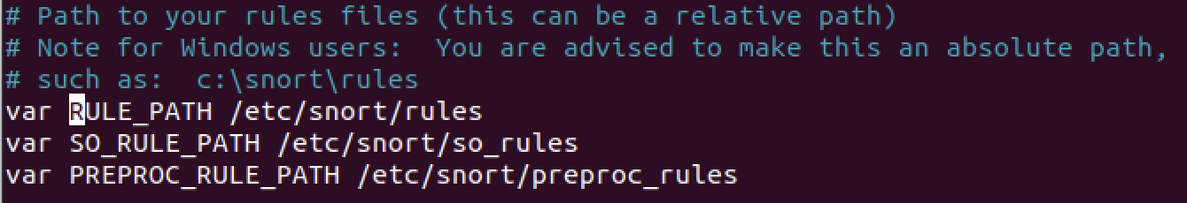
  - Snort can listen on different networks and network interfaces according to what’s available on the system, and it determines the system’s IP address from the value of the “HOME_NET” variable in Snort’s configuration file: 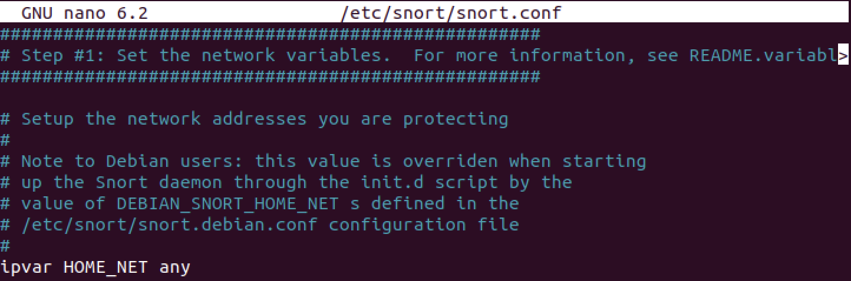
  - Snort can be started in intrusion detection mode using the following command: “sudo snort -dev -l [log_directory] -c [config_file]” where “-d” is used to log application layer data, “-e” is used to log link layer data, and “-v” displays packet information in the console. This checks incoming network traffic against Snort’s pre-defined rules, which currently are the “Community Ruleset”: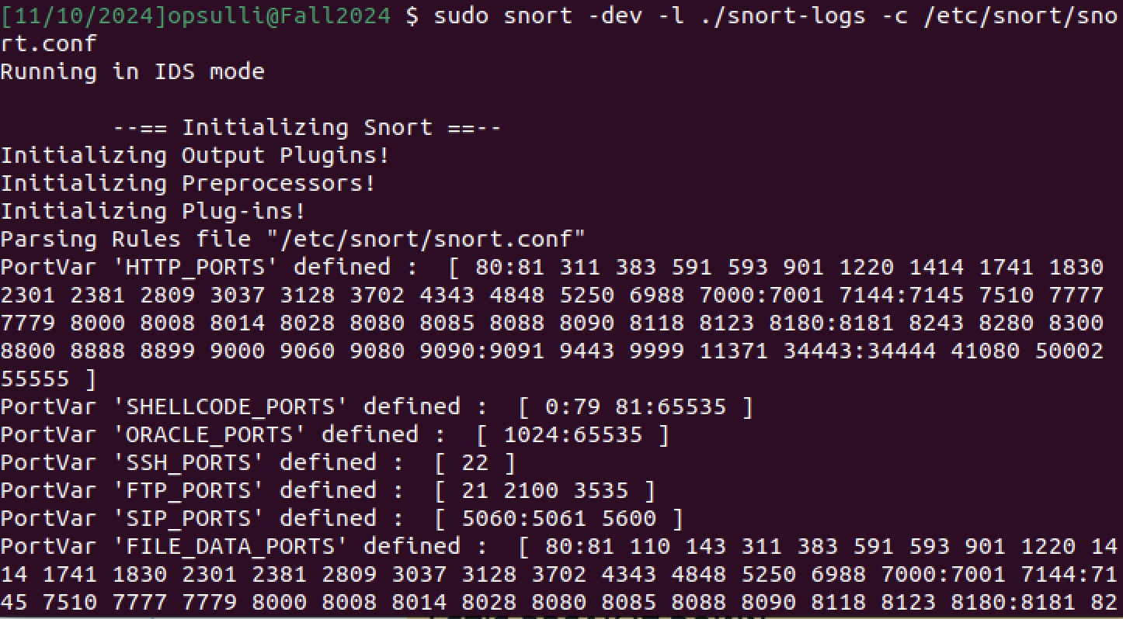
  - Snort can also be used as a basic packet sniffing tool by running with minimal options like “sudo snort -v”: 