Solution Worksheet
Identify the POTENTIAL services needed and the purpose for each service that will be used to move TigerMed’s current environment to AWS:
- Amazon RDS for SQL Server
- Amazon EC2
- Elastic Load Balancing
- Amazon Virtual Private Cloud (VPC)
- Identity and Access Management (IAM)
- Amazon S3
- Amazon Route 53

Identity and Access Management
TigerMed Company Account
Systems Administrator Group | Database Administrator Group | Monitoring Group | Role
Amos Admeen |  |  | Lead Systems Administrator
 | Dee Beead |  | Database Administrator
Barb Cistems |  |  | Systems Administrator
 |  | Noah Sleep | AWS Resource Monitor
 | Ghat Yurdata |  | Sr. Database Administrator
 |  | Isaac Zeeall | AWS Resource Monitor
 |  | Ida See | AWS Resource Monitor

Use a table like this to work out the groups and their associated permissions
Role/Group | Permissions
Systems Administrator Group | Full Access: Complete control over all systems and configurations.  User Management: Ability to create, modify, and delete user accounts and groups.  System Configuration: Modify system settings, install and update software.
Database Administrator Group | Database Access: Full read/write access to all databases.  User Management: Create and manage database users and permissions.  Schema Management: Modify database schemas and structures.  Data Integrity: Enforce data integrity and validation rules.
Monitoring Group | Read-Only Access: View system and database performance metrics.  Alerts and Notifications: Configure alerts for system performance issues.  Reporting: Generate reports on system and database health.  Incident Reporting: Ability to report incidents to the relevant groups.

User Authentication
Requirement | Solution
Passwords should be at least 8 characters and have 1 uppercase, 1 lowercase, 1 special character, and a number | Use an IAM policy to set the requirements for the password and not let the password continue without the user completing all of the requirements
Passwords must be changed every 90 days; the last three passwords cannot be reused | Send out an email to each user or text reminder to let them know that their password will need to be reset two weeks before the password will expire. Add an IAM policy that sets it up within application
All administrators require programmatic access | Each admin should have an access key ID and a secret access key
Administrator sign-in to the AWS Management Console requires the use of Virtual MFA | Each admin should have the 12 digit account ID, an IAM username, and an IAM password

Network Architecture
VPC | Region | Purpose | # of Subnets | # of AZs | VPC CIDR  Range
TigerMed-US-VPC | us-east-1 | Handles U.S. traffic | 4 | 2 | 10.1.0.0/16
TigerMed-APAC-VPC | ap-northeast-1 | Handles APAC traffic | 4 | 2 | 10.2.0.0/16
TigerMed-EU-VPC | eu-west-2 | Handles Europe traffic | 4 | 2 | 10.3.0.0/16

Subnet Name | VPC | Subnet Type | AZ | Subnet CIDR Range
TigerMed-US-Public-1 | TigerMed-US-VPC | Public | us-east-1a | 10.1.1.0/24
TigerMed-US-Private-1 | TigerMed-US-VPC | Private | us-east-1a | 10.1.2.0/24
TigerMed-US-Public-2 | TigerMed-US-VPC | Public | us-east-1b | 10.1.3.0/24
TigerMed-US-Private-2 | TigerMed-US-VPC | Private | us-east-1b | 10.1.4.0/24
TigerMed-APAC-Public-1 | TigerMed-APAC-VPC | Public | ap-northeast-1a | 10.2.1.0/24
TigerMed-APAC-Private-1 | TigerMed-APAC-VPC | Private | ap-northeast-1a | 10.2.2.0/24
TigerMed-APAC-Public-2 | TigerMed-APAC-VPC | Public | ap-northeast-1b | 10.2.3.0/24
TigerMed-APAC-Private-2 | TigerMed-APAC-VPC | Private | ap-northeast-1b | 10.2.4.0/24
TigerMed-EU-Public-1 | TigerMed-EU-VPC | Public | eu-west-2a | 10.3.1.0/24
TigerMed-EU-Private-1 | TigerMed-EU-VPC | Private | eu-west-2a | 10.3.2.0/24
TigerMed-EU-Public-2 | TigerMed-EU-VPC | Public | eu-west-2b | 10.3.3.0/24
TigerMed-EU-Private-1 | TigerMed-EU-VPC | Private | eu-west-2b | 10.3.4.0/24

Web and Application Tier
Tier | Tags* | OS | Instance Type | Justifications | # of instances | User Data?  Y/N
Web |  | Windows Server 2016 | t3.medium | 2 vCPUs, 4GB RAM, 5Gbit network | 2 (4) | N
App |  | Windows Server 2016 | t3.xlarge | 4 vCPUs, 16GB RAM, 5Gbit network | 2 (4) | N
DB |  | SQL Server Standard Edition | db.m4.2xlarge |  | 1 (2) | Y

Security Groups
Security Group | Type | Protocol | Port | Source | Description
Web | HTTP and HTTP/S | TCP | 80 and 443 | IPv4 anywhere | Allow connections from public internet
App | HTTP and HTTP/S | TCP | 80 and 443 | 10.1.2.0/24 (or relevant private subnet for AZ) | Connect to private subnets for communication
DB | Custom TCP | TCP | 1433 | 10.1.2.0/24 (or relevant private subnet for AZ) | Connect to private subnets for communication

High Availability
- What do you need for a high availability environment?
  - Resilient Architecture
    - Load Balancer: Distribute traffic among multiple web/application servers to ensure no single point of failure.
    - Redundant Servers: Deploy multiple instances of web and application servers across different availability zones (AZs).
  - Automatic Server Replacement:
    - Health Checks: Implement monitoring to detect unresponsive servers. Use tools like AWS CloudWatch or similar services to automatically replace non-responding servers.
    - EC2 Auto Scaling: Use auto scaling groups (ASGs) to manage instances that automatically replace unhealthy instances. Also useful for scaling up during times of heavy use and down during low utilization.
  - Failure Detection:
    - CloudWatch metrics: Verifies the system is performing as expected. Creates an alarm to initiate an action if a metric goes outside an acceptable range.
  - Back-ups
    - Backup Strategies: Regular automated backups and point-in-time recovery options to prevent data loss.
    - Database Replication: Use database replication features that support Multi-AZ (e.g., AWS RDS, Azure SQL) to ensure data availability and failover capabilities.
- What do you need to configure automatic scaling?
  - Elastic Load Balancer
    - Works well with CloudWatch, which will alert the application when utilization rates are out of normal range
    - Evenly distributes traffic across compute instances, which is important as instances are added/removed in response to traffic.
  - CloudWatch Metrics
    - Monitoring must be enabled for autoscaled EC2 instances and the Auto Scaling group as a whole
    - Alarms need to be added for high and low traffic scenarios, which will alert the Auto Scaling group to add or remove instances
  - EC2 Auto Scaling Group
    - Needs to have a minimum, desired, and maximum instance capacity
    - Needs a target value for scaler to maintain
    - Needs a template instance for the group to replicate
Auditing
- AWS CloudTrail
- Amazon S3
- AWS IAM (Identity and Access Management):
- Amazon CloudWatch

Questions:
Will doctors only be working with people in their region?
Is it more likely for one region to have more participants than another region?
Are they expecting to expand to other countries and where would these countries be located?
Does the doubling requirement apply to each region?
Are you expecting constant usage by all participants?
Does the company have different domains for the different regions?
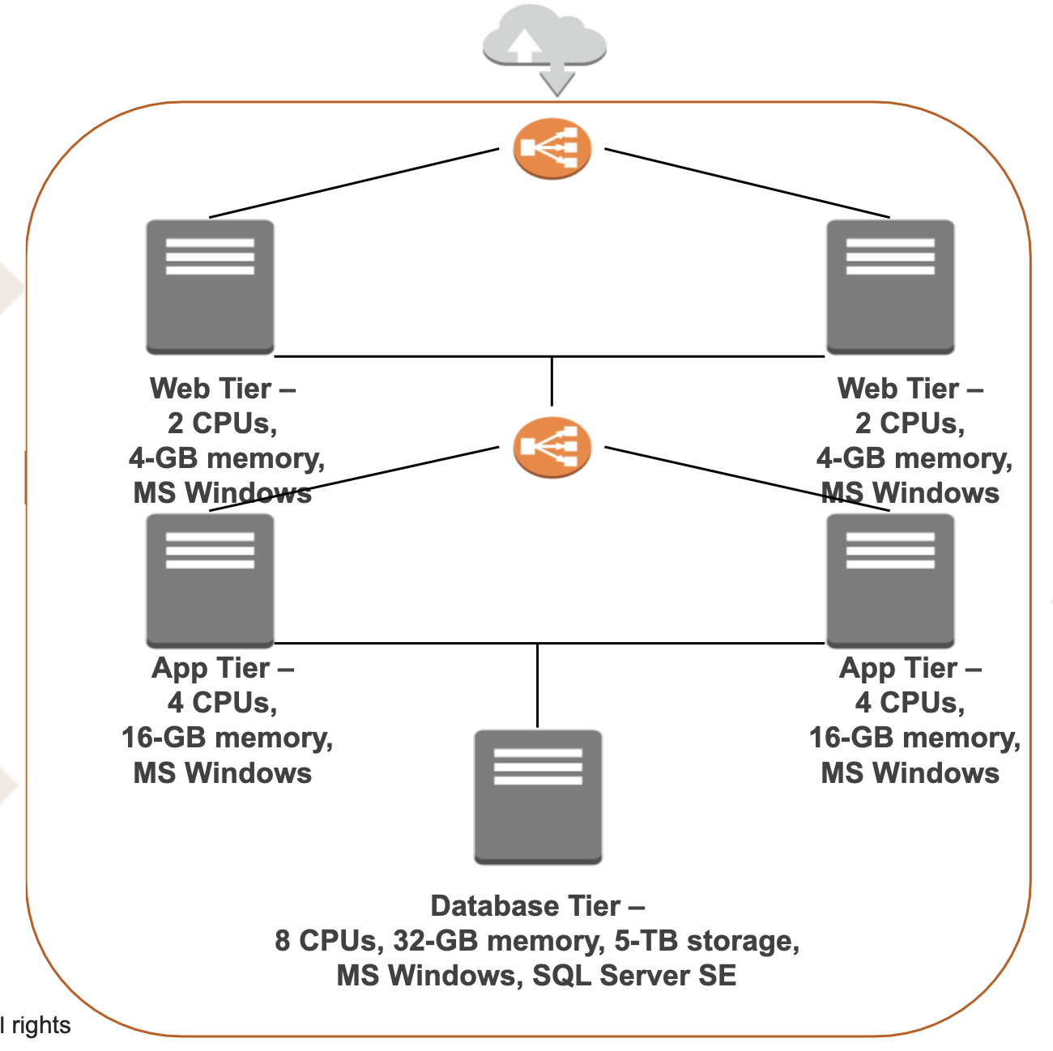
–
Key things to note/requirements:
- Use current architecture but for double demand
- Using sql server
- US, Asia Pacific, Europe
- Uploading images and documents, buckets
- Host dev, prod, and test
- Dont need advanced config for database, rds will be good
- Secure bc medical PII
- Load balancers for web AND app tier
- Resilient (high availability, scale, business continuity)
- Auditing to track user actions
- Role for app to read/write to buckets

