CPSC 2150 Lab 2 Report
Owen Sullivan, Jeremy Sarasua, Aileen Shi, Ethan Coffey

Requirements Analysis

Functional Requirements:

- As a customer, I need to be able to search items so that I can pick out which ones I want to buy.
- As a customer, I need to be able to add stuff to my shopping cart so that I can buy them.
- As a customer, I need to be able to delete things from my shopping cart if I change my mind.
- As a customer, I need to be able to add payment information to my account so that I can make purchases.
- As a customer, I need to be able to add an address to my account so that I can have things shipped there.
- As a customer, I need to be able to add a second address to serve as a separate billing address for purchases.
- As a customer, I need to be able to initiate a return if I am unhappy with a product.
- As a customer, I need to be able to leave a review in order to rate a product.
- As a customer, I need to be able to sign in to my Amazon Prime account so I can access better deals.
- As a customer, I need to be able to talk to customer service to discuss any issues I encounter with my purchases.
- As a customer service representative, I need to be able to find a customer’s order information in order to provide support or initiate a return, etc.
- As a customer, I need to be able to track my package in order to see where it is and when it will be delivered.
- As a customer, I need to be able to save items in my cart for later if I do not wish to purchase them immediately.
- As a customer, I need to be able to make lists so that I can share them with my friends or family.
- As a content creator, I need to be able to generate an affiliate link for items so that I can get a cut of products I help sell.
- As a seller, I need to be able to check statistics about the items I’ve sold so that I can generate sales reports.
- As a customer, I need to be able to add items to a list I’ve created so that I can find them easily later.
- As a customer, I need to be able to find and search through reviews about a product in order to learn more about its quality.
- As a seller, I need to be able to change information (such as price) about the products I sell in order to create sales or promotions.
- As a seller, I need to be able to add descriptions or other product info to my products in order to provide accurate details about my products.
- As a seller, I need to be able to remove products from my store so that I can stop selling them.
- As a customer, I need to be able to find and view my past purchases in order to reference previous order details.
- As a customer, I need to be able to purchase an item that I’ve previously purchased again in order to have more than one.
- As a customer, I need to be able to create a subscription to a product that I wish to purchase frequently so that I don’t need to remember to purchase it again.
- As a customer, I need to be able to modify my language settings so that I can read in another language if I speak it.
- As a customer, I need to be able to create specific Prime Video profiles so that I can store different preferences for different people.
- As a customer, I need to be able to view recommendations by Amazon so that I can find new content or items.
- As a delivery driver, I need to be able to find the address where I’m supposed to deliver a package so that I can deliver effectively.
- As a delivery driver, I need to be able to find where to pick up a return box so that a customer’s return can be completed.
- As a warehouse worker, I need to be able to find the appropriate box to use for a certain item size.
- As a warehouse worker, I need to be able to find a shipping label to put on a package so that it can be delivered.
- As a customer, I need to be able to message a seller of an item so that I can discuss issues about a product directly with the seller.
- As a seller, I need to be able to respond to customers so that I can handle issues with purchases.
- As a customer, I need to be able to browse through a list of items that I’ve previously viewed but not purchased so that I can find items again.
- As a customer, I need to be able to manually add my interests so that Amazon can effectively suggest new items or services.
- As a customer, I need to be able to access Amazon’s Luna gaming service easily so that I can play video games on the go.
- As a systems administrator, I need to be able to add new tiers of cloud storage through AWS so that I can expand my cloud systems.
- As a systems administrator, I need to be able to provision new AWS virtual machines so that I can move functional computer systems off-location.
- As a customer, I need to be able to access Amazon’s pharmacy services easily so that I can schedule delivery for medications along with any other items I purchase.
- As a customer, I need to be able to have medications delivered through Amazon’s pharmacy services without any human contact so that I don’t risk getting any sicker.
- As a medication producer, I need to be able
- As a seller, I need to be able to upload product images so that customers can see what my products look like.
- As a seller, I need to be able to upload product usage videos so that customers can see how my products work.
- As a home user, I need to be able to ask Alexa for information about the weather so that I can start my day more effectively.
- As a home user, I need to be able to ask Alexa for information about tracking my packages so that I can predict when they’ll arrive.
- As a customer, I need to be able to add songs to playlists on Amazon music so that I can keep track of the songs I like.
- As a customer, I need to be able to add my insurance information so that my medications can be covered by my insurance.
- As a customer, I need to be able to filter songs on Amazon music by genre so I can ignore any genres of music I don’t like.
- As a sales representative, I need to be able to offer my customers a credit card through Amazon so that they can receive the benefits that the credit card offers.
- As a customer, I need to be able to recover my account password so that I can still access my account if I forget my login information.

Non-Functional Requirements

- The backend items database needs to include lots of identifying metadata that allows search functionality to effectively find items based on loose descriptions.
- All of the website deployments need to be hosted on Amazon Web Services as a server cost-cutting measure.
- All identifying user information needs to be stored in a secure and encrypted way.
- Any website parts that face consumers need to load in under three seconds.
- The website frontend needs to be partially written in JavaScript.

System Design

Student:
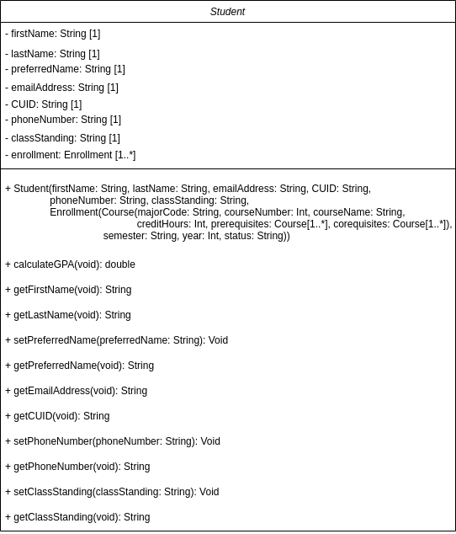

Course:

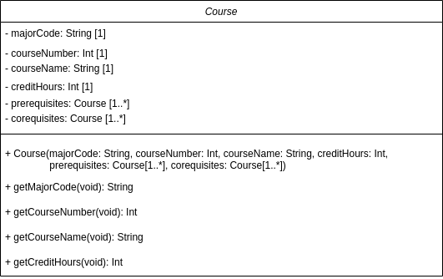

Enrollment:

