CPSC 2150 Lab 3 Report
Owen Sullivan, Ethan Coffey, Aileen Shi, Jeremy Sarasua

System Design

ascendingOrderThree:

Activity diagram
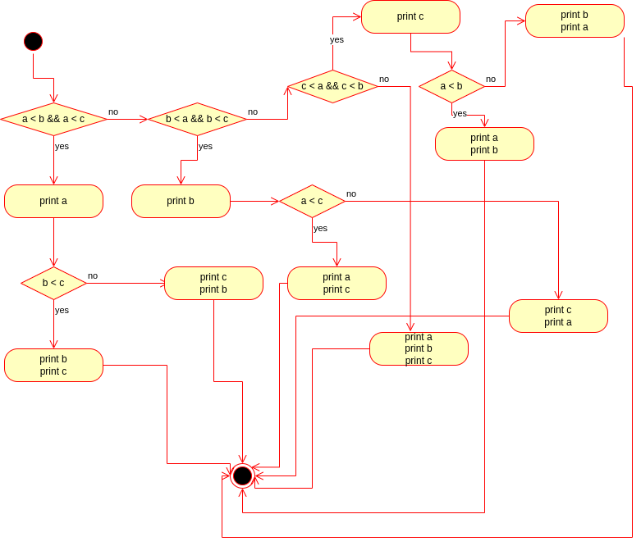

isPalindrome:

Activity diagram
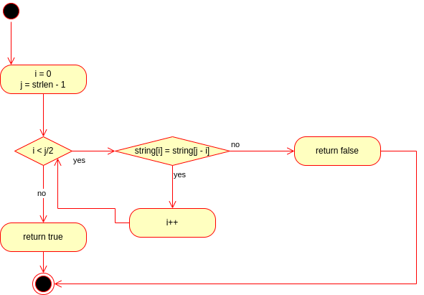

calculateGPA:

Activity diagram
