Case Study – 5
(60 points)
Name: Owen Sullivan
Clemson ID: C34243277
Submission: Save this Word document with your answers as a PDF file and upload the PDF file to Canvas.

Build a set of Data Flow Diagrams for the EVCSS Project. Use one of the diagramming tools identified on the “External Tools Page” in Canvas. Make sure you have processes and data stores in your level 0 & 1 DFDs.
- (10 pts) Context Diagram, Fig 5.11 & Fig 5.12
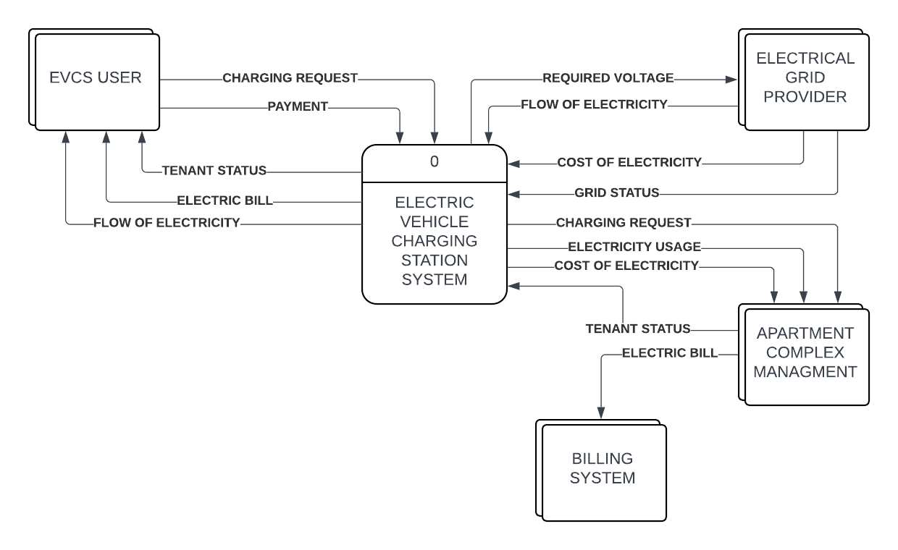

- (10 pts) Level 0 DFD, Fig 5.12 & Fig 5.13
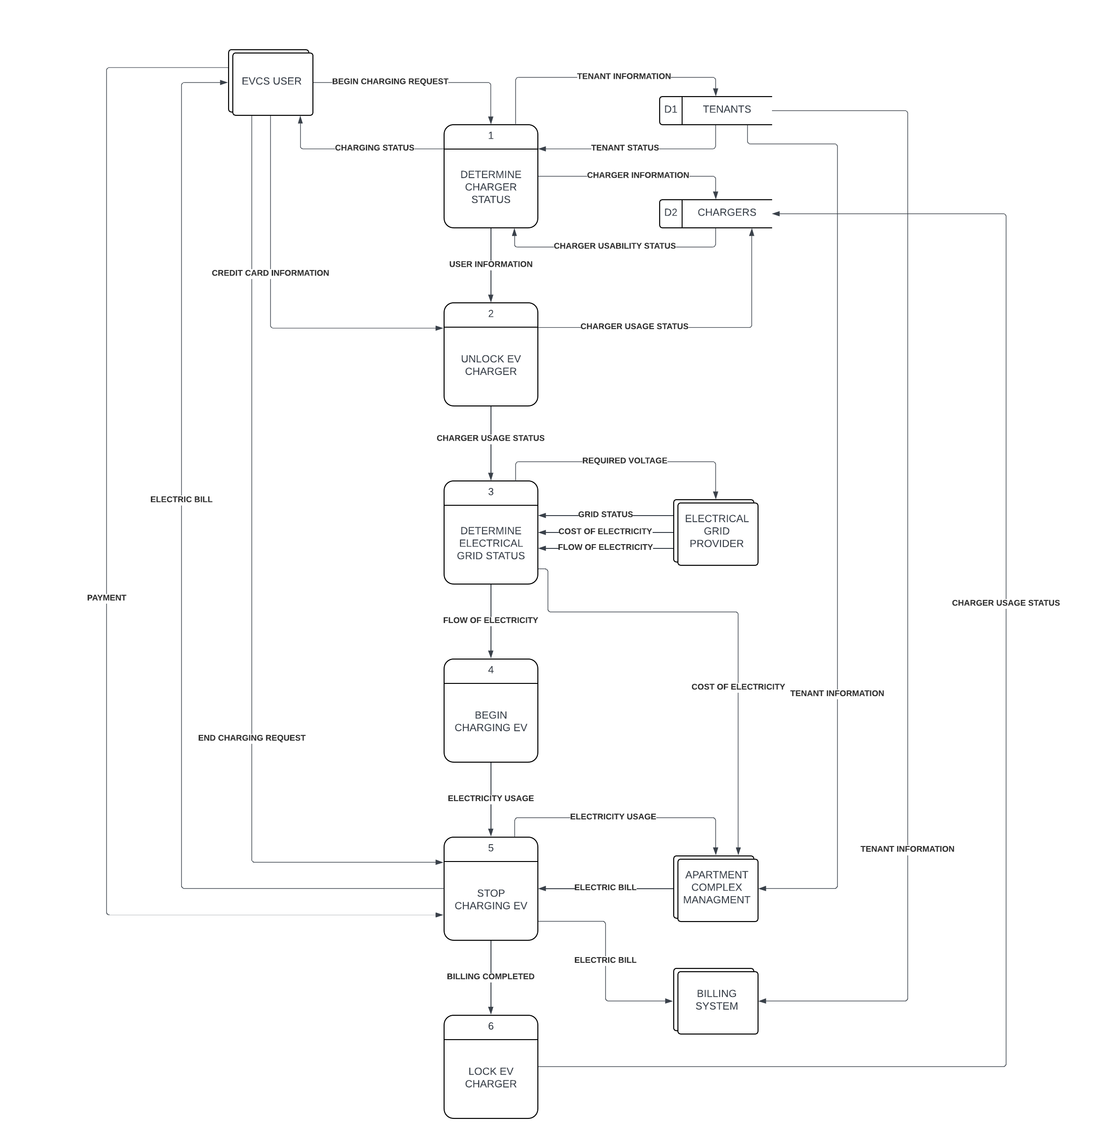

- (20 pts) Level 1 DFDs (4 DFDs worth 5 pts each), Fig 5.14 & Fig 5.15
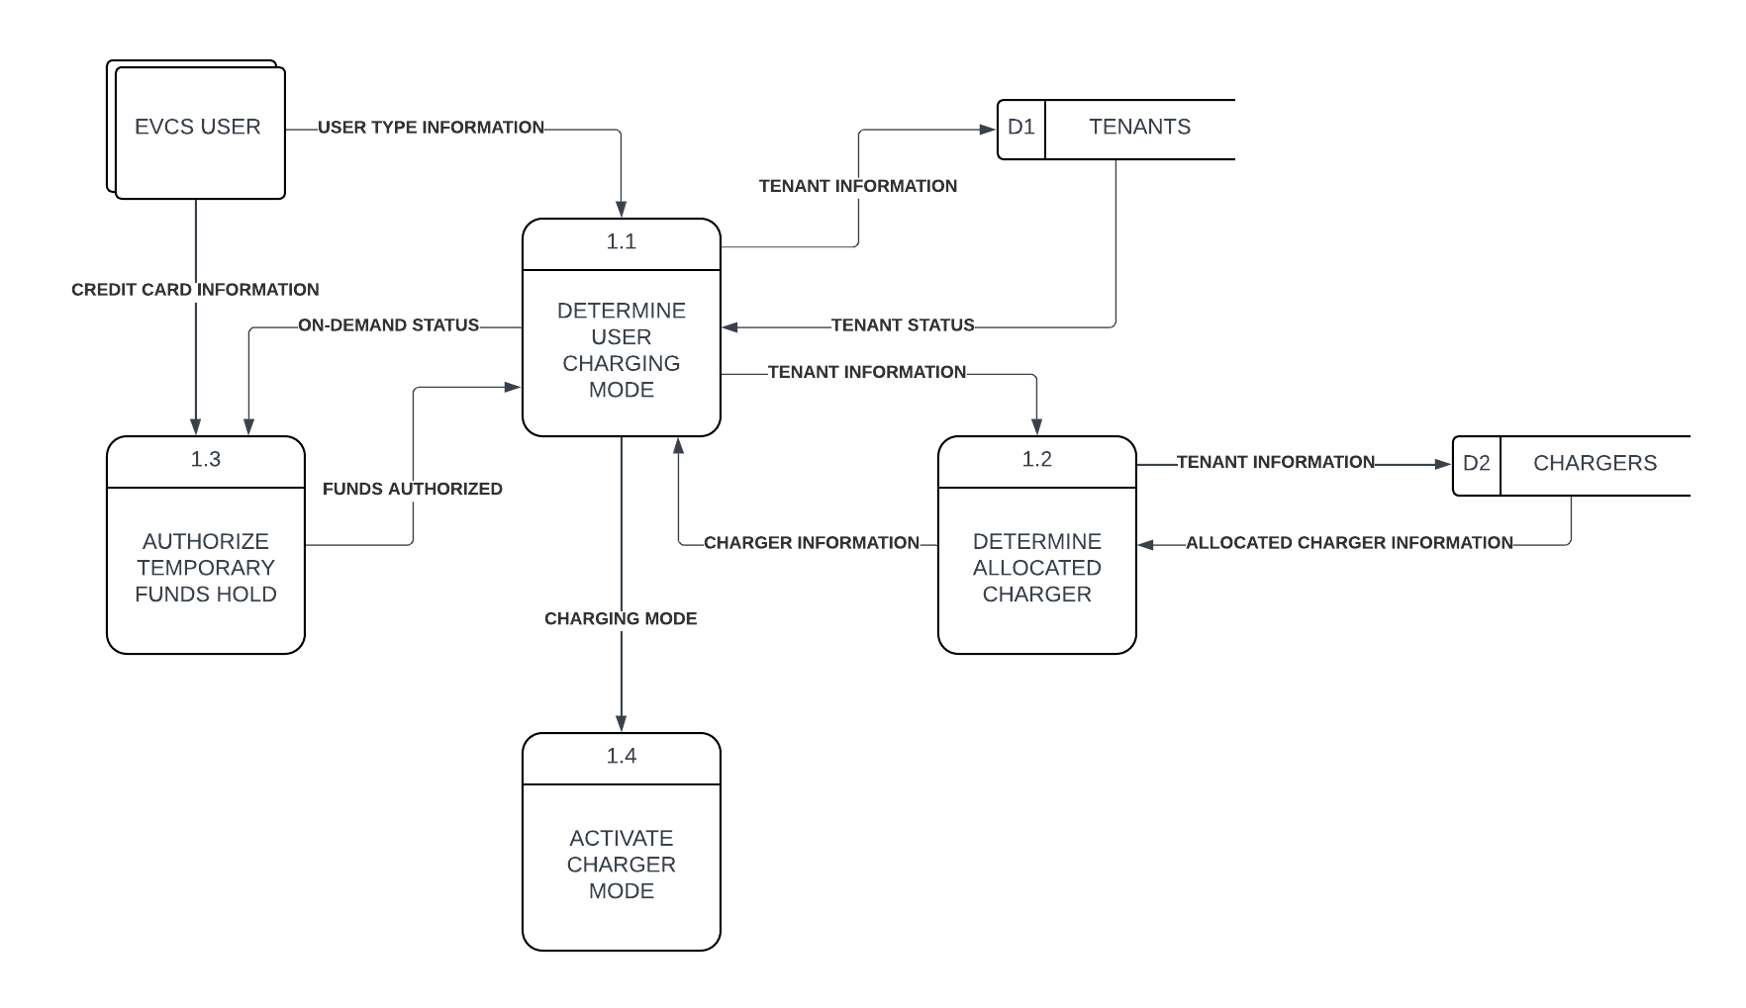
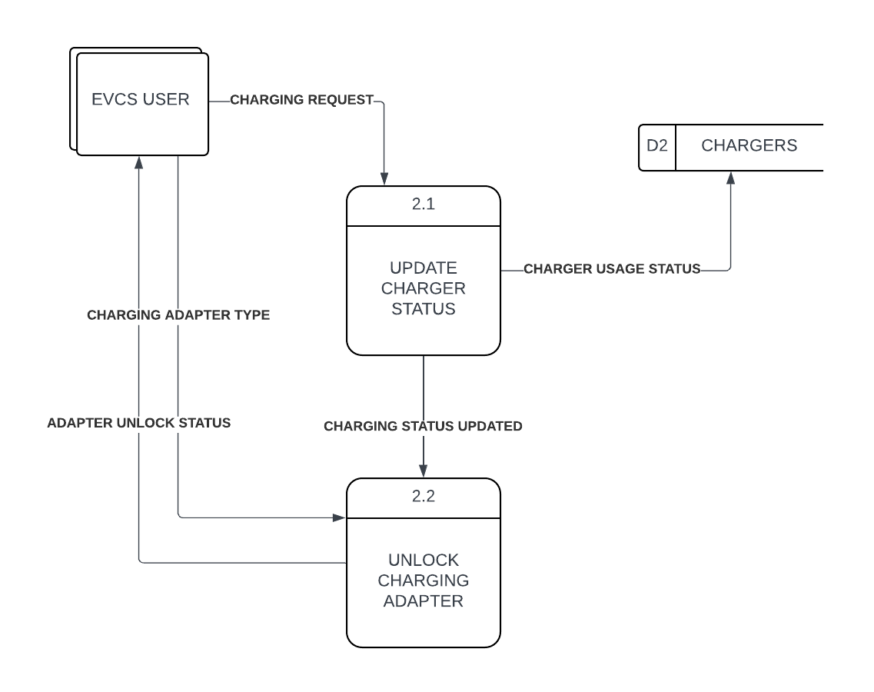
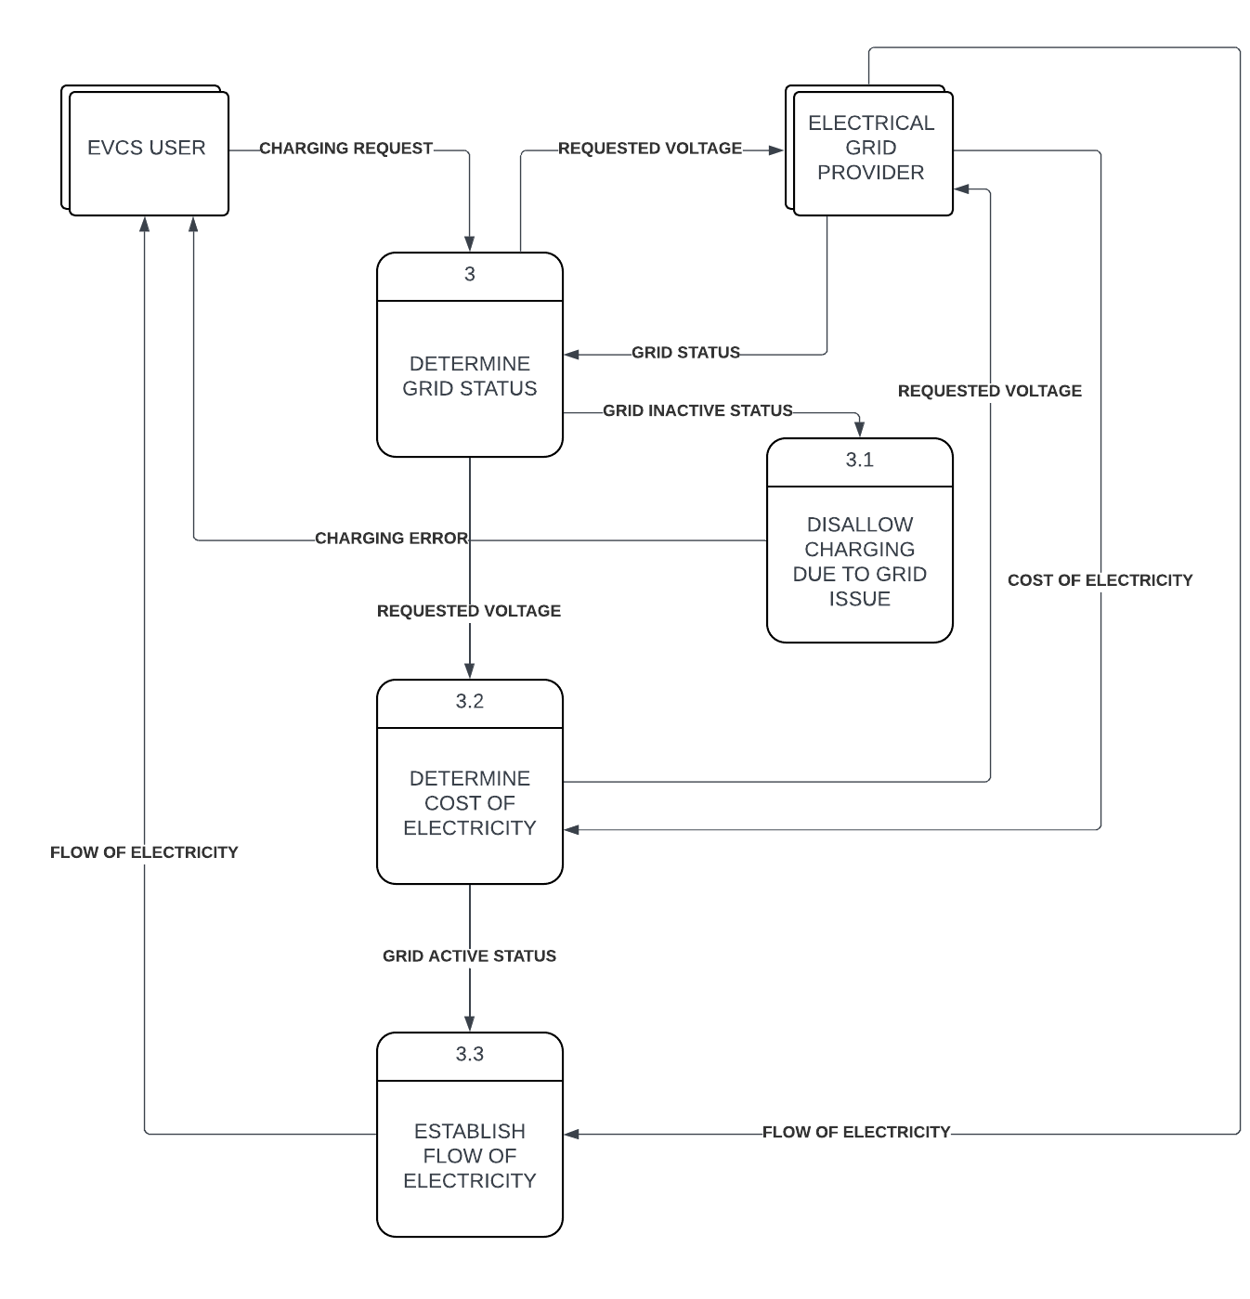
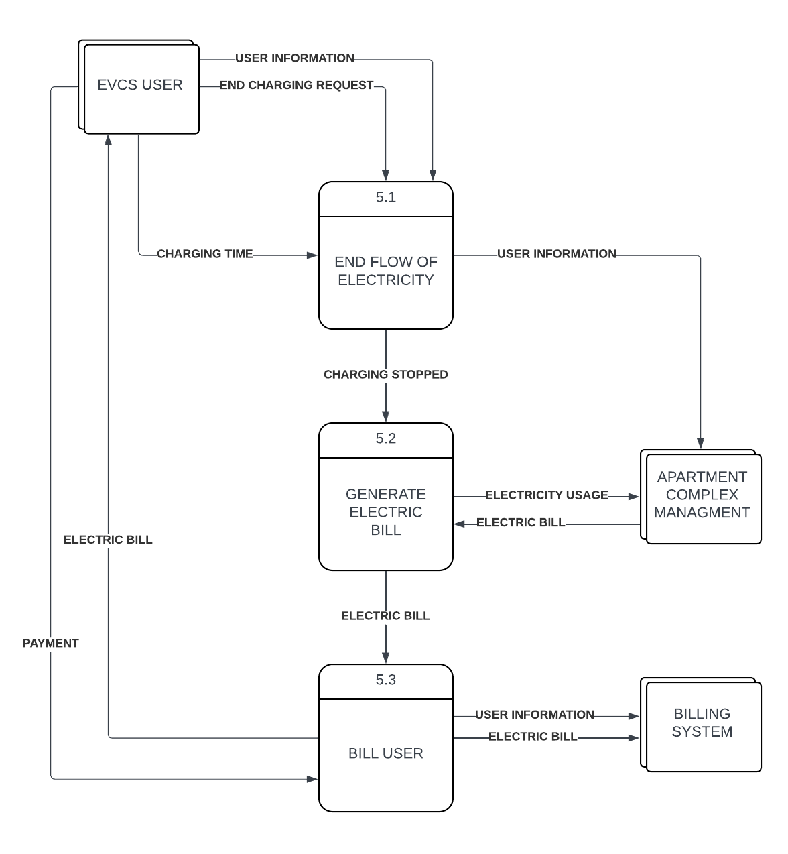
(20 pts) Build a Data Dictionary (Section 5.8, pp. 164-167) for the EVCSS Project using Excel, documenting the Data Elements, the Data Flows, Data Stores, Processes, and External Entities based on your data flow diagrams above.
Name | Type | Description
EVCS USER | External Entity | A user of an electric vehicle charging station, which can be either an apartment tenant or an on-demand user
ELECTRICAL GRID PROVIDER | External Entity | A provider of electricity through a connected grid of wires, poles, and other means of distribution
APARTMENT COMPLEX MANAGEMENT | External Entity | Person(s) responsible for managing the apartment complex where electric vehicle charging stations are available for use, as well as the tenants of the apartment complex
BILLING SYSTEM | External Entity | System which manages the billing of apartment complex tenants
TENANTS | Data Store | A collection of tenant information, including their lease status, tailored billing rates, and charger allocations
CHARGERS | Data Store | A collection of information about the various electric vehicle charging stations available for use within the apartment complex
DETERMINE CHARGER STATUS | Process | A process which determines whether a charger is available for use by the user attempting to charge an electric vehicle
DETERMINE USER CHARGING MODE | Process | A process which determines the type of user requesting a charging session (tenant or on-demand)
DETERMINE ALLOCATED CHARGER | Process | A process which determines if a charger is allocated to the tenant requesting a charging session
AUTHORIZE TEMPORARY FUNDS HOLD | Process | A process which places a temporary hold on an on-demand user’s credit card to verify that they have sufficient funds to cover the balance after charging
ACTIVATE CHARGER MODE | Process | A process which activates an electric vehicle charger based on the type of user requesting a charging session
UNLOCK EV CHARGER | Process | A process which unlocks an electric vehicle charger and prepares it for use
UPDATE CHARGER STATUS | Process | A process which updates an electric vehicle charger’s status in CHARGERS
UNLOCK CHARGING ADAPTER | Process | A process which unlocks an electric vehicle charger’s charging adapter
DETERMINE ELECTRICAL GRID STATUS | Process | A process which determines if the electrical grid is ready and able to supply electricity to an electric vehicle and initiates the external flow of electricity
DETERMINE GRID STATUS | Process | A process which determines if the electrical grid can supply electricity or has issues preventing it from doing so
DISALLOW CHARGING DUE TO GRID ISSUE | Process | A process which notifies the user of an electric vehicle charger of electrical grid issues and prevents the flow of electricity
DETERMINE COST OF ELECTRICITY | Process | A process which gets the latest electricity cost from an electrical grid
ESTABLISH FLOW OF ELECTRICITY | Process | A process which starts the process of electricity delivery if the electrical grid can do so
BEGIN CHARGING EV | Process | A process which starts the process of delivering electricity to an electric vehicle
STOP CHARGING EV | Process | A process which ends the delivery of electricity to an electric vehicle
END FLOW OF ELECTRICITY | Process | A process which cuts off the flow of electricity from the electrical grid
GENERATE ELECTRIC BILL | Process | A process which determines the final cost of a charging session and prepares to bill the user
BILL USER | Process | A process which posts the electric bill to a tenant’s billing system account or bills an on-demand user’s credit card
LOCK EV CHARGER | Process | A process which locks an electric vehicle charger’s charging adapter
CHARGING REQUEST | Data Flow | A request from an electric vehicle charger user to begin charging which includes information about the type of vehicle being charged and information about the user
PAYMENT | Data Flow | A completed payment from an on-demand user
REQUIRED VOLTAGE | Data Element | Information about the voltage required by the electric vehicle being charged
FLOW OF ELECTRICITY | Data Flow | The flow of electricity between an electrical grid and an electric vehicle charger
GRID STATUS | Data Element | Information about whether an electrical grid is ready and able to provide a flow of electricity
ELECTRICITY USAGE | Data Element | Information about how much electricity was used during a charging session
COST OF ELECTRICITY | Data Element | Information about how much electricity from a given electrical grid provider costs
TENANT INFORMATION | Data Element | Information about an apartment complex tenant, including basic details like their name and apartment unit
TENANT STATUS | Data Element | Information about an apartment complex tenant’s lease status and whether electric vehicle charging is permitted
ELECTRIC BILL | Data Element | A finalized bill for an electric vehicle charging session
CHARGING STATUS | Data Element | Information about whether an electric vehicle charging station is actively charging an electric vehicle
CREDIT CARD INFORMATION | Data Element | Information about an on-demand user’s mode of payment, including the payment information itself
CHARGER INFORMATION | Data Element | Information about an electric vehicle charger’s allocation status
CHARGER USABILITY STATUS | Data Element | Information about whether an electric vehicle charger can be used by the user requesting a charging session
BILLING COMPLETED | Data Flow | Results from a user being successfully billed for a charging session

