Case Study – 6
(50 points)
Name: Owen Sullivan
Clemson ID: C34243277
Submission: Save this Word document with your answers as a PDF file and upload the PDF file to Canvas.

(30 pts) Build a high-level object model for the EVCSS Project. You should have multiple classes, subclasses and super-classes in your model. Remember, we are modeling the system level objects not low-level software objects. Your objects must have both methods (ie operations) and attributes (ie internal state data). (Fig 6.1, Fig 6.2 & Fig 6.6)
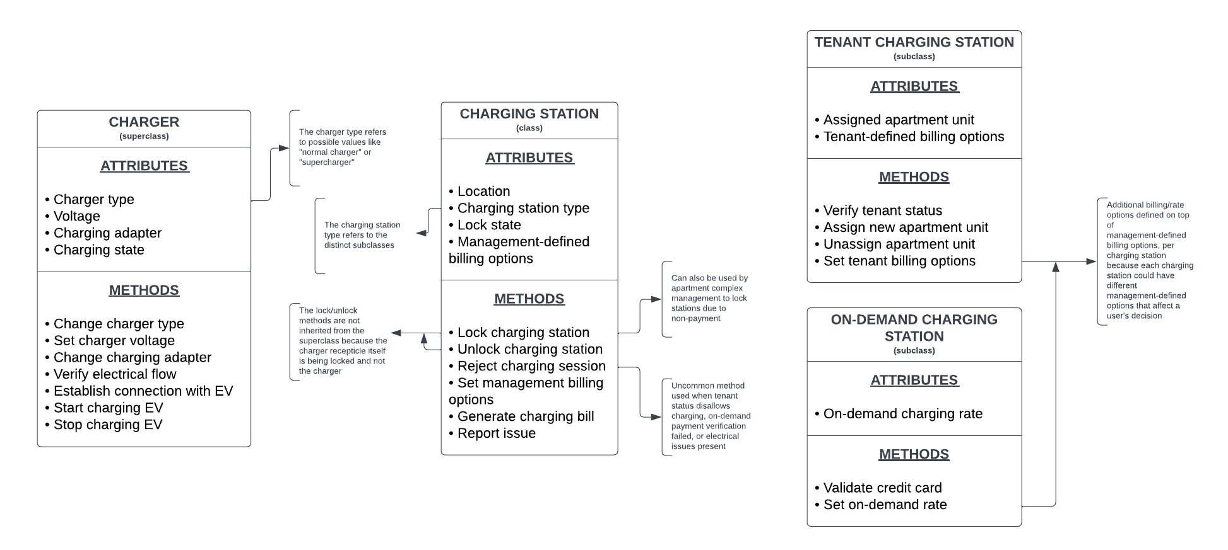
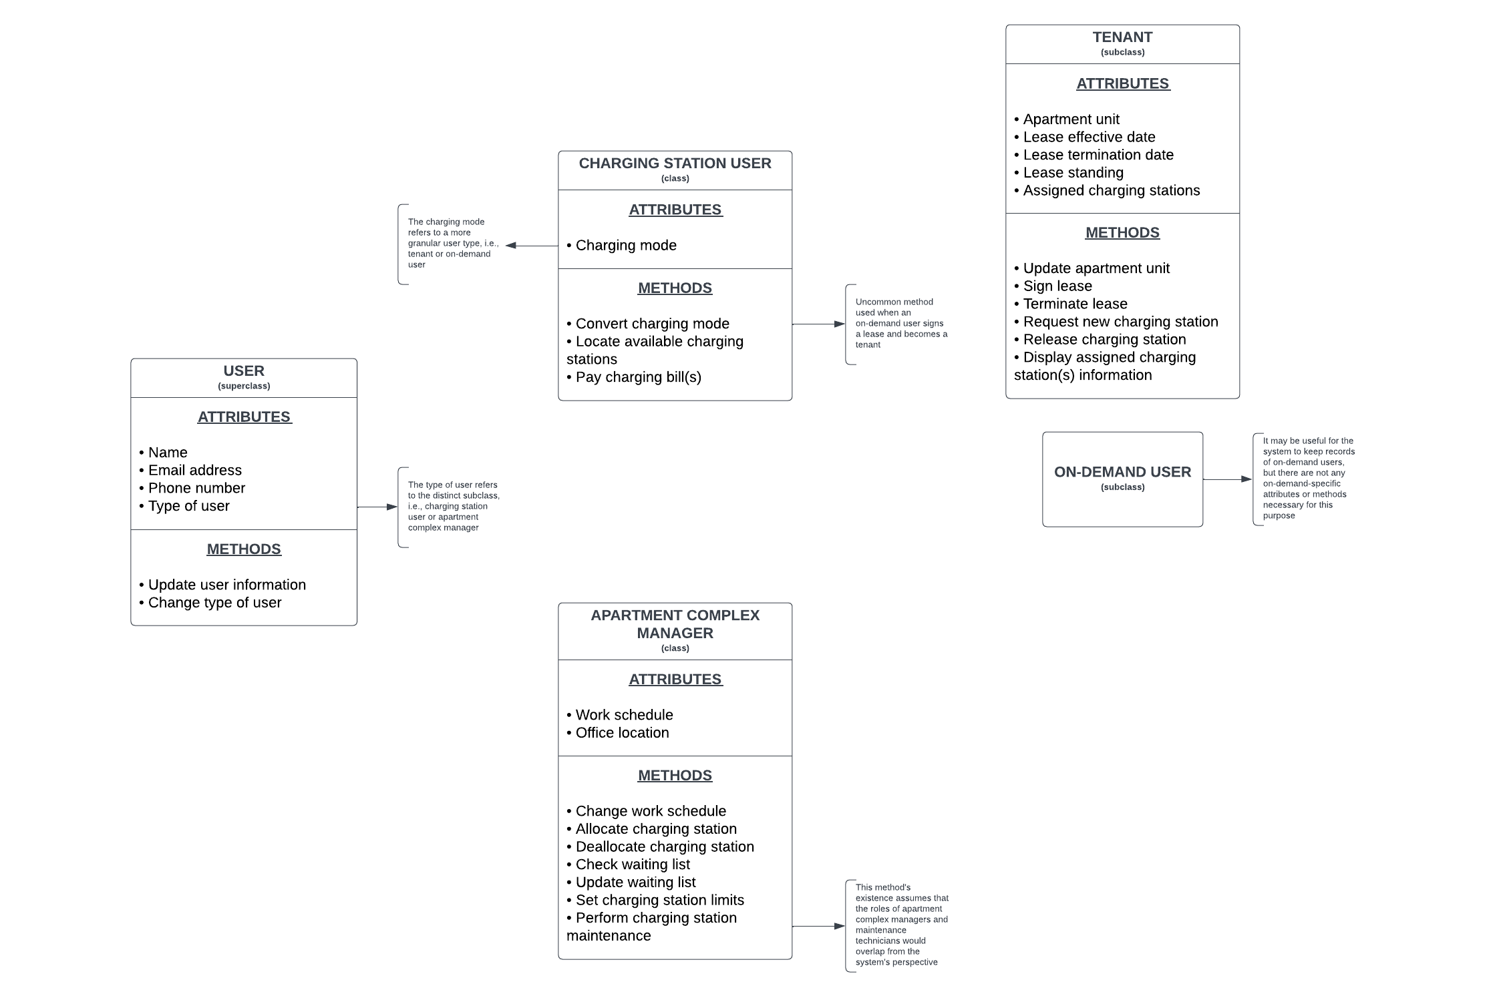
(10 pts) Build 2 use cases for the EVCSS Project (Fig 6.15)
CHARGE A VEHICLE Use Case
Name: | Charge a Vehicle
Actor(s): | Apartment tenant; on-demand user
Successful completion: | 1. The user’s vehicle is charged to 100% of battery capacity  2. The user is billed according to the duration of charging and the rate(s) set for the specific electric vehicle charging station used
Alternative(s): | 1. The user’s vehicle is charged to the user’s maximum preferred capacity  2. The user is billed according to the duration of charging and the rate(s) set for the specific electric vehicle charging station used
Precondition(s): | 1. The user has parked an electric vehicle in front of charging station  2. The user has successfully unlocked the charging station
Assumption(s): | 1. A stable flow of electricity to the charging station being used is available  2. The user’s electric vehicle is not already charged to 100% of battery capacity  3. The correct charging adapter to charge the user’s electric vehicle is available and operational

RESERVE A CHARGING STATION Use Case
Name: | Reserve a Charging Station
Actor(s): | Apartment tenant
Successful completion: | 1. The tenant’s active lease status and ability to reserve new charging stations are verified  2. The selected electric vehicle charging station is reserved for exclusive use by the tenant
Alternative(s): | 1. The tenant’s active lease status is not verified (the tenant’s lease has been terminated)  2. The selected electric vehicle charging station is not reserved for exclusive use by the tenant  1. The tenant’s ability to reserve new charging stations is not verified (the tenant is not allowed to reserve more charging stations)  2. The selected electric vehicle charging station is not reserved for exclusive use by the tenant
Precondition(s): | 1. The tenant has selected a charging station to reserve  2. The selected charging station is not already reserved
Assumption(s): | There is at least one unreserved charging station available at the selected apartment complex

(10 pts) Build 2 state transition diagrams for the EVCSS Project (Fig 6.20). Each diagram must have at least 5 unique states (not counting the start and end states).
