Case Study – 8
(60 points)
Name: Owen Sullivan
Clemson ID: C34243277
Submission: Save this Word document with your answers as a PDF file and upload the PDF file to Canvas.

(40 pts) Create 4 UI Mockups/Wireframes for the Mobile App portion of the EVCSS Project with data validation constraints indicated. Your mockups should illustrate how an EV Driver is going to interact with the system from their mobile device. You should use one of the diagramming tools identified on the “External Tools Page” in Canvas or one of your own choosing.
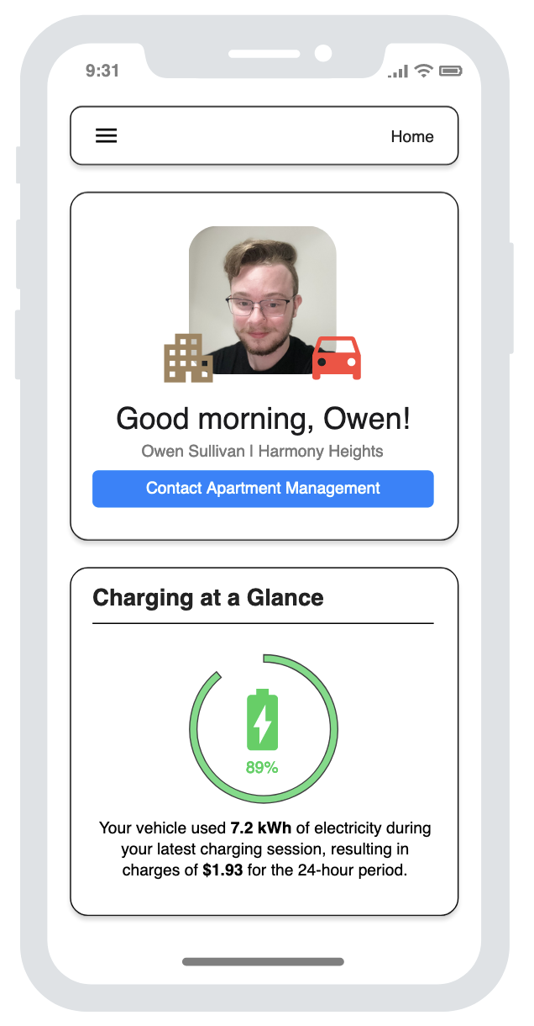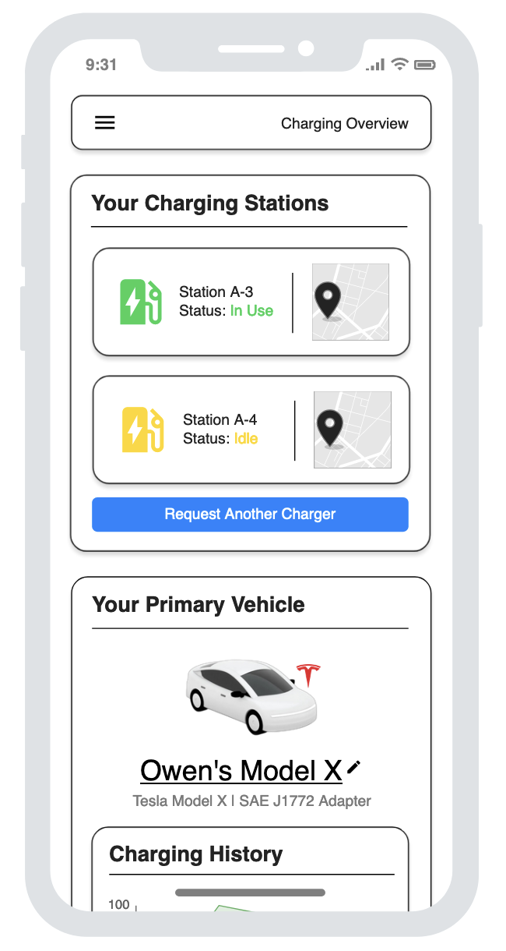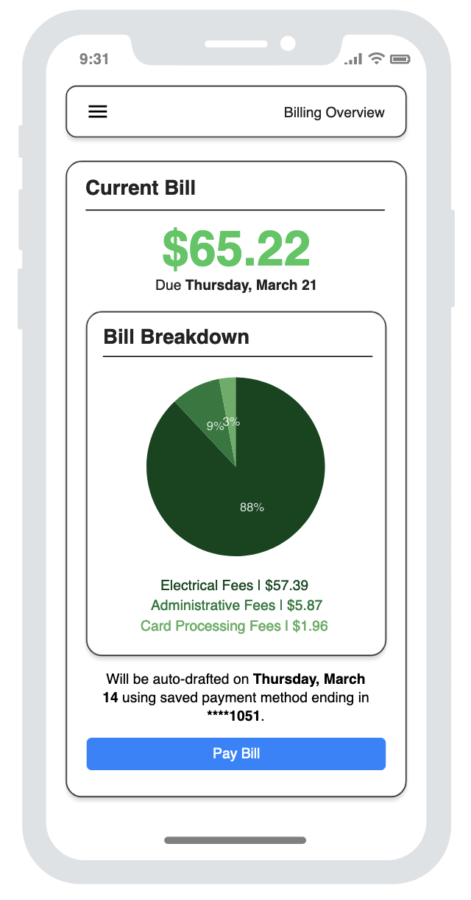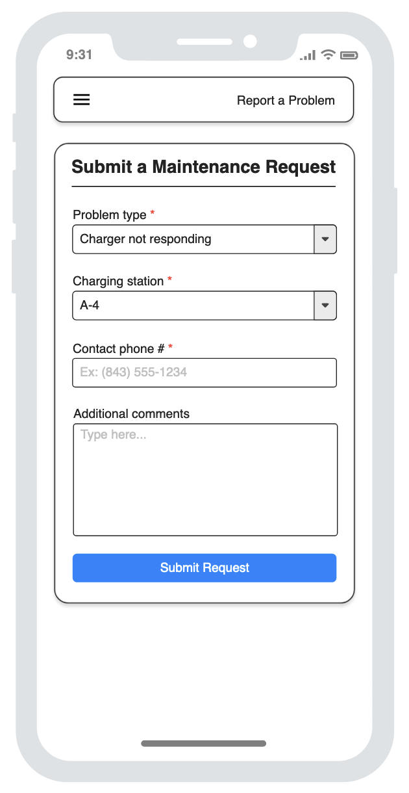
(20 pts) Create 2 UI Mockups/Wireframes for the Desktop Administrative interface to the EVCSS system. Your mockups should illustrate how will the admin users of the system interact with the system. The client and the management users will be closely monitoring the system.
