Case Study – 9
(40 points)
Name: Owen Sullivan
Clemson ID: C34243277
Submission: Save this Word document with your answers as a PDF file and upload the PDF file to Canvas.

Design the primary data storage needed to support the EVCSS. This is a high-level data design for the system that we expect to evolve as the implementation progresses.
(10 pts) List all the entities for the EVCSS Project.
- Apartment building
- Apartment unit
- Parking garage
- Parking spot
- Charging station
- Operating system
- Charger
- Lock
- Management dashboard
- Tenant dashboard
- Apartment manager
- Maintenance technician
- Tenant
- On-demand user
- Bill
- Billing system
- Billing policy
- Allocation list
- Waiting list
- Credit card
- Issue report
- Electric grid
(15 pts) Create an ERD for the EVCSS Project with cardinality like that shown in Fig 9.19. Make sure you use proper Crow’s Foot notation and label the relationship lines appropriately.
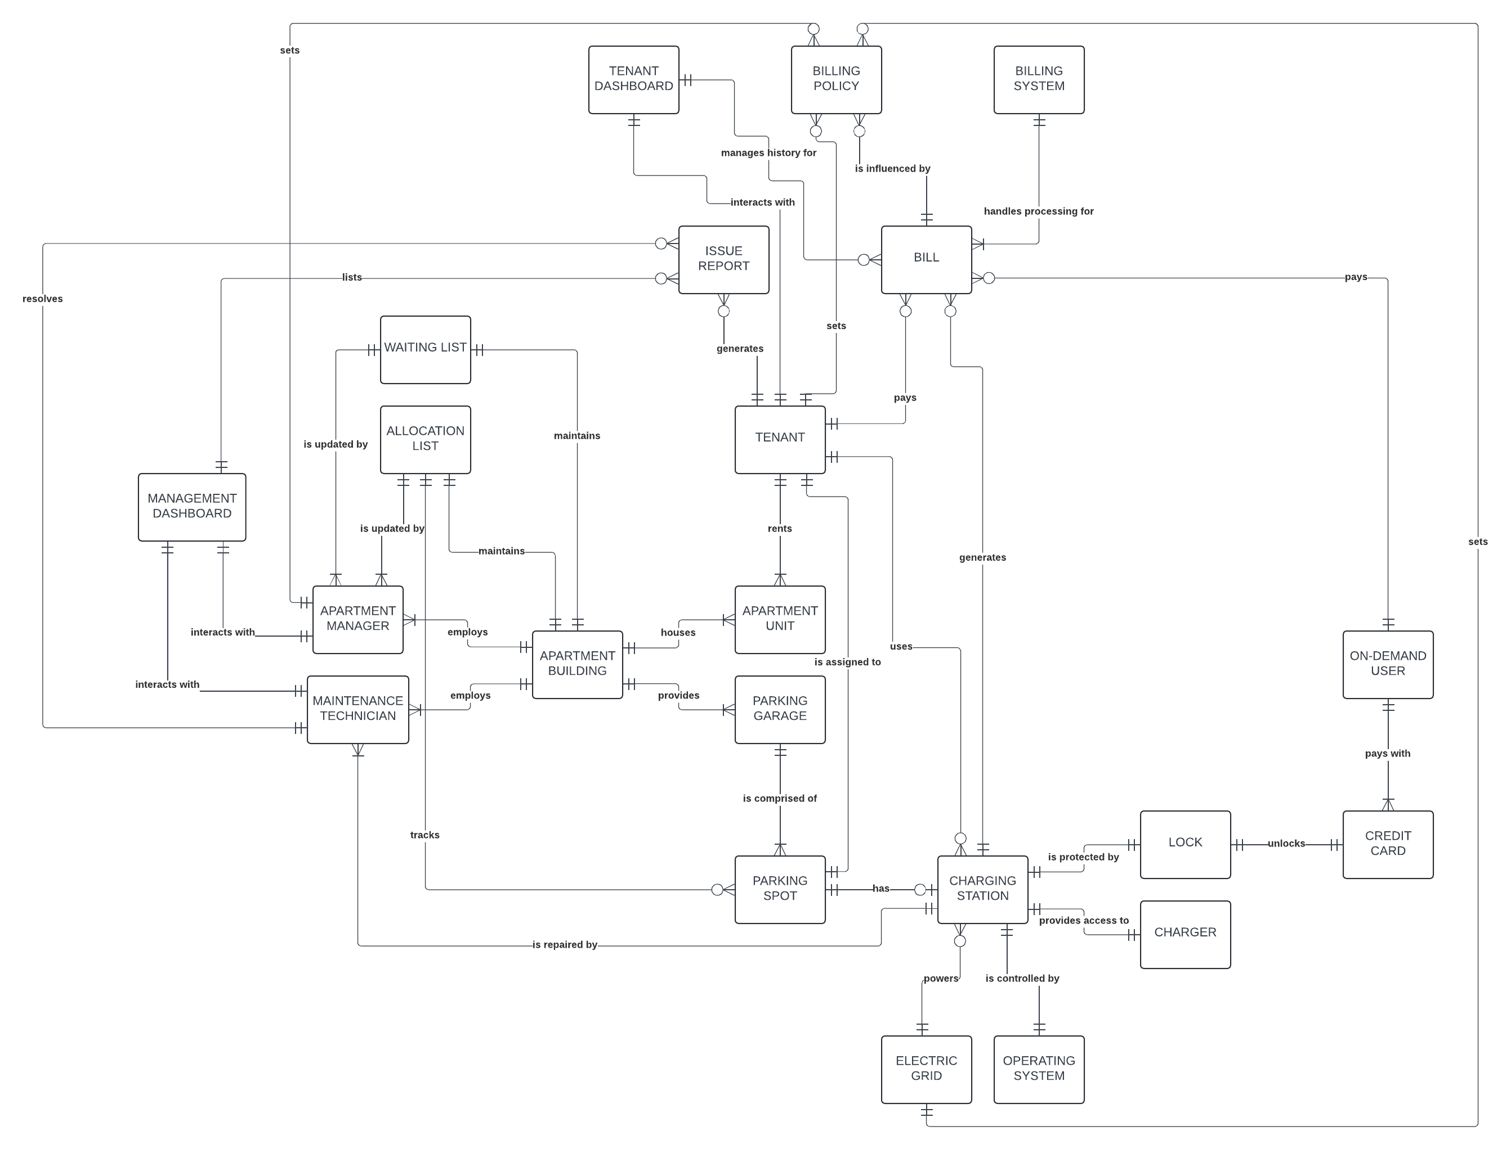
(15 pts) Design 3NF tables for the EVCSS Project based on your ERD, make sure the Primary Keys and Foreign Keys are identified. You can use a graphical notation or standard notation to express your table design. (Bold is required, Underlined is primary key, Italics is foreign key)
APARTMENT_BUILDING(ApartmentBuildingNum, ApartmentBuildingStreet, ApartmentBuildingCity, ApartmentBuildingState, ApartmentBuildingZip, ApartmentBuildingPhone, ApartmentBuildingNumFloors)
APARTMENT_UNIT(ApartmentUnitNum, ApartmentUnitApartmentBuildingNum, ApartmentUnitAssignedTenantNum, ApartmentUnitNumRooms, ApartmentUnitSquareFootage, ApartmentUnitFloor)
PARKING_GARAGE(ParkingGarageNum, ParkingGarageApartmentBuildingNum, ParkingGarageNumLevels, ParkingGarageNumSpots)
PARKING_SPOT(ParkingSpotNum, ParkingSpotParkingGarageNum, ParkingSpotAssignedTenantNum, ParkingSpotWidth, ParkingSpotLength)
CHARGING_STATION(ChargingStationNum, ChargingStationParkingSpotNum, ChargingStationAssignedTenantNum)
OPERATING_SYSTEM(OperatingSystemNum, OperatingSystemChargingStationNum, OperatingSystemType, OperatingSystemVersion, OperatingSystemInstallDate)
CHARGER(ChargerNum, ChargerChargingStationNum, ChargerVoltage, ChargerAdapterType)
LOCK(LockNum, LockChargingStationNum, LockStatus)
MANAGEMENT_DASHBOARD⁴(ManagementDashboardNum, ManagementDashboardApartmentBuildingNum, ManagementDashboardHostingMethod)
TENANT_DASHBOARD⁴(TenantDashboardNum, TenantDashboardApartmentBuildingNum, TenantDashboardHostingMethod)
APARTMENT_MANAGER(ApartmentManagerNum, ApartmentManagerApartmentBuildingNum, ApartmentManagerManagementDashboardNum, ApartmentManagerSalary, ApartmentManagerFirstName, ApartmentManagerLastName, ApartmentManagerPhone, ApartmentManagerStreet, ApartmentManagerCity, ApartmentManagerState, ApartmentManagerZip)
MAINTENANCE_TECHNICIAN(MaintenanceTechnicianNum, MaintenanceTechnicianApartmentBuildingNum, MaintenanceTechnicianManagementDashboardNum, MaintenanceTechnicianSalary, MaintenanceTechnicianFirstName, MaintenanceTechnicianLastName, MaintenanceTechnicianPhone, MaintenanceTechnicianStreet, MaintenanceTechnicianCity, MaintenanceTechnicianState, MaintenanceTechnicianZip)
TENANT(TenantNum, TenantApartmentBuildingNum, TenantApartmentUnitNum, TenantTenantDashboardNum, TenantFirstName, TenantLastName, TenantRentRate, TenantPhone, TenantNumChargingStationsAllocated)
ON_DEMAND_USER(OnDemandUserNum, OnDemandUserChargingStationNum, OnDemandUserCreditCardIDNum)
BILL(BillNum, BillBillingSystemNum, BillAmount, BillPaidStatus, BillUserType, BillTenantNum, BillOnDemandUserNum)
BILLING_SYSTEM(BillingSystemNum, BillingSystemApartmentBuildingNum, BillingSystemName, BillingSystemProviderName, BillingSystemProviderPhone)
BILLING_POLICY(BillingPolicyNum, BillingPolicyBillingSystemNum, BillingPolicyApartmentBuildingNum, BillingPolicyChargingStationNum, BillingPolicyTenantNum)
ALLOCATION¹(AllocationApartmentBuildingNum, AllocationChargingStationNum, AllocationTenantNum)
WAITING_LIST_ENTRY²(WaitingListApartmentBuildingNum, WaitingListTenantNum)
CREDIT_CARD(CreditCardIDNum³, CreditCardNameOnCard, CreditCardNum³, CreditCardExpiration, CreditCardSecurityCode)
ISSUE_REPORT(IssueReportNum, IssueReportAffectedChargingStationNum, IssueReportReportingTenantNum, IssueReportRespondingMaintenanceTechnicianNum, IssueReportType, IssueReportDescription, IssueReportStatus)
ELECTRIC_GRID(ElectricGridNum, ElectricGridAssociatedApartmentBuildingNum, ElectricGridProviderName, ElectricGridProviderPhone)
¹ The name of this table was chosen because each record is a single allocation and not a new allocation list in and of itself.
² The name of this table was chosen because each record is a single waiting list entry and not a new waiting list in and of itself.
³ The distinction between CreditCardIDNum and CreditCardNum is that the former is a primary key and the latter is the actual 16-digit number associated with a credit card.
⁴ The existence of the MANAGEMENT_DASHBOARD and TENANT_DASHBOARD tables is based on the assumption that a version of the EVCSS with an expanded feature set for global operation may include the ability for apartment complexes to split the organization of multiple tenants, apartment buildings, parking garages, and etc. across more than one instance of each dashboard for large-scale applications.

