Class Exercise – 13.2
Name: Owen Sullivan
Assignment ID: 98321
Submission: Save this Word document with your answers as a PDF file and upload the PDF file to Canvas.
T-Shirt Sizing
Use T-Shirt Sizing method to estimate how long the EVCSS Project will take to implement with a team of 9 IT/Software Engineering staff.
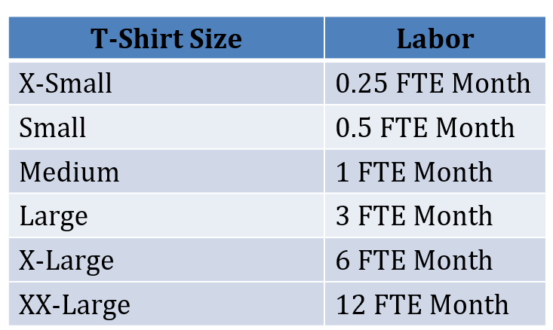
- What “size” is the EVCSS Project? Is it even on the chart??
The EVCSS project is X-Large (6 FTE Months) or XX-Large (12 FTE Months).
Function Point Sizing
- Consider the activity diagram shown below. The design elements implied by this diagram are embedded in the diagram using the following legend:
EI = External Input: User screen, form, or dialog to add, change, or delete data.
EO = External Output: Screen, report, or graph generated for use by a user or other program (typically more complex in terms of formatting or summarization than an EQ).
EQ = External Query: Retrieving data from the DB with minimal formatting.
ILF = Internal Logical File: A single table in a relational DB or a flat file.
EIF = External Interface File: Groupings of data from/to an outside application.
  - Count the design elements of each type:
EI: 2
EO: 5
EQ: 2
ILF: 2
EIF: 3
  - Use the associated Excel file to estimate the number of unadjusted function points:
[Rate every element as “medium complexity” to keep the process simple by filling in the grey values in the function points table.]

82 function points

  - Use the associated Excel document to convert unadjusted function points to staff months:
[Use a 6 member team]

General — 11.885094 staff months
Enhancement — 11.55878003 staff months
New Development — 13.38753624 staff months

  - What happens to staff months and duration if we double the size of the staff:

The estimates nearly double.
