Class Exercise – 5.1
Name: Owen Sullivan
Assignment ID: 61235
Submission: Save this Word document with your answers as a PDF file and upload the PDF file to Canvas.

Case in Point 5.1: Big Ten University
You are the IT director at Big Ten University. As part of a training program, you decide to draw a DFD that includes some obvious mistakes to see whether your newly hired junior analysts can find them. You came up with the diagram 0 DFD shown in Figure 5-19. Based on the rules explained in this chapter, how many problems should the analysts find? [HINT, there are more than 5!]

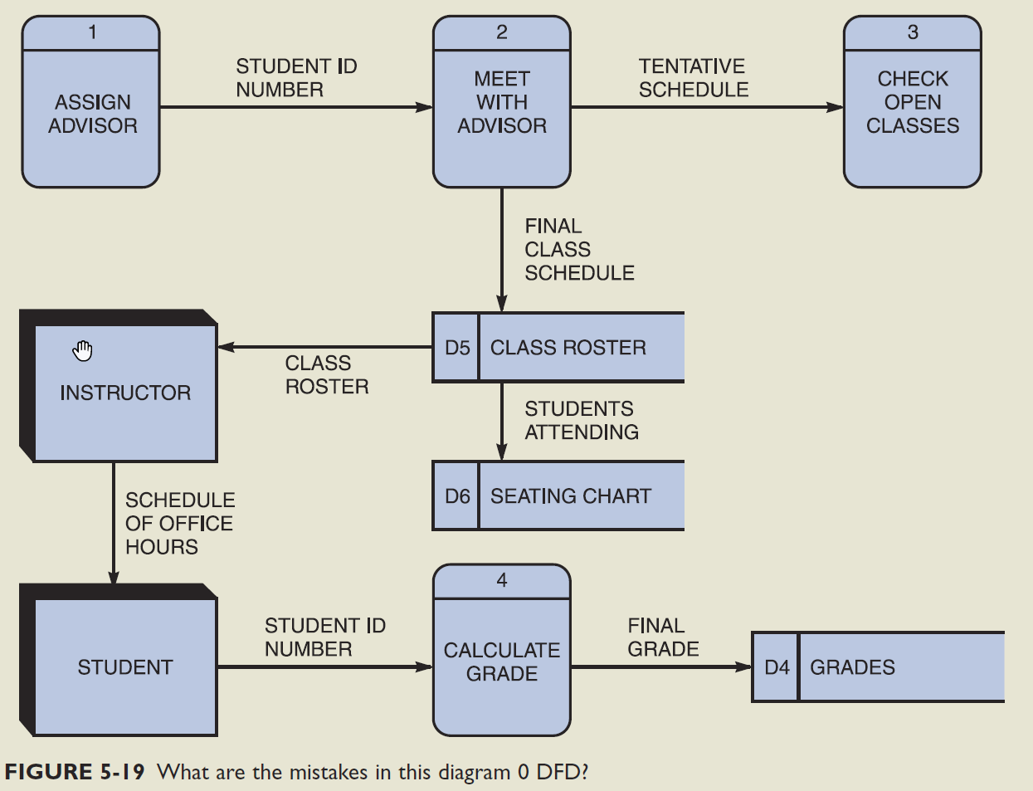

List the issue you see here.

- There is a required process missing between D5 and D6.
- The external entity “INSTRUCTOR” is connected to D5 without a connecting process.
- Process #1 does not have an input.
- Process #3 does not have an output.
- D4 does not have an outgoing flow.
- “INSTRUCTOR” and “STUDENT” cannot be connected without a process.
- No clear connection between the “STUDENT ID NUMBER” input and process #4.
- D6 does not have an outgoing flow.

