Class Exercise – BC1
Name: Owen Sullivan
Assignment ID: 12641
Submission: Save this Word document with your answers as a PDF file and upload the PDF file to Canvas.

Failures in Software

A longtime colleague of mine has spent years collecting data on software intensive system failures, both operational and developmental. That data was distilled and used to produce this web site:
https://spectrum.ieee.org/lessons-from-a-decade-of-it-failures
for the IEEE. The data is a few years old now (and due to be updated soon), but not much has changed on this front (you can easily believe that people aren’t particularly quick to share this sort of data either).
We’ll start with the graveyard of epic failures, “Lesson 5: Monuments to Failure”
Using the link “Lesson 1: The Staggering Impact of IT Systems Gone Wrong” change the settings in the dropdowns to match those in the image and answer the questions below.
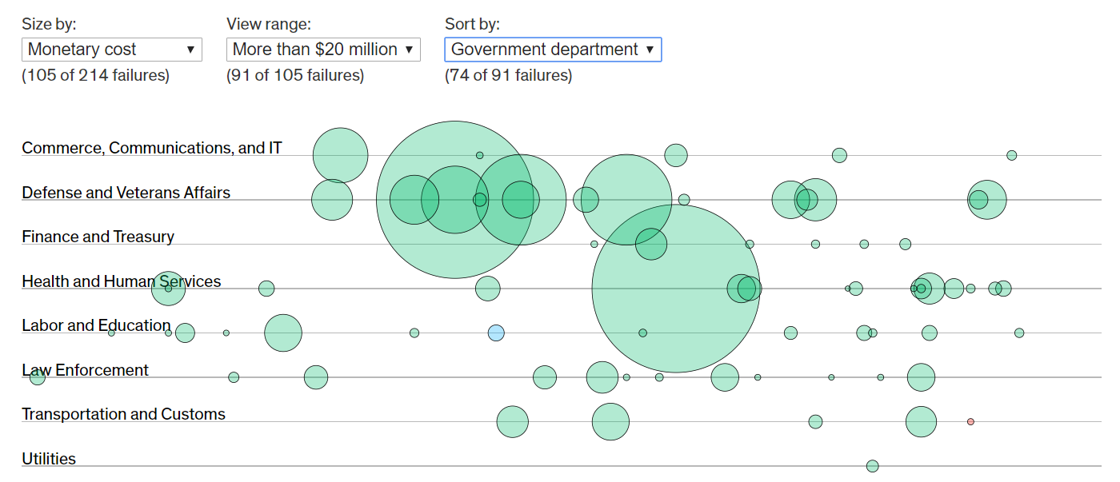
Clicking on the circles will bring up more information on the project.
What was the largest failure in each of these Government departments (list the project name and the $ cost)?
Commerce: U.S. Census transition to electronic records — $798 million spent + $2.2 billion to revert to paper
Defense: U.S. Army Future Combat System — $200 billion plan, $18 billion spent
Health & Human Services: U.K. National HER program — £12.7 billion plan, £12 billion wasted
Law Enforcement: U.K. FiReControl Project — £469 million plan, £250 million wasted
Transportation & Customs: SBInet — $1 billion spent
Repeat the process.
Change the settings in the dropdowns to match those in the image and answer the questions below.
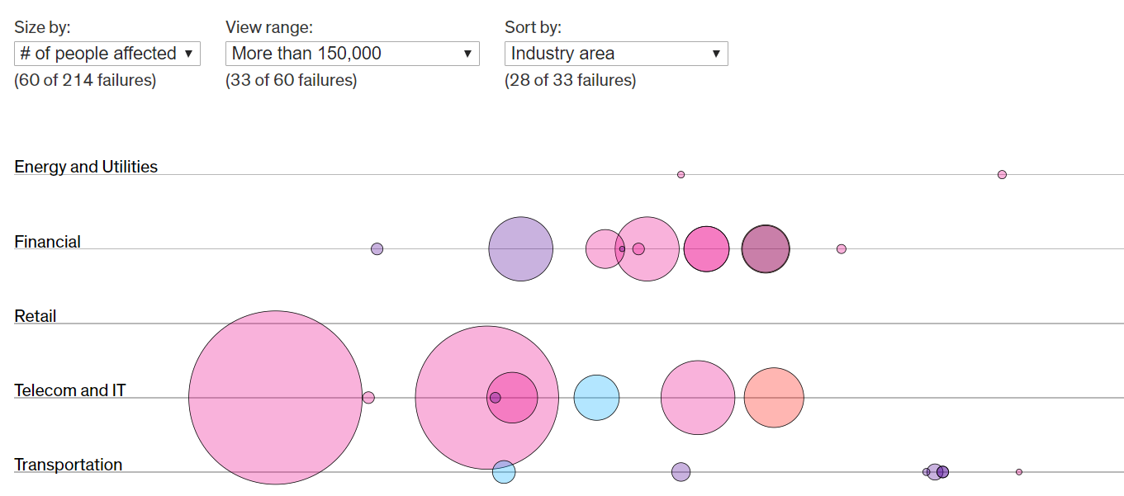

What was the largest failure in each of these industry areas (list the project name and the # of people impacted)?
Energy and Utilities: Duke Energy false reports — 500,000 people affected
Financial: German bank card date issue / Korea’s NH bank computer crash — 30 million people affected each
Retail: N/A (none listed for this industry area)
Telecom & IT: Skype software update — 220 million people affected
Transportation: Toyota gas pedals/software issues — 3.8 million people affected

Take the quiz at “Lesson 4: The IT Failure Blame Game”
How many did you get correct?

What was the most surprising result you found in the answers?

What “lesson learned” do you see in this data?

Has anything changed since this data was collected? Not really, see this 2019 companion article: https://spectrum.ieee.org/riskfactor/computing/it/five-enduring-government-it-failures

