Class Exercise – 1.1
Name: Owen Sullivan
Clemson/Assignment ID: file1
Submission: Save this Word document with your answers as a PDF file and upload the PDF file to Canvas.

Use this file structure to answer the questions below

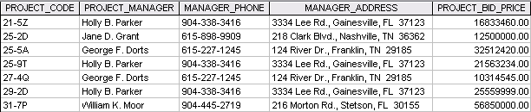

- How many records does the file contain? How many fields are there per record?

The file contains 7 records with 5 fields each.

- What problem would you encounter if you wanted to produce a listing by city? How would you solve this problem by altering the file structure?

You wouldn’t be able to get just the records by city without first extracting the city from each record’s “MANAGER_ADDRESS” field. This could be solved by splitting the MANAGER_ADDRESS field into distinct fields for each major part of a full address, such as: “MANAGER_STREET_ADDRESS”, “MANAGER_CITY”, “MANAGER_STATE”, “MANAGER_ZIP_CODE”, etc.

- If you wanted to produce a listing of the file contents by last name, area code, city, state, or zip code, how would you alter the file structure?

I would split each of the relevant fields. For example, “PROJECT_MANAGER” would become: “PROJECT_MANAGER_FIRST_NAME”, “PROJECT_MANAGER_LAST_NAME”, etc.

- What data redundancies do you detect? How could those redundancies lead to anomalies?

There are some records with the same entries for the “PROJECT_MANAGER”, “MANAGER_PHONE”, and “MANAGER_ADDRESS” fields. If you needed to make a change to a project manager’s address, for example, you would need to be sure that the change is made across all relevant records exactly so that there is not conflicting data. Otherwise, there could be incomplete or incorrect data for a project manager.

