Class Exercise – 1.2
Name: Owen Sullivan
Clemson/Assignment ID: file2
Submission: Save this Word document with your answers as a PDF file and upload the PDF file to Canvas.

Use this file structure to answer the questions below

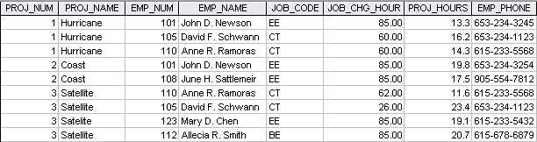

- Identify and discuss the serious data redundancy problems exhibited by the file structure above.

There are multiple repeated field entries across records for employee information, meaning that there could easily be inconsistency between records (ex: you could have an employee with two different phone numbers but not know which is correct). Additionally, the project numbers and project names are reused, which could cause the wrong information to be referenced if someone doesn’t know to look for distinguishing field data like employee information.

- Looking at the EMP_NAME and EMP_PHONE fields, what change(s) would you recommend?

I’d break those fields up into fields like “EMP_FIRST_NAME” and “EMP_LAST_NAME” for “EMP_NAME” and “EMP_AREA_CODE” and “EMP_LOCAL_PHONE” for “EMP_PHONE” in order to separate the information that might need to be parsed frequently if left as-is.

