Class Exercise – 11.3
Name: Owen Sullivan
Clemson/Assignment ID: perf2
Submission: Save this Word document with your answers as a PDF file and upload the PDF file to Canvas.

Query Optimization

Based on this ERD
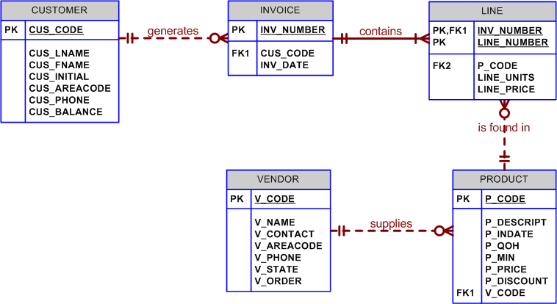
And using the following query:

SELECT P_CODE, SUM(LINE_UNITS)
FROM LINE
GROUP BY P_CODE
HAVING SUM(LINE_UNITS) > (SELECT MAX(LINE_UNITS) FROM LINE);

- What is the likely data sparsity of the LINE_UNITS column?
The data sparsity is likely high given that there could be any number of units sold for a single product.
- Should you create an index? If so, what would the index column(s) be and why.
Yes, because the index can help increase performance when finding the MAX of LINE_UNITS.
- Should you create an index on P_CODE and Why?
If so, write the SQL command to create that index. If not, explain your reasoning.
Yes, an index would help, but adding one is probably not necessary because P_CODE is the primary key of PRODUCT and the foreign key of LINE. The DBMS is likely already indexing P_CODE. However, if the index needs to be added manually, it can be done so with: CREATE INDEX LINE_NXD1 ON LINE(P_CODE)

