Class Exercise – 13.1
Name: Owen Sullivan
Clemson/Assignment ID: 6233
Submission: Save this Word document with your answers as a PDF file and upload the PDF file to Canvas.

STAR Schema
1. Fill in the diagram below to build the STAR schema for the following ORDER data.
Use Figure 13.10 as your guide.
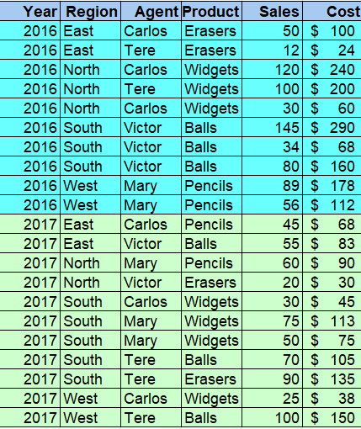
AGENT
ORDER Fact Table
YEAR

PRODUCT
YEAR
REGION
AGENT
PRODUCT
TOTAL_VALUE

REGION

