Class Exercise – 2.1
Name: Owen Sullivan
Clemson/Assignment ID: erd1
Submission: Save this Word document with your answers as a PDF file and upload the PDF file to Canvas.

DealCo Relational Model
Use the model shown to answer the following questions. The model shows the initial entities and attributes for the DealCo stores, located in two regions of the country.

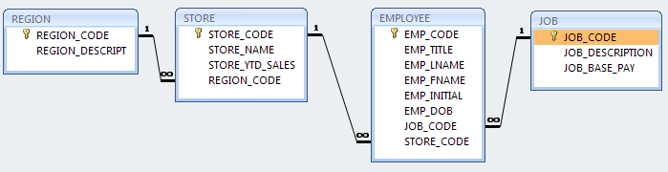
- Identify each relationship type and write all of the business rules.

There is a 1-to-many relationship between REGION and STORE such that one REGION can have many STOREs, connected by the REGION primary key REGION_CODE. Thus, any STORE can have only one matching REGION_CODE, but a REGION can be associated with multiple STOREs.

There is a 1-to-many relationship between STORE and EMPLOYEE such that one STORE can have many EMPLOYEEs, connected by the STORE primary key STORE_CODE. Thus, any EMPLOYEE can have only one matching STORE_CODE, but a STORE can be associated with multiple EMPLOYEEs.

There is a 1-to-many relationship between JOB and EMPLOYEE such that one JOB can have many EMPLOYEEs, connected by the JOB primary key JOB_CODE. Thus, any EMPLOYEE can have only one matching JOB_CODE, but a JOB can be associated with multiple EMPLOYEEs.

- Create the basic Crow’s Foot ERD for DealCo.

