Class Exercise – 3.1
Name: Owen Sullivan
Clemson/Assignment ID: ch31
Submission: Save this Word document with your answers as a PDF file and upload the PDF file to Canvas.

StoreCo Database Tables
Use the database shown to answer the following questions

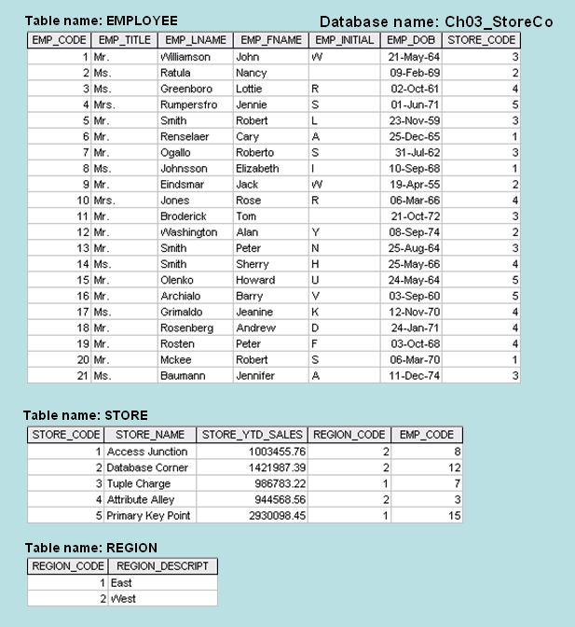

- For each table, identify the primary key and the foreign key(s). If a table does not have a foreign key, write None in the space provided.

Table name | Primary key | Foreign key
EMPLOYEE | EMP_CODE | STORE_CODE
STORE | STORE_CODE | REGION_CODE, EMP_CODE
REGION | REGION_CODE | None

- Do the tables exhibit entity integrity? Answer yes or no and then explain your answer.

Yes, because all the tables have unique, non-null primary keys (meaning no duplicates or blanks).

- Do the tables exhibit referential integrity? Answer yes or no and then explain your answer. Write NA (Not Applicable) if the table does not have a foreign key.

The EMPLOYEE table does exhibit referential integrity because the foreign key STORE_CODE is the primary key of the STORE table.

The STORE table does exhibit referential integrity because the foreign keys REGION_CODE and EMP_CODE are the primary keys of the REGION and EMPLOYEE tables, respectively.

The REGION table does not have a foreign key, thus, N/A.

- Describe the type(s) of relationship(s) between STORE and REGION.

The relationship between STORE and REGION is many-to-one because there can be many stores in one region.

