Class Exercise – 3.2
Name: Owen Sullivan
Clemson/Assignment ID: ch32
Submission: Save this Word document with your answers as a PDF file and upload the PDF file to Canvas.

BeneCo Database Tables
Use the database shown to answer the following questions. Note that the database is composed of four tables that reflect these relationships:
- An EMPLOYEE has only one JOB_CODE, but a JOB_CODE can be held by many EMPLOYEEs.
- An EMPLOYEE can participate in many PLANs, and any PLAN can be assigned to many EMPLOYEEs.
Note also that the M:N relationship has been broken down into two 1:M relationships for which the BENEFIT table serves as the composite or bridge entity.
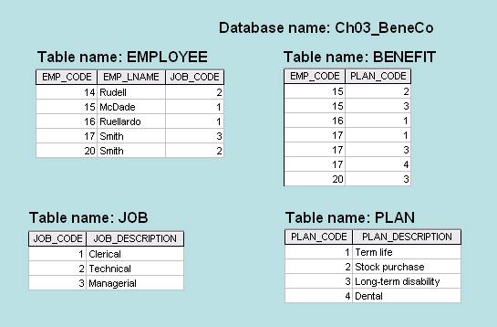

- For each table in the database, identify the primary key and the foreign key(s). If a table does not have a foreign key, write None in the assigned space provided.

The EMPLOYEE table has a primary key of EMP_CODE and a foreign key of JOB_CODE.

The BENEFIT table has a primary key which is a composite key of EMP_CODE and PLAN_CODE. Because the primary key is a composite, each key is also a foreign key.

The JOB table has a primary key of JOB_CODE and no foreign key.

The PLAN table has a primary key of PLAN_CODE and no foreign key.

- Create the ERD to show the relationship between EMPLOYEE and JOB.



- Do the tables exhibit entity integrity? Answer yes or no and then explain your answer.

Yes, because all tables have a primary key with unique values, including the composite key for the BENEFIT table because there are no duplicate pairs of values.

- Do the tables exhibit referential integrity? Answer yes or no and then explain your answer. Write NA (Not Applicable) if the table does not have a foreign key.

The EMPLOYEE table does have referential integrity because the foreign key JOB_CODE is the primary key of the JOB table.
The BENEFIT table does have referential integrity because the foreign keys EMP_CODE and PLAN_CODE are the primary keys of the EMPLOYEE and PLAN tables, respectively.
The JOB table does not have any foreign keys, thus, N/A.
The PLAN table does not have any foreign keys, thus, N/A.

