Class Exercise – 3.3
Name: Owen Sullivan
Clemson/Assignment ID: ch33
Submission: Save this Word document with your answers as a PDF file and upload the PDF file to Canvas.

TransCo Database Tables
Use the database shown to answer the following questions.
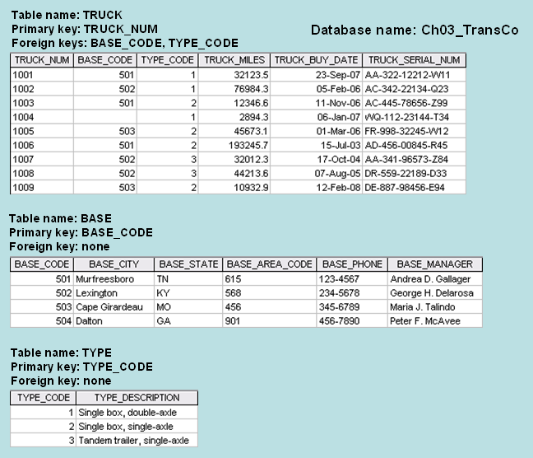

- For each table, identify the primary key and the foreign key(s). If a table does not have a foreign key, write None in the space provided.

Table name | Primary key | Foreign key
TRUCK | TRUCK_NUM | BASE_CODE, TYPE_CODE
BASE | BASE_CODE | None
TYPE | TYPE_CODE | None

- Do the tables exhibit entity integrity? Answer yes or no and then explain your answer.

All of the tables exhibit entity integrity because the primary keys have unique values and none of the values are null.
- Do the tables exhibit referential integrity? Answer yes or no and then explain your answer. Write NA (Not Applicable) if the table does not have a foreign key.

The TRUCK table does exhibit referential integrity because the foreign keys BASE_CODE and TYPE_CODE are the primary keys of the BASE and TYPE tables, respectively.

The BASE and TYPE tables do not have foreign keys, thus, N/A.

- Create the ERD for this database.
