Class Exercise – 5.1
Name: Owen Sullivan
Clemson/Assignment ID: 2BIT
Submission: Save this Word document with your answers as a PDF file and upload the PDF file to Canvas.

Enhanced ERD

- Two-Bit Drilling Company keeps information on employees and their insurance dependents. Each employee has an employee number, name, date of hire, and title. If an employee is an inspector, then the date of certification and the renewal date for that certification should also be recorded in the system. For all employees, the Social Security number and dependent names should be kept. All dependents must be associated with one and only one employee. Some employees will not have dependents, while others will have many dependents. Create a Crow’s Foot ERD using a specialization hierarchy if appropriate.
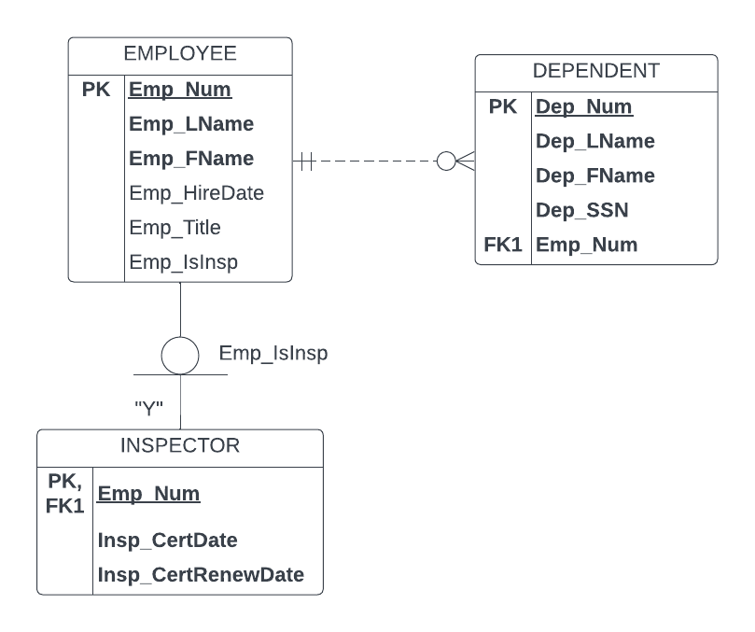
- Tiny Hospital keeps information on patients and hospital rooms. The system assigns each patient a patient ID number. In addition, the patient’s name and date of birth are recorded. Some patients are resident patients (they spend at least one night in the hospital) and others are outpatients (they are treated and released). Resident patients are assigned to a room. Each room is identified by a room number. The system also stores the room type (private or semiprivate), and room fee. Over time, each room will have many patients that stay in it. Each resident patient will stay in only one room. Every room must have had a patient, and every resident patient must have a room.
Is a specialization hierarchy appropriate for this scenario?
No, specialization hierarchy is not appropriate because there is no need to store additional attributes about resident patients vs. outpatients. The relationship between PATIENT and ROOM is such that a patient does not have to be assigned to a room, and the distinction between whether or not a patient has a room assignment is sufficient to describe whether a patient is a resident or an outpatient.

