1.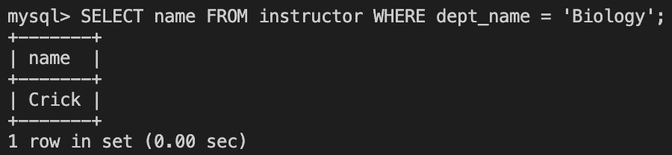

2.
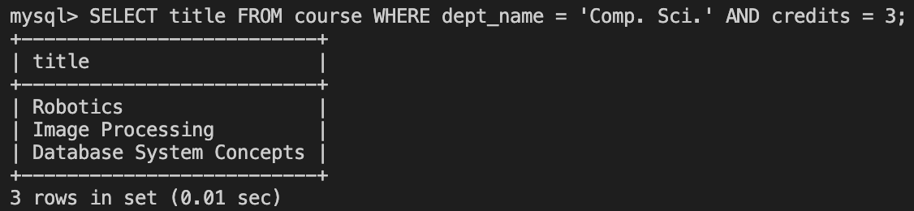

3.
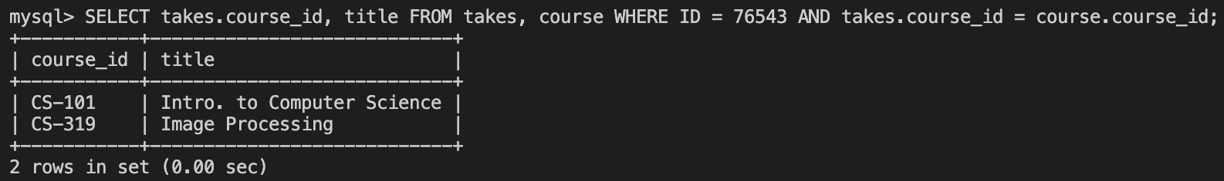

4. For this one, I wasn’t sure if the instructions were specifying just the dept_name or the entire department table, so I did the latter just to be thorough.
