Setting up:
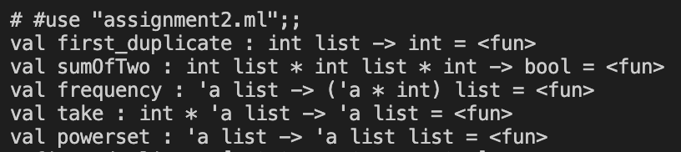
2.1: First Duplicate in a List (first_duplicate):
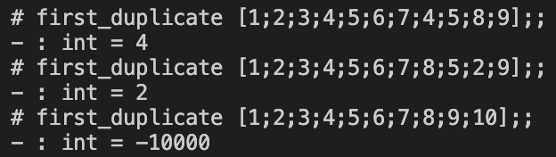
2.2 The Sum of 2 Problem (sumOfTwo):
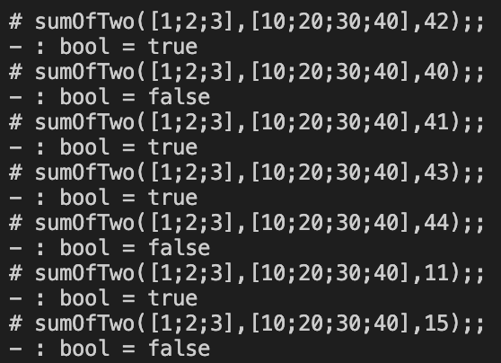
2.3 Frequency Count (frequency):
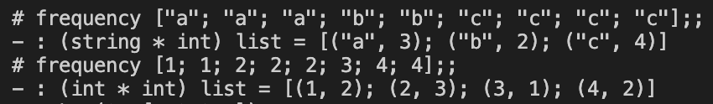
2.4 take Function:
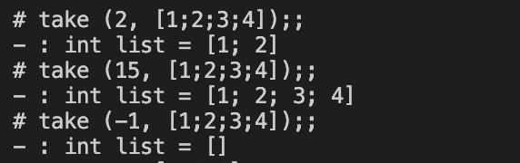
2.5 powerset Function:
