DMMT #1 Documentation
  - For https://notowens.best, created for CPSC 3750 by Owen Sullivan.

Note:
I have been doing web design at some level for about 8 years now, so I’ve kind of been applying DMMT’s basic principles implicitly whenever I design my web pages. I use Bootstrap for front end, and my pages are usually just modified clones of each other, so there’s not a lot I can improve without adding more content to the pages (which seems counterintuitive).

Principles applied:
- “Every page needs a name” (Chapter 6) and “Format text to support scanning” (Chapter 3):
  - Previously, my Moving Buttons page (https://nowowens.best/ButtonMove/ButtonMove.php) did not have a header, and had too much subtitle text for the content section. I added a header and wrote better text for the page.
  - Before image:
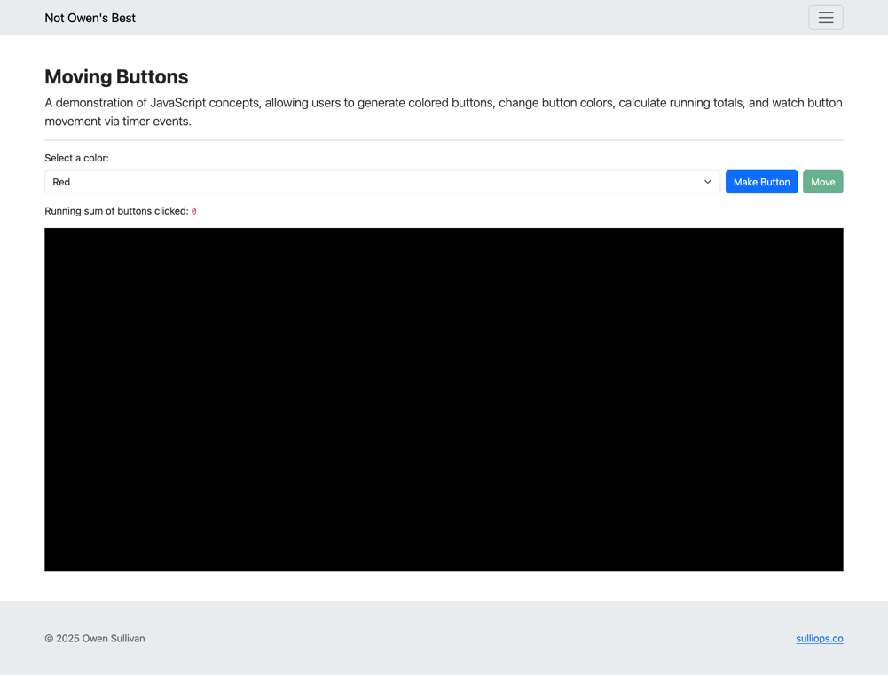
  - After image:
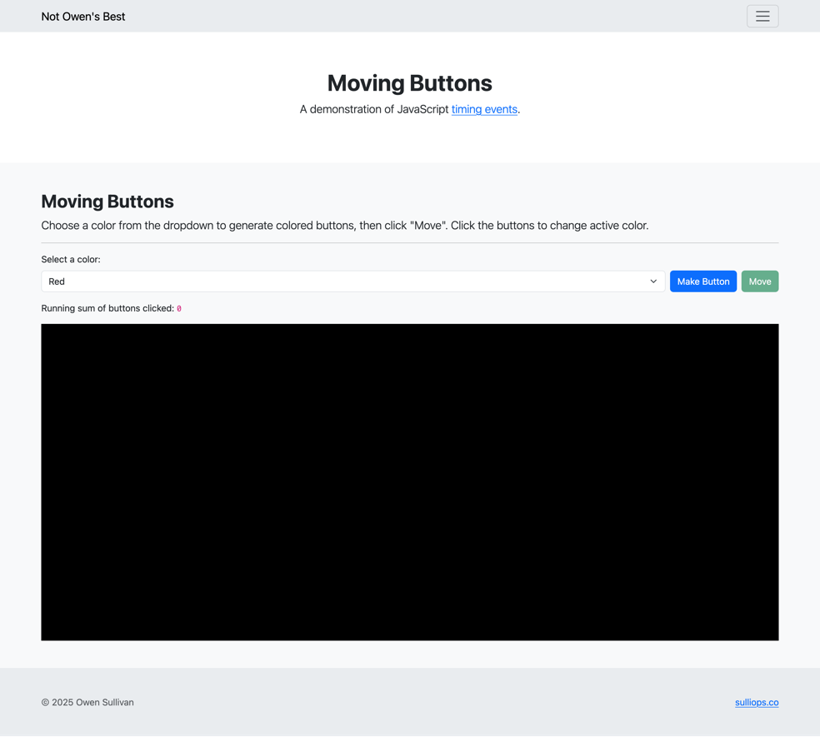
- “You are here” (Chapter 6):
  - Previously, you could not tell what page you were on via my common navbar. I modified the navbar to set the “active” class on the navbar link (or navbar dropdown menu item) for the current page. The PHP code that does this can be seen at https://github.com/CPSC3750/sulliops/blob/main/navbar.php.
  - Image 1:
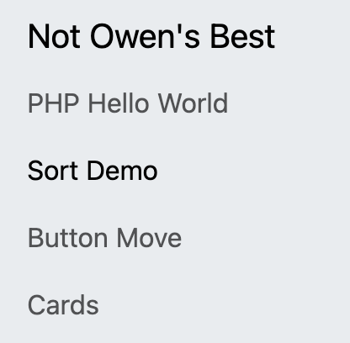
  - Image 2:
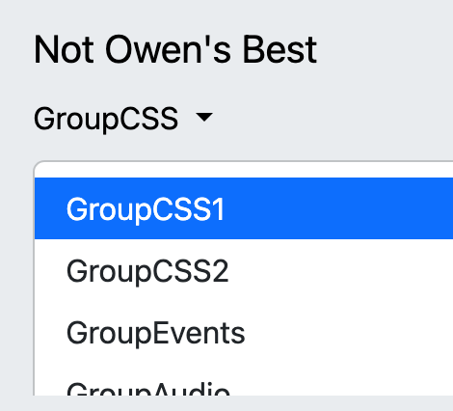
- “Reduce distractions” (just a general principle from the book):
  - Previously, my navbar would expand out across the page. As I add more links, it’s getting larger and larger and beginning to cover the entire window. So, I made it smaller and scrollable. The relevant code is found at https://github.com/CPSC3750/sulliops/blob/main/navbar.php.
  - Before image:
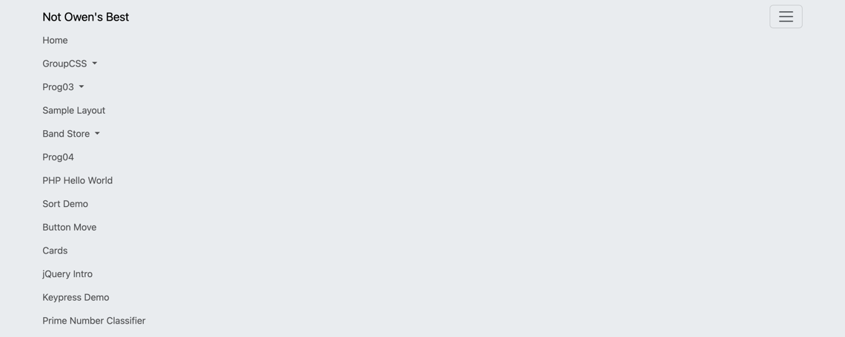
  - After image:

- Maintain consistency (also a general principle):
  - Previously, my home page’s (https://github.com/CPSC3750/sulliops/blob/main/index.php) image gallery section did not have any subtitle text and was using a different background color than all the other sections on my site. I fixed both these issues.
  - Before image:
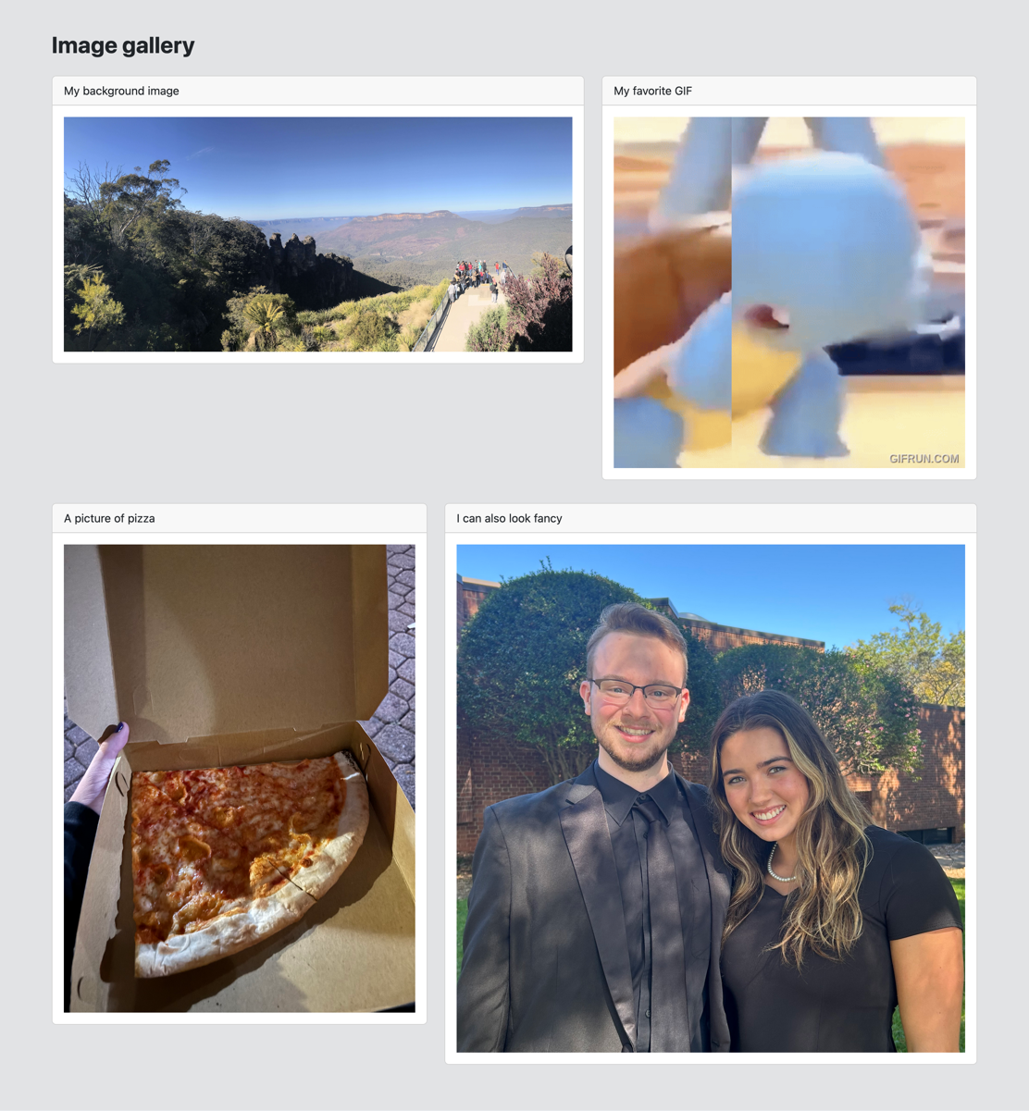
  - After image:
