ShipME Web Application Final Report

ShipME Web Application
Final Report
Coby Foy, Tim Koehler, Isaiah Pham, & Owen Sullivan
Spring 2025

Table of Contents
Introduction 2
Our Team 2
Our Partner 3
The Problem 4
Proposed Solution 5
Getting Started 6
Initial Stages 6
Tech Stack 6
Roadmap 7
Design 8
Containerization 8
Database Schemas 8
User Interface 11
External Integrations 16
Cloud Platform 17
Development 18
Database & RESTful API 18
React User Interface 20
Documentation 21
Development Guide 21
Application Deployment Guide 22
User Manual 52
Demo Videos 106
Appendix 106
GitHub Repository 106
Project Artifacts 107

Introduction

Our Team
We are the CECAS ME team (“Spare Parts”), one of many teams in the Clemson University Computer Science capstone course (CPSC 4910) for Spring 2025.
Excerpts from the team bio¹ we created at the beginning of the semester are copied below:

Coby Foy is a senior Computer Science major from Lexington, SC. He previously interned at BlueCross BlueShield of South Carolina as both a tester and test designer, and enjoys UI/UX, database design, and backend development. His primary role throughout our project was that of a UI designer, drawing up mockups throughout the semester that the team would use to implement our frontend pages. He also helped drive the design of our database schemas.

Tim Koehler is a senior Computer Science major from Greer, SC, with minors in Business Administration and Cybersecurity. His previous experience includes stints at Infor and Hexagon, where he developed automation scripts for cloud environments using Python and PowerShell. He’s also familiar with databases and API development. He worked on multiple components of our project, especially the backend API, the notification pop-ups, and the ability to import and re-sync a class roster by uploading a CSV file.

Isaiah Pham is a senior Computer Science major from Lexington, SC. He previously completed a co-op with MITRE, where he worked on a configurable training course website called xAcademy for Air Force Central, among other sponsors. He is comfortable with frontend and backend development, as well as testing; he’s also a Residential Community Mentor on campus, plays in a jazz and concert band, and plays intramural basketball and soccer. He served as our primary UI programmer, helping us get off the ground with the React JavaScript framework.

Owen Sullivan is a senior Computer Information Systems major from Charleston, SC. He is an experienced full-stack developer and Systems Administrator, and previously interned with Benefitfocus and a small business called Intellectus in Chantilly, VA. He served as a Teaching Assistant for the Computer Science department for two years, and is an accomplished choral singer both nationally and internationally (including with Clemson Choirs). He served as our team leader, managing many aspects of our application’s design and implementation.
With a wide variety of skills and experiences, each member of our team brought unique perspectives to help deliver a thoughtful, practical, usable, and useful product for the Clemson University Department of Mechanical Engineering.
¹ See Artifact 1 - Team Bio for the original team biography, produced at the beginning of the semester and delivered to our partner as a first introduction.

Our Partner

Background
The Mechanical Engineering Department at Clemson University is a unit within the University’s College of Engineering, Computing, and Applied Sciences (CECAS). This college houses Clemson’s technology and engineering departments, preparing students to become technical leaders who can function as productive, innovative, and valuable members of society. The Department of Mechanical Engineering attracts roughly 1,000 students each year, including graduate and international students. The department aims to prepare students to become adept mechanical engineering professionals, leading the world in developing and continuously improving solutions for challenges and opportunities in global markets. Preparing students to address these challenges from an ethical, responsible, and opportunistic perspective, the department instills the values of lifelong learning and professional excellence.
There are a number of stakeholders invested in this project, including (but not limited to): Dr. Tim Guggisberg, coordinator for the Mechanical Engineering capstone course (ME 4020), who will serve as the initial point of contact for the project; additional faculty and instructors for the Mechanical Engineering capstone course who will use the final project; students taking the Mechanical Engineering capstone course, both at the undergraduate and graduate level, who will use the final project; Prof. Carrie Russell, coordinator for the Computer Science capstone course (CPSC 4910), who will serve as the Product Owner and Project Manager.

ME 4020 Overview
Per the Clemson University course catalog, the Internship in Engineering Design capstone course (ME 4020) involves the “creative application of general engineering knowledge in solving an open-ended design problem provided by a sponsor typically external to the University.” Students are “evaluated by a faculty jury,” and they “present results to the jury and sponsor through written reports and oral presentations”. Students work in self-managed teams of 4-6 to engineer practical solutions to open-ended problems, and typically 3-4 teams will address the same problem. ME 4020 works with industry partners to find real-world problems and supports each team with 2 faculty members as weekly advisors, as well as external retired engineering professionals, graduate students familiar with project management and design, and team coaches (more information).

Partner Goals
To be able to successfully prototype their solutions, students must manually complete Excel templates² representing a single order and email them to their instructor. Instructors then place orders for parts from the students’ chosen supplier(s) and manually track the order status. Unfortunately, these orders can become cumbersome to create and organize, resulting in a “stovepiped" ordering process. Course instructors expressed the difficulty in manually managing student orders, describing the process as exhibiting a “significant” administrative load. Therefore, it was imperative that a more automated procedure be implemented to decrease the time spent managing orders. With some experience creating Python scripts to automate various tasks within his course, Dr. Guggisberg discovered that a more technical solution to automate and streamline the ME 4020 parts requesting process could be achieved. Without technical advisors, however, his plans to create a centralized asset-tracking system could not come to fruition. After reaching out to Professor Carrie Russell, coordinator for CPSC 4910, Dr. Guggisberg was given an opportunity to create a partnership between the CECAS Mechanical Engineering Department and the School of Computing at Clemson University. This partnership, forged in a collective effort to help modernize one of the ME 4020 course’s core tasks, aimed to help course members spend less time managing spreadsheets and more time innovating.
This led to a desire for a custom-tailored order management system to serve as a central hub for managing students’ parts requests. The system needed to allow the import of ME 4020 rosters, limiting access to registered students and instructors within the various ME 4020 course sections. Since the system would replace the manual management of large quantities of Excel spreadsheets, it was crucial that it allowed for a more streamlined part requesting process. The ultimate goal was to build a one-stop shop for instructors to view and manage requests. Without having to manually sift through spreadsheets, the instructor would be able to more easily view and manage student part requests. This enhanced process would increase productivity within the department and allow ME 4020 faculty to refocus their time on helping students complete their projects.
² See the attached file “ME 4020 Excel Template.xlsx” for the Excel template used by current ME 4020 students to request parts.

The Problem
The current parts requesting process requires the course instructor to manually manage large quantities of Excel spreadsheets from the various teams within the ME 4020 capstone course. The course instructor has described this process as time-consuming, cumbersome, and inefficient. While the current process is well-defined and functional, Dr. Tim Guggisberg expressed concern about the high administrative burden of managing large quantities of spreadsheets, especially during more strenuous periods in a semester.

Proposed Solution
Dr. Guggisberg requested a software solution to streamline the parts requesting process. A web application, which would serve as a central hub for students, TAs, and instructors to submit and manage requests, would help to address the bottlenecks present in the existing process.
The application would allow students to submit requests for supplies on behalf of their teams, as well as receive alerts when those requests are approved, canceled, or ordered. Providing students with email notifications would allow students to know the status of their requests without them having to be in constant contact with their instructor.
On the administrative side, the application would allow instructors to view and manage students’ requests, filtered by supplier, approving or denying requests as they see fit. Instructors would also be able to log orders for requested parts and send one-way communications to students about their statuses. In addition, the application would allow for the easy import and management of course rosters, the exporting of financial data for record-keeping purposes, and a number of other administrative tasks.
Our team’s proposed solution is ShipME, a custom-tailed asset tracking system in the form of a full-stack web application. On a high level, ShipME provides all of the aforementioned functionality in addition to other features, such as Microsoft account single sign-on (SSO) for authentication. ShipME has the potential to drastically improve the experience for everyone involved in the ME 4020 capstone course. In particular, it will drastically reduce the administrative load on Dr. Guggisberg (or any course coordinator going forward), allowing him to spend less time organizing spreadsheets and more time providing dedicated, personalized mentorship and support for his students.
ShipME in its final form represents continuous development on the original, detailed specifications outlined in Dr. Guggisberg’s original spec sheet³. Although the application may appear and function considerably differently than originally intended, it incorporates decisions made by members of our team in conjunction with Dr. Guggisberg to improve on the initial vision. We are confident that ShipME will deliver a better experience for ME 4020 students and faculty for years to come.
³ See the attached file “Order Tracking System Project.pdf” for the original project specifications.

Getting Started

Initial Stages
After conducting research on the ME 4020 capstone program and establishing contact with Dr. Guggisberg⁴, our team spent the first two development sprints intensely brainstorming. Our primary considerations included the technologies which would power the (then unnamed) ShipME application, as well as how each of Dr. Guggisberg’s stated requirements would be implemented.
Drawing inspiration from our collective experience with popular frontend and backend technologies, we decided on our tech stack (elaborated on in the next section) and began drafting our application’s most basic components: the frontend, the backend, and the database.
⁴ See the attached file “CECAS ME Draft Email.pdf” for the full text of our team’s initial email to Dr. Guggisberg.

Tech Stack
Our team selected a handful of core technologies to power ShipME: the frontend (user interface) is powered by the React JavaScript framework, the backend (API) is powered by Express.js, the database is powered by PostgreSQL, and everything is connected using Docker containerization. The production application is hosted on the Amazon Web Services platform, and the application is secured using Microsoft account authentication leveraging the OAuth 2.0 protocol.
React was chosen for the frontend for its modernity, extensive documentation, and relative ease of use compared to other runtimes. React excels at the stateful management of application data, which helps ensure the correct data can be shown at the appropriate times. We paired it with the React Bootstrap component library, which provides a number of customizable and reusable user interface components (like sections, cards, buttons, and etc.), to ensure consistency in the application’s design. Using a component library like Bootstrap was a particularly important early decision, as most of the team had little to no prior web development experience.
The backend (API) is powered by Express.js, which is the “de facto standard” for Node.js API development (according to Wikipedia). From the start, we knew the API would function entirely on JSON data for both inputs and outputs, and thus there was no need for anything more complex.
PostgreSQL was chosen for the database for the simple reason that it’s free and open source, which would allow for greater flexibility when deploying it to a production environment. PostgreSQL also includes extended functionality not found in other relational database management systems, such as the ability to truncate tables and cascade deletions.
Amazon Web Services was chosen for hosting for a few key reasons: we needed a cloud platform that some team members had at least a bit of experience working with, we needed one that supported deploying our Docker containers, and we needed one that would allow ownership transfer to Dr. Guggisberg after the project’s formal end.
Finally, OAuth 2.0 was the obvious candidate for authentication thanks to its widespread use for single sign-on (SSO) capability. What wasn’t immediately obvious was how OAuth 2.0 would be used, particularly which provider users would authenticate with. Canvas was originally meant to be the provider, as the original project specifications called for deeper integration with Canvas courses and rosters, however we were unable to secure access to Clemson University’s Canvas API and later pivoted to Microsoft account authentication.

Roadmap
As a result of difficulties gaining access to services required for development and deployment, such as the Canvas API and Amazon Web Services, our project roadmap changed frequently.
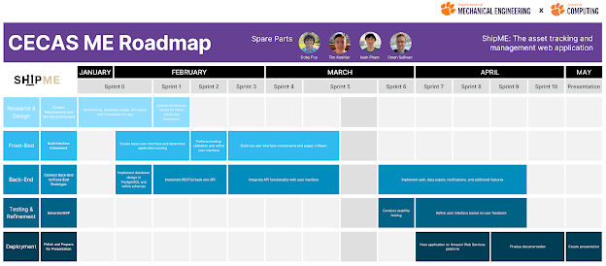
Figure 1 - Project Roadmap
To start, the team prioritized establishing a basic set of database tables and relationships, as these would provide the foundation for API development. Next, those relationships were implemented and refined while barebones Docker containers were created for both the frontend and backend. During this early process, the team engaged in further requirements discovery with Dr. Guggisberg, and we also began correspondence with CCIT in pursuit of access to Canvas and AWS.
From there, API development became the main focus and progressed smoothly until such time that enough API methods were available to begin consumption by a user interface. Since building the frontend required each team member learn the React framework, only a very basic UI was maintained and iterated on until the aforementioned difficulties were mitigated.
The project roadmap was adjusted in response to our requests for access to the Canvas API and a CCIT-managed AWS environment being denied. We had previously intended to integrate SSO near the beginning using Canvas as the provider, but with that avenue closed we had to shift towards using Microsoft accounts. This led to most of the UI work being completed in the final five weeks of the semester.

Design

Containerization
From the beginning, our team needed a reliable and consistent solution to develop, run, and deploy our application. Because our hosting service would not be selected until well past the halfway point in the semester, it was especially important that ShipME be deployable anywhere and consistently functional.
With that in mind, we pursued a containerized solution using Docker, an open-source containerization platform for developing, shipping, and running applications. Docker allows for software to be packaged and run in a container, which virtualizes all the necessary compute resources and provides networking independently of the host machine. Any machine that can run Docker can run a Docker container without having to install and configure dependencies on the host environment.
The frontend, backend, and database each have their own Docker container and use a Docker bridge network to communicate with each other, keeping each service connected but decoupled. This containerized solution is also infrastructure-agnostic, allowing ShipME to be deployed anywhere from cloud providers like AWS to on-premises servers.

Database Schemas
To address the need to store persistent application data, a relational database schema was developed based on the various types of information needing to be stored. The team identified unique characteristics and attributes of potential application data, then created tables representing entities such as users, parts, requests, orders, and etc.
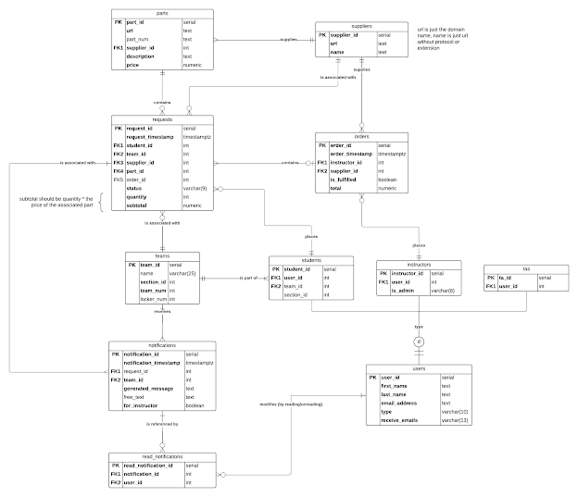
Figure 2 - Database Entity Relationship Diagram (ERD)
The “users” table was created to store each individual user’s identifiable information, such as their names and email addresses. In order to distinguish between the roles that exist within the ME 4020 course, subtype tables were created and connected to the “users” table through a one-to-one (1:1) required relationship. That is to say that each user must be either a student, instructor, or TA, and each subtype table stores properties specific to each role.
Notably, the attribute “is_admin” (found in the “instructors” table) is used to distinguish between normal instructors and ShipME’s administrator user, who acts as the application’s owner. The attribute functions similarly to a boolean value, however it is stored as a string so that an additional “incoming” value can be used. This additional value allows the “is_admin” attribute to define who the singular current administrator is, who the singular incoming administrator is (while an ownership transfer is in progress), and which instructors are not the administrator. Ownership can be transferred by the current administrator to another registered instructor, and the process can be cancelled until the incoming administrator progresses the transfer by logging in (which updates the “is_admin” value to “true”).
The “student” subtype table implements a one-to-many (1:M) relationship with the “teams” table. This means that each ShipME team consists of at least one student, and each student is assigned a singular team. This relationship defines student team assignments, and the “teams” table contains an attribute which defines a team’s course section number. All of that contributes to ShipME’s roster management capabilities.
The “requests” table fulfills the need to store line items for student parts requests, expanding on requirements from the initial project specifications. Each row represents a request for any quantity of a single part supplied by a single supplier, placed by a single student on behalf of their team (members of which can receive status notifications). In other words, “requests” is on the “many” side of one-to-many (1:M) relationships with each of the relevant tables. When a request for a unique part is created, a new “parts” row is added to store the part’s URL, description, price, and etc, allowing that information to be autofilled when the part is requested again. Each part is associated with a supplier through a one-to-many (1:M) relationship, and supplier attributes are extracted from and populated by the part’s URL in order to allow grouping requests by supplier.
That complex web of relationships enables one of ShipME’s most important and powerful features: its ability to consolidate requests by suppliers for regular order placement. The “orders” table, which implements a special one-or-zero-to-many (0,1:M) relationship with “requests”, tracks orders placed with a single supplier (1:M) containing any number of requests. Orders are placed by instructors, hence that one-to-many (1:M) relationship, in a fashion similar to assembling a shopping cart on an online store. Among the table’s attributes is a “total”, which provides a way to track financial and order frequency data for later analysis.
Given that an order cannot exist without at least one request for the chosen supplier, it’s possible for a request row to have a null value for its “order_id” foreign key attribute. That attribute’s value is supplied whenever the request is associated with a new order. Requests also contain a “status” attribute with a number of possible values, such as “requested”, “approved”, “on hand”, “delivered”, and “cancelled”. These flexible status values allow instructors to flexibly deny or modify requests, like in cases where an instructor knows a requested part is already on hand or decides a requested part is too expensive.
The “notifications” table, which is associated with both “teams” and “requests” via one-to-many (1:M) relationships, records both system-generated and instructor-generated notifications. Request creation, as well as changes to a request’s status, automatically generate notifications for the appropriate users. Instructors can also send custom notifications to students in a team. And, although notifications are inherently tied to student teams, the “for_instructor” attribute is used to deliver notifications (specifically for newly-created requests) to the instructor view. Notification records are displayed within ShipME.
Finally, the “read_notifications” bridge table implements a many-to-many (M:M) relationship between “users” and “notifications”, allowing ShipME users to mark notifications as read on an individual level within the application interface.

User Interface
Initial mockups for ShipME’s user interface were designed in Figma, a popular tool for prototyping high-fidelity UI/UX mockups^{5, 6}. Using standard design principles, our team set out to create an intuitive interface that easily allows users to complete core tasks like placing requests and orders. The interface consists of two “views”, each providing access to different pages and functionalities: the instructor view (which is also seen by TA users) and the student view.
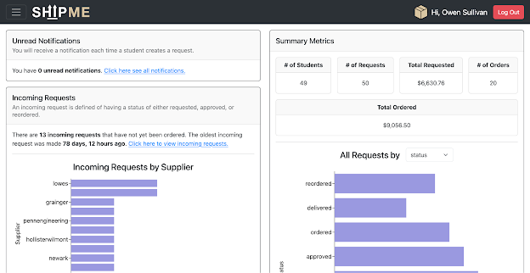
Figure 3 - Dashboard (Instructor View)
The Dashboard, available to all ShipME users, displays at-a-glance metrics and graphs for request data (as well as order data for instructors and TAs). It also displays the user’s unread notification count.
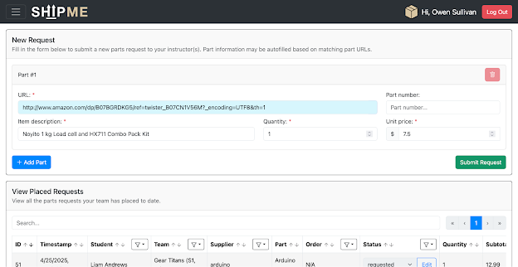
Figure 4 - Requests Page (Student View)
The Requests page, also available to all user types, is where requests can be viewed and placed on behalf of a student team. Students can view and modify the requests created for their team, whereas instructors and TAs can view requests placed by all students. The page includes a request form, which allows for any number of individual parts to be requested at one time.
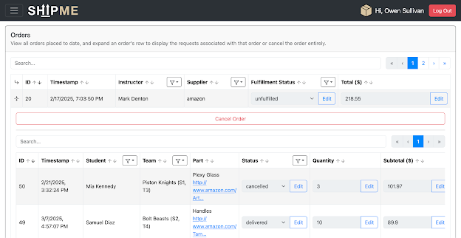
Figure 5 - Orders Page (Instructor View)
The Orders page, viewable only by instructors and TAs, provides the ability to group requests by supplier, create new orders from approved/reordered requests, and view/modify existing orders and their associated requests all in one place.
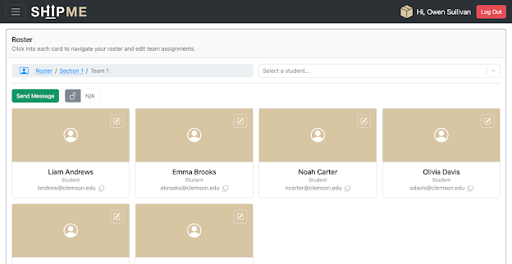
Figure 6 - Roster Page (Instructor View)
The Roster page, viewable only by instructors and TAs, provides full-suite roster management functionality. Instructors can view and modify student team assignments, as well as modify a team’s locker assignment and send messages directly to that team. Additionally, instructors and the application administrator can manage and add faculty users.
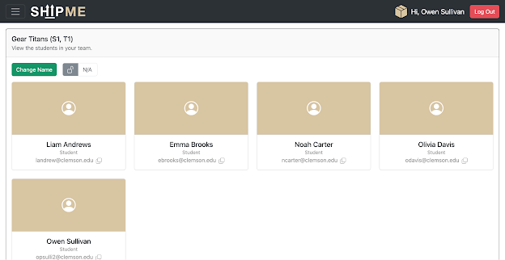
Figure 7 - Team Page (Student View)
The Team page, viewable only by students, displays all team members within a student’s team along with their user information. Students can edit their team’s name and locker assignment to make their ShipME experience more personalized and help reduce administrative load. Students can also view faculty users, similarly to instructors on the Roster page.
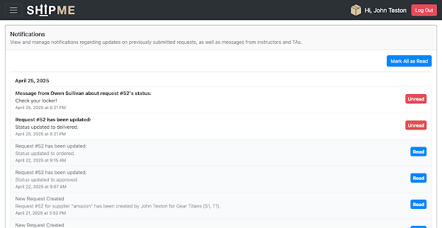
Figure 8 - Notifications Page (Student View)
The Notifications page, viewable by all ShipME users, displays a user’s notifications and allows them to be marked as read/unread. Instructors can also send custom notifications to students and their teams from this page.
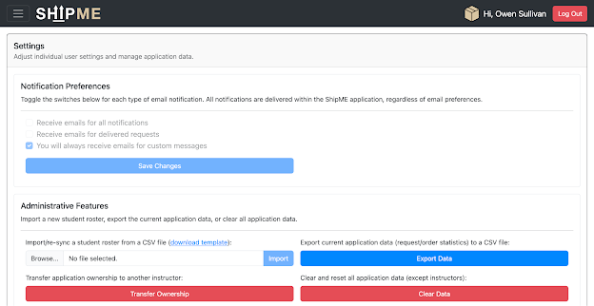
Figure 9 - Settings Page (Instructor View)
The Settings page, viewable by all ShipME users, provides access to notification settings and administrative functions (for instructors and the application administrator). Notification settings are displayed for all users as a placeholder for potential future improvement, however the ability to change them is only exposed to students. Instructors can import new rosters and export application data to CSV, and the administrator user can initiate/cancel an ownership transfer or clear the application data.
⁵ See files in the attached folder “ShipME UI Mockups” for the complete collection of ShipME user interface mockups.
⁶ The mockups can also be viewed on Figma directly, however there is no guarantee that the link will resolve properly in the future.

External Integrations
The ShipME application itself only integrates one third-party service: the Microsoft identity platform.
As previously mentioned, the original plan was to use Canvas as the OAuth 2.0 provider for user authentication. However, once it became clear that path was closed to us, we chose to pivot and use Microsoft accounts for authentication. Just as with Canvas, every ShipME user should have a university-issued Microsoft account. Additionally, CCIT has made the decision to ditch Google accounts in favor of Microsoft accounts, which makes Microsoft the obvious choice for longevity.
This integration allows ShipME to rely on responses from Microsoft’s authentication service to verify users, as opposed to implementing a more traditional database-based authentication system. The single sign-on approach is much simpler, requiring significantly less code to integrate; ShipME simply has to verify that a valid Microsoft account’s username (email address) is found in the database. SSO is also more secure, as Microsoft accounts can be configured with two-factor authentication. And, most importantly for users, it’s more convenient; once a user logs into ShipME, they could (theoretically) remain logged in on a device so long as they aren’t signed out of their Microsoft account.
An honorable mention for external integrations is the EasyPost API, which we briefly planned to integrate for the purpose of tracking shipments from suppliers. This would have allowed ShipME to display shipment statuses using tracking numbers provided for and associated with orders placed by instructors, however shipment logging functionality was later cut from the application.
One final note about external integrations is the use of Amazon’s Simple Email Service platform for sending mail via the Secure Mail Transfer Protocol (SMTP). This isn’t really an integration, since any SMTP provider could be used with the same code, but ShipME nevertheless makes use of it.

Cloud Platform
ShipME’s production environment, deployed and managed through the Amazon Web Services platform, is designed to mirror the development environment very closely.
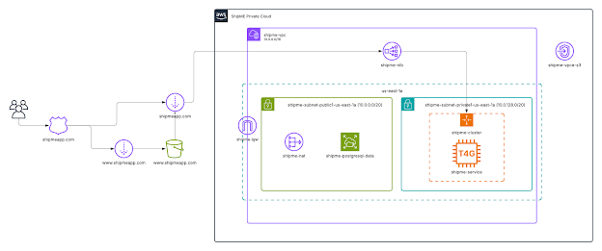
Figure 10 - AWS Deployment Diagram
Starting from left to right, web traffic to the shipmeapp.com public domain is handled by a Route 53 Domain Name Service (DNS) zone. DNS directs traffic to one of two destinations: a CloudFront distribution for traffic on shipmeapp.com (without the “www” subdomain), or a second CloudFront distribution for traffic on www.shipmeapp.com which points to an S3 webpage redirect bucket (which, in turn, redirects back to the first CloudFront distribution). A TLS certificate for the site is also served by the primary CloudFront distribution.
Traffic directed through the primary CloudFront distribution is passed to a Network Load Balancer, which acts as a port forwarder from HTTP port 80 to HTTP port 5173 (the port on which the ShipME frontend container is exposed). This allows all three ShipME Docker containers (frontend, backend, and database) to run within a single EC2 instance (t4g.medium), orchestrated by an Elastic Container Service auto-scaling cluster, within a private VPC subnet. The t4g.medium instance type was chosen for its relatively low cost, high performance, and moderate compute capacity. The Docker containers themselves are hosted in private Elastic Container Repository repositories.
Database data is stored persistently using an Elastic File System volume, which exists on a complimentary public VPC subnet. A VPC endpoint is used to allow the S3 webpage redirect bucket to function properly, and an Internet Gateway is used to enable one-way communication to the outside internet from within ShipME’s Docker containers.
Experienced AWS users and cloud professionals may notice that running all three Docker containers on a single server inside a single Availability Zone is far from ideal. This design resulted from time constraints imposed on production deployment and readiness by the significant delay our team faced gaining access to an AWS environment. Future deployments could be revised to leverage a multi-instance strategy, or alternatively serverless compute solutions like Fargate.
For the purposes of ShipME’s completion and initial deployment, however, we believe the current cloud strategy is sufficient. The single T4G instance should be able to handle traffic from somewhere between 50 and 100 users, although this has not been adequately tested. In case the server is not powerful enough to handle peak load, the instance type could be changed to increase available compute capacity.
This solution, as designed and implemented, will incur a monthly cost of just under $80 (exact figure unknown). The cost is slightly variable in that the amount of web traffic served by the Network Load Balancer per month creates fluctuations in that service’s cost, however the difference should be almost negligible.

Development

Database & RESTful API
ShipME’s PostgreSQL database was implemented according to the relational schema defined previously. A few constraints were used within the table definitions: “NOT NULL” to ensure required fields have values, “UNIQUE” in cases where non-foreign key values should be unique to a table, and “ON DELETE CASCADE” for subtype tables’ supertype-referencing foreign keys. Additionally, some fields use “CHECK” constraints to require values matching one in a list of strings.
When the database container is run and PostgreSQL detects that there is no database data, it runs an initialization script to define the ShipME database structure. This file is called “init.sql”, and tables are created in a very specific order to ensure foreign key relationships can be defined without issue. There is also a script called “test_data.sql” that generates a semi-randomized set of test (read: fake) data, which was used to facilitate quicker development.
The backend RESTful API allows the frontend user interface to retrieve and modify database data. The API implements endpoint methods for retrieving existing data, such as users, requests, and orders, as well as for supplying and transforming new or updated information. When using the ShipME user interface, the API is queried to fetch relevant information for display on each page. When information is created, updated, or deleted, the site updates in real time to resynchronize with the database.
When retrieving a list of entity objects (such as users), the API supports query parameters based on attributes relevant to the type of data being retrieved. Where filtering is supported, API calls can include optional query parameters to retrieve data filtered by the values of those parameters. Page components such as dropdown menus use filtered API calls to retrieve data that matches user-selected criteria or search terms. This ensures that the user interface retrieves only the relevant subsets of data, rather than entire datasets from the database, wherever possible.
The API accepts and returns data using standard JavaScript Object Notation (JSON). API methods which return JSON data always transform any properties to the appropriate types for consumption by the frontend (such as changing numeric values to numbers, when they are stored as strings in the database). API methods which accept JSON data always validate the data, checking for the correct type for a property as well as ensuring that any foreign key references are valid.
To allow different types of users to interact with ShipME and have distinct properties and permissions, user entities make use of a supertype-subtype relationship. The “users” table in the database is special, and so are its subtype tables (“instructors”, “tas”, and “students”); user records have a “type” field that determines what subtype a user is.
Because the “users” table is the supertype, the API accepts values for subtype-specific attributes as part of the relevant POST method’s body. The POST method for “users” also creates the appropriate subtype records, which is why none of the subtype entities have corresponding POST methods. The individual GET methods for each subtype return the supertype user object, as opposed to the subtype object. This decision was made for convenience, as subtype records are not used as frequently throughout ShipME. However, the team later wished these relationships had been implemented differently, as it can be confusing to retrieve subtype records from the API.
Experienced JavaScript developers or those familiar with RESTful APIs and their consumption can read the ShipME backend API documentation for more detailed usage information⁷. The backend container also hosts a copy of Swagger UI for visual API reference and testing.
⁷ See the attached file “ShipME API Documentation.pdf” for the full API specification documentation, which was generated from OpenApi 3.0 specification YAML.

React User Interface
ShipME’s frontend user interface was built using React with TypeScript and bundled through Vite for hot reloading and faster development. The interface uses modular components for scalability and reusability, and TypeScript helps with error checking and enforcing the types of data being used throughout the application.
Authentication is handed on the frontend via an “AuthProvider” context that wraps around the root of the application’s pages and handles Microsoft authentication via MSAL. The email address returned from Microsoft authentication is checked against the email addresses in the “users” table in the database to verify access to the application and return the appropriate user information. The user type is checked on each page via a React hook so that only users with an allowed type (instructor, TA, or student) can view and interact with application data and functionality.
React’s state and effect hooks are leveraged to manage real-time synchronization of user interactions with the API. When users create part requests, update orders, or change personal settings, the UI immediately reflects those changes while updating the database in the background. Conditional rendering based on user roles ensures each user type only sees components relevant to them. For example, students are restricted from viewing or editing orders placed by instructors.
Each page also leverages Bootstrap utility classes for consistent styling and interactions. The React JSX notation for page markup allows both React components (such as wrappers provided by React Bootstrap) and standard HTML to be used at the same time, and a mix of both are used throughout the frontend code. Reusable components are grouped together in the source code according to their functionalities and usage.
The frontend also includes wrapper functions for all backend API methods, which serve as a form of middleware. These functions, such as “createRequest”, perform the simple action of making Fetch API calls and returning data matching TypeScript types (JSON object structures) for each entity. They also pass on errors from the backend API and/or database, so that errors can be handled appropriately.
Like the backend API, the User type and its subtypes (Instructor, TA, and Student) implement a supertype-subtype relationship. The User supertype allows all subtype properties, which is why it may appear bloated to experienced programmers. This approach allows subtype attributes to be returned alongside supertype attributes, which make referencing subtype attributes throughout the application far easier.

Documentation

Development Guide

Setting Up & Tearing Down
To run and develop ShipME on your local machine, follow these steps:
- Follow Docker’s installation guide to install Docker.
- Clone the ShipME source code repository⁸ to a local directory.
- Run the following commands in a terminal from the repository root: docker compose build followed by docker compose up.
- To remove ShipME containers, run: docker compose down.
- To delete the database’s persistent data volume, run: docker volume rm s25-cecas-me_postgres_data.
Note: Local development requires setting a number of environment variables through a “.env” file. There is a template with all of the required variable names called “.env.template” in the source code root. Follow Step 1 of the Application Deployment section to register the application with the Microsoft identity platform, if necessary.
⁸ See the GitHub Repository section for a link to the ShipME GitHub repository.

Repository Structure
The ShipME source code is a mono-repository structure organized into three top-level directories: “frontend”, “backend”, and “db”. A given directory contains all of the files necessary to run the relevant container, as well as the source code for the relevant ShipME component. Each directory also contains a “README.md” file which provides a brief description of the service contained within⁹.
Although each Docker container has its own “Dockerfile”, there is a top-level “docker-compose.yml” file in the root of the repository that is used to network each container together. This file is what is acted on when you execute any of the docker compose commands above.
The organization of files within each ShipME component’s directory should be fairly self-explanatory to developers familiar with ShipME’s tech stack.
⁹ See the attached folder “READMEs” for the “README.md” files for each ShipME component.

Application Deployment Guide
Deploying ShipME is a time-consuming process that requires a number of precise steps. Although anyone should be able to follow these steps, our team highly recommends the process be carried out by an experienced Amazon Web Services user. The steps are written under the assumption that whomever attempts deployment can effectively navigate the AWS web console.
Additionally, these steps assume the domain shipmeapp.com is hosted through Route 53 on the AWS account which will host ShipME. Instructions for setting up the domain and a hosted DNS zone are not provided in this report, as they cannot easily be replicated without purchasing another domain. They also assume that the AWS account has been approved for production use of Simple Email Service, and those instructions are not provided here for the same reason. Instead, follow the guide: Request production access (Moving out of the Amazon SES sandbox).
Note: Throughout these steps’ screenshots, the string “shipme-demo” is used as opposed to simply “shipme”. When following these steps, replace all instances of “shipme-demo” with “shipme”. Otherwise, deployment may not succeed.
- Follow the guide to register an application in Microsoft Entra ID for ShipME’s single sign-on (SSO) integration: How to register an app in Microsoft Entra ID - Microsoft identity platform.
  - Select the “Accounts in this organizational directory only” option for “Supported account types”.
  - Select “Single-page application (SPA)” under “Redirect URI” and enter “https://shipmeapp.com”.
  - Note down the client ID after the app is registered.
  - Optionally, add “http://localhost” as a redirect URI after the app is registered. Instructions: How to add a redirect URI to your application - Microsoft identity platform.
- Create an identity for the shipmeapp.com domain in Simple Email Service using the “Create identity” wizard.
  - Note: Creating the identity will automatically create the necessary DNS records in Route 53.
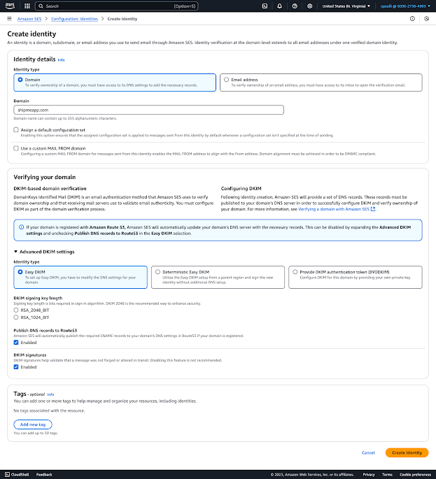
- Create SMTP credentials for Simple Email Service using the “Create user” wizard.
  - Name the user “shipme-smtp-user”.
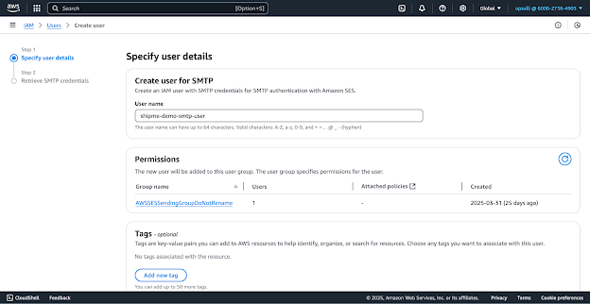
  - Note down the SMTP user name and SMTP password for later use. Optionally, download the credentials as a CSV.
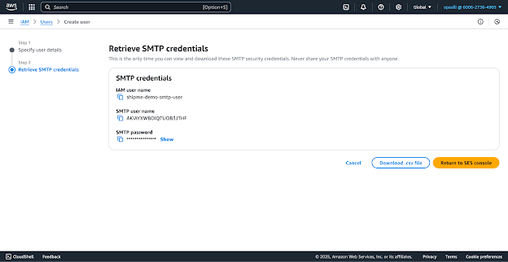
- Create a new VPC using the “Create VPC” wizard.
  - Select the “VPC and more” option under “Resources to create”.
  - Ensure “Auto-generate” is checked for “Name tag auto-generation”, and enter “shipme” in the text field.
  - Under “Number of Availability Zones (AZs)”, select 1.
  - Add a NAT Gateway in 1 AZ.
  - Ensure the “S3 Gateway” option is selected under “VPC endpoints”.
  - Leave all other options as default, and verify selections against the screenshot below. Click “Create VPC” when ready to proceed.
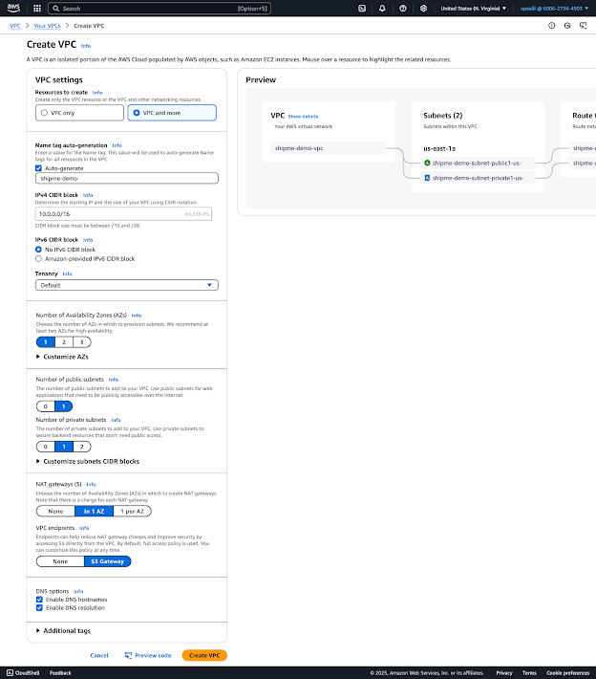
- Once the VPC has been fully provisioned, create VPC security groups for cloud resources that will exist within the VPC. Because some SGs will have rules which depend on other SGs, it’s easier to create the five required security groups first and assign rules afterwards.
  - Create the following five SGs in the VPC you created earlier: “shipme-nlb-sg”, “shipme-ecs-sg”, “shipme-frontend-sg”, “shipme-backend-sg”, “shipme-db-sg”. Enter appropriate descriptions for each.
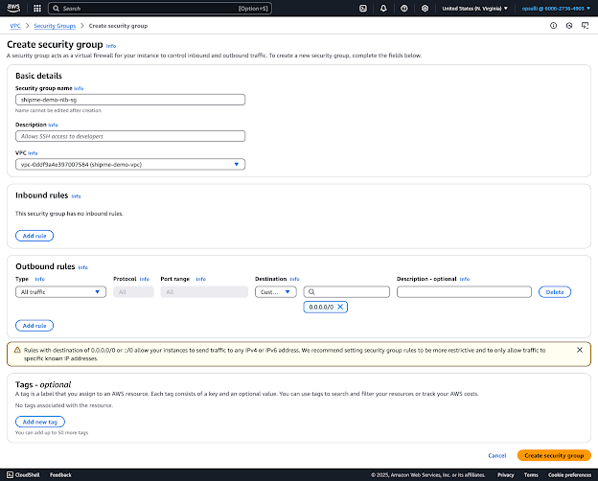
  - Edit the newly-created SGs to use the appropriate inbound and outbound rules.
    - For the “shipme-nlb-sg” SG:
      - Inbound:
Type | Protocol | Port range | Source |  | Description
HTTP | TCP | 80 | Custom | com.amazonaws.global.cloudfront.origin-facing | Allow incoming HTTP traffic from CloudFront
      - Leave the default outgoing rule in place.
    - For the “shipme-ecs-sg” SG:
      - Inbound:
Type | Protocol | Port range | Source |  | Description
All traffic | All | All | Custom | shipme-ecs-sg | Allow container-to-container communication
Custom TCP | TCP | 5173 | Custom | shipme-nlb-sg | Allows traffic from NLB
SSH | TCP | 22 | Custom | 10.0.128.0/20 | Allows SSH from private1 subnet
      - Leave the default outgoing rule in place.
    - For the “shipme-frontend-sg” SG:
      - No inbound rules are necessary.
      - Leave the default outgoing rule in place.
    - For the “shipme-backend-sg” SG:
      - Inbound:
Type | Protocol | Port range | Source |  | Description
Custom TCP | TCP | 3000 | Custom | shipme-frontend-sg | Allows traffic from frontend
      - Leave the default outgoing rule in place.
    - For the “shipme-db-sg” SG:
      - Inbound:
Type | Protocol | Port range | Source |  | Description
PostgreSQL | TCP | 5432 | Custom | shipme-backend-sg | Allows traffic from backend
NFS | TCP | 2049 | Custom | shipme-ecs-sg | Allows EFS traffic from ECS
      - Leave the default outgoing rule in place.
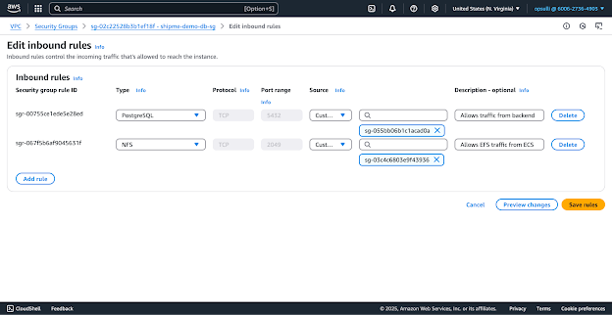
- Create a new EFS volume using the “Create File System” wizard.
  - Name the volume “shipme-postgresql-data”.
  - Leave all settings on the first page as default, and make sure they match the screenshot below. Click “Next” when you’re ready to proceed.
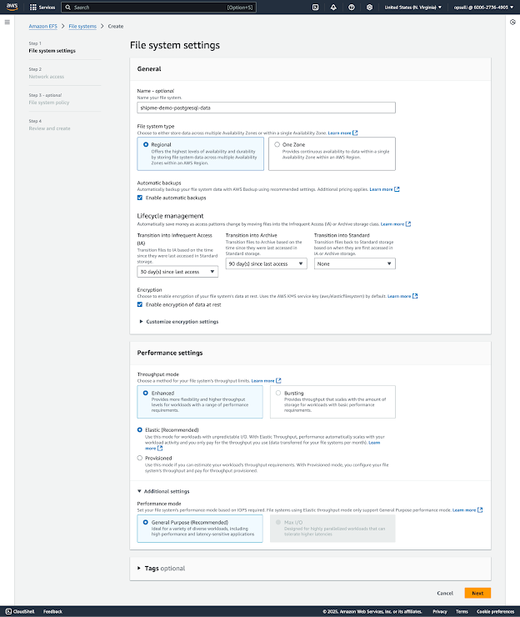
  - Select the “shipme-vpc” VPC under the “Network” section.
  - Change the selected security group under “Mount targets” to “shipme-db-sg”, instead of the pre-selected “default” SG. Click “Next” to proceed.
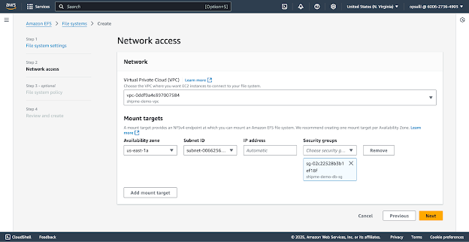
  - Click through the remaining screens, then finally the “Create” button.
  - Note down the unique file system ID generated by AWS upon creation of the EFS volume (a string starting with “fs-”).
- Create Elastic Container Registry repositories for each ShipME container using the “Create private repository” wizard.
  - Create three repositories: “shipme/frontend”, “shipme/backend”, and “shipme/db”. Leave all settings as default.
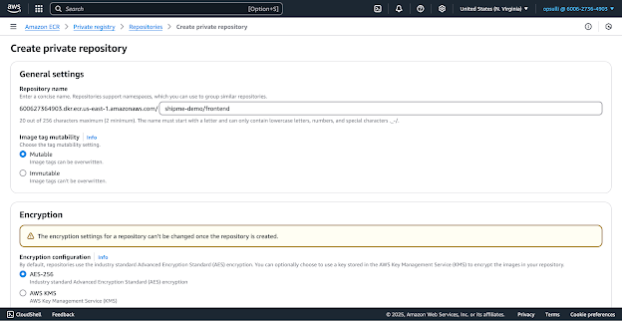
- Build and push the three ShipME Docker containers to the newly-created ECR repositories.
  - Follow the steps in the Local Development section of this report to ensure you can run the containers on your local machine.
    - Note: Deploying the containers requires the use of a multi-architecture build tool. Although it should work just fine on a Windows-based host machine, these instructions assume the use of a UNIX-based host (such as a Mac).
  - Install the AWS CLI by following: Installing or updating to the latest version of the AWS CLI. Then run the command aws configure from a terminal and follow the configuration guide: Setting up the AWS CLI.
  - Install and configure the Docker buildx plugin by running the command: docker buildx create --use --name multiarch-builder
  - Authenticate Docker with AWS by running: aws ecr get-login-password --region us-east-1 | docker login --username AWS --password-stdin [AWS_ACCOUNT_ID].dkr.ecr.us-east-1.amazonaws.com
    - Note: Replace “[AWS_ACCOUNT_ID]” with your AWS account ID, found in the AWS web console. You should see the output “Login Succeeded” if authentication was successful.
  - From the root of the ShipME source code repository (where the file “docker-compose.yml” is located), run the following command for each container: docker buildx build [CONTAINER_NAME] --platform linux/arm64 -t [AWS_ACCOUNT_ID].dkr.ecr.us-east-1.amazonaws.com/shipme/[CONTAINER_NAME]:latest --push
    - Note: Replace both instances of “[CONTAINER_NAME]” with the name of the container you are building/pushing, such as “frontend”. Replace “[AWS_ACCOUNT_ID]” with your AWS account ID, found in the AWS web console.
- Create a new Elastic Container Service cluster using the “Create cluster” wizard.
  - Name the cluster “shipme-cluster”.
  - Under the “Infrastructure” panel, de-select “AWS Fargate (serverless)” and select “Amazon EC2 instances”.
    - Change the selection for “Container instance Amazon Machine Image (AMI)” to “Amazon Linux 2 (arm64)”.
    - Under “EC2 instance type”, choose an EC2 instance type and size. The team recommends the “t4g.medium” instance type.
    - Under “Desired capacity”, set both the minimum and maximum values to 1.
    - Under “SSH Key pair”, click the “Create a new key pair” button to open the “Create key pair” wizard in another browser tab. Enter “shipme-instance-keypair” as the name and click “Create key pair”.
      - Note: This action downloads the generated key pair (a .pem file). It is extremely important that this file be kept in a secure place and not shared with anyone who should not have direct access to the server running ShipME. If you lose this file, you will have to re-create the ECS cluster.
      - Select the key pair in the cluster creation wizard after creation.
  - Under the “Network settings for Amazon EC2 instances” panel, select the “shipme-vpc” VPC.
    - Remove all subnets except “shipme-subnet-private1-us-east-1a” (the private subnet).
    - Clear the default security group selection and choose the “shipme-ecs-sg” security group.
  - Verify your settings match the below screenshot, then click “Create” to proceed.
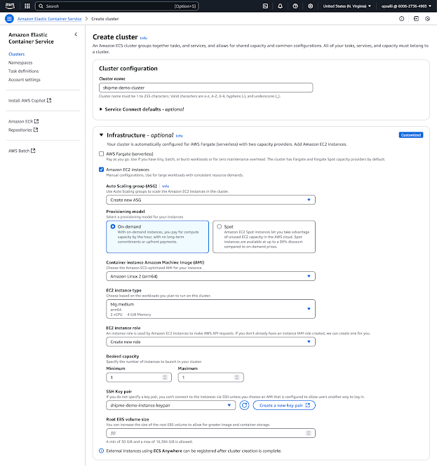
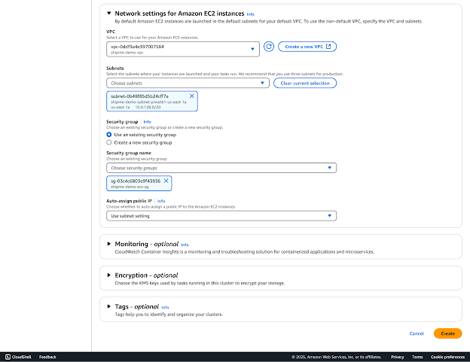
- Create an ECS task definition using the “Create new task definition with JSON” button. The task definition must be created with JSON as opposed to the GUI, as it uses some options which do not have dedicated UI elements.
  - Paste the contents of the file “task_definition.json” in the root of the ShipME source code repository⁷.
  - Change all instances of the following placeholder values to valid values:
    - “[AWS_ACCOUNT_ID]” becomes your AWS account ID, found in the AWS web console.
    - “[MSAL_CLIENT_ID]” becomes the client ID found in the Microsoft identity platform portal that you created earlier.
    - “[SES_SMTP_USERNAME]” becomes the Simple Email Service SMTP username you created earlier.
    - “[SES_SMTP_PASSWORD]” becomes the SMTP user’s password that you created earlier.
    - “[DATABASE_PASSWORD]” becomes an alphanumeric string of your choosing for the PostgreSQL database’s password.
    - “[FILE_SYSTEM_ID]” becomes the EFS volume ID you noted down earlier (starting with “fs-”).
  - Click “Create” when you are 100% sure you have supplied the correct values for the above. Those values are environment variables for each of ShipME’s containers and they’re crucial for successful deployment.
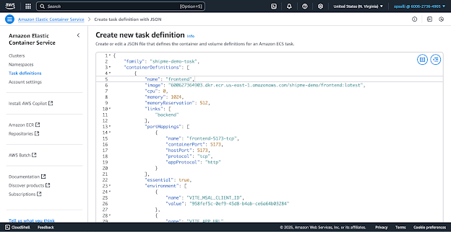
- Create an EC2 target group using the “Create Target Group” wizard.
  - Choose “Instances” under “Choose a target type”.
  - Name the target group “shipme-frontend-tg”.
  - Under “Protocol : Port”, select “TCP” and enter port 5173.
  - Under “Health Checks”, select “TCP”.
  - Verify the configuration matches the screenshots below, then click “Next” to proceed.
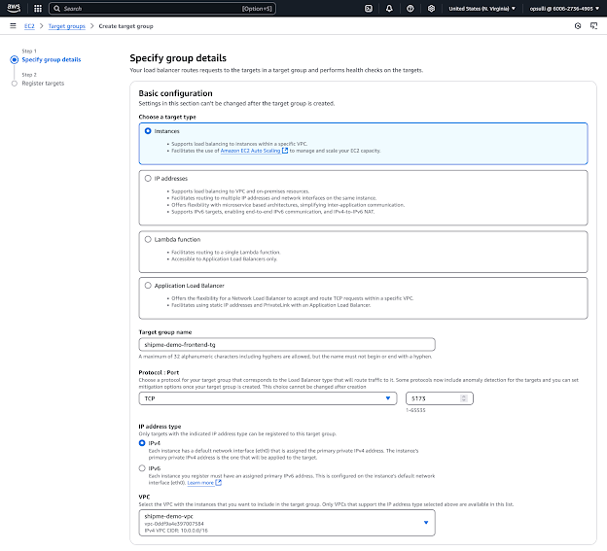
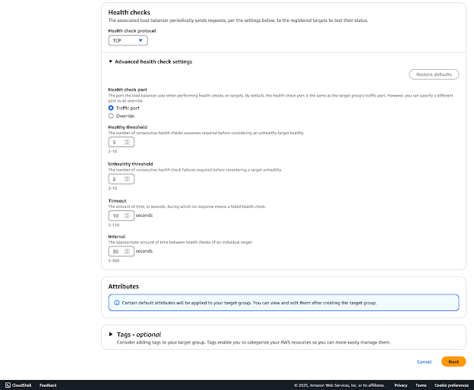
  - Click “Create Target Group”.
- Create a Network Load Balancer using the “Create Network Load Balancer” wizard.
  - Name the load balancer “shipme-nlb”.
  - Make sure “Internet-facing” is selected for “Scheme”.
  - Select the “us-east-1a” Availability Zone under “Availability Zones and subnets”.
  - Clear the default security group and select the “shipme-nlb-sg” security group.
  - Select the previously-created “shipme-frontend-sg” under the “Default action” field for the listener.
  - Verify your settings match the screenshots below, then click “Create load balancer”.
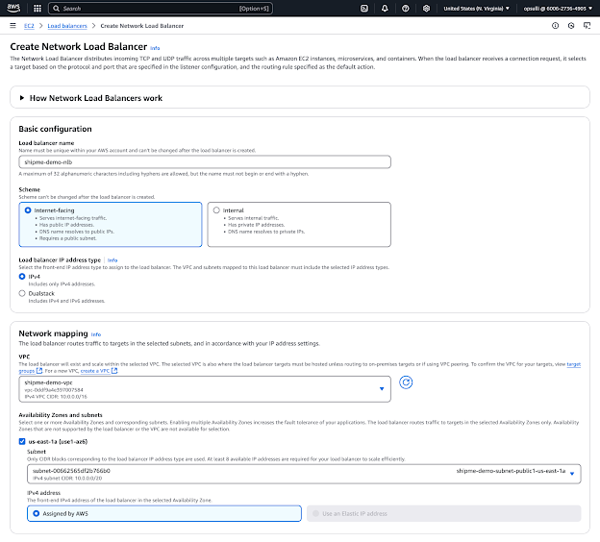
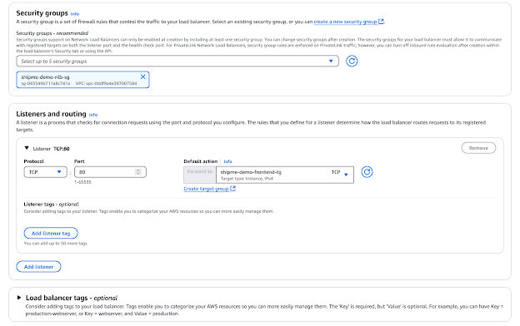
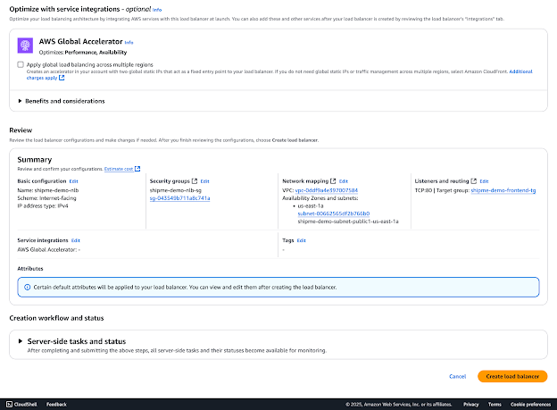
- Request an SSL certificate for “shipmeapp.com” using the “Request public certificate” wizard.
  - Enter the following fully qualified domain names: “shipmeapp.com” and “*.shipmeapp.com”.
  - Ensure “DNS validation” is selected.
  - Click “Request”.
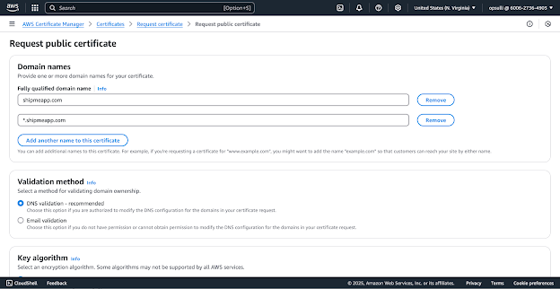
  - Once the certificate has been requested, view it and click “Create records in Route 53”. The appropriate DNS records for domain verification will be created automatically and the certificate will be issued shortly after.
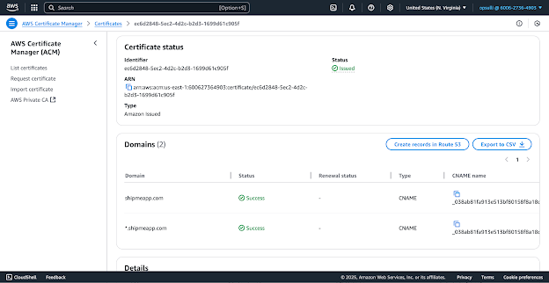
- Create an S3 bucket using the “Create S3 bucket” wizard.
  - Name the bucket “www.shipmeapp.com”.
  - Uncheck “Block all public access” and check the “I acknowledge…” box to confirm.
  - Verify your settings match the screenshots below, then click “Create Bucket”.
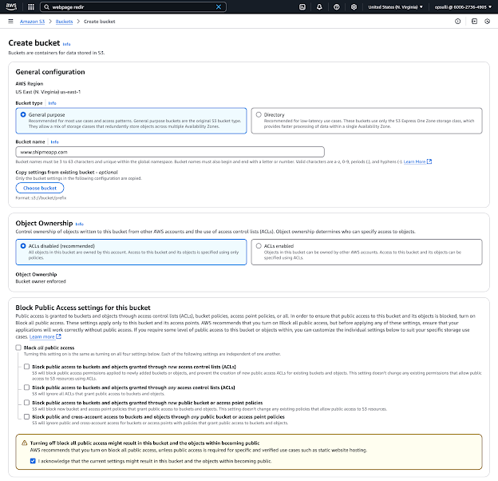
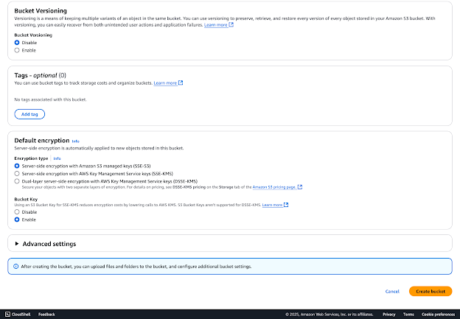
  - After the bucket is created, edit the “Static web hosting” section of the bucket’s properties. Enable static web hosting with the “Redirect requests for an object” hosting type, and enter “shipmeapp.com” as the host name with “https” as the protocol.
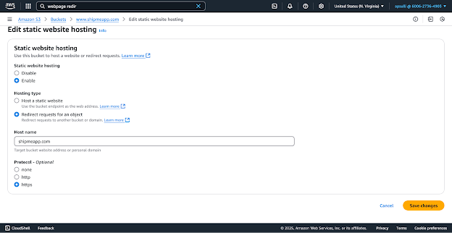
- Create a new CloudFront distribution using the “Create distribution” wizard.
  - Under the “Origin” panel, configure the following:
    - Choose “shipme-nlb” as the origin domain. The field will update with the complete DNS name automatically.
    - Select “HTTP only” for the protocol and make sure port 80 is used.
  - Under the “Default cache behavior” panel:
    - Select “Redirect HTTP to HTTPS” for “Viewer protocol policy”.
  - Disable the Web Application Firewall (WAF).
  - Under the “Settings” panel:
    - Add “shipmeapp.com” as an alternate domain name (CNAME).
    - Select the SSL certificate you created earlier for “shipmeapp.com”.
  - Verify your settings match the screenshots below, then click “Create distribution”.
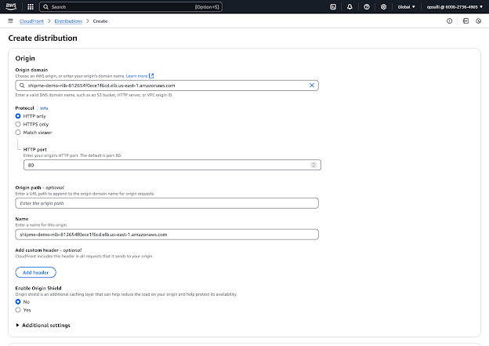
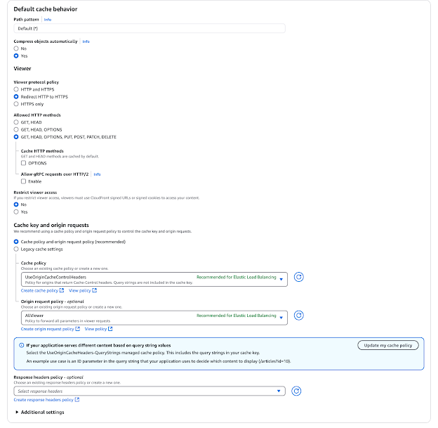
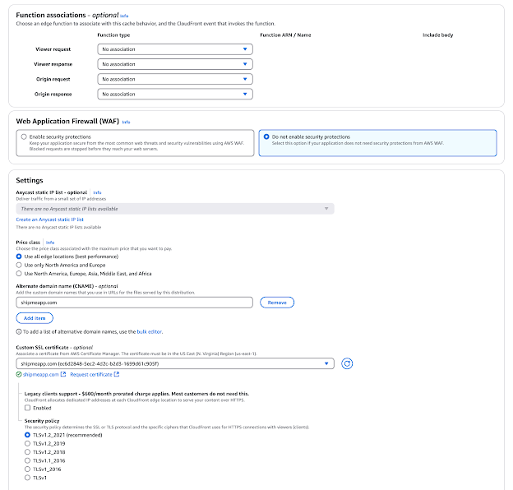
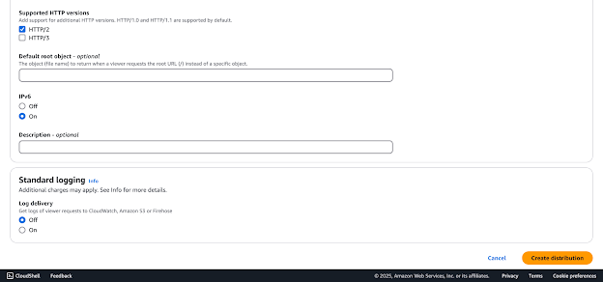
- Create another new CloudFront distribution using the “Create distribution” wizard.
  - Under the “Origin” panel, configure the following:
    - Enter “www.shipmeapp.com.s3-website-us-east-1.amazonaws.com” as the origin domain.
    - Select “HTTP only” for the protocol and make sure port 80 is used.
  - Under the “Default cache behavior” panel:
    - Select “Redirect HTTP to HTTPS” for “Viewer protocol policy”.
  - Disable the Web Application Firewall (WAF).
  - Under the “Settings” panel:
    - Add “www.shipmeapp.com” as an alternate domain name (CNAME).
    - Select the SSL certificate you created earlier for “shipmeapp.com”.
  - Verify your settings match the screenshots below in Step 14 (with appropriate changes), then click “Create distribution”.
- Create an ECS service under the cluster “shipme-cluster” using the “Create service” wizard.
  - Select the task definition family “shipme-task”. Make sure the latest task definition revision is selected.
  - Name the service “shipme-service”.
  - Expand the “Load balancing” panel and check the “Use load balancing” box.
  - Select the “shipme-vpc” VPC.
  - Choose “Network Load Balancer” for “Load balancer type”.
  - Make sure “frontend 5173:5173” is the selected container.
  - Select the “shipme-nlb” load balancer.
  - Choose “Use an existing listener” and select the “TCP:80” listener.
  - Verify your settings match the screenshots below, then click “Create”.
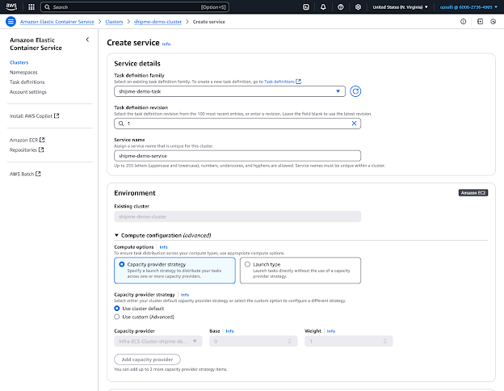
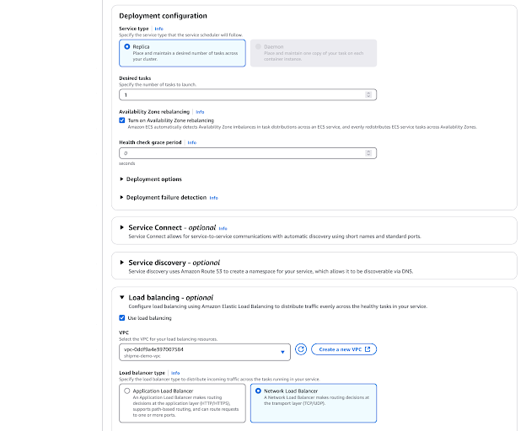
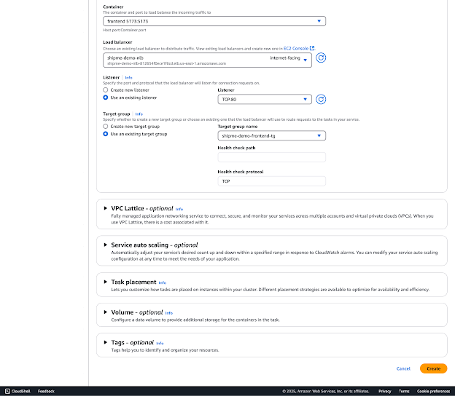
- Create DNS records on the shipmeapp.com domain in Route 53 using the “Create record” wizard.
  - Add the following records:
Record name | Record type | Alias? | Route traffic to | Distribution
 | A | Yes | Alias to CloudFront distribution | shipmeapp.com
www | A | Yes | Alias to CloudFront distribution | www.shipmeapp.com
⁷ The file “task_definition.json” is also attached with this report.

User Manual
To better understand how to use ShipME’s user interface, follow along with the provided steps for your assumed user role (Administrator, Instructor, TA, or Student):
- Open your preferred web browser and navigate to shipmeapp.com.
- Bookmark the tab for easier future navigation.

Faculty
- If setting up ShipME for the first time, a pop-up modal prompts you to enter user information for the intended application administrator. This step is only shown when an administrator user does not exist in the database. Admin only. Non-admin Instructors and TAs skip this step.
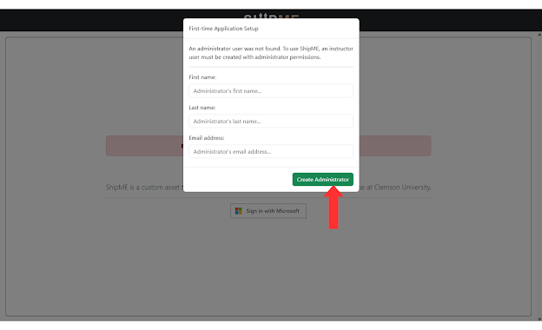
  - Note: Ensure you enter the correct @clemson.edu domain email address of the person you wish to be the administrator, as this step grants full permissions to whomever owns that address. Failure to enter a valid @clemson.edu domain will result in an error. Proceed with caution when entering an email address. This step is irreversible.
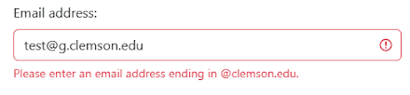
- Click the “Sign In With Microsoft” image.
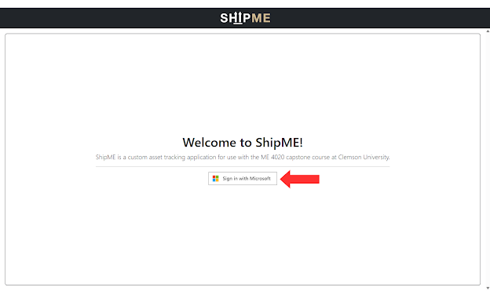
- Log in with your university-issued Microsoft account credentials in the OAuth 2.0 pop-up.
  - Note: Your Clemson Microsoft account email address is your Clemson username (such as “jteston”) followed by “@clemson.edu”. I.e., “jteston@clemson.edu”.
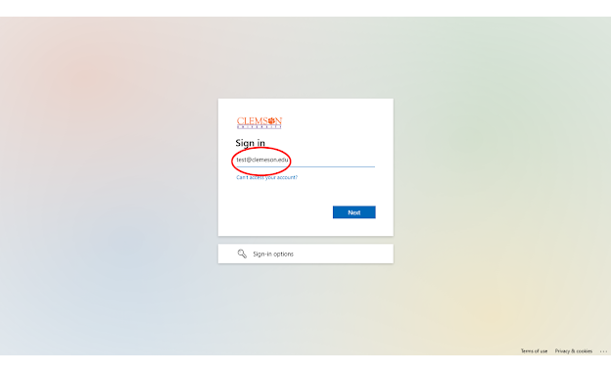
- You will now be directed to Clemson University’s single sign-on (SSO) portal. Enter in your password and click “Sign In”.
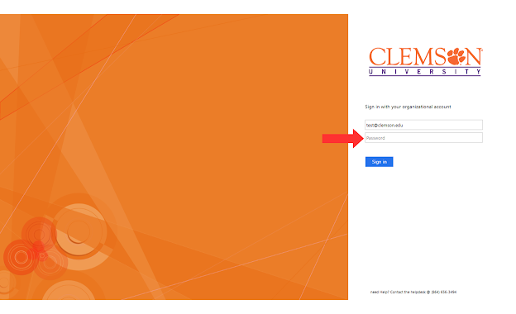
- To reduce how often you have to log in, click “Yes” to automatically sign in to your account when opening ShipME.
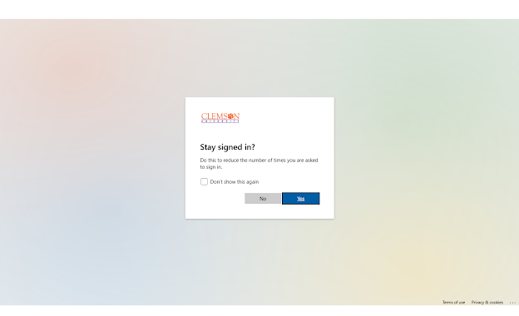
- After logging in, you will be directed to the Dashboard. The Dashboard provides summary metrics of your course within ShipME.
  - Under the “Unread Notifications” panel, select the underlined “Click here to see all notifications” to navigate to the Notifications page.
  - Under the “Incoming Requests” panel, select the underlined “Click here to view incoming requests” to navigate to the Requests page.
  - Under the “Summary Metrics” panel, select a category from within the dropdown menu to display visualizations of various application data.
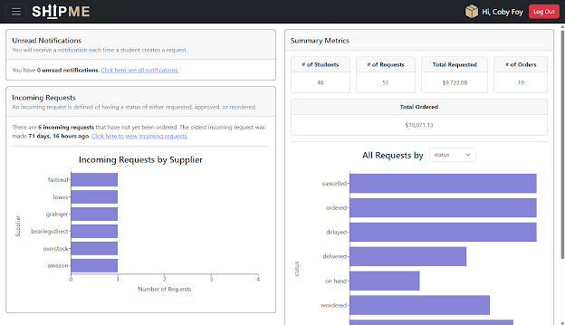
- Access the sidebar navigation menu by clicking the icon with three lines stacked on top of each other in the top left corner of the page. This is used to navigate to other pages within ShipME.
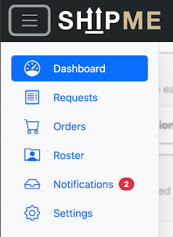
- Navigate to the Settings page to upload your student roster. Admin and Instructors only. TAs skip this step.
  - To export a roster CSV from Canvas, see this article.
  - Edit your file to ensure it includes the correct headers (click “download template” to download a sample CSV). You will receive upload errors if your headers do not match what the system expects.
  - Enter student team assignments in the “Team #” column. The team number is specific to their course section; if a student is assigned to the second team in course section 300, enter “2” for the value.
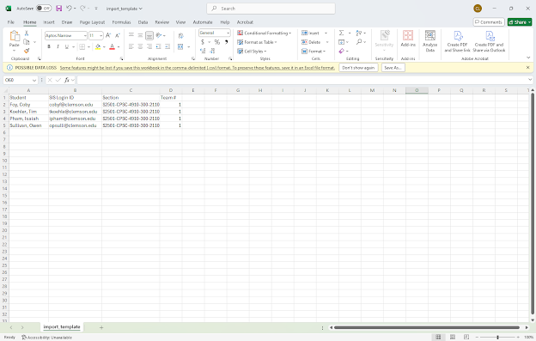
  - Click “Browse” and navigate to your roster CSV file within your computer’s file explorer.
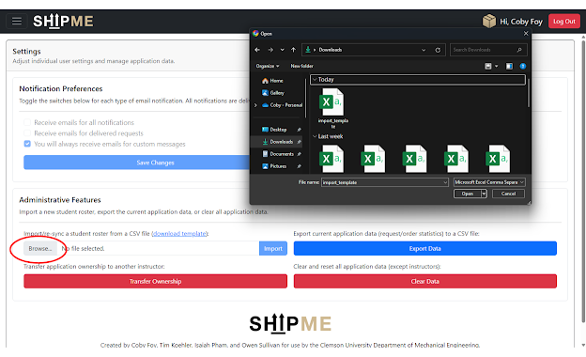
  - Click “Import” to upload the roster CSV.
  - In the pop-up modal, click “Import Roster” to confirm.
  - If you see a success message, your roster was successfully uploaded
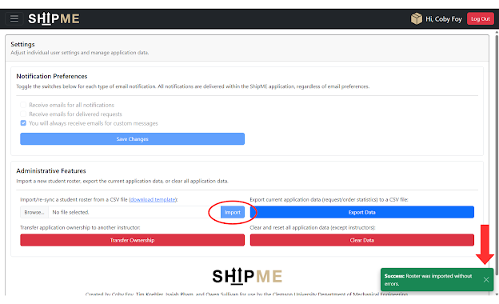
- Navigate to the Settings page to export your semester’s order data.
  - Click the “Export Data” button to download a CSV file of all orders and associated requests.
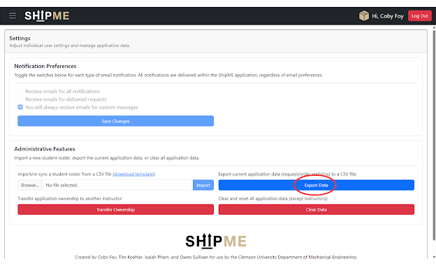
  - Inspect your file for all transactions since the application data was last cleared. Save the file for financial record keeping purposes.
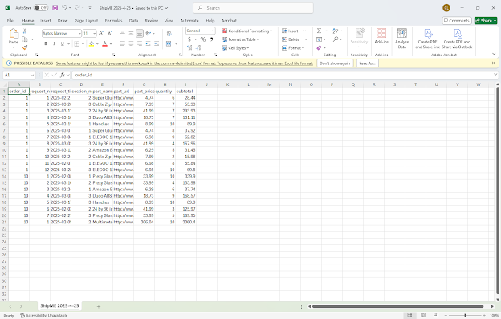

- Navigate to the Settings page to clear all data within ShipME. Admin only. Non-admin Instructors and TAs skip this step.
  - Click the “Clear Data” button to clear all data within the application, with the exception of the current instructors and administrator.
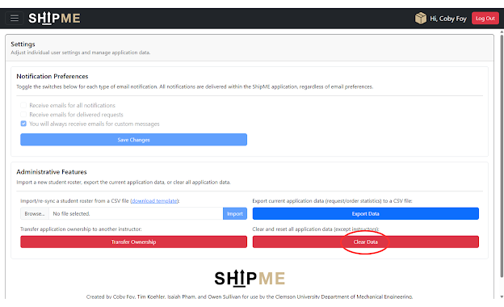
- Navigate to the Settings page to transfer administrative control to another instructor. Admin only. Non-admin Instructors and TAs skip this step.
  - In the event you would like to transfer administrative control of ShipME to another individual, click the “Transfer Ownership” button.
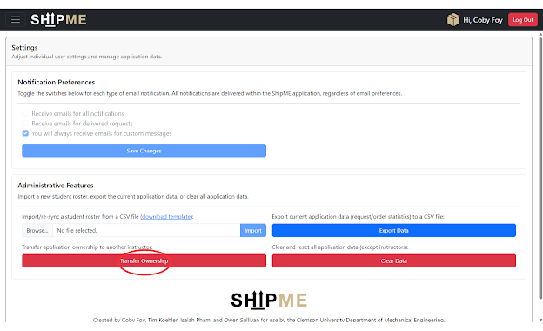
  - From within the pop-up, select a preexisting instructor. If none exists, you will have to add an additional instructor. See Step 19 for details on how to add instructors.
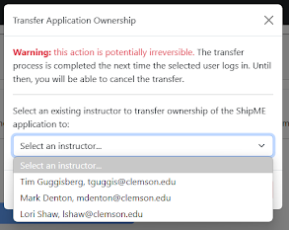
  - Click “Transfer Ownership” to initiate the transfer. This action is potentially irreversible.
    - Note: The transfer will complete once the selected instructor logs into ShipME (which may be done simply by loading the ShipME site, if the instructor was already logged in). Until then, the transfer can be cancelled by clicking the “Cancel Ownership Transfer” button, which is now yellow.
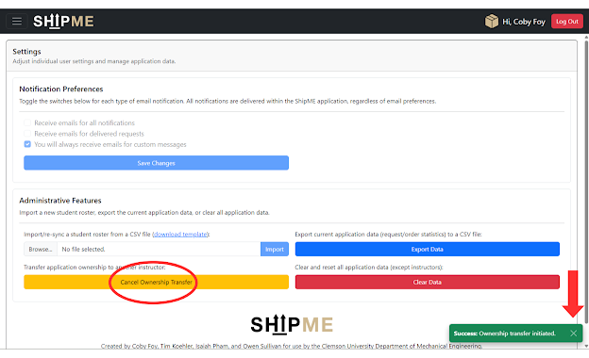
    - Cancel the transfer by clicking “Cancel Transfer” from within the pop-up modal.
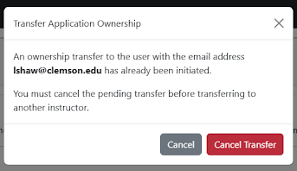
- Navigate to the Requests page to view all previously submitted requests.
  - Under the “View Placed Requests” panel, a table is populated with each row representing all existing requests.

  - Use the “Select a student…” dropdown and search for a student by name or email address to filter requests placed by a specific student.
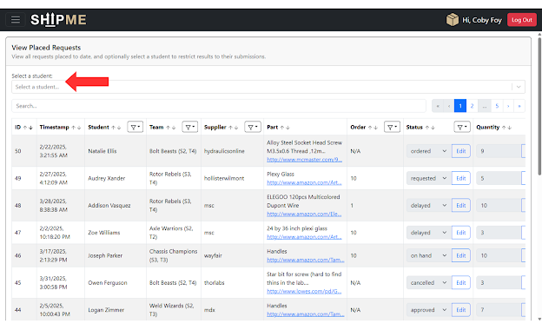
  - Navigate the table by clicking the pagination system’s arrow or number buttons.
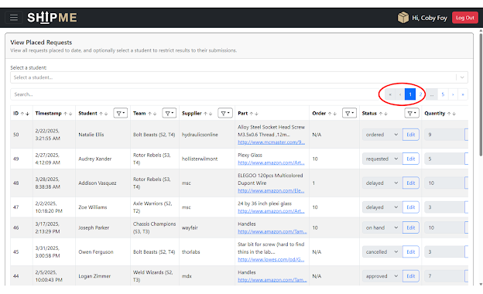
  - Click the arrow beside the “ID” column header to sort the requests in chronological (default) or reverse chronological order.
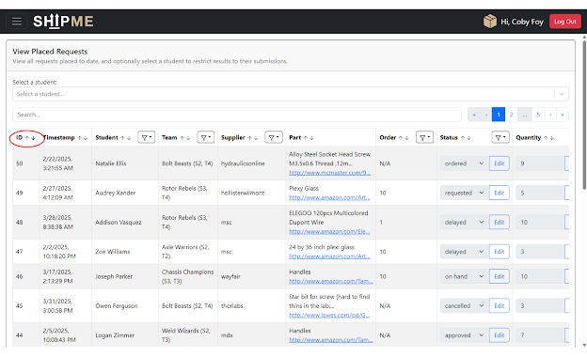
  - Click the filter icon next to some column headers to filter the requests by various property values.
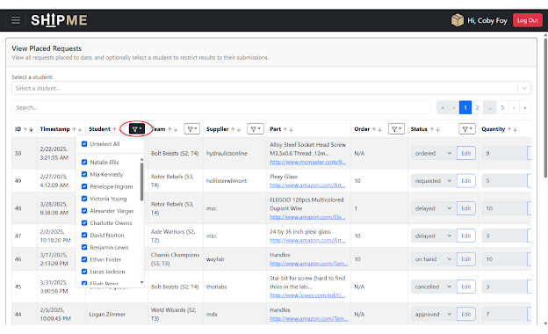
  - Click the “Edit” buttons within each row to edit the Status, Quantity, or Subtotal of any given request. These changes will be reflected if an order is associated with the request. Ensure you click “Update” to save your changes to a request.
    - Note: Updating the Quantity of a request will automatically recalculate the Subtotal based on the price of the part being requested. Updating the Subtotal independently will not change the Quantity value.
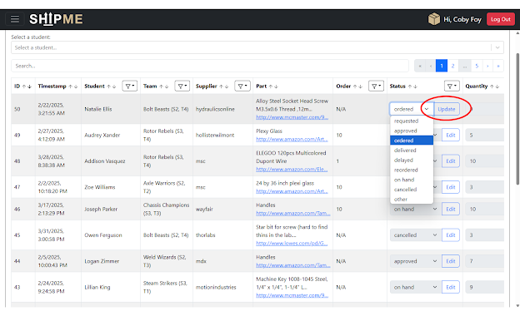
- Navigate to the Requests page to place a request on behalf of a student.
  - Under the “New Instructor Request” panel, place a request by selecting a student from the “Select a student…” dropdown.
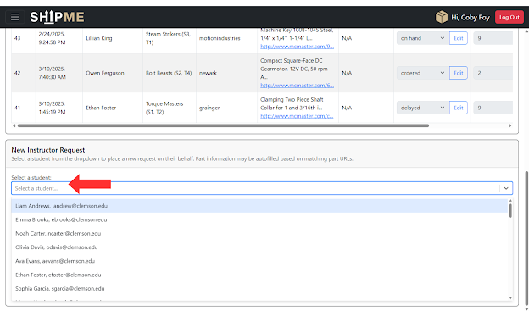
  - Enter the required information for a particular part.
  - Use the “Add Part” button to add any number of additional parts to be requested.
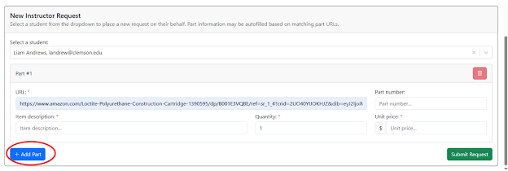
  - To remove a part from the request submission, select the red button with the trash can icon.
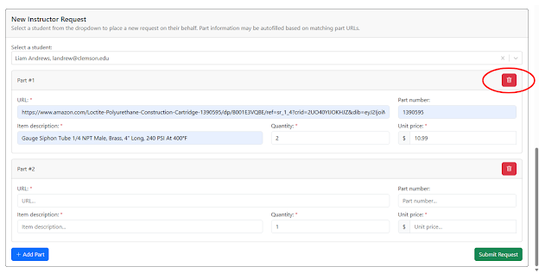
  - Click “Submit Request” to submit the request(s) on behalf of the selected student.
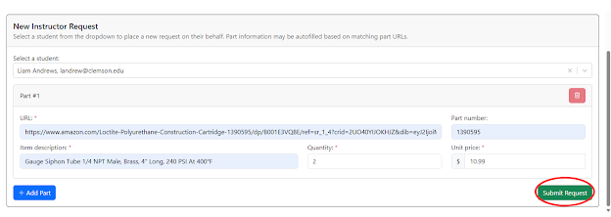
  - After confirming your request line items, click “Confirm Request”. The request is now marked with a status of “requested”, and is now visible within the “View Placed Requests” panel at the top of the Requests page and within the “Incoming Requests” panel on the Orders page.
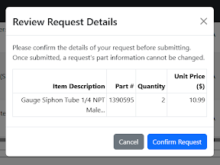
- Navigate to the Orders page to view incoming requests with a status of “requested”, “approved”, or “reordered”. TAs are unable to modify requests/orders or create new orders from within the Orders page.
  - Under the “Incoming Requests” panel, select a supplier from the “Selected supplier” dropdown menu to view all associated requests.
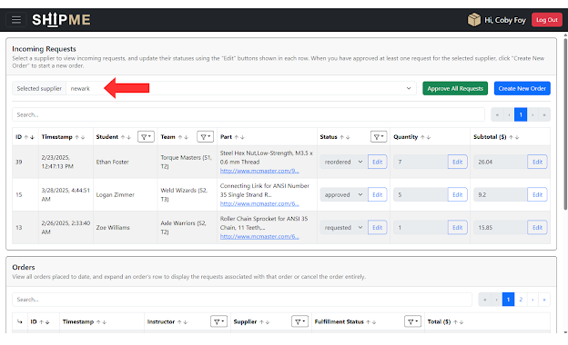
  - Update request attributes by clicking the “Edit” buttons within each row.
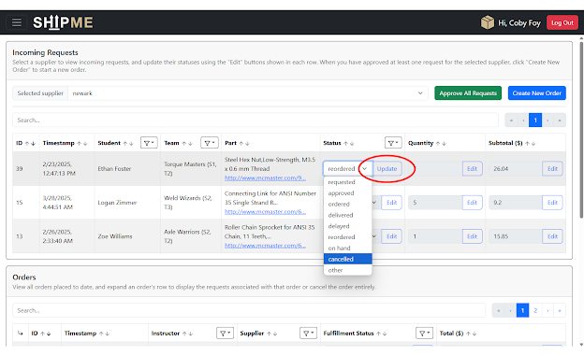
  - To generate an associated order for a request or group of requests, first ensure at least one request has a status of either “approved” or “reordered”. Click the “Approve All Requests” button to mark all requests associated with the selected supplier as “approved”.
    - Note: The “reordered” value for a request’s status is special in that it counts a request as approved by an instructor. Although changing the value to “approved” will not cause any problems, it is not strictly necessary to associate a reordered request with a new order.
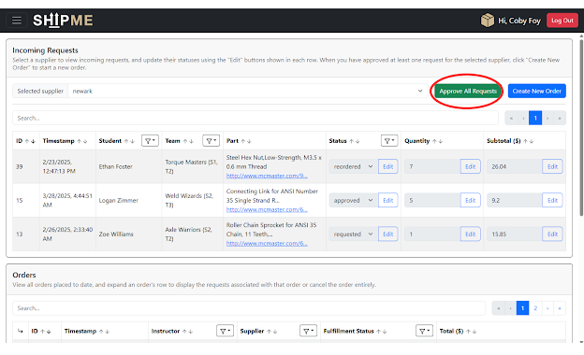
    - For any request you wish to remove from view, simply change its status to “cancelled”.
    - When changing a request’s status to values other than “requested”, “approved”, or “ordered”, you can optionally enter a custom message to send to the team that placed the request.
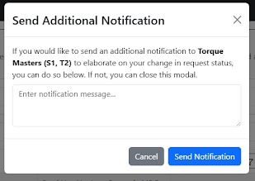
  - To generate a new order, click “Create New Order”.
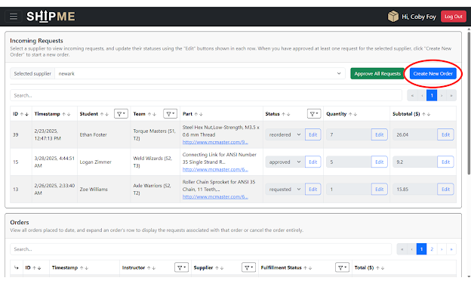
  - Within the pop-up modal, ensure your order information is correct and click “Create Order”.
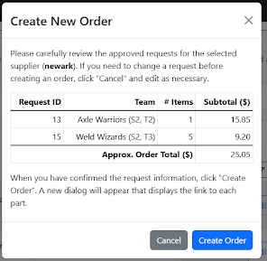
  - If the actual order total is different than the anticipated subtotal, you can update it here. When the order has been placed, click “Finalize Order”.
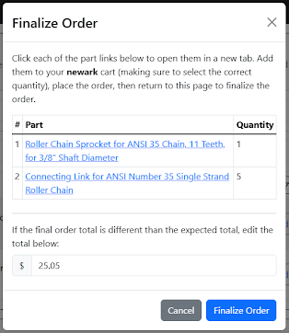
  - The order is now populated in the “Orders” panel on the Orders page.
- Navigate to the Orders page to view all orders. TAs are unable to modify order information within the Orders page.
  - Under the “Orders" panel, update order fulfillment statuses by clicking the “Edit” buttons under the “Fulfillment Status” column.
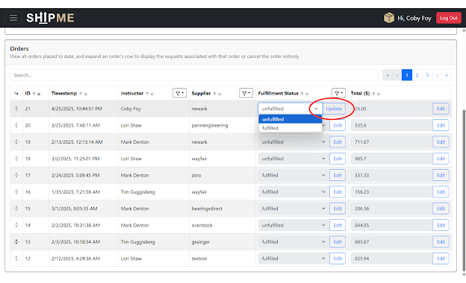
  - If you need to update the order total to account for tax or fees, you may edit the Total column.
  - Select the arrow icon in the leftmost column of each order row to expand the row and view all associated requests. You can navigate the sub-table to manage those requests.
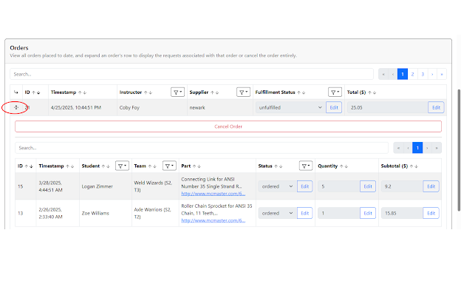
  - To cancel an unfulfilled order, click the “Cancel Order” button after expanding the order row. This marks all associated requests as “cancelled”.
    - In the pop-up modal, click “Cancel Order” to confirm.
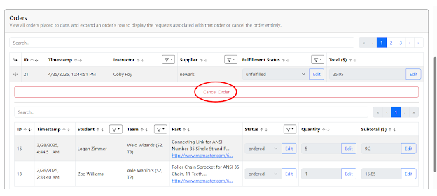
- Navigate to the Roster page to manage your student roster and faculty users.
  - Under the “Roster” panel, you can navigate through the student directory by clicking into Sections, Teams, and Students cards.
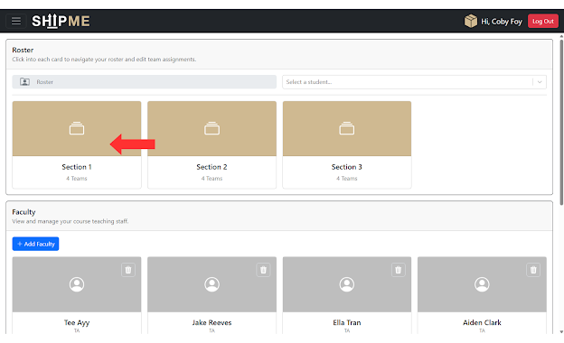
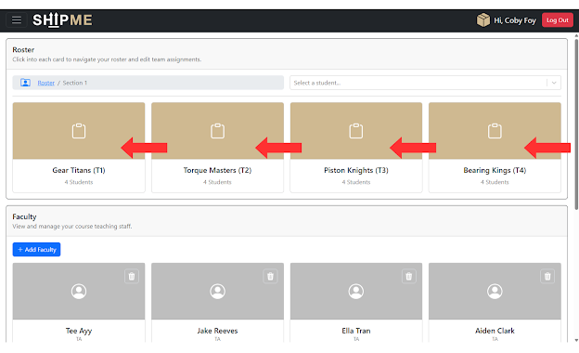
  - Optionally, search for a student by name or email address using the “Select a student…” dropdown.
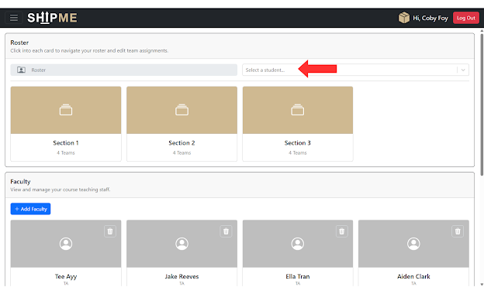
  - Once navigated into any particular team’s view, send a custom message to students in that team by clicking the “Send Message” button.
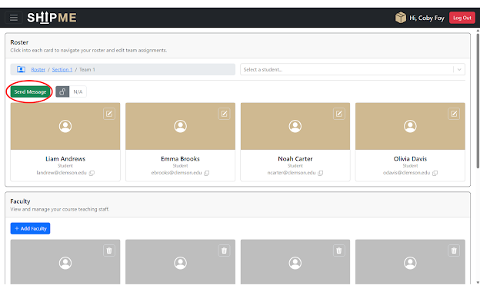
    - In the pop-up modal, enter in your message and click “Send Notification”. This will automatically override any student notification preferences and send both an in-app notification and email to the students.
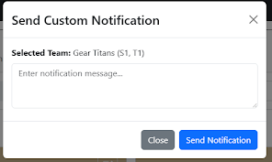
  - Assign a locker to a team by entering a valid number in the locker field.
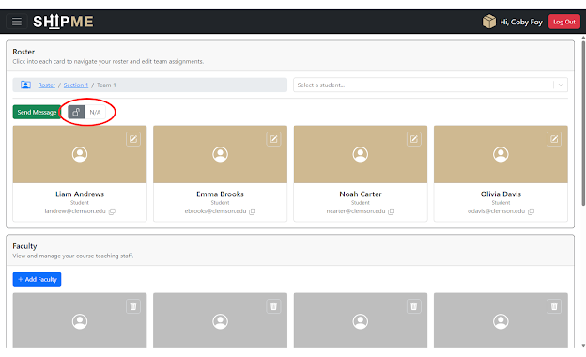
    - If no locker is assigned, an unlock icon is displayed with the text “N/A”.
    - To assign a locker, click within the text field.
      - Enter a valid integer. You will receive errors if the input is not a number or if the locker assignment is already taken.
      - Note: A maximum of 3 characters may be entered in this field.
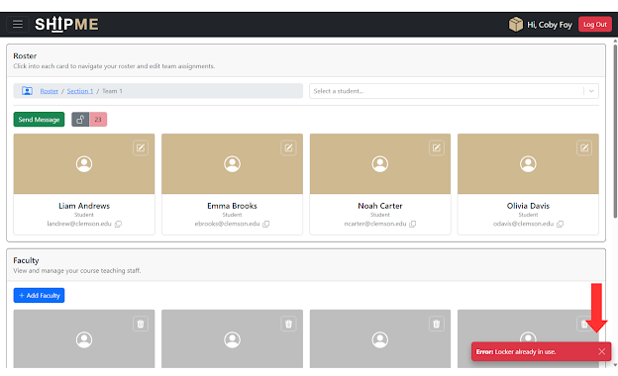
      - Click “Assign” to assign the locker to the team.
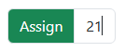
    - If a locker is assigned, a lock icon is displayed with the assigned locker number.
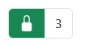
    - To remove a locker assignment, hover over the lock icon and click the red trash can icon.
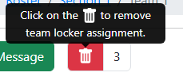
  - To move a student from one team to another, click the button with the pencil icon in the top right of their student card.
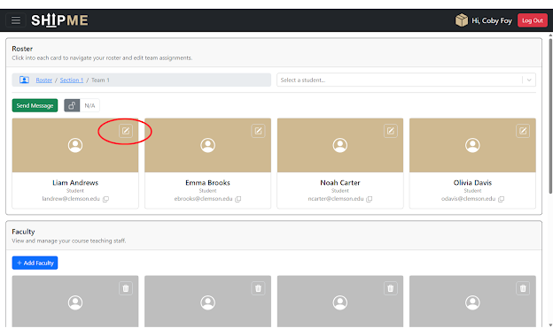
    - Select a section from the “Select a section…” dropdown menu.
    - Once a valid section is selected, the “Select a team…” dropdown menu becomes enabled. Select a team from within the selected section to move the student into.
    - Click the “Change Team” button to confirm the team change.
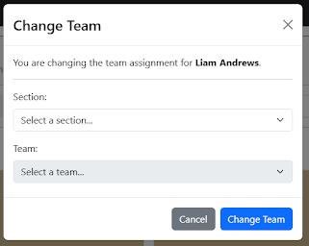
- Under the “Faculty” panel, view and manage your teaching staff. Admin and Instructors only. TAs skip this step.
  - Click the “Add Faculty” button to add a TA or Instructor. Admin only. Non-admin Instructors and TAs skip this step.
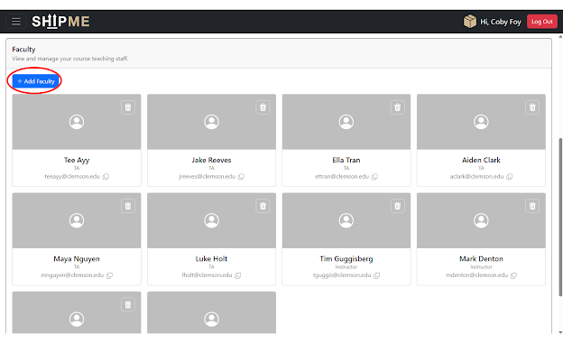
    - Fill in the required user information in the pop-up modal.
      - Note: Ensure a valid @clemson.edu email address is entered.
    - Click the “Add User” button to confirm.
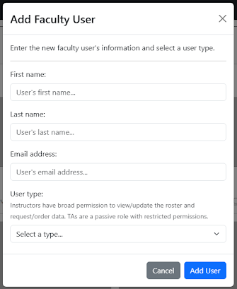
  - To remove a faculty user, select the button with the trash can icon at the top right of their user card.
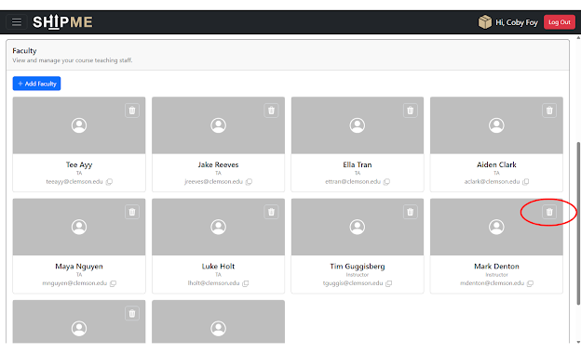
    - Confirm the action by clicking “Delete User”. This action is irreversible.
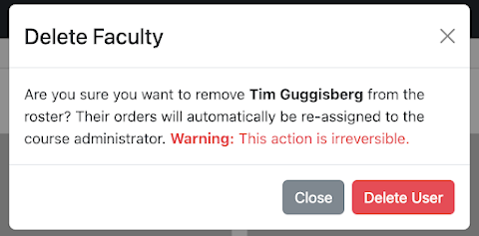
      - Note: If an instructor has previously placed orders, all of their associated orders will be reassigned to the administrator given that they are the only user within ShipME who can delete instructors.
    - Note: The administrator user can remove both instructors and TAs, however non-administrator instructors can only remove TAs.
- Navigate to the Notifications page to view messages generated by incoming requests.
  - All your received notifications are populated on the page, and you may mark individual notifications as read/unread by clicking the “Read”/”Unread” buttons to the right of each message. Alternatively, click the “Mark All as Read” button at the top of the page to mark all notifications as read.
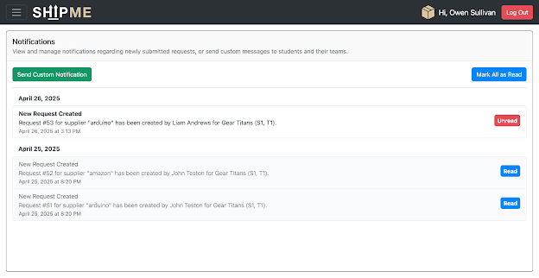
- Navigate to the Notifications page to send messages to students.
  - Click the “Send Custom Notification” button to send a custom message to a student.
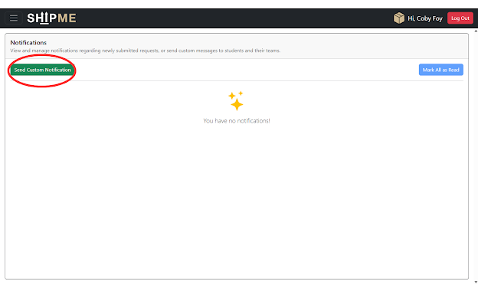
    - Note: This will also send the student’s team members the same message.
  - In the pop-up modal, select a student from the “Select a student…” dropdown menu.
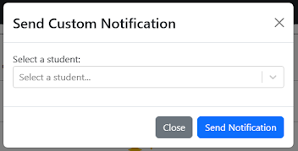
  - Enter your custom message in the text field and click the “Send Notification” button to confirm.
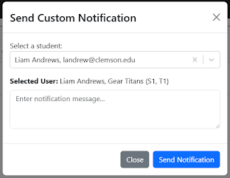

Student
- Click the “Sign In With Microsoft” image.
- Log in with your university-issued Microsoft account credentials in the OAuth 2.0 pop-up.
  - Note: Your Clemson Microsoft account email address is your Clemson username (such as “jteston”) followed by “@clemson.edu”. I.e., “jteston@clemson.edu”.
- You will now be directed to Clemson University’s single sign-on (SSO) portal. Enter in your password and click “Sign In”.
- To reduce how often you have to log in, click “Yes” to automatically sign in to your account when opening ShipME.
- After logging in, you will be directed to the Dashboard. The Dashboard provides summary metrics of your team within ShipME.
  - Under the “Unread Notifications” panel, select the underlined “Click here to see all notifications” to navigate to the Notifications page.
  - Under the “Pending Requests” panel, select the underlined “Click here to view incoming requests” to navigate to the Requests page.
  - Under the “Summary Metrics” panel, select a category from within the dropdown menu to display visualizations of various application data.
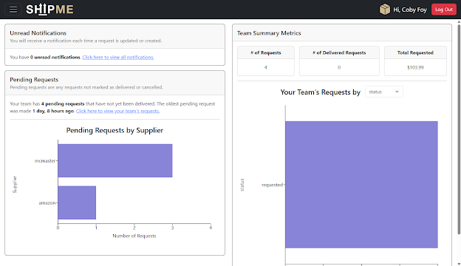
- Access the sidebar navigation menu by clicking the icon with three lines stacked on top of each other in the top left corner of the page. This is used to navigate to other pages within ShipME.
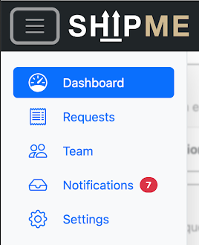
- Navigate to the Settings page to manage your application preferences.
  - To update your email notification preferences, select the notification types you would like to receive by checking the corresponding boxes.
    - Note: You will always receive emails for custom messages from course instructors.
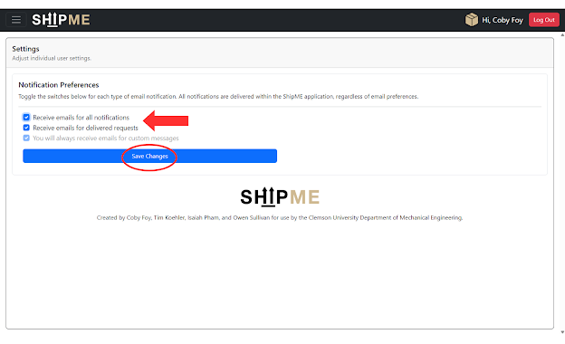
- Navigate to the Requests page to create requests for your team.
  - Under the “New Request” panel, place a request by entering the required information for a particular part.
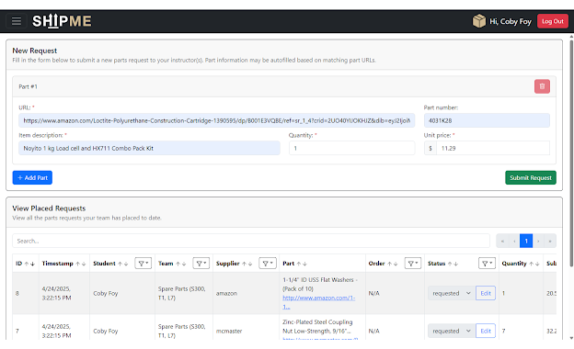
  - Use the “Add Part” button to add any number of additional parts to be requested.
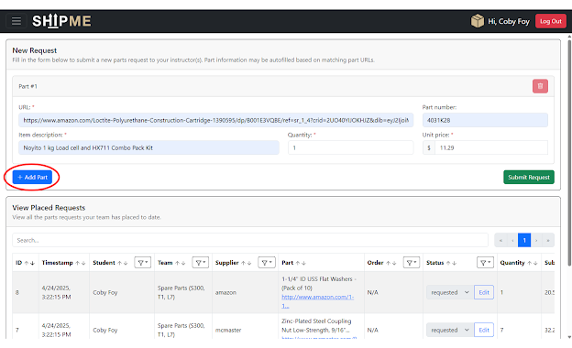
  - To remove a part from the request submission, select the red button with the trash can icon.
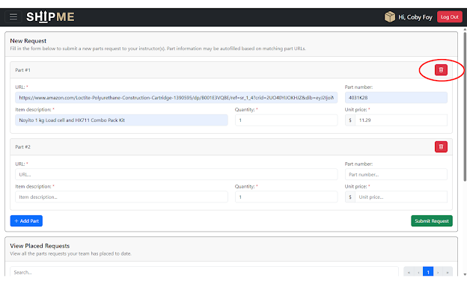
  - Click “Submit Request” to submit the request(s) on behalf of your team.
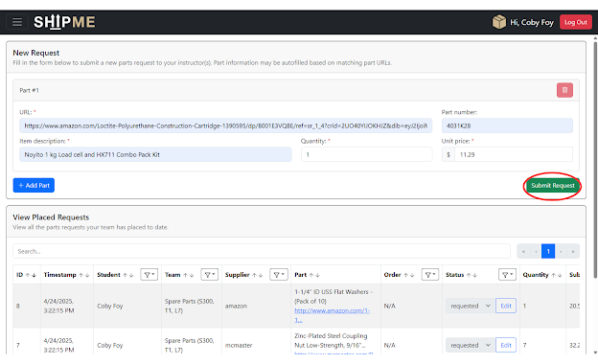
  - After confirming your request line items, click “Confirm Request”. The request is now marked with a status of “requested”, and is now visible within the “View Placed Requests” panel at the bottom of the Requests page.
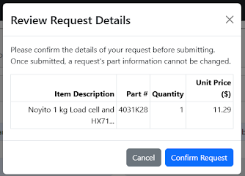
- Navigate to the Requests page to view your team’s previously submitted requests.
  - Under the “View Placed Requests” panel, a table is populated with rows of requests previously placed by members of your team.
  - Navigate the table by clicking the pagination system’s arrow or number buttons.
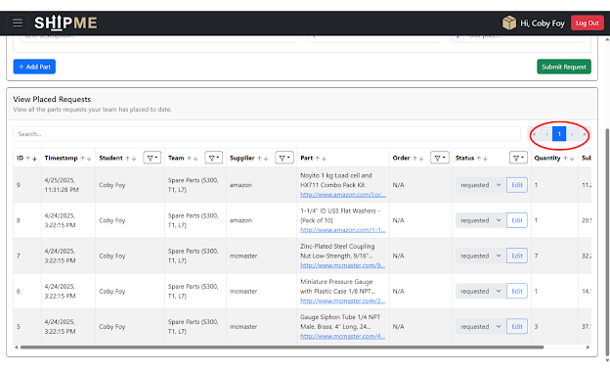
  - Click the arrow beside the “ID” column header to sort the requests in chronological (default) or reverse chronological order.
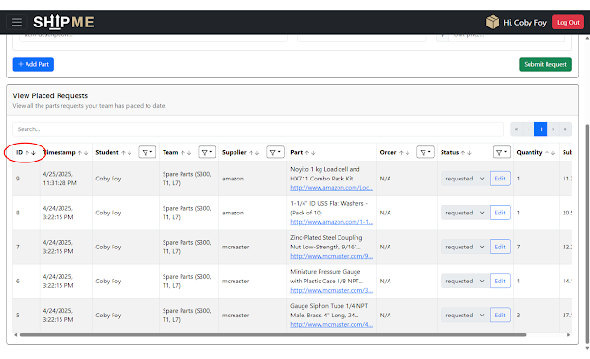
  - Click the filter icon next to some column headers to filter the requests by various property values.
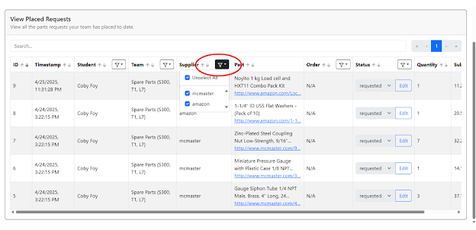
  - To cancel a previously submitted request, click the “Edit” button under the Status column and change the status to “cancelled”.
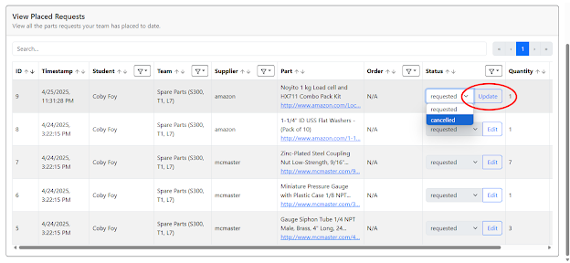
- Navigate to the Team page to view your assigned team.
  - Click the “Change Name” button to edit your team’s name.
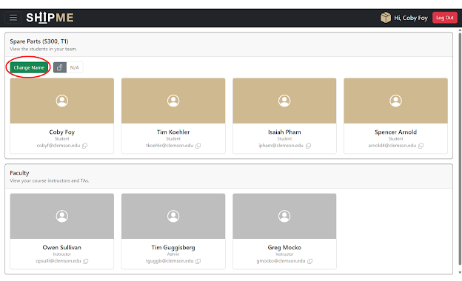
    - In the input field, enter the new team name and click “Change Name” to confirm.
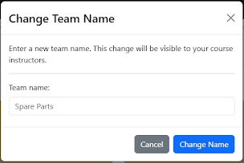
  - Assign a locker to your team by entering a valid number in the locker field.
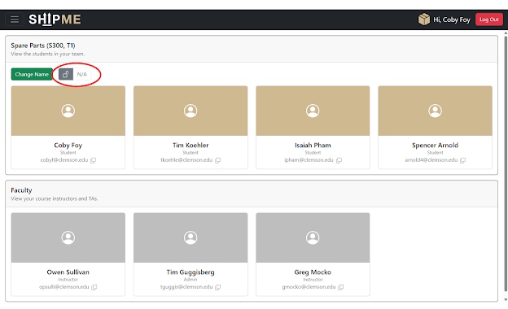
    - If no locker is assigned, an unlock icon is displayed with the text “N/A”.
    - To assign a locker, click within the text field.
      - Enter a valid integer. You will receive errors if the input is not a number or if the locker assignment is already taken.
      - Note: A maximum of 3 characters may be entered in this field.
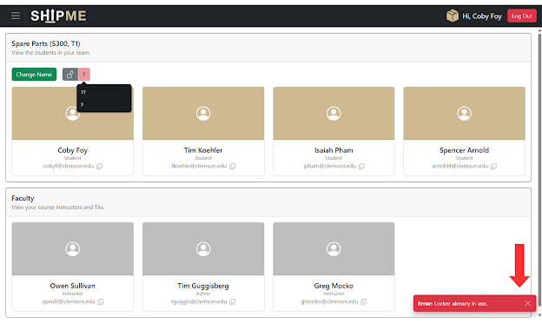
      - Click Assign to assign the locker to your team.
    - If a locker is assigned, a lock icon is displayed with the assigned locker number.
    - To remove a locker assignment, hover over the lock icon and click the red trash can icon.
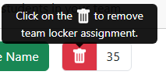
- Navigate to the Team page to view your current course instructors and TAs.
  - Click the copy icon to copy a faculty user’s email address to your clipboard.
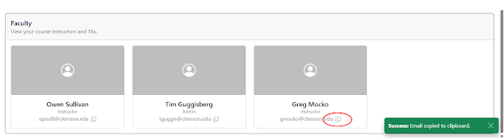
- Navigate to the Notifications page to view notifications generated by request updates or custom messages from instructors.
  - All your received notifications are populated on the page, and you may mark individual notifications as read/unread by clicking the “Read”/”Unread” buttons to the right of each message. Alternatively, click the “Mark All as Read” button at the top of the page to mark all notifications as read.
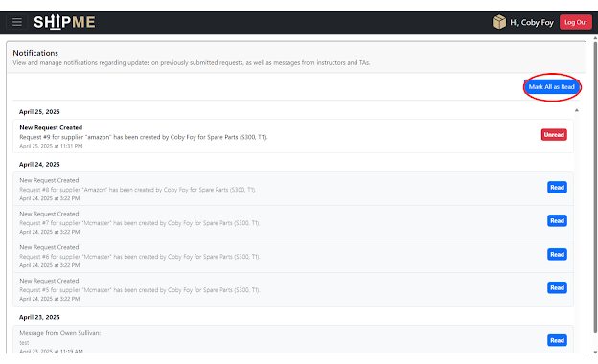

Demo Videos
Included with this report are video demonstrations of ShipME’s features and the processes by which users can interact with the application. There are videos demoing both instructor actions and student actions¹⁰.
¹⁰ See the attached files “Instructor Demo Video.mp4” and “Student Demo Video.mp4” for the demo videos.

Appendix

GitHub Repository
The GitHub repository for the completed ShipME application and each of its components can be found at https://github.com/Clemson-Capstone/s25-cecas-me.

Project Artifacts

Artifact 1 - Team Bio
