CPSC Study Lab — Week 1 (September 19)

Lesson Information — SSH, the School of Computing Virtual Environment, file transfer methods, and etc.

What are the SoC machines?
The School of Computing provides a virtual Linux environment for students to test their programs, as opposed to students using (and potentially damaging) their own computers.

Each student is provided an account on the Linux environment which syncs across virtual machines and matches their Clemson login credentials.

More information about the virtual environment and accounts system can be found at: https://computing.clemson.edu/help/linuxaccount.html

What is SSH?
Secure Shell, abbreviated SSH, is a protocol that allows a client machine to access a remote execution shell on a host machine via a network.

It most frequently runs on port 22, as in the instance of the School of Computing virtual environment.

How do I use SSH with the SoC machines?
On modern operating system releases, using SSH is very easy.

For Windows users who have updated their computer’s software since 2019, SSH is built into either the “Command Prompt” or “Windows Terminal” applications.

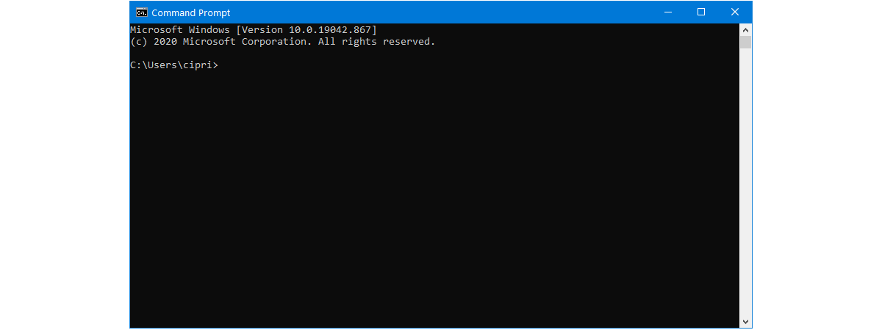

For macOS and Linux users, SSH is built into the operating system’s “Terminal” or equivalent application.

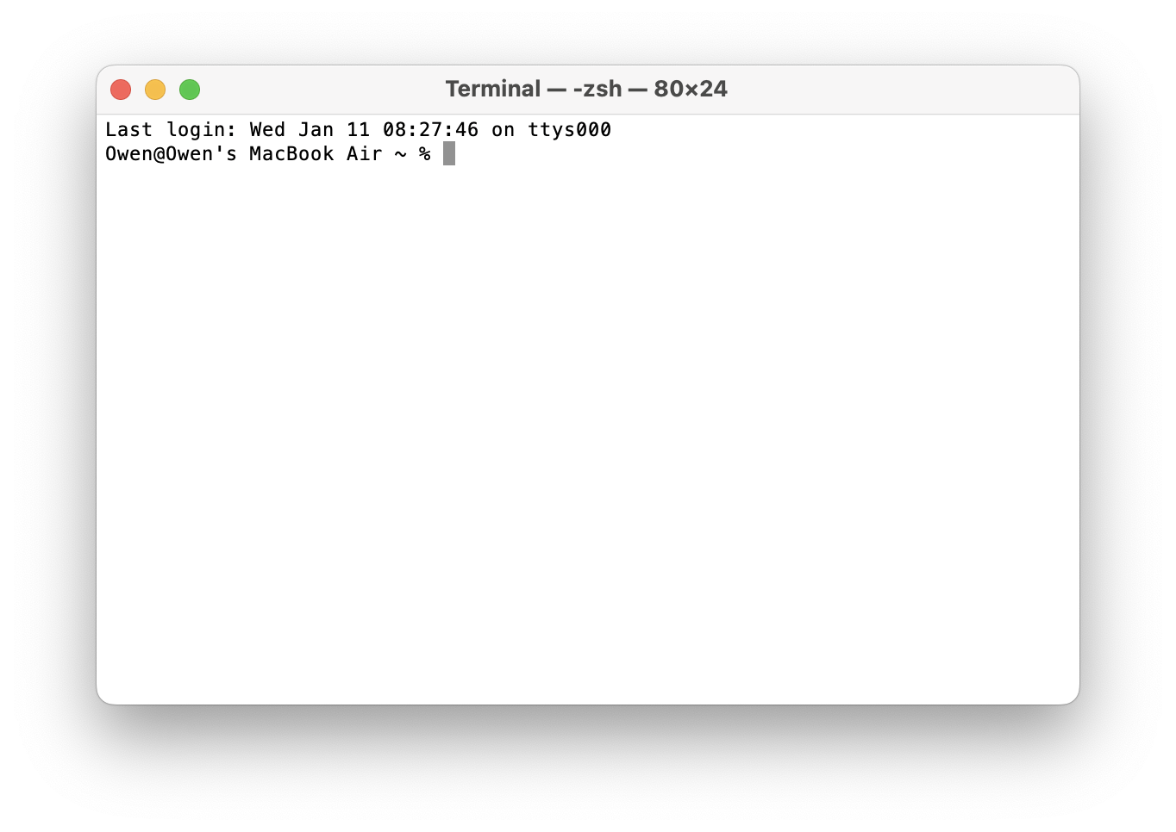
To SSH into a remote host, use the following command syntax (replacing [your_username] with your Clemson username, without the @clemson.edu part):

ssh [your_username]@access.computing.clemson.edu

When prompted, enter your Clemson account password. Most modern SSH clients, including the terminals built into operating systems as described above, do not show password characters as they are typed for security purposes. Press “Enter” when you have finished entering your password.

After logging in successfully, you will see a screen in your terminal application like the following:

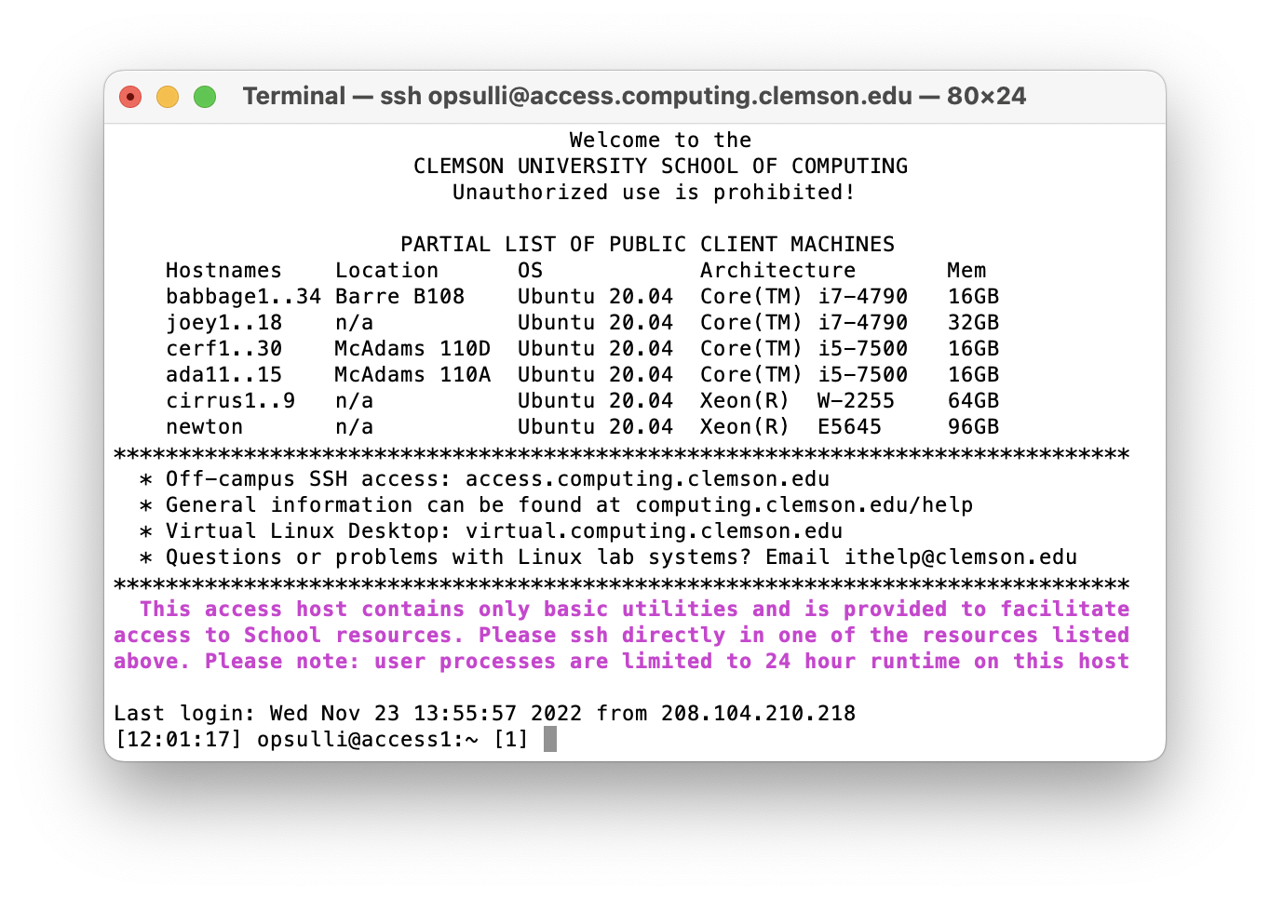
This is the School of Computing virtual environment’s access node, which itself cannot perform most common Linux actions. Instead, this access node is meant to provide access to “named” machines for off-campus users as a security measure.

To be able to use the SoC virtual environment to its fullest, you must SSH one level further into one of the “named” machines listed when you login to the access node (see above screenshot where names include “babbage1..34”, “joey1..18”, and etc.).

Once you have chosen a “named” machine, such as “babbage12”, you can issue the following command to login to that machine (replacing the machine name below with whichever “named” machine you chose):

ssh babbage12

Then, enter your Clemson password again and press “Enter”.

Transferring files to/from the SoC machines:

Connecting:
There are many ways to interact with the School of Computing virtual environment, but the most beginner-friendly method by far is using graphical user interface (GUI) file transfer applications like FileZilla.

FileZilla can be downloaded for free on both PC and Mac at: https://filezilla-project.org/download.php?type=client

After installing FileZilla and opening it, you will see a screen like the image below:

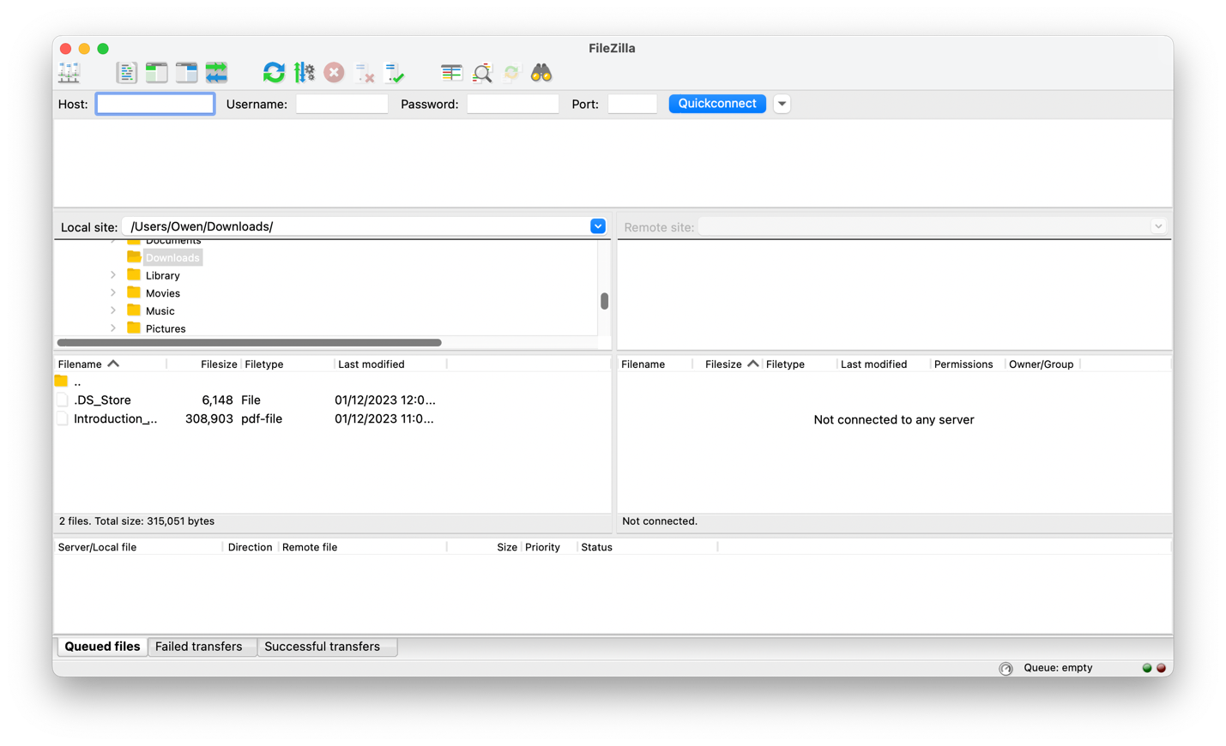
At the top-left is the “Host” text box; this is where you enter the server you’re trying to transfer files to/from. For the purposes of using FileZilla with the School of Computing virtual environment, you should use the following host: access.computing.clemson.edu

In the “Username” text box, enter your Clemson username (without the @clemson.edu part). The “Password” text box should be self-explanatory.

The “Port” text box exists as an optional field for cases when the server being accessed is configured differently than default. For example, some servers restrict file transfer to port 22, which represents the SFTP (Secure File Transfer) protocol and shares a port with SSH. However, the most common file transfer method is the standard FTP (File Transfer) protocol, which operates on port 21. When the standard port 21 is being used, the “Port” text box can be left blank.

Once the correct information has been entered, click “Quickconnect”. You can also save the connection details in FileZilla, although this will not be covered in CPSC Study Labs.

Transferring files:
After you’ve connected, details about the files and directories stored on the remote server will populate in the FileZilla window.

In the middle-most section of the FileZilla window, directory listings for your computer (on the left) and the remote machine (on the right) are found. Use the left panel to navigate through your local computer, and find a folder you wish to store copied files in. Use the right panel to navigate through your SoC home directory, which contains any files you've created.

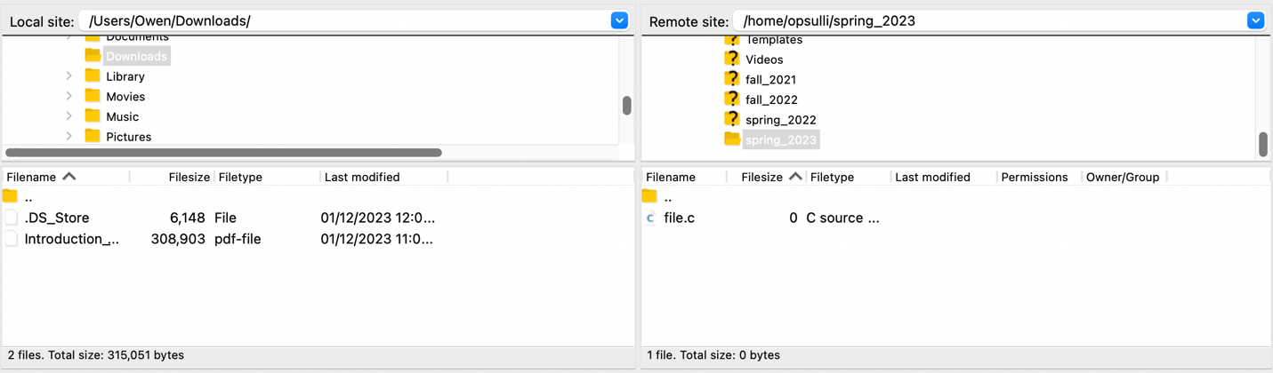

Find the file you wish to copy, then select and drag from the right side to the left. The file becomes accessible on your local computer in the directory you copied to.

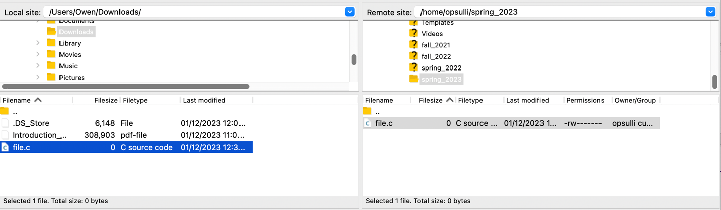

More information:
If you are struggling to navigate FileZilla, watch the following _{video} for more detailed guidelines about the FileZilla interface: https://youtu.be/adxmlHDim6c

